**Name: Pratham Kandari**

**Sap ID: 500097663**

**Batch: 7**

**Course: BTech CSE CCVT**

1. What are the various Compute services of AWS?

Ans: Various Compute services of AWS are:

a) Amazon EC2: Amazon Elastic Compute Cloud is a web service that provides choice of latest processor, storage, networking, operating system, to help us best match of our workload.

b) Amazon ECS: Amazon Elastic Container Service. It is highly scalable and has fast container management service.

c) Amazon EKS: Amazon Elastic Kubernetes Service makes Kubernetes create and operate easily on AWS.

d) Amazon Lightsail: A Virtual Private Server(VPS). Used for beginners or students as it provides everything you need to build an application or a website.

e) AWS Batch: It manages compute environments and job queues.

f) AWS Lambda(Serverless): It runs code in response to events and automatically manages the underlying compute resources for you.

2. What are the different instance types and pricing plans in AWS EC2?

Ans: Different instance types are:

a) General Purpose: These instances are used when user wants a balance of compute, memory and networking resources and can be used for variety of workloads.

b) Compute Optimized: Batch processing workloads, media transcoding, high speed web servers, high performance computing (HPC), scientific modelling, dedicated gaming servers and ad server engines, machine learning inference, and other compute-intensive applications are all well suited for instances from this family.

c) Memory Optimized: For workloads that process big data sets in memory, memory-optimized instances are made to execute quickly.

d) Accelerated Computing: Compared to software operating on CPUs, accelerated computing instances use hardware accelerators, or co-processors, to execute tasks like floating point number calculations, graphics processing, or data pattern matching.

e) Storage Optimized: Compared to software operating on CPUs, accelerated computing instances use hardware accelerators, or co-processors, to execute tasks like floating point number calculations, graphics processing, or data pattern matching.

f) HPC Optimized: For running HPC workloads at scale on AWS, high performance computing (HPC) instances are designed specifically to provide the highest price performance. Applications that profit from high-performance processors, such as extensive, sophisticated simulations and deep learning workloads, are best served by HPC instances.

Different pricing plans are:

a) On Demand: In this arrangement, depending on the instances you select, there are no upfront costs and you only pay for compute capacity per hour or per second (only for Linux Instances). You only pay for the instances you use and can adjust your compute capacity to fit the needs of your application.

b) Reserved: You can save up to 75% on Amazon EC2 Reserved Instances when compared to the cost of On-Demand Instances. In specified Availability Zones, it also offers capacity reserve. Reserved Instances, as opposed to On-Demand Instances, can offer considerable savings for applications with predictable workload.

c) Spot: Unused EC2 instances are known as Amazon EC2 Spot Instances in the AWS cloud. Spot Instances can be purchased for up to 90% less than on-demand rates. Based on supply and demand, the Spot price of Amazon EC2 spot instances changes from time to time.

3. What is AMI and its different possibilities in AWS?

Ans: An instance can be launched using an Amazon Machine Image (AMI), which is a supported and updated image offered by AWS.

Different possibilities are:

Operating System:

You can choose an AMI on the basis of the supported operating system (or OS) like Windows or Linux.

32-bit or 64-bit Architecture:

This parameter is based on the architecture of your selected OS.

Region:

This parameter is based on the selected region of the Amazon machine image that comprises regions, availability zones, and local zones. Each region operates in different geographical regions and is independent of each other.

Storage (EBS or Instance store):

This AMI parameter is based on the storage of the root device. Based on storage, AMIs are categorized as either of the following two types namely:

EBS-backed instances: In this case, the root device for an AWS instance – launched using AMI – is an Amazon EBS volume that has been created from Amazon EBS.

Instance store-backed instances: In this case, the root device for an AWS instance – launched using Ami – is an Amazon instance store volume that has been created from an Amazon S3 template.

4. What is Region, Availability Zone, Local Zone, AWS Outposts and AWS Wavelength?

Ans: Region: It is a separate geographic area.

         Availability Zone: Availability Zones are multiple, isolated locations within each Region.

         Local Zone: You can offer applications to end users that need single-digit millisecond latency by using AWS Local Zones, a form of AWS infrastructure deployment that places compute, storage, databases, and other select services closer to major population, industrial, and IT centres.

       AWS Outputs: Outputs enable you to get access to information about resources within a stack.

  AWS Wavelength: For developers to innovate and create a new class of applications, AWS Wavelength blends the high bandwidth and ultralow latency of 5G networks with AWS computation and storage capabilities.

**Experiment -1**

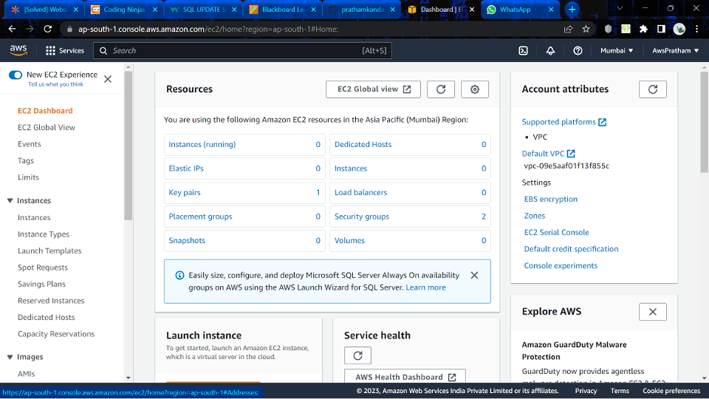

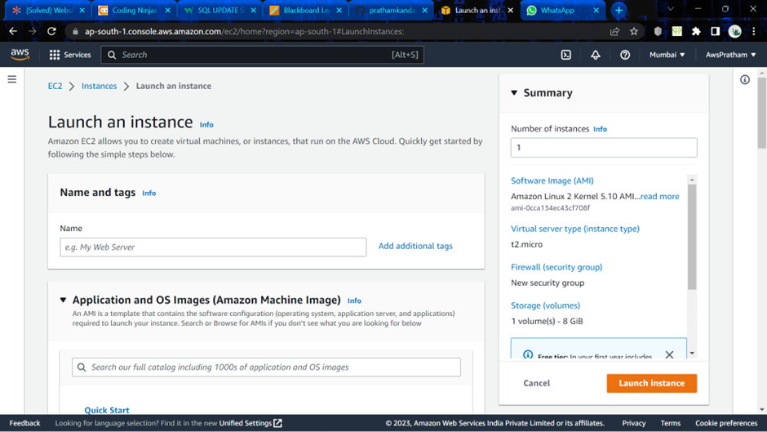

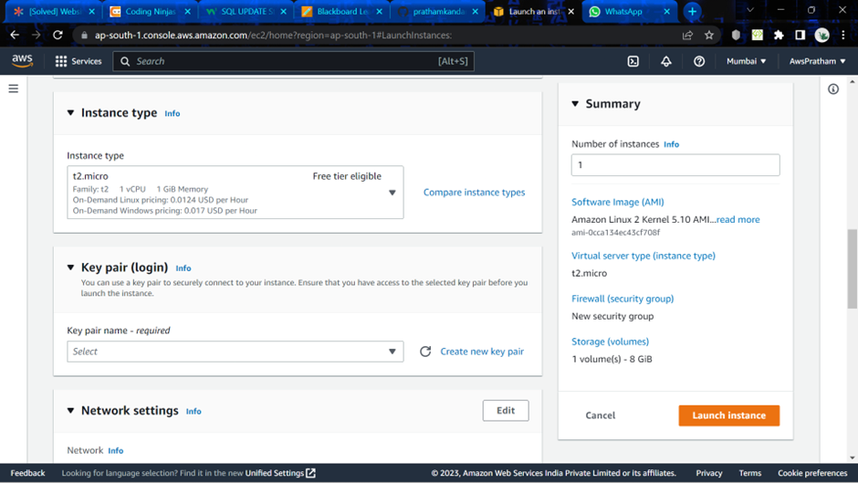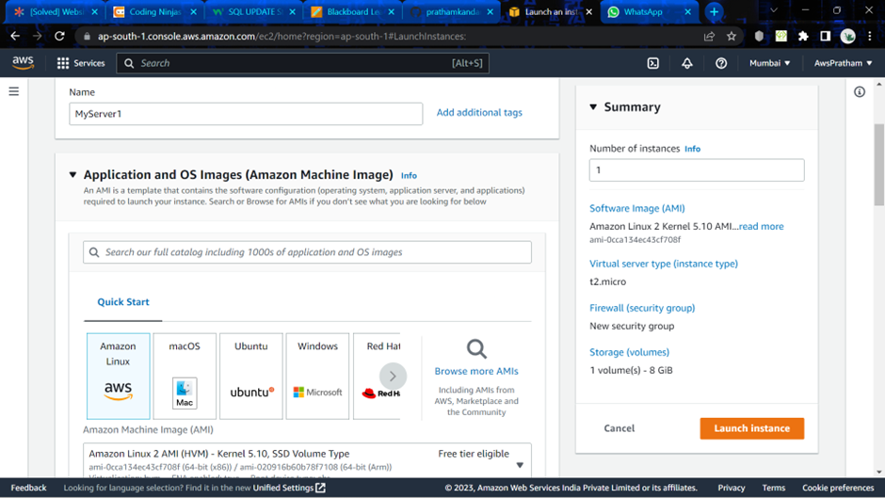

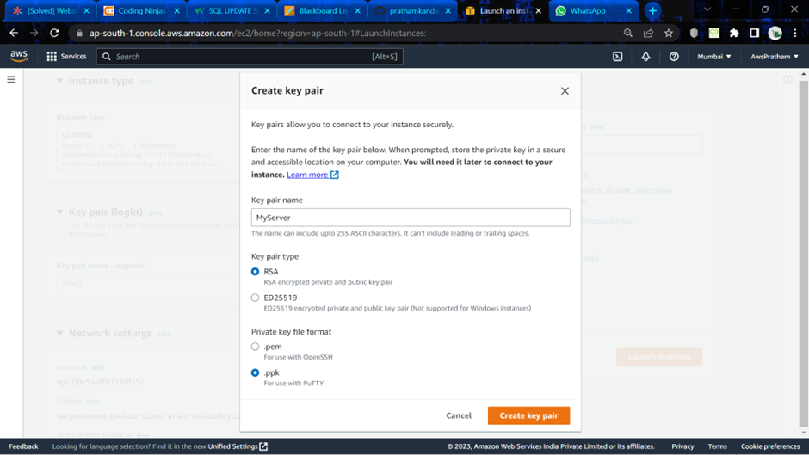

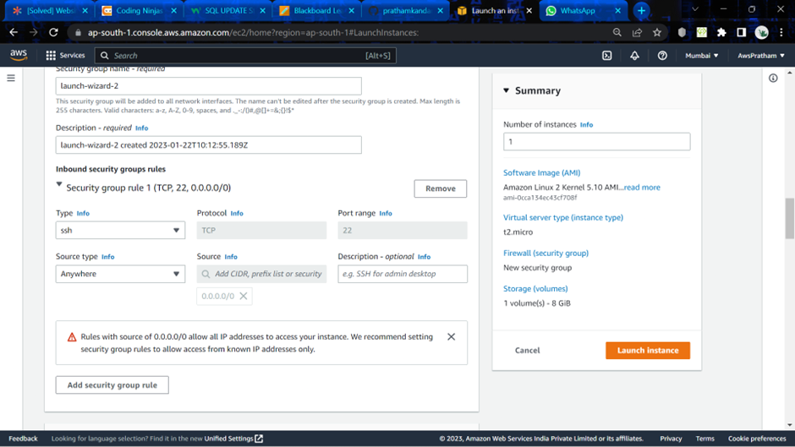

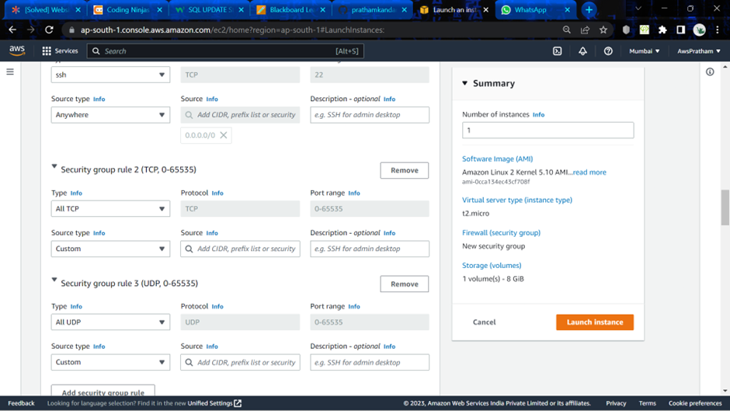

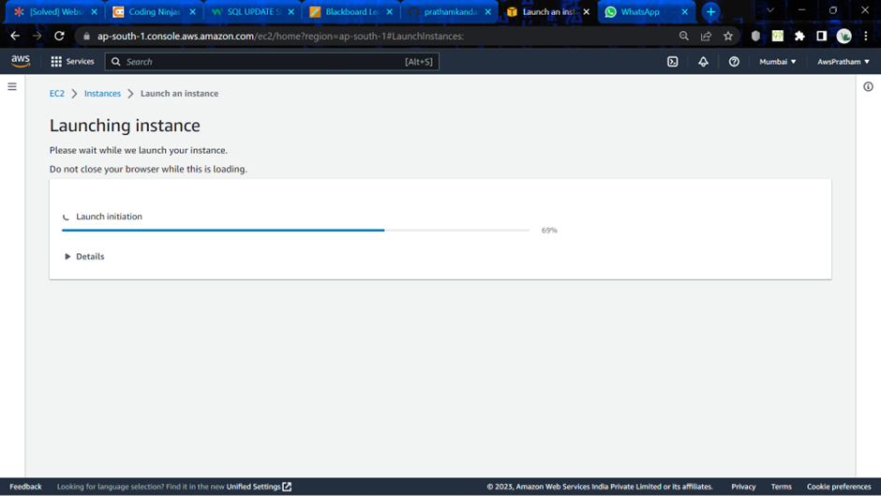

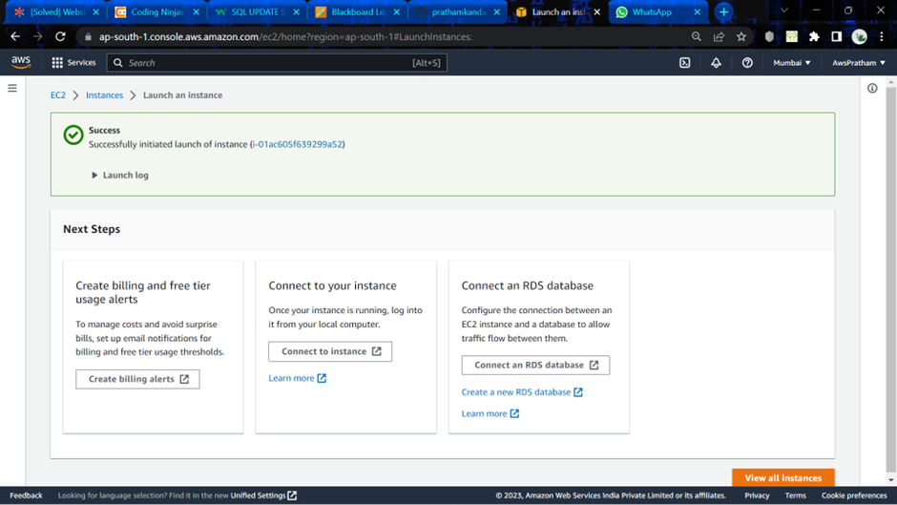

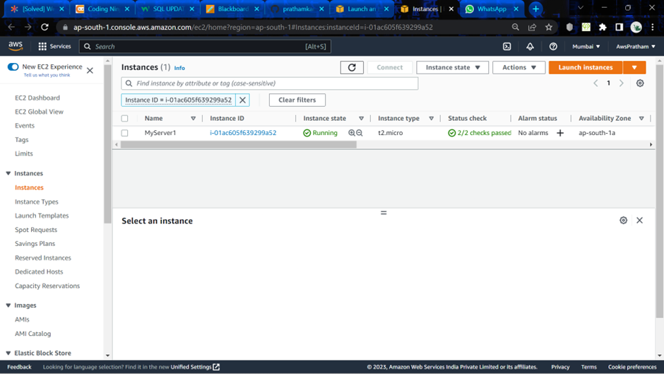

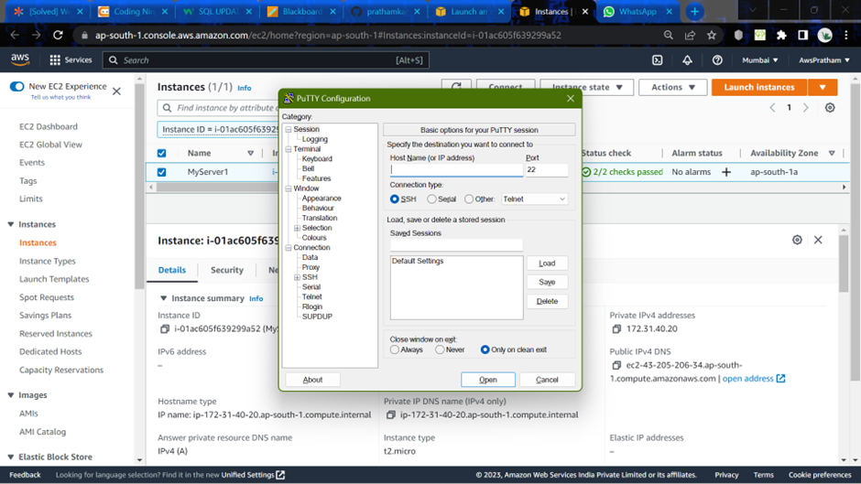

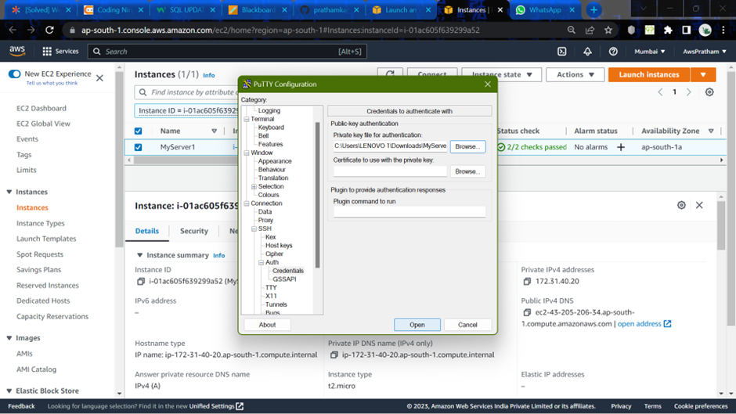

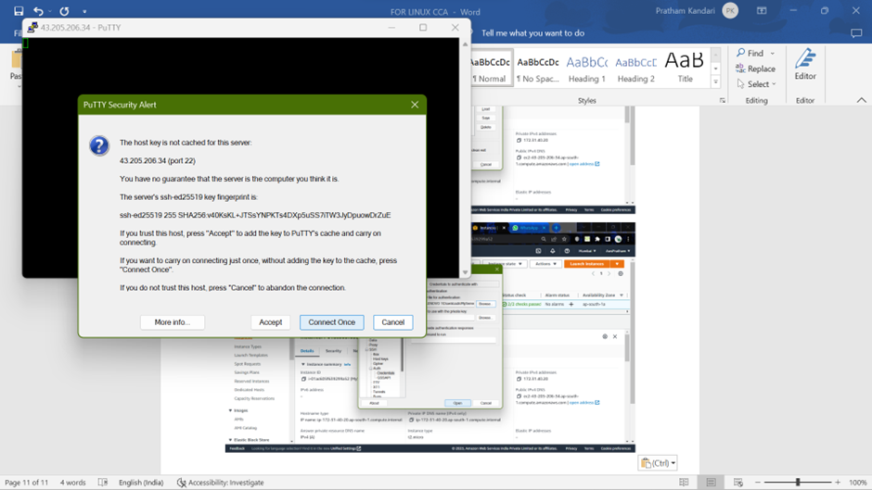

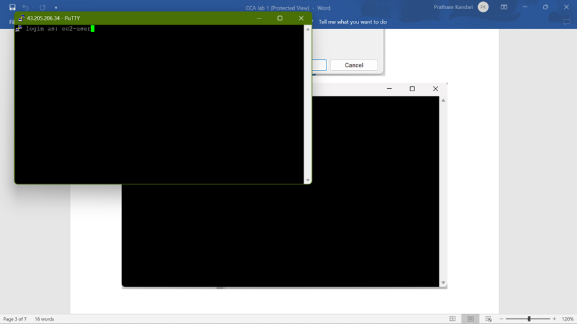

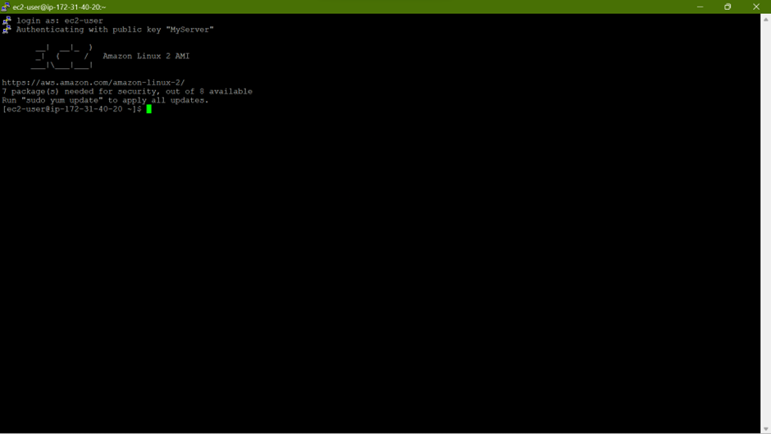

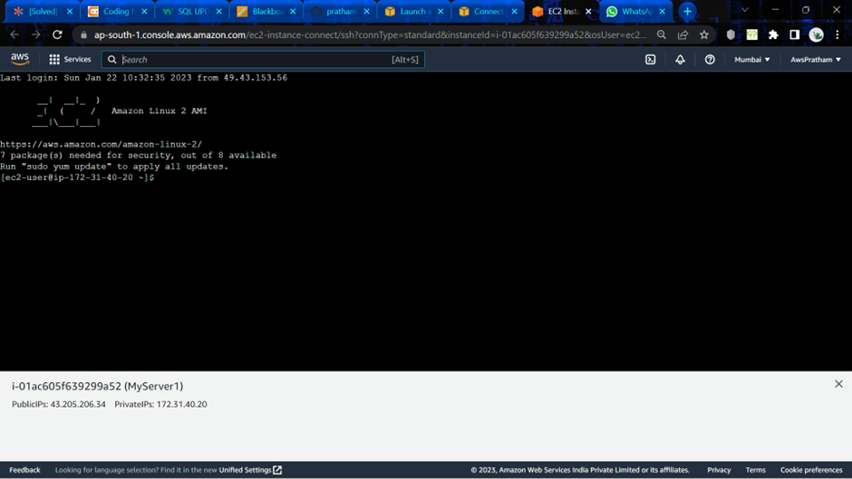

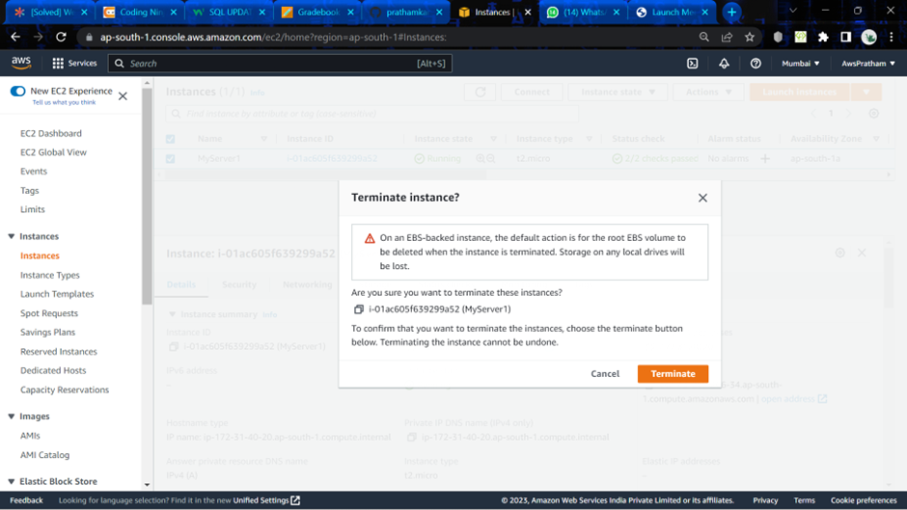

Q: Explain the following commands in LINUX environment.

Ans: 1. usermod- usermod command or modify user is a command in Linux that is used to change the properties of a user in Linux through the command line. After creating a user we have to sometimes change their attributes like password or login directory etc. so in order to do that we use the Usermod command.

2. chmod- this command is used to change the access mode of a life.

3. groups- Groups are nothing but the collection of users. Groups make it easy to manage users with the same security and access privileges.

4. touch- this command is a way to create empty files. You can update the modification and access time of each file with the help of touch command.

5. find- The **find** command in UNIX is a command line utility for walking a file hierarchy. It can be used to find files and directories and perform subsequent operations on them.

6. ls with various options- the use of it is to display all the files and sub-directories in the current directory.

7. vi- It is the default editor that comes with LINUX.

8. grep- The grep filter looks for a specific character pattern within a file and displays all lines that match that pattern.

9. groupadd- It is used to create a new user group.

**Experiment -2**

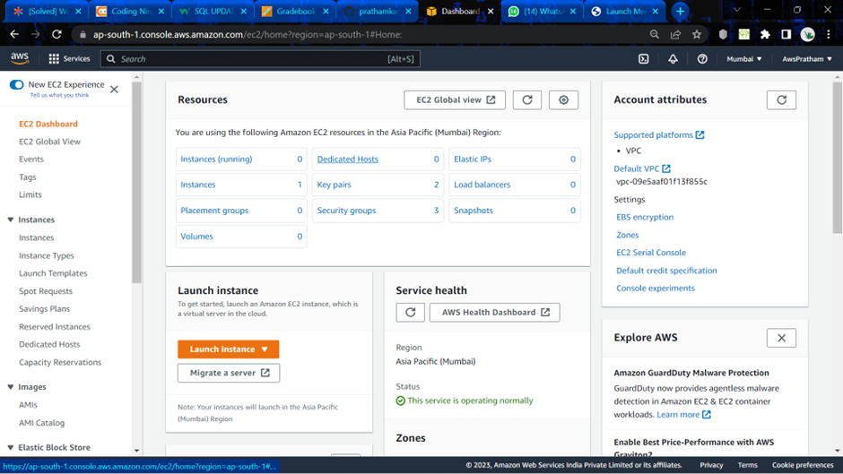

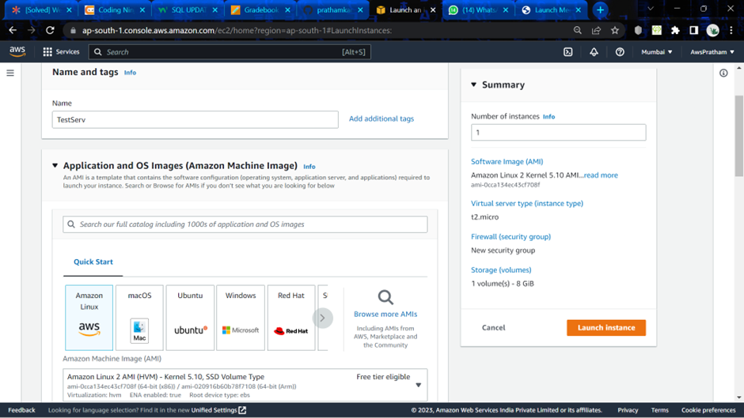

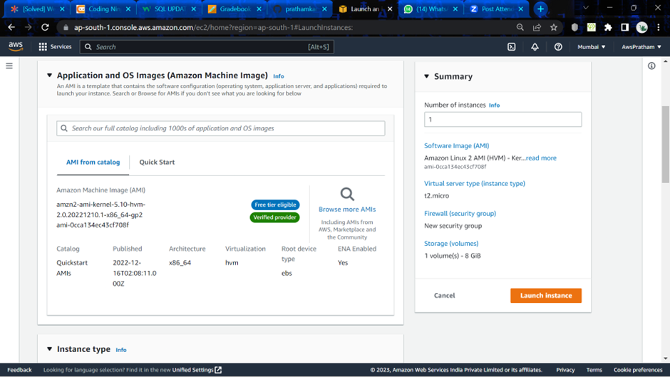

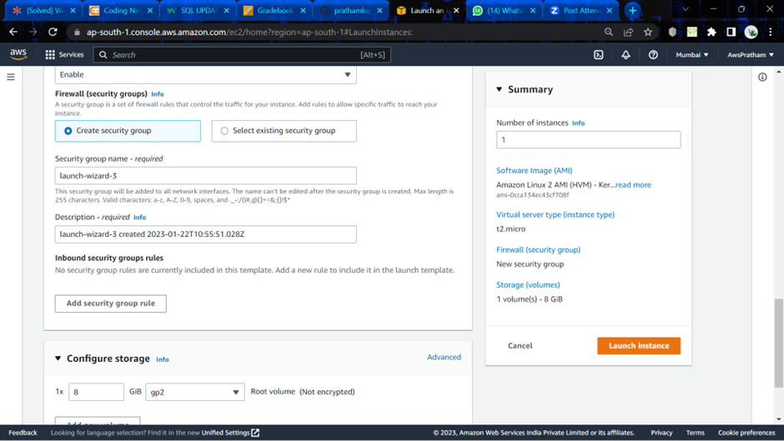

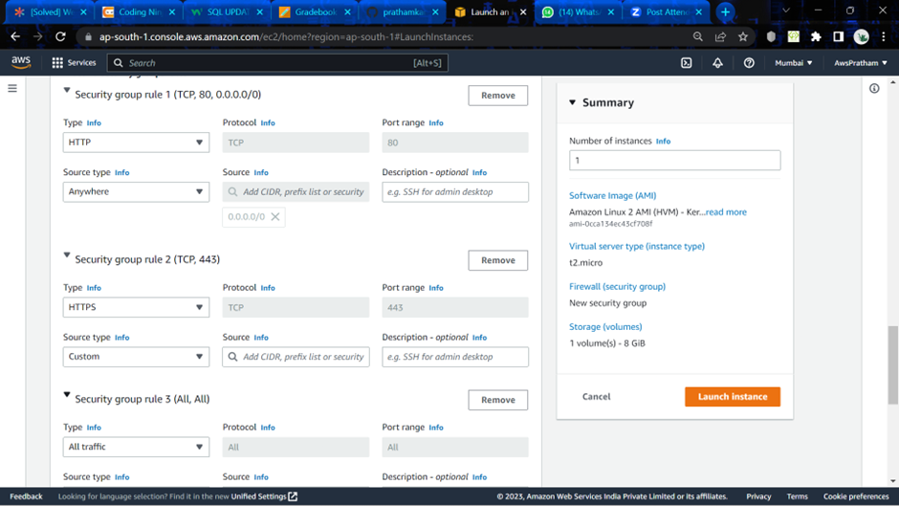

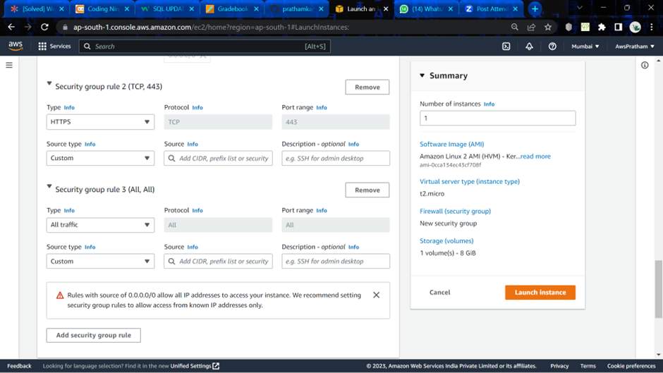

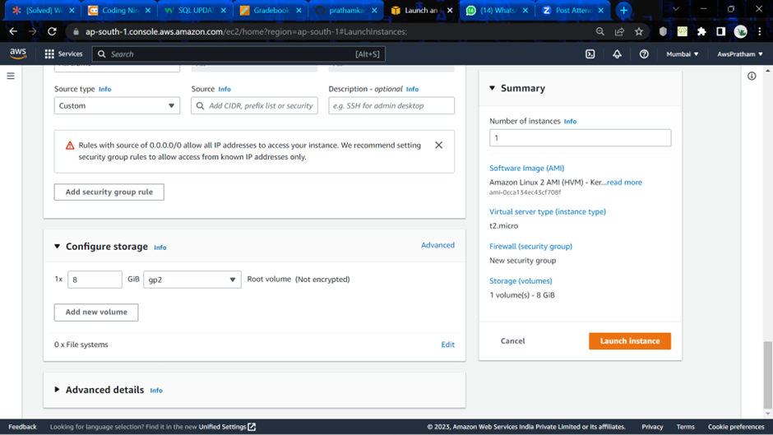

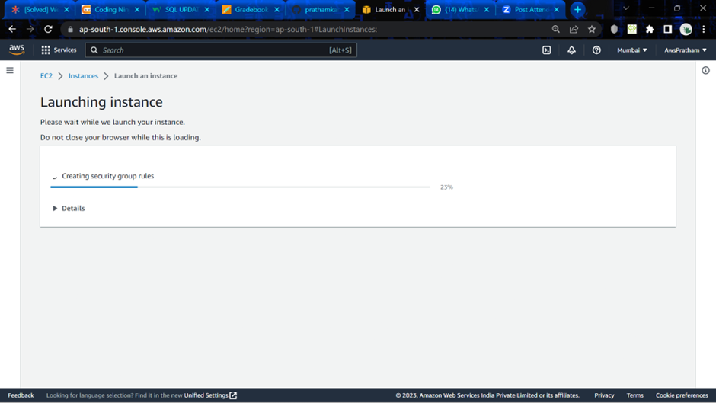

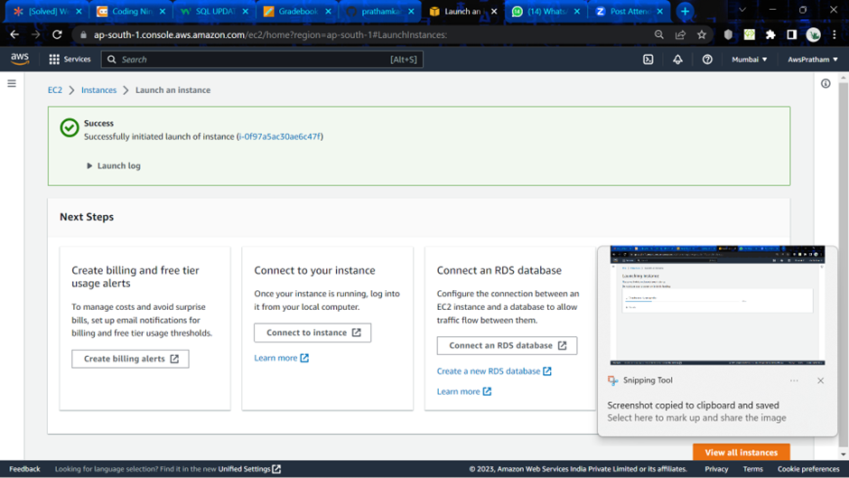

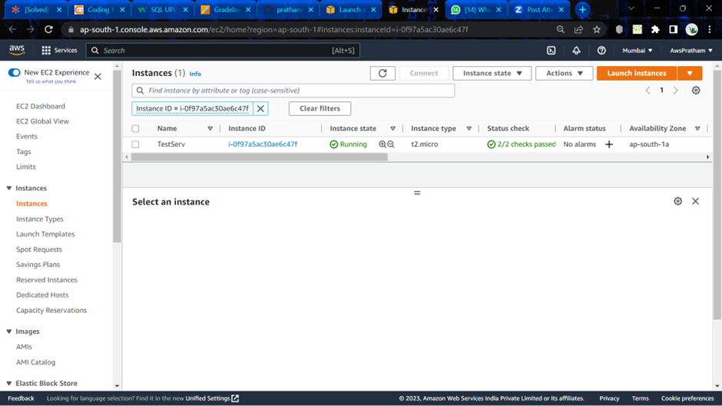

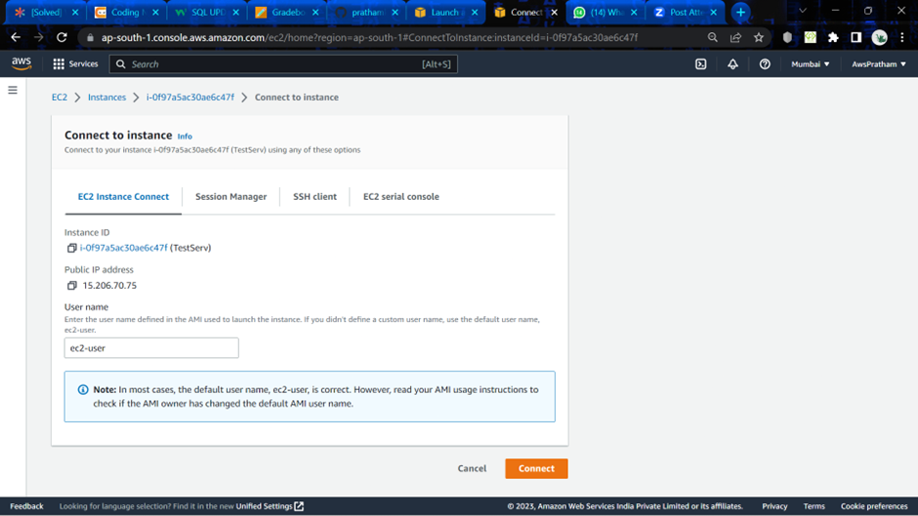

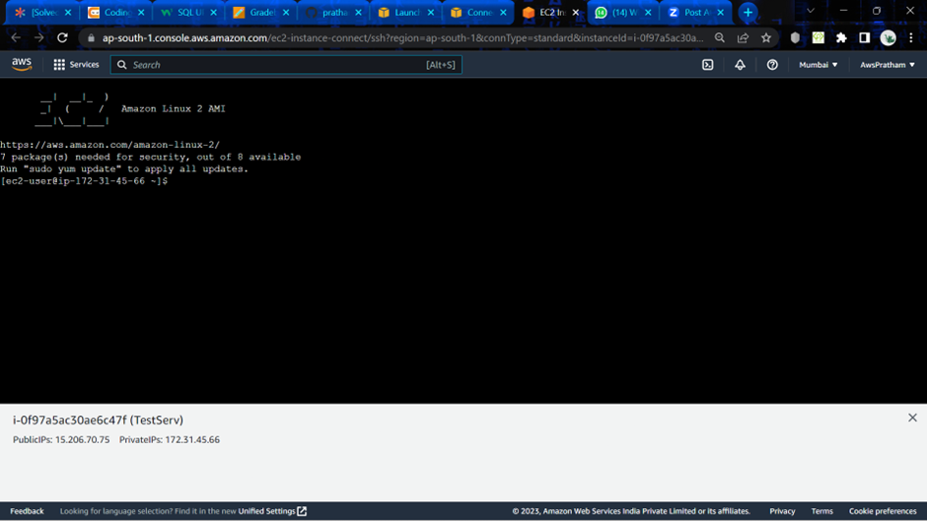

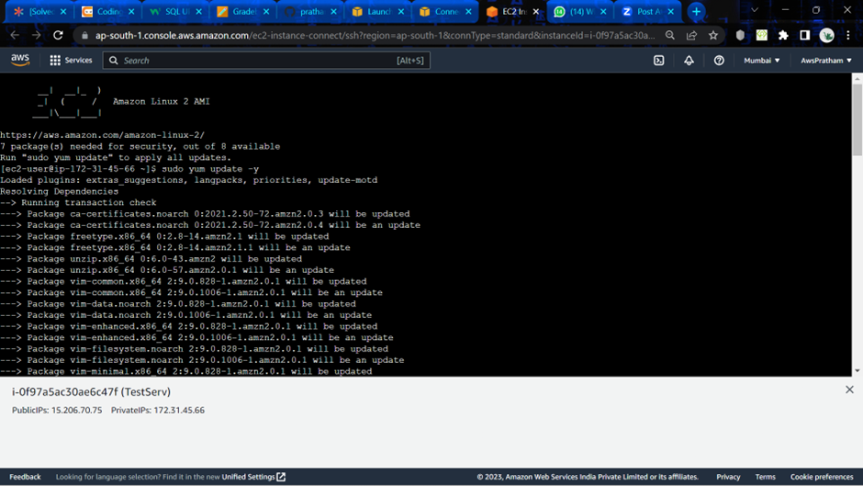

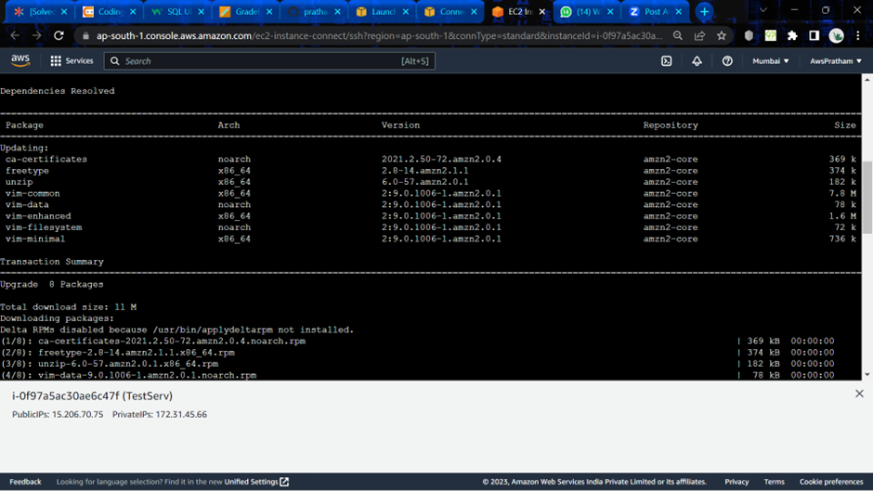

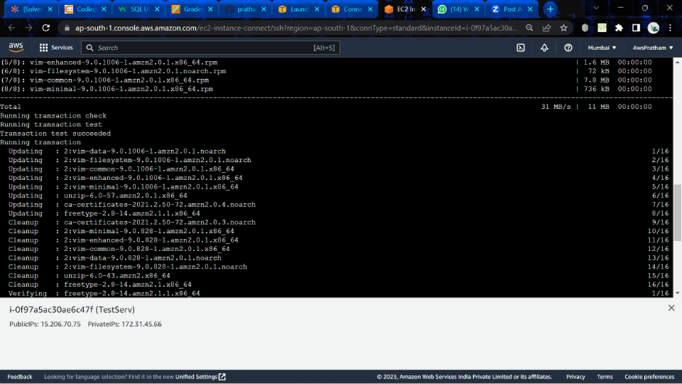

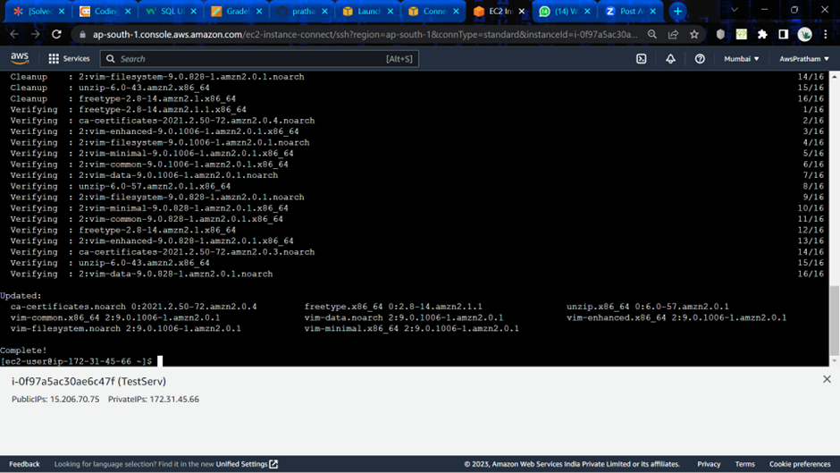

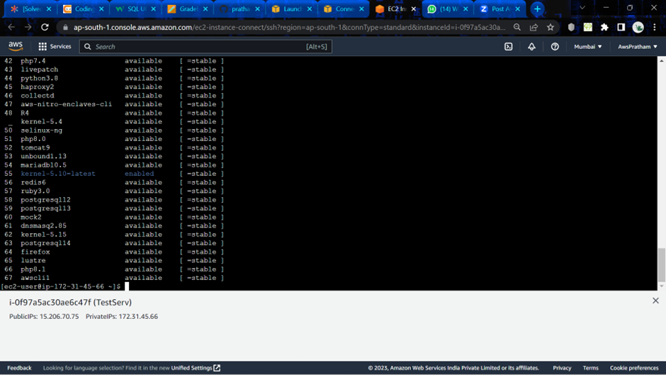

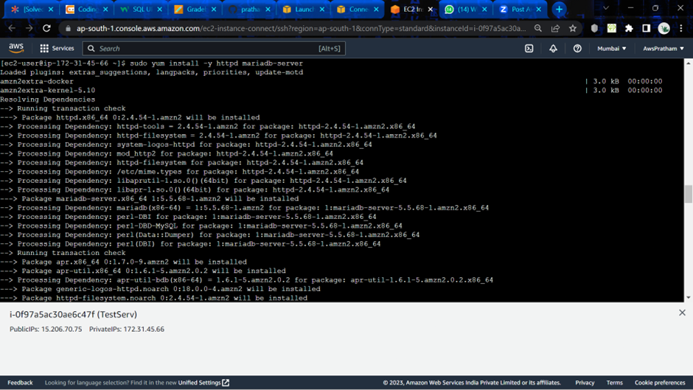

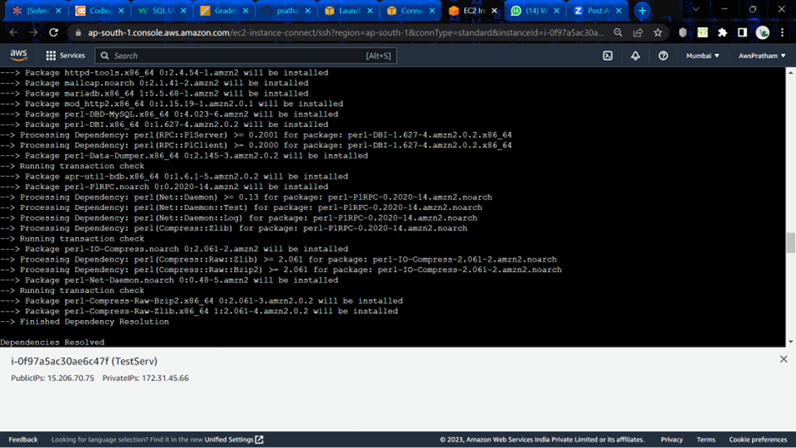

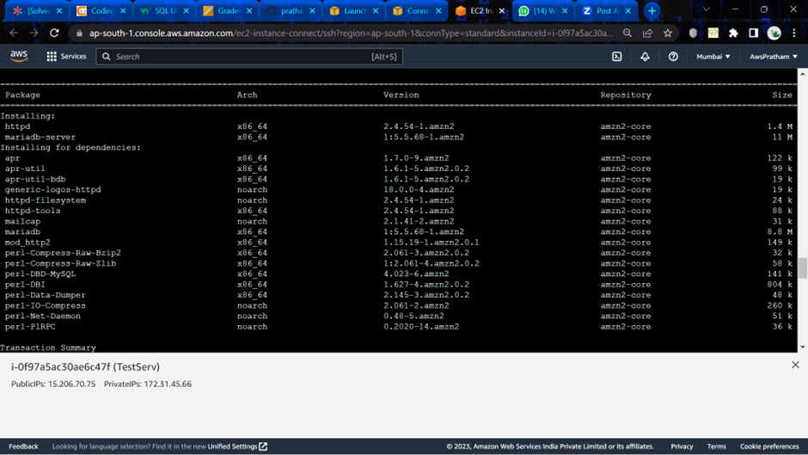

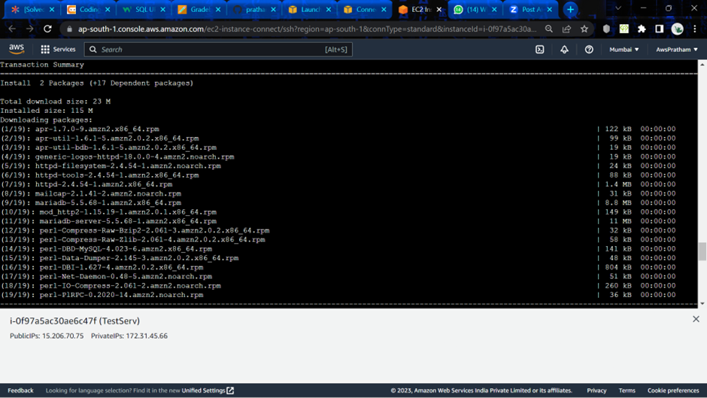

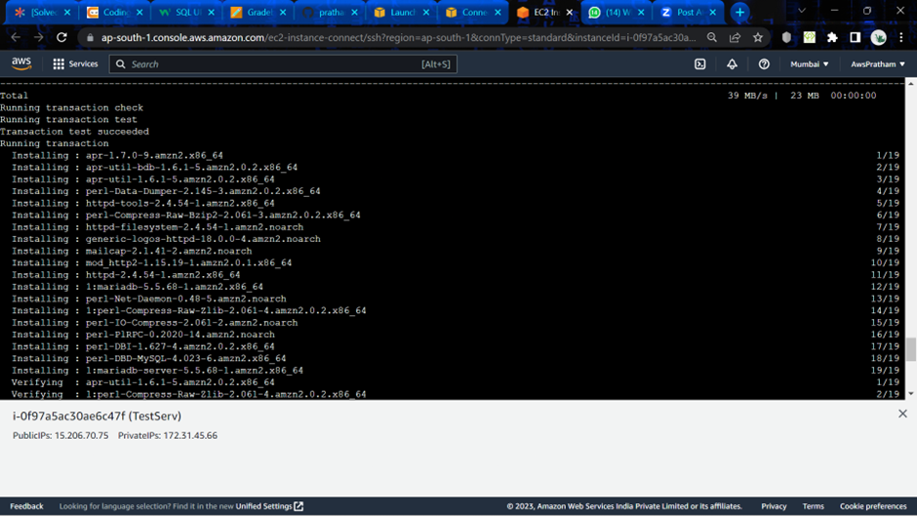

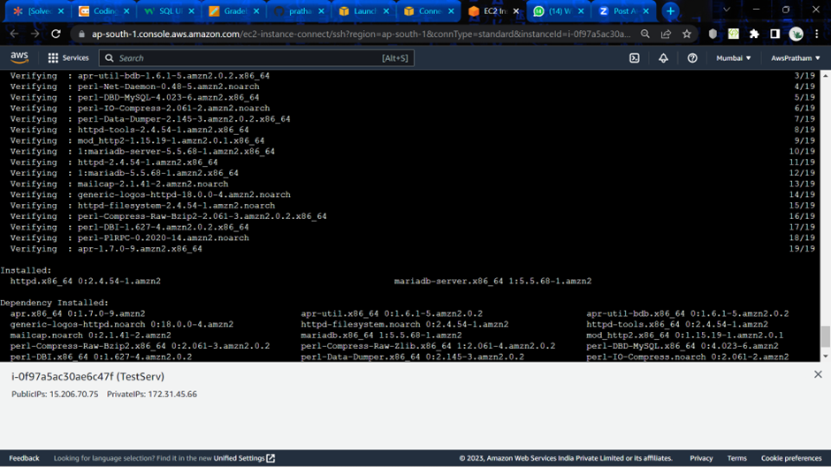

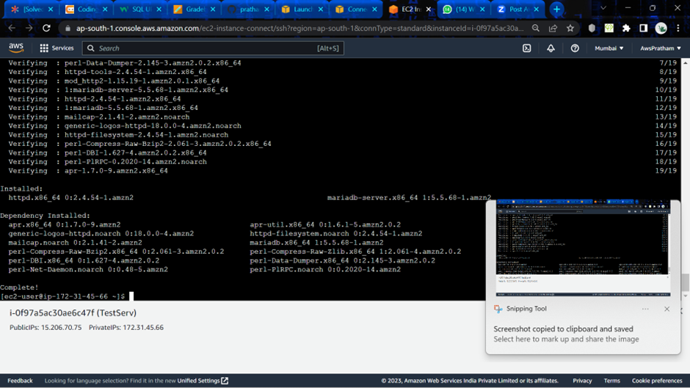

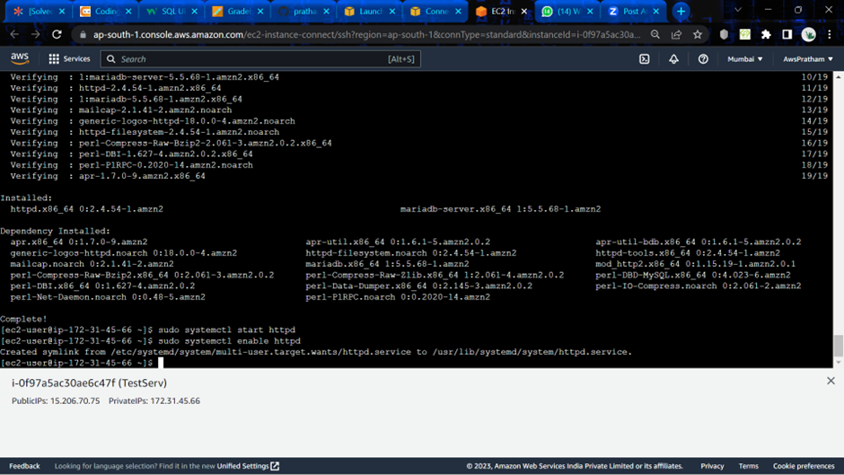

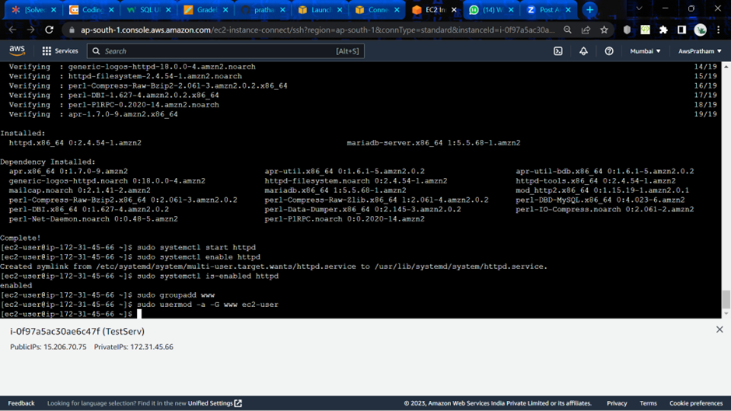

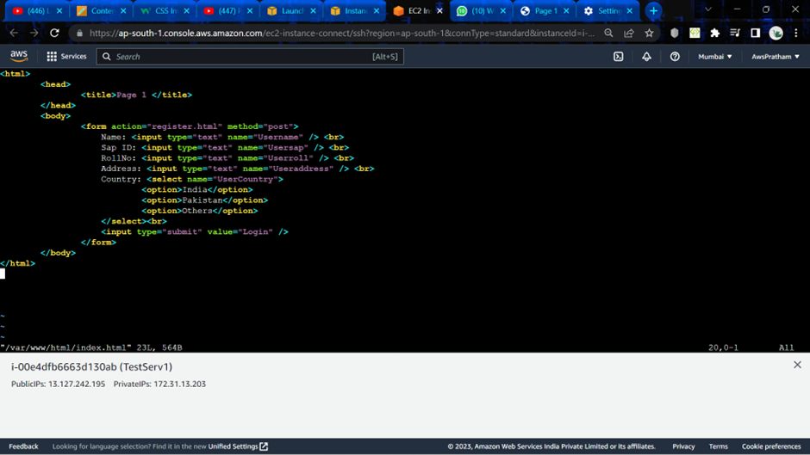

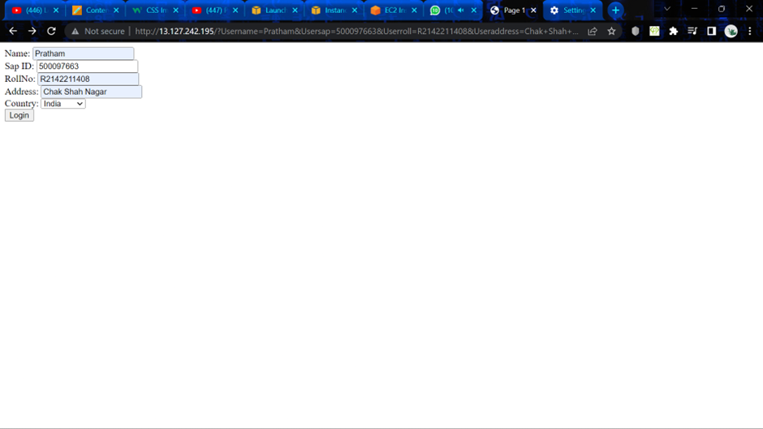



**Experiment -3**

Autoscaling in EC2 Instances

Q:1. List the key components of Autoscaling.

Ans: There are three components of Autoscaling:

1. **Configuration Templates:** This component specifies what the auto scaler will launch. Your business may use a launch template and maybe a launch configuration as a configuration template for such EC2 instances. You can specify information for your instances such as the AMI ID, instance type, key pair, private networks, and block device mapping.
2. **Groups:** This element specifies where the autoscaling will occur. Basically, specifying the load balancer, the minimum and maximum number of EC2 instances, the VPC, and subnets to use. Your EC2 instances are organised into groups that may be scaled and managed as logical units. When creating an AWS EC2 auto scaling group, you can choose the desired, minimum, and maximum number of EC2 instances. You can discover several more features by thoroughly investigating the Auto Scaling groups.
3. **Scaling Options:** This element specifies when autoscaling occurs. With AWS EC2 Auto Scaling, there are numerous ways to scale your Auto Scaling groups. Users can, for instance, configure a group to dynamically scale based on a timetable or when specific conditions are met.

Q:2. Differentiate between Launch Template and Launch Configuration. Which is recommended and why?

Ans:

|  |  |
| --- | --- |
| **Launch Configuration** | **Launch Template** |
| ·       Launch configuration is an instance configuration template that an ASG uses to launch EC2 instances.  ·       Launch configuration is similar to EC2 configuration and involves the selection of the [Amazon Machine Image](https://jayendrapatil.com/aws-ec2-ami/) (AMI), block devices, key pair, instance type, security groups, user data, EC2 instance monitoring, instance profile, kernel, ramdisk, the instance tenancy, whether the instance has a public IP address, and is EBS-optimized.  ·       Launch configuration can be associated with multiple ASGs  ·       **Launch configuration can’t be modified after creation and needs to be created new if any modification is required.**  ·       Basic or detailed monitoring for the instances in the ASG can be enabled when a launch configuration is created.  ·       By default, basic monitoring is enabled when you create the launch configuration using the AWS Management Console, and detailed monitoring is enabled when you create the launch configuration using the AWS CLI or an API  ·       AWS recommends using Launch Template instead. | ·   A Launch Template is similar to a launch configuration, with additional features, and is recommended by AWS.  ·   Launch Template allows **multiple versions of a template** to be defined.  ·   With versioning, a subset of the full set of parameters can be created and then reused to create other templates or template versions *for e.g, a default template that defines common configuration parameters can be created and allow the other parameters to be specified as part of another version of the same template.*  ·   Launch Template allows the selection of both **Spot and On-Demand Instances or multiple instance types.**  ·   Launch templates support **EC2 Dedicated Hosts**. Dedicated Hosts are physical servers with EC2 instance capacity that are dedicated to your use.  ·   Launch templates provide the following features  §  Support for multiple instance types and purchase options in a single ASG.  §  Launching Spot Instances with the capacity-optimized allocation strategy.  §  Support for launching instances into existing Capacity Reservations through an ASG.  §  Support for unlimited mode for burstable performance instances.  §  Support for Dedicated Hosts.  §  Combining CPU architectures such as Intel, AMD, and ARM (Graviton2)  §  Improved governance through IAM controls and versioning.  §  Automating instance deployment with Instance Refresh. |

Q:3. Explain the different AutoScaling options available in EC2 with the help of suitable options.

Ans: There are four main types of AWS autoscaling: manual scaling, scheduled scaling, dynamic scaling, and predictive scaling.

·      **Manual scaling**

In this type of scaling, the number of instances is changed manually. It involves a manual execution of scaling actions. The number of instances can be increased or decreased manually using a CLI or console. This type of scaling is ideal when users do not need automatic scaling.

·      **Scheduled scaling**

This type involves the automatic execution of scaling actions based on certain schedules. They can be executed at a specific time during the day, month, week, or year. This type of scaling is ideal when traffic occurs at a specific time.

For example, it can be used if there is heavy traffic during the weekends and relatively less traffic during the weekdays. In this case, the number of instances can be scheduled to increase when the weekend begins. This number can be reduced when the weekend ends.

·      **Dynamic scaling**

In dynamic scaling, the number of EC2 instances is changed automatically based on signals that are provided by a CloudWatch alarm. Dynamic scaling is mostly employed when there is unpredictable traffic.

·      **Predictive scaling**

Predictive scaling involves using machine learning algorithms to program the desired number of instances. Future traffic can be predicted to provide the appropriate number of instances. This type of scaling is ideal when the traffic is predictable.

1. **Manual Auto Scaling Group:**

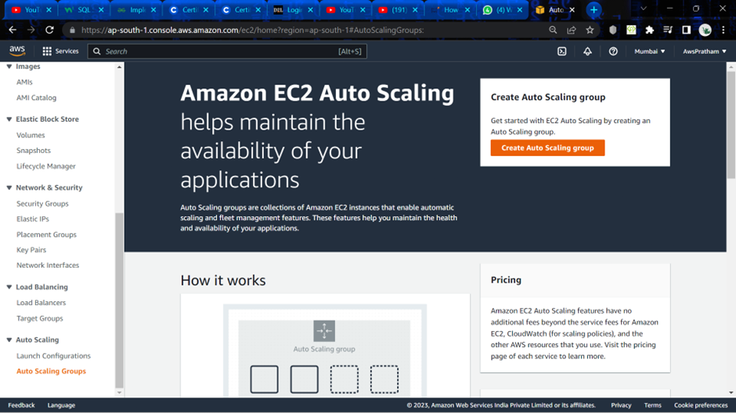

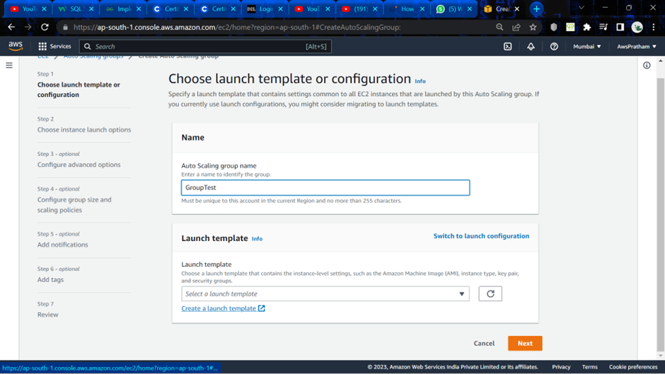

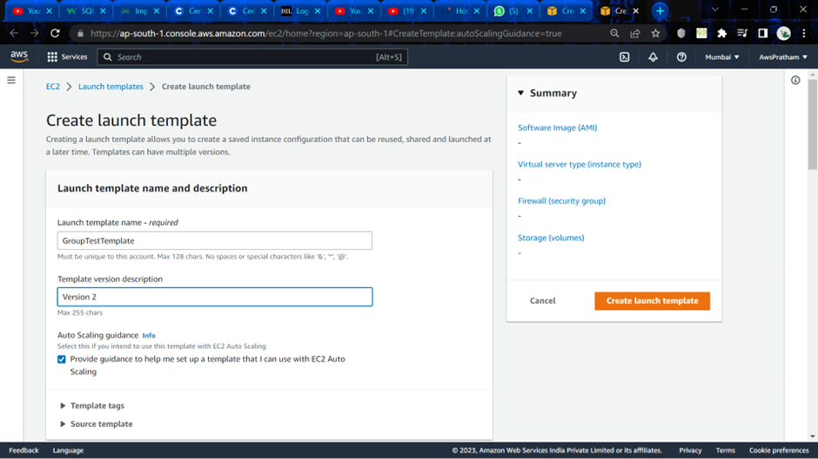

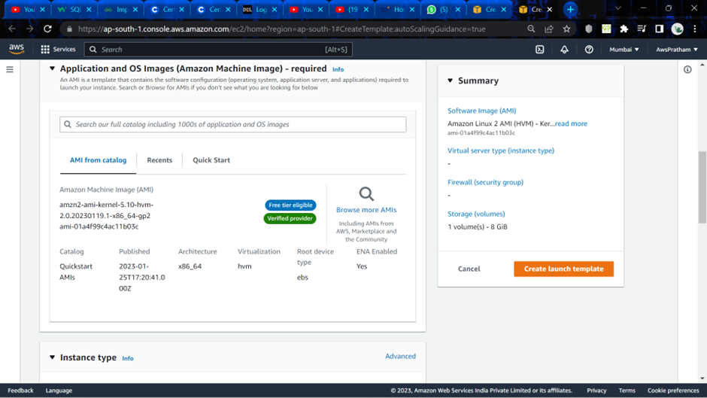

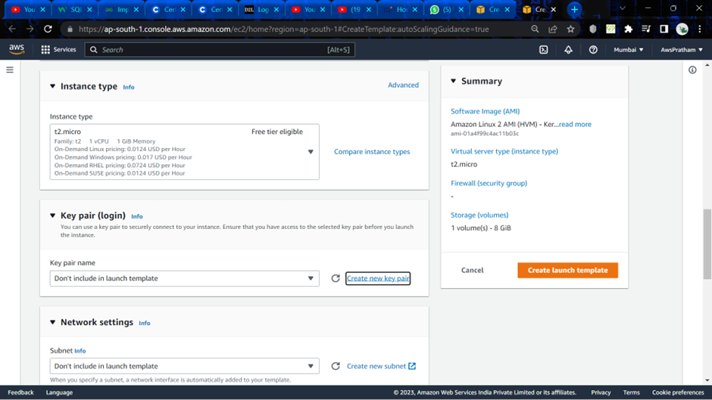

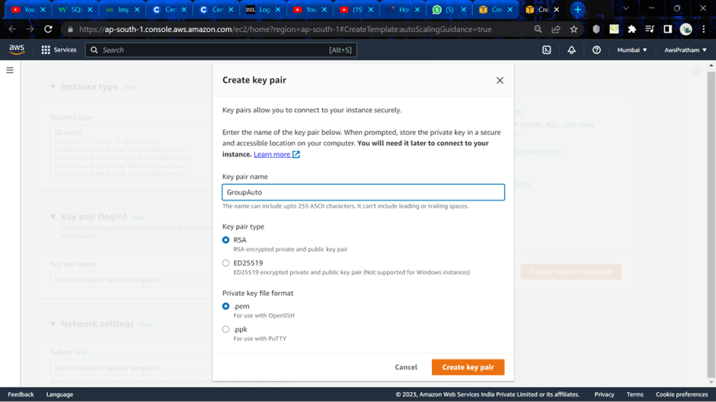

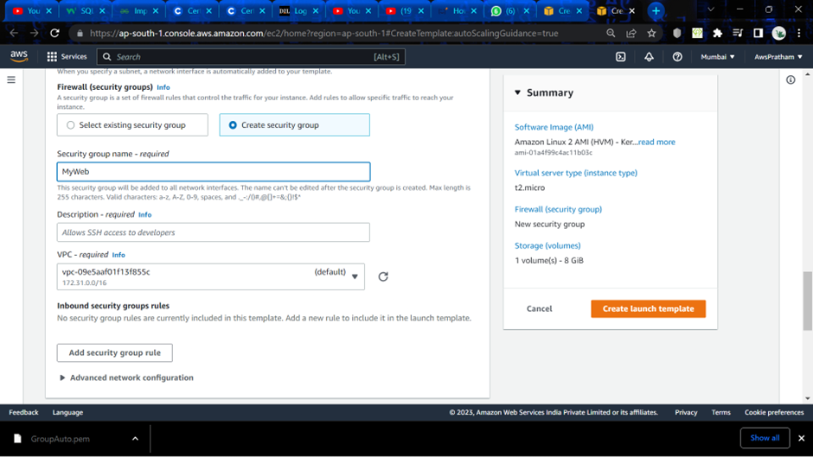

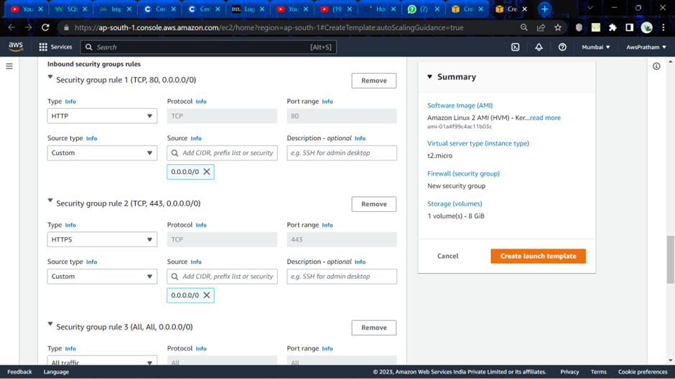

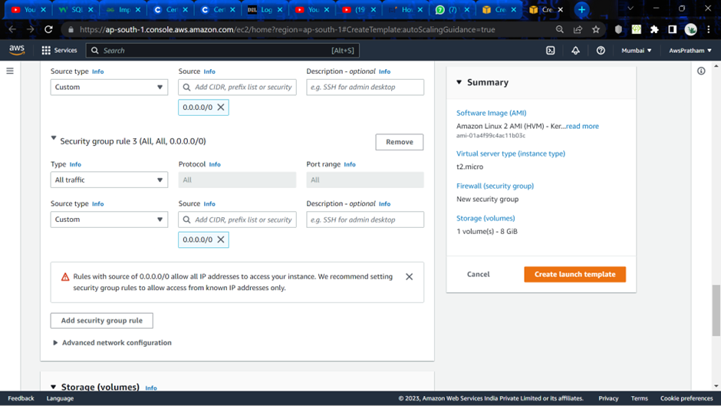

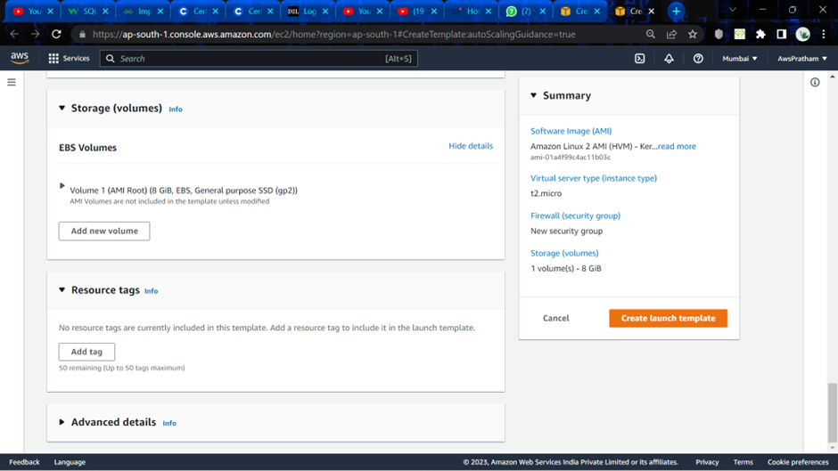

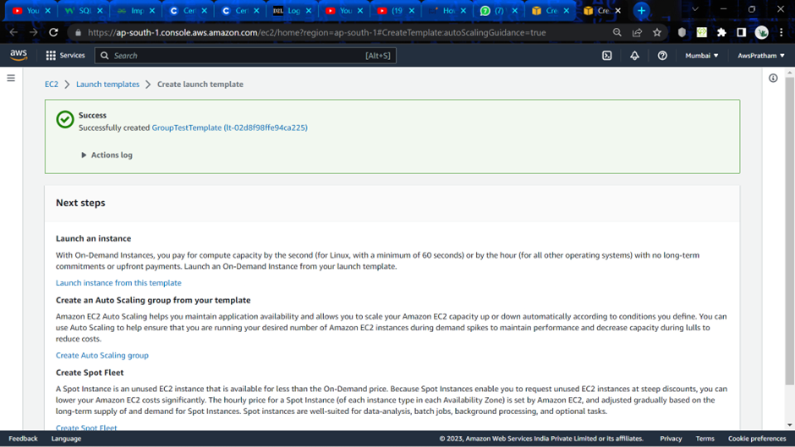

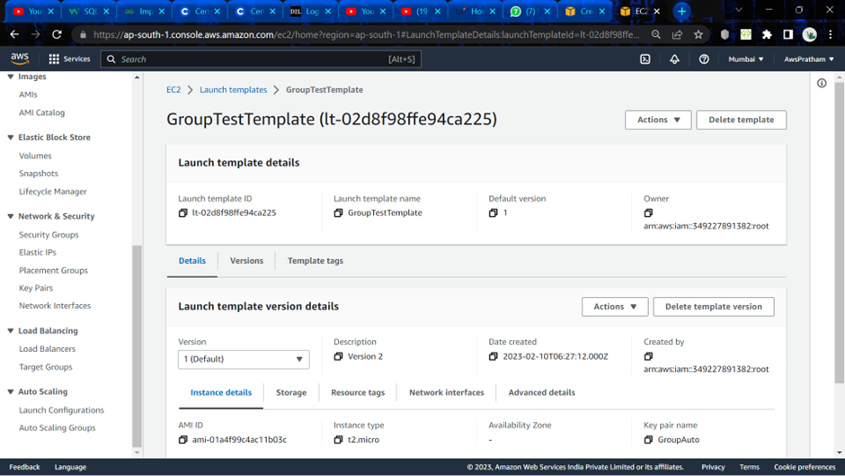

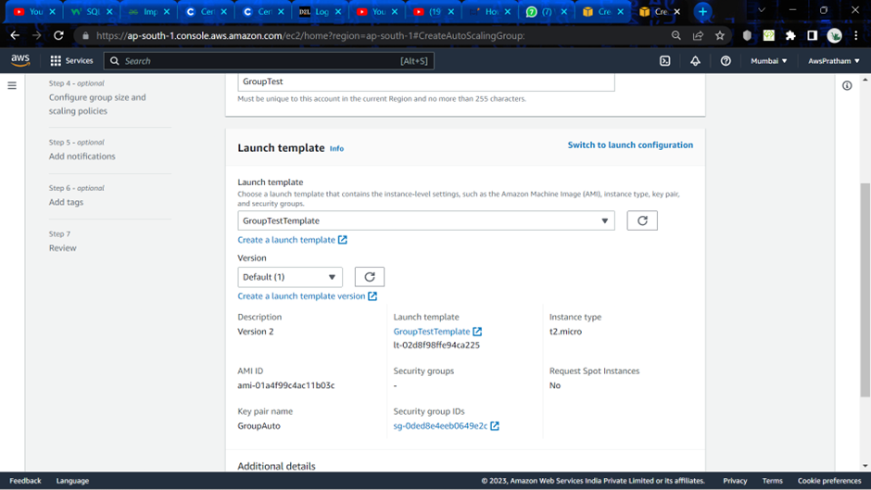

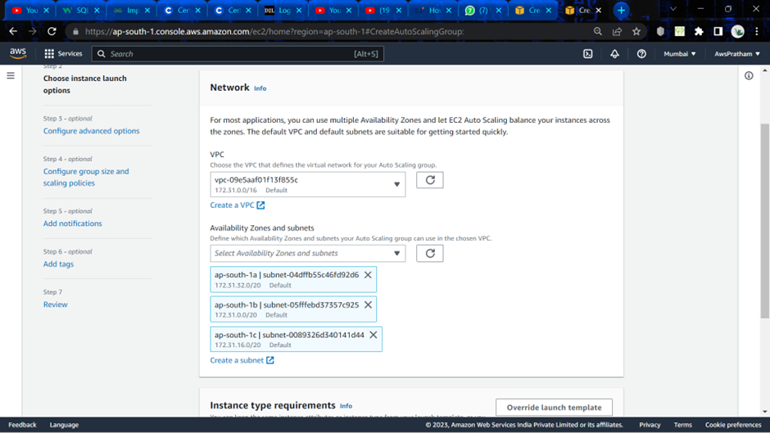

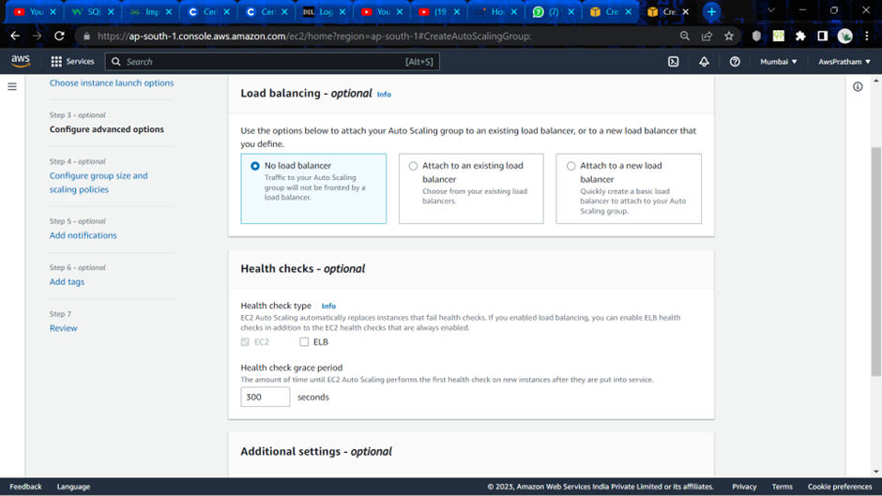

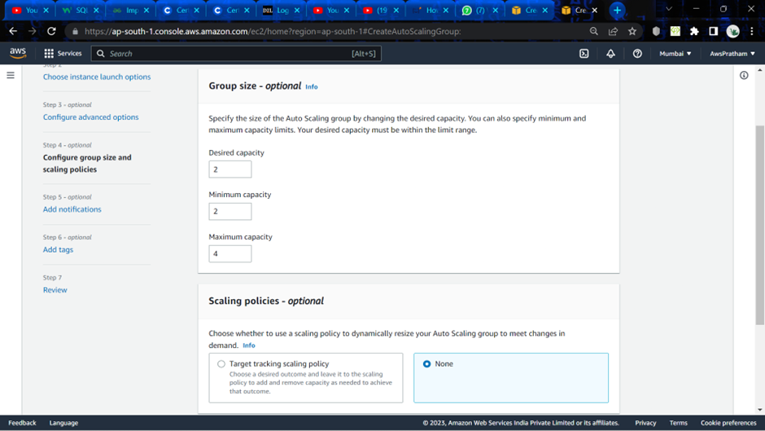

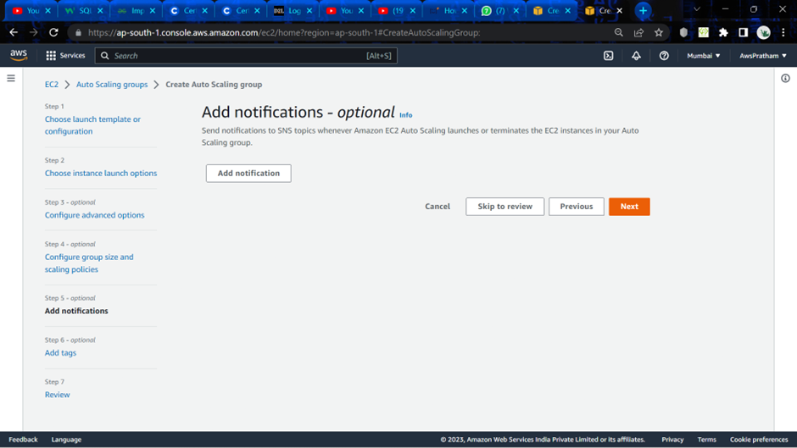

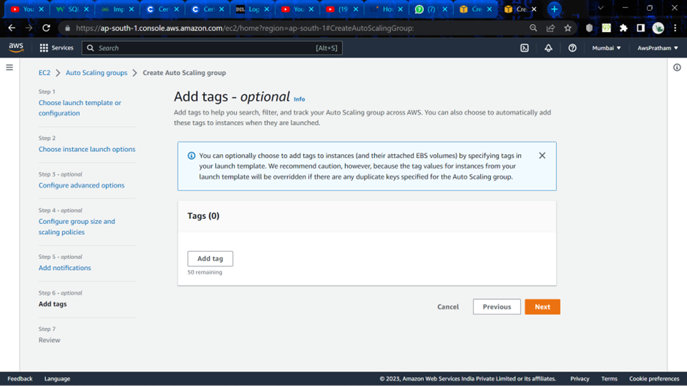

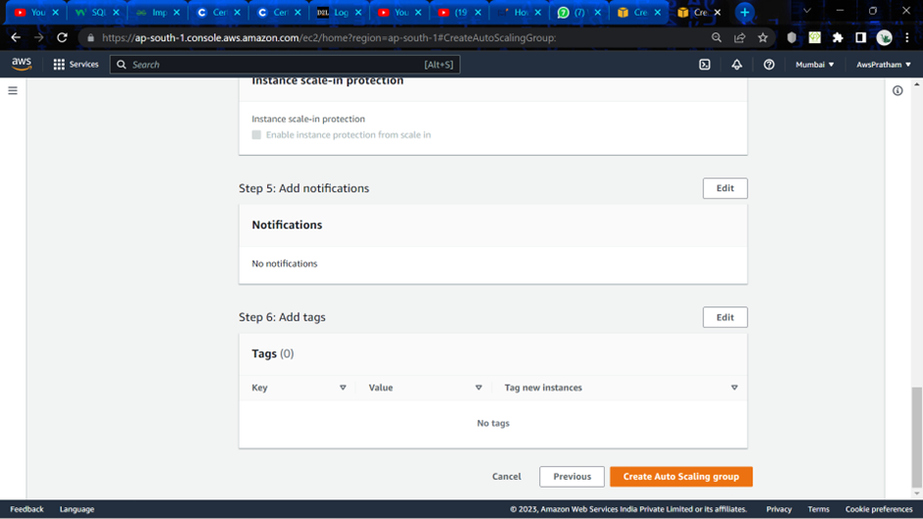

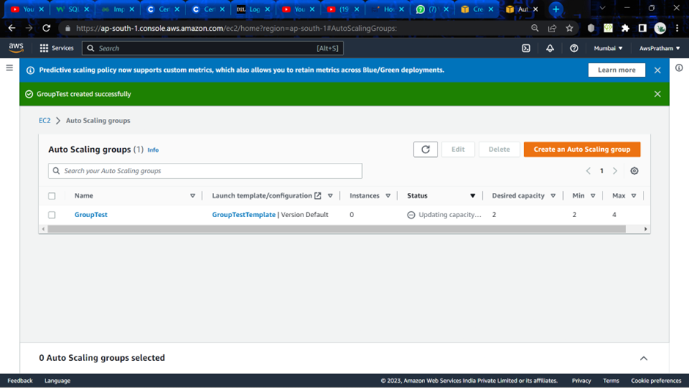

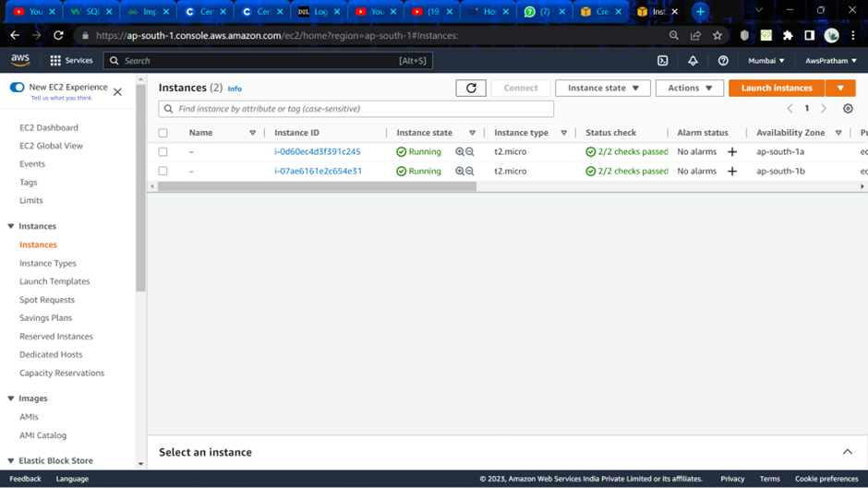

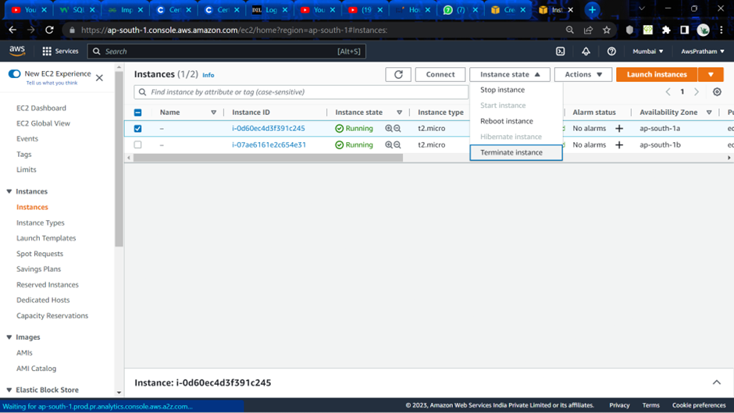

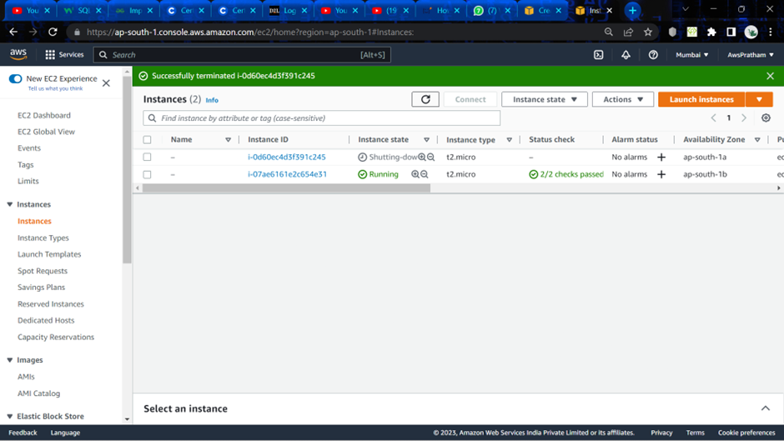

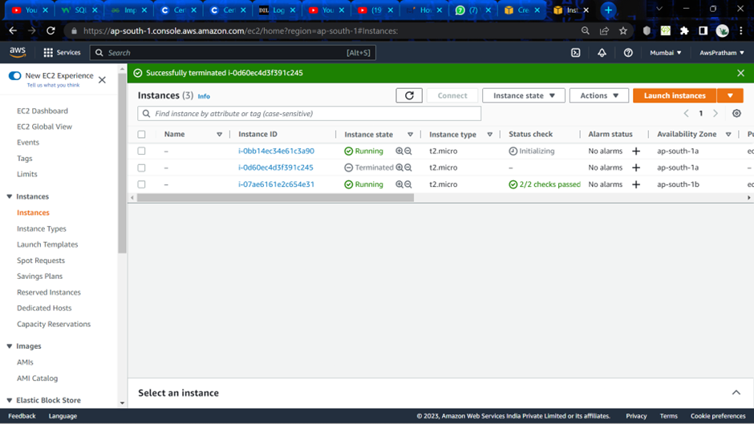

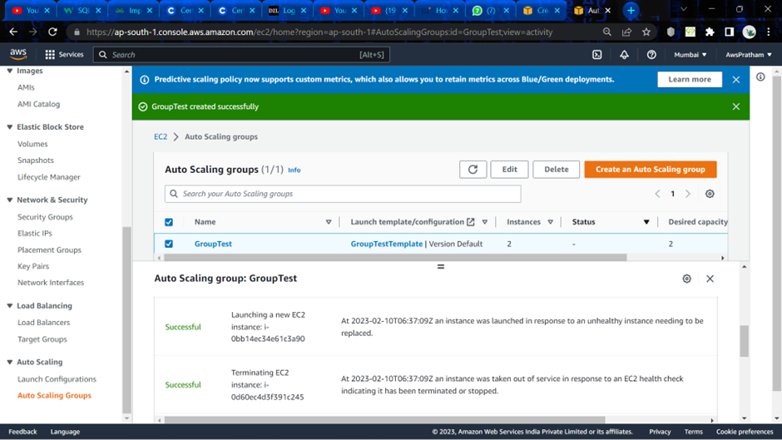

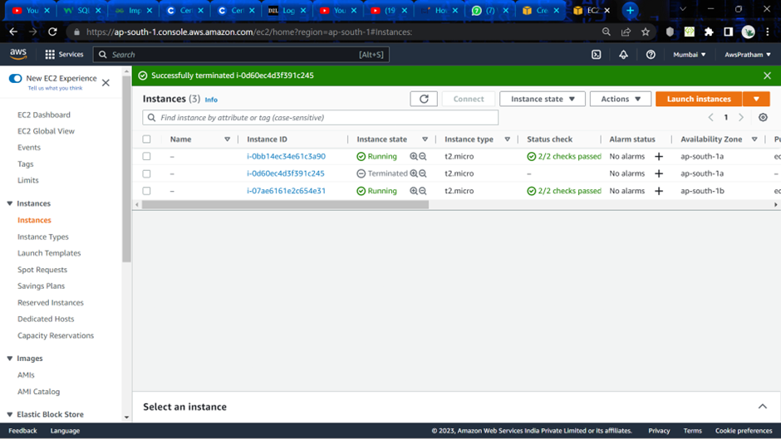

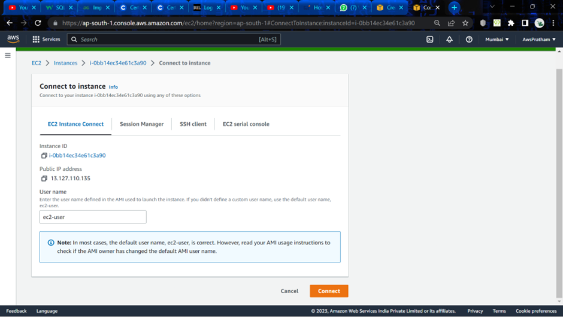

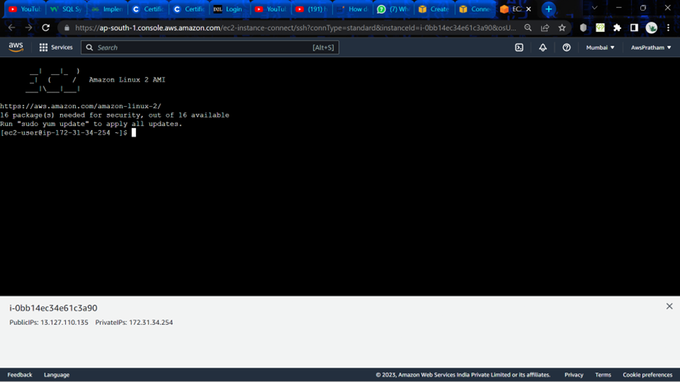

1. **Scale on Demand Autoscaling:**

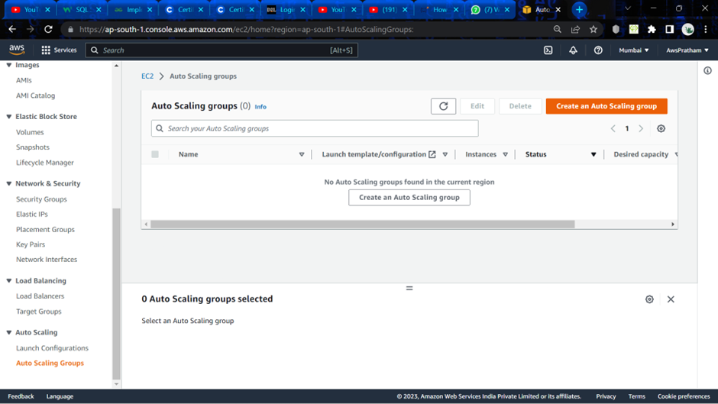

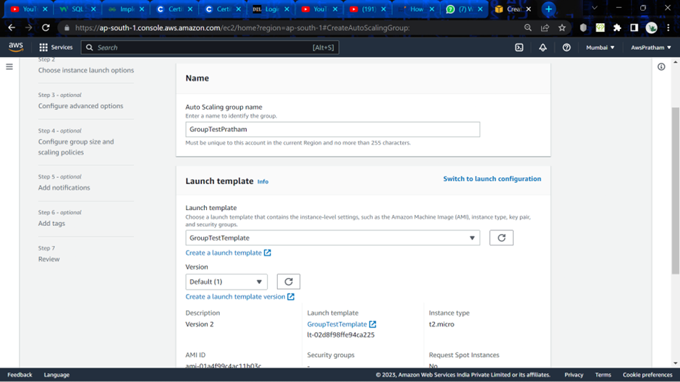

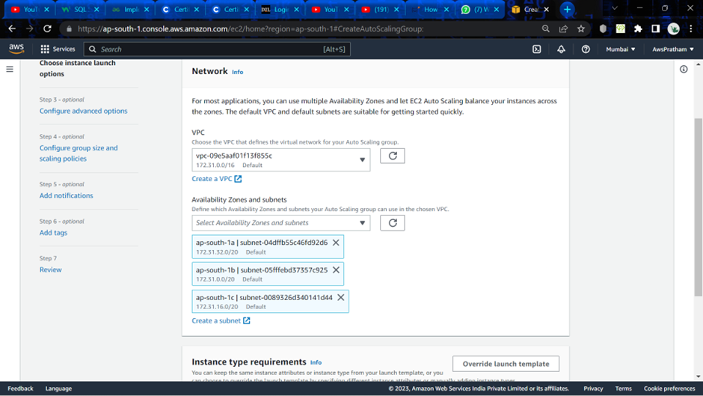

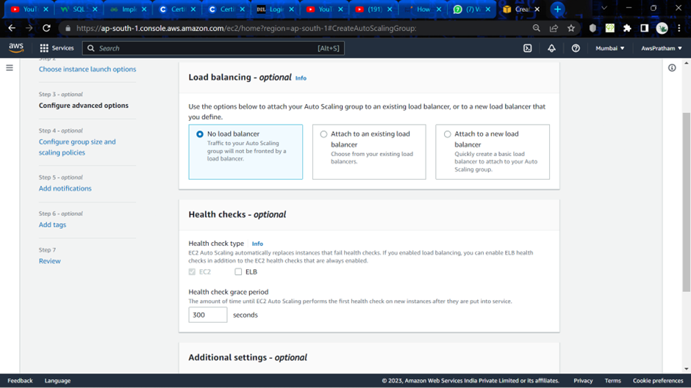

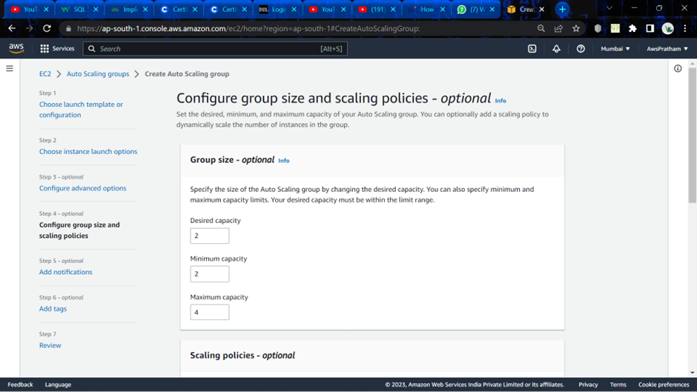

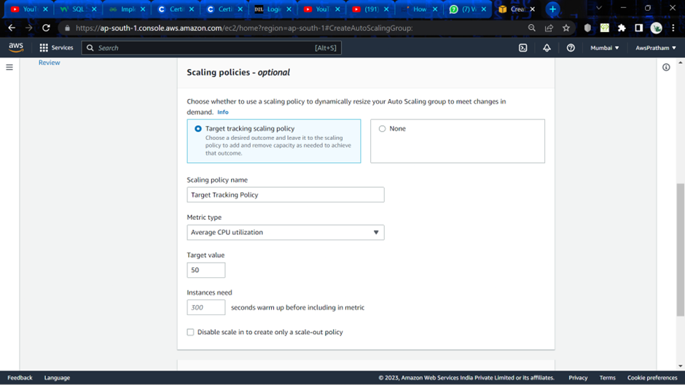

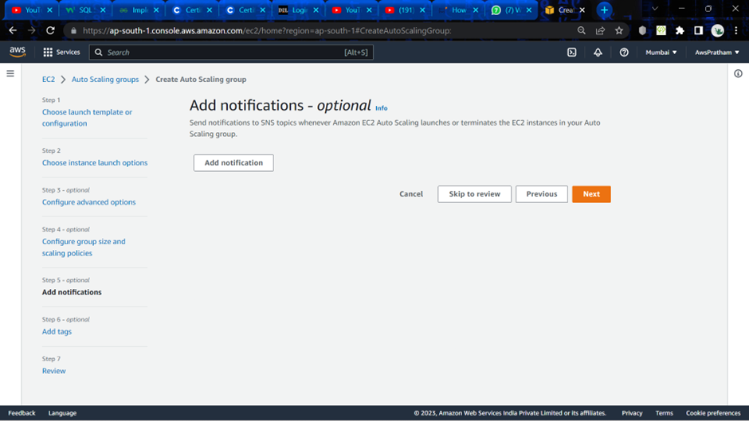

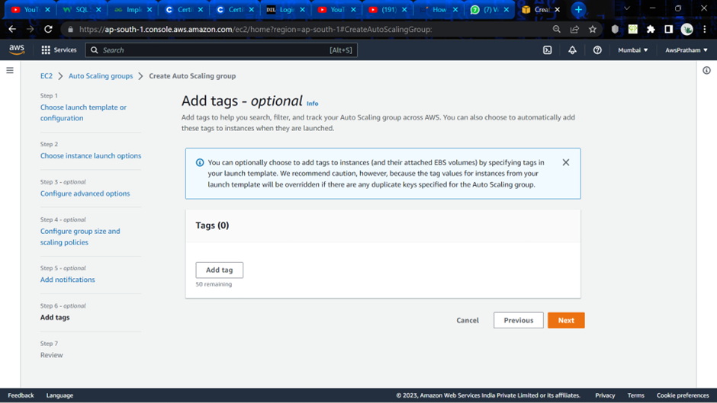

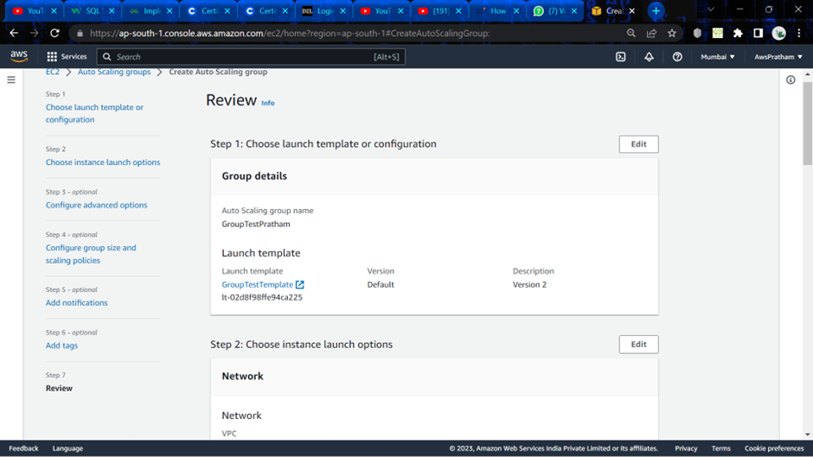

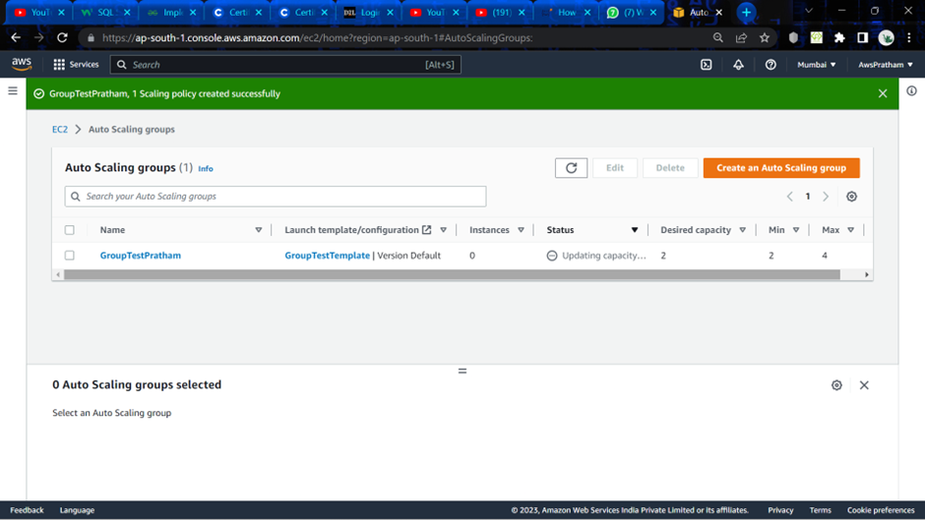

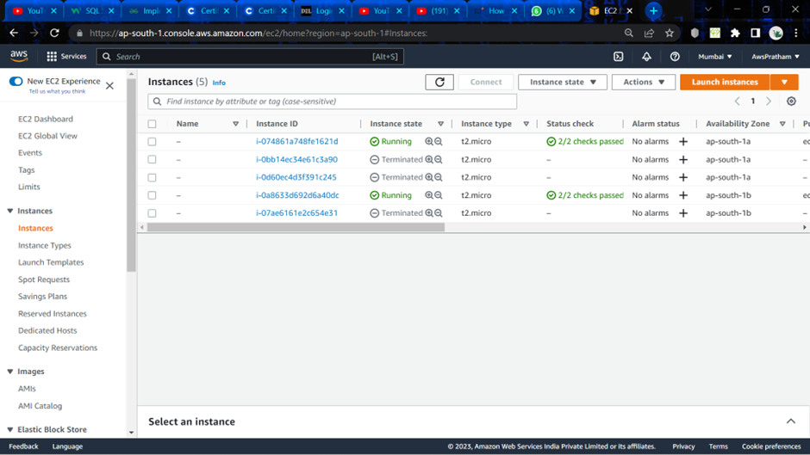

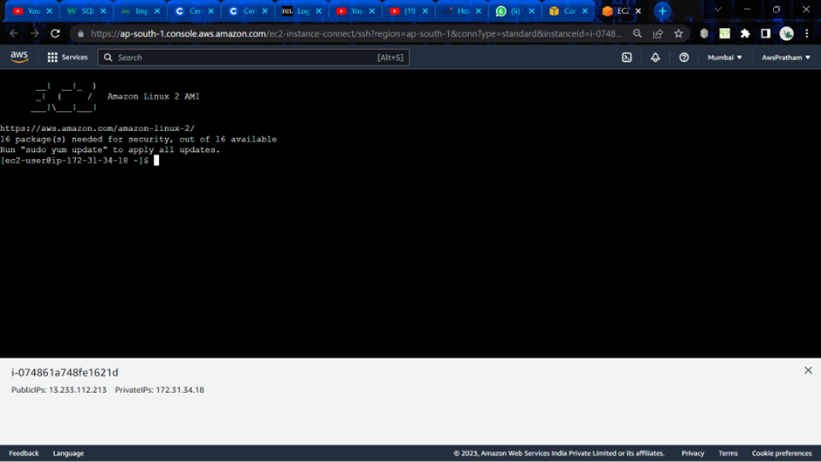

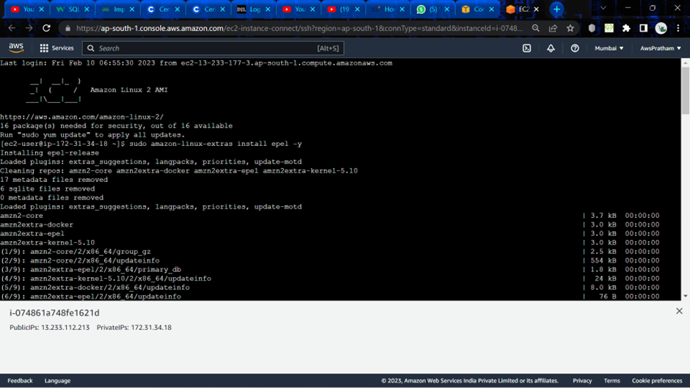

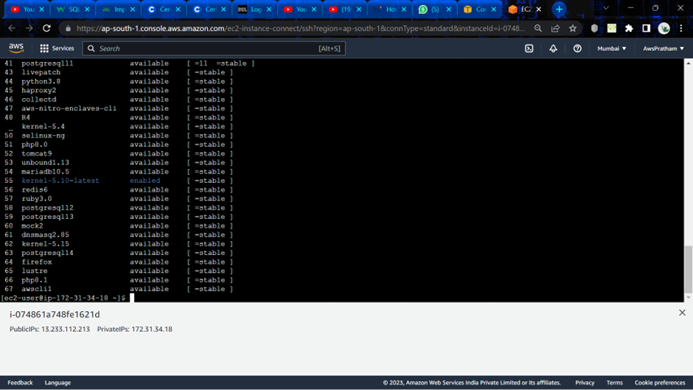

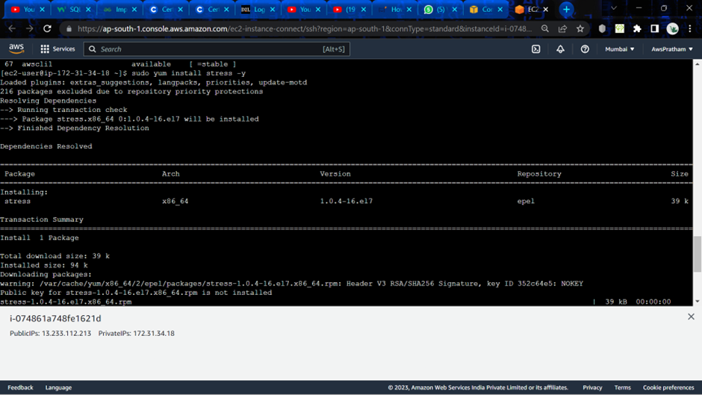

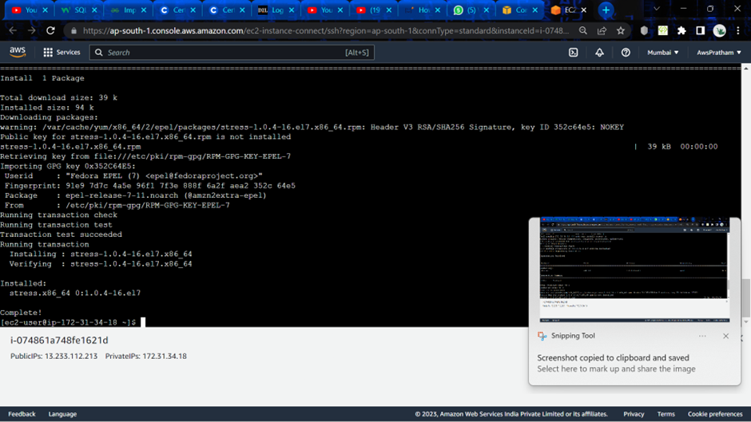

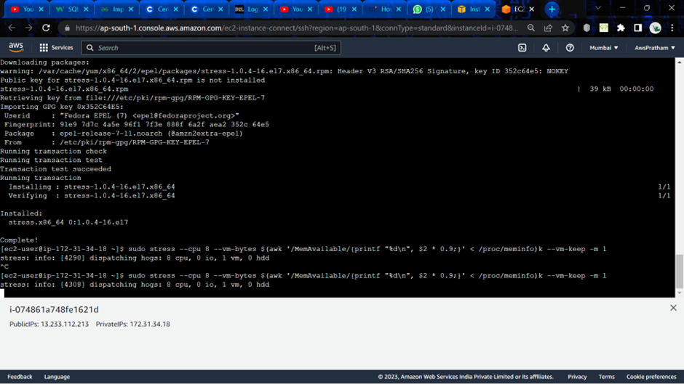

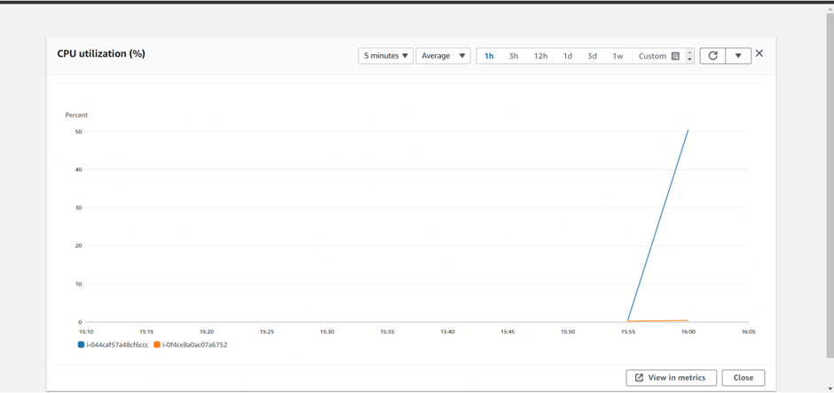

**Experiment -4**

Application Load Balancer in AWS

Q:1. Enumerate and differentiate different Load balancers in AWS?

Ans:

1. Application Load Balancer: An application load balancer can route requests to one or more ports on each container instance in your cluster, enables path-based routing, and makes routing decisions at the application layer (HTTP/HTTPS). Dynamic host port mapping is supported by application load balancers.
2. Network Load Balancer: The transport layer (TCP/SSL) routing decisions are made by a network load balancer. Millions of queries can be handled per second. Using a flow hash routing technique, the load balancer chooses a target from the target group for the default rule after receiving a connection. On the port given in the listener configuration, it tries to establish a TCP connection to the chosen target. Without changing the headers, it transmits the request. Dynamic host port mapping is supported by network load balancers.

Q:2. Explain:

1. Load Balancer: Load balancing is the method of distributing network traffic equally across a pool of resources that support an application. Modern applications must process millions of users simultaneously and return the correct text, videos, images, and other data to each user in a fast and reliable manner.

1. Target Group: Target groups use the protocol and port number that you specify to route requests to one or more registered targets, such as EC2 instances. A target can be registered with various target groups. Health checks can be set up for each target group. All targets registered to a target group that is specified in a listener rule for your load balancer are subject to health checks.

1. Rules: Your devices can communicate with AWS services thanks to rules. Based on the MQTT topic stream, rules are examined, and subsequent actions are taken.

1. Listeners: A process that monitors connection requests is called a listener. It is set up with a protocol and a port for connections from the front end (client to load balancer) and a protocol and a port for connections from the back end (load balancer to back-end instance).

1. Load Scheduling Algorithms: There are two types of Load Scheduling Algorithms:

1. Round Robin Load Balancing Method: The simplest and most popular load balancing algorithm is round-robin load balancing. Application servers receive client requests in a straightforward rotation. The first client request is sent to the first application server in the list, the second client request is sent to the second application server, the third client request is delivered to the third application server, the fourth client request is sent to the first application server, and so on.

1. Weighted Round Robin Load Balancing Method: Similar to the round-robin load balancing method, weighted round robin has the added benefit of distributing incoming client requests across the server farm in accordance with the respective capacities of each server. It works well when distributing incoming client requests among a group of servers with various capacities or resources. Based on criteria of their choosing, the administrator gives a weight to each application server that represents the relative capacity of each server in the farm to handle traffic.

1. Least Connection Load Balancing Method: A dynamic load balancing mechanism called least connection load balancing distributes client requests to the application server that has the fewest active connections at the moment the client request is received. This technique takes the active connection load into account. When application servers have identical specs, one server may be overwhelmed due to longer-lasting connections. This method works well with incoming requests that have variable connection latency and a group of servers that have similar processing capabilities and resource availability.

1. Weighted Least Connection Load Balancing Method: The weighted least connection load balancing algorithm expands on the least connection load balancing technique to take into consideration various application server properties. Based on the relative processing power and resource availability of each server in the farm, the administrator gives a weight to each application server. Using the assigned server weights and active connections, the LoadMaster decides how much of each server should be loaded balanced (e.g., if there are two servers with the lowest number of connections, the server with the highest weight is chosen).

And so on.

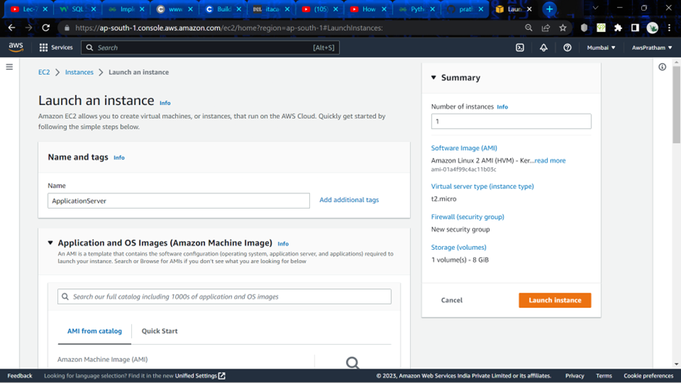

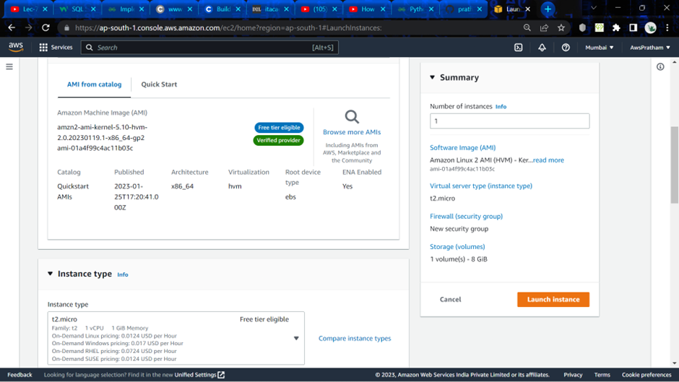

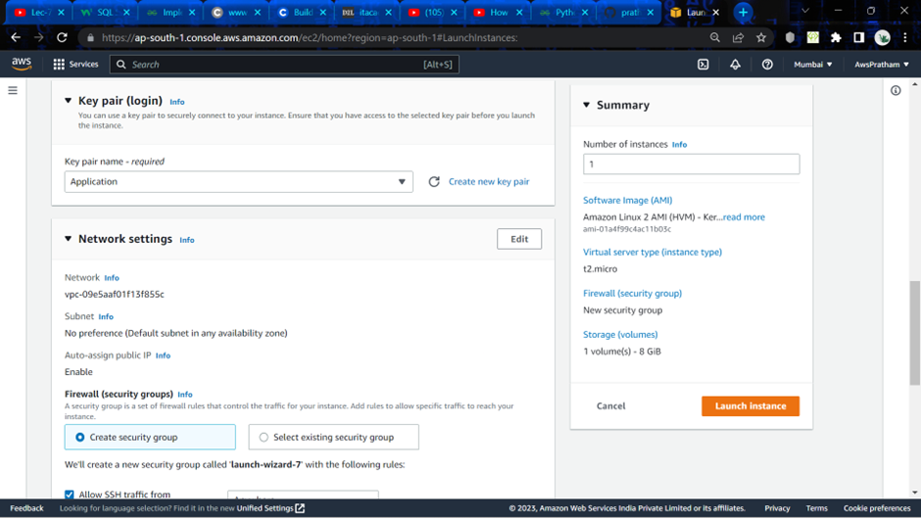

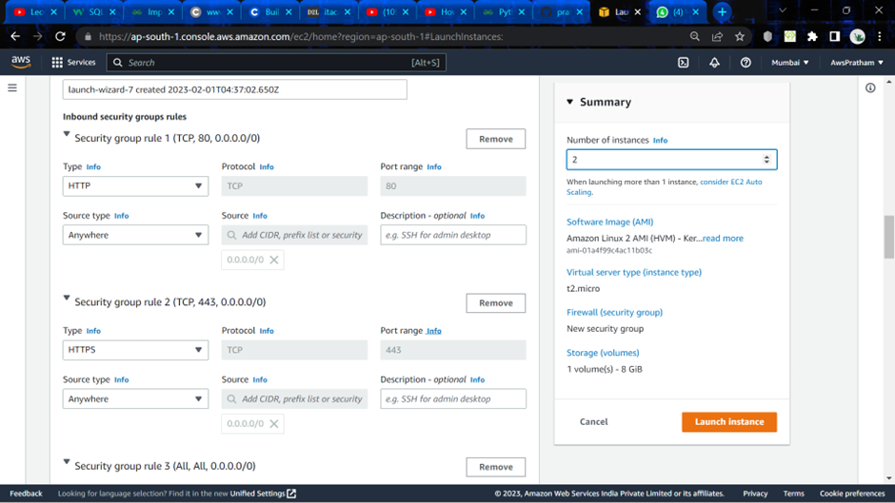

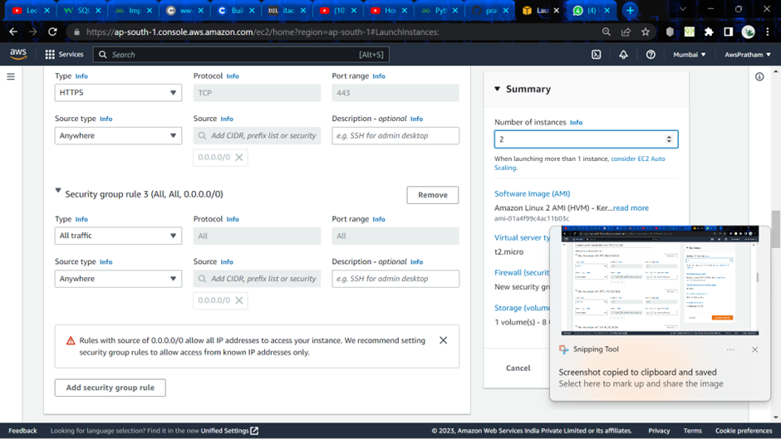

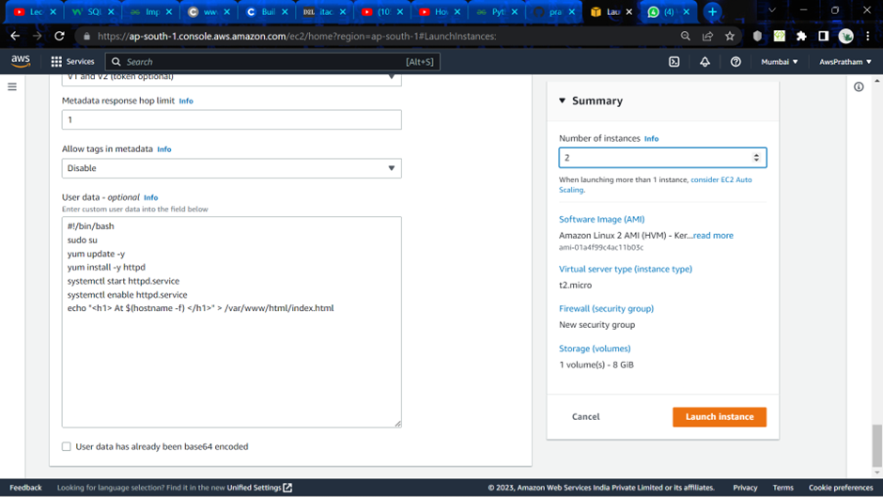

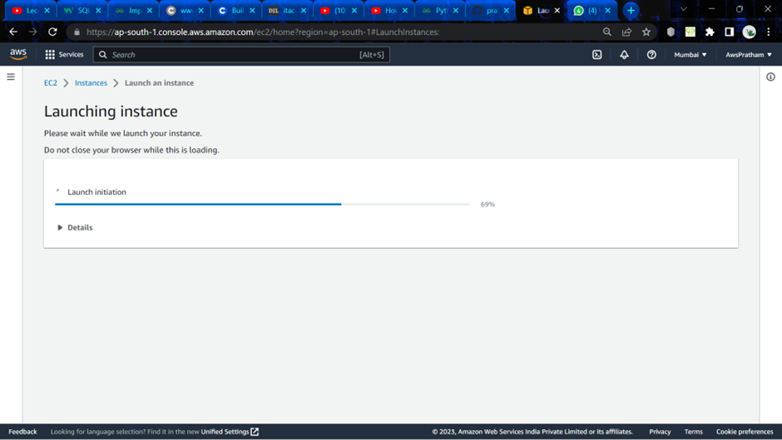

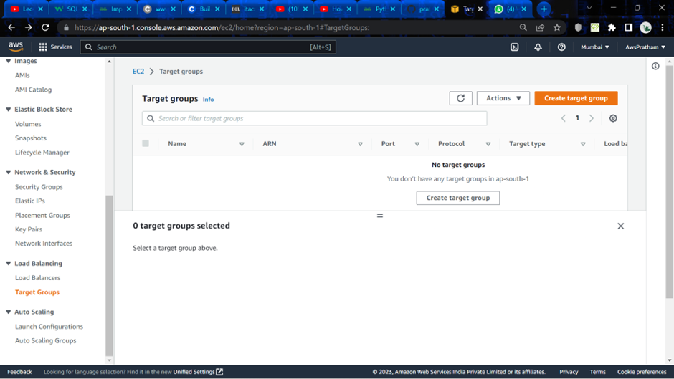

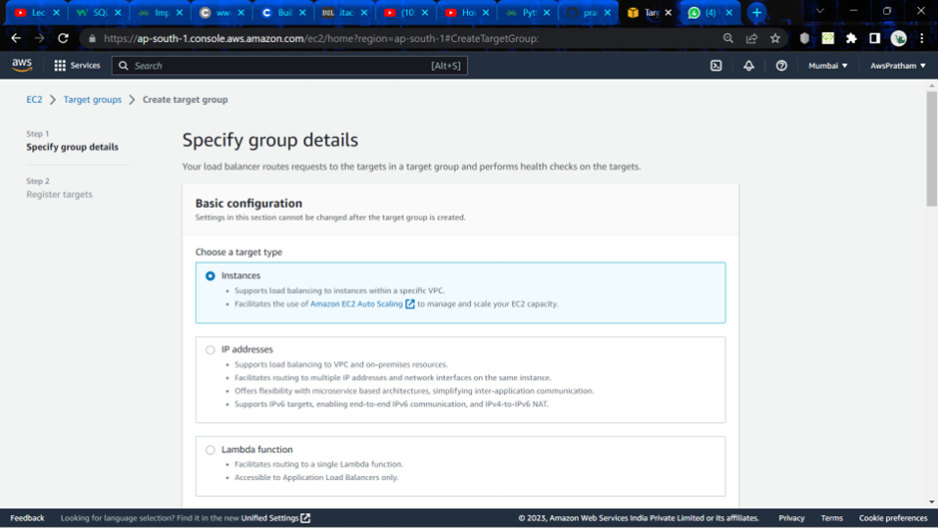

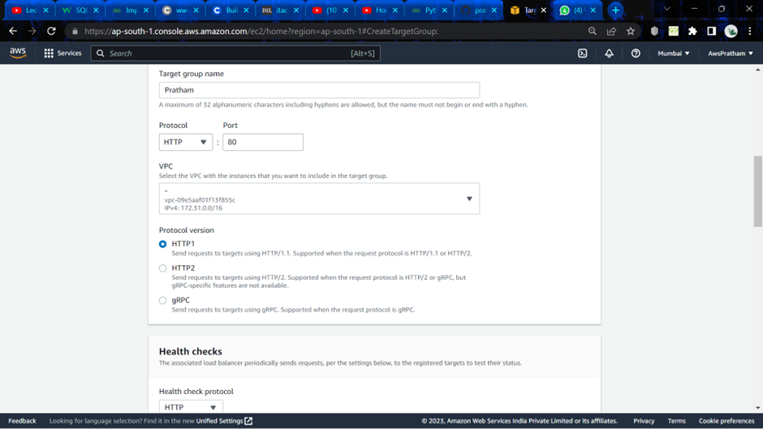

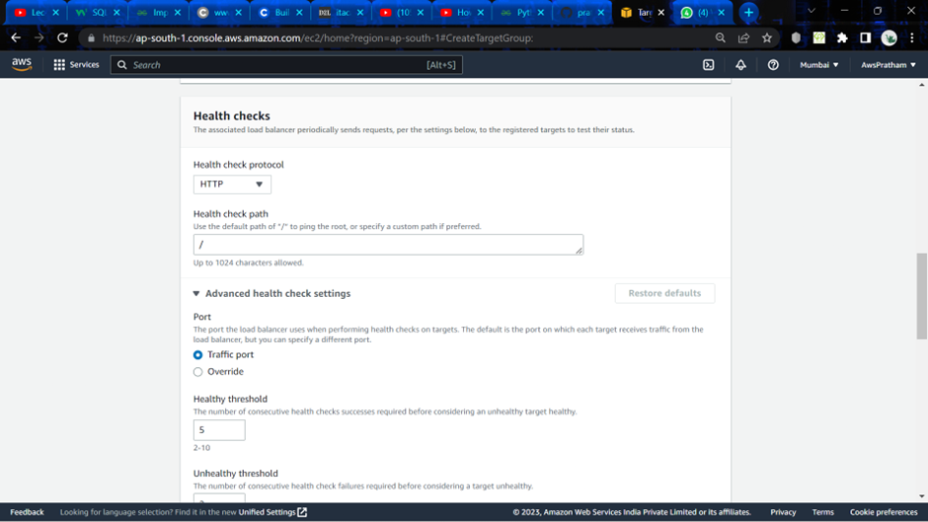

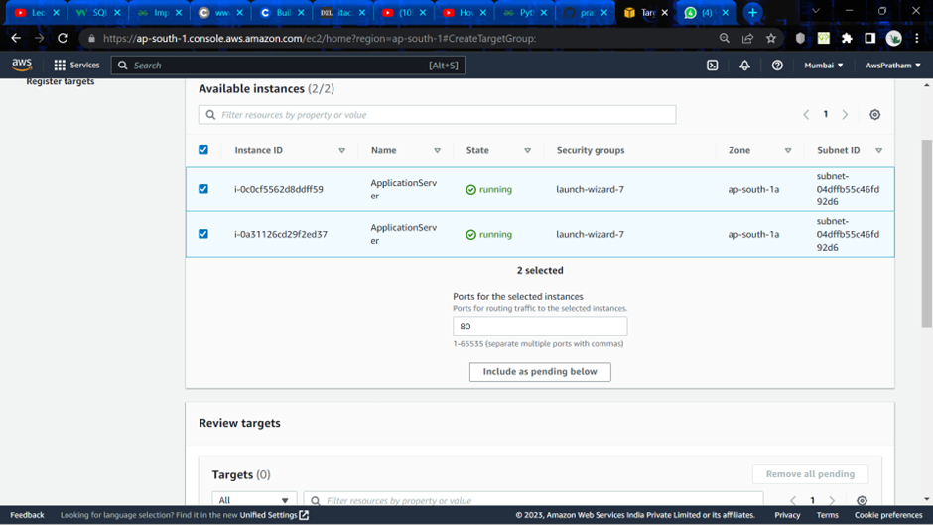

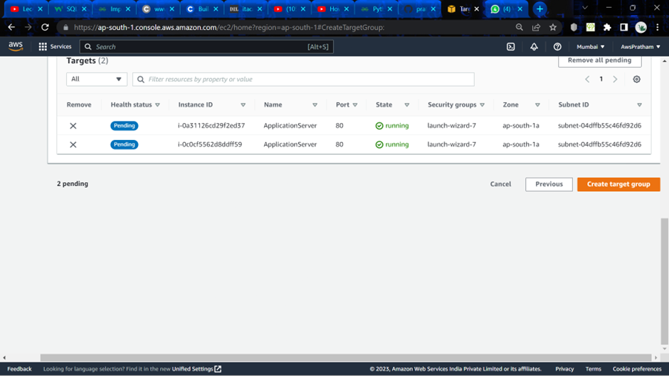

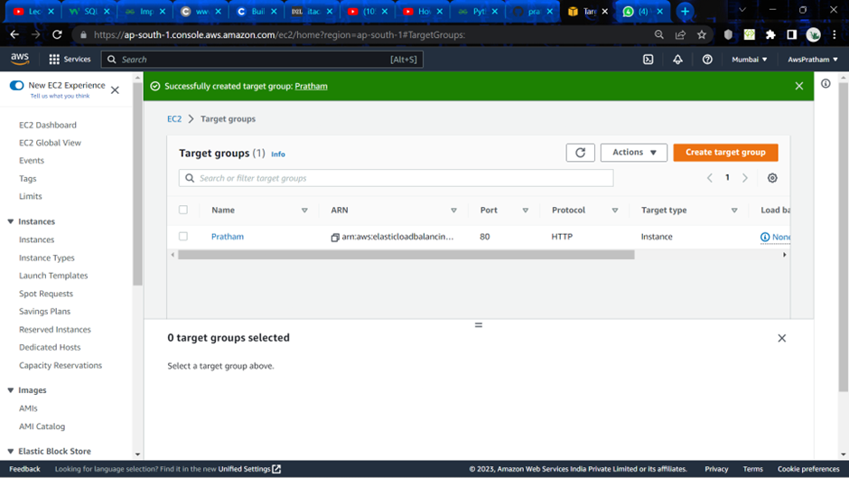

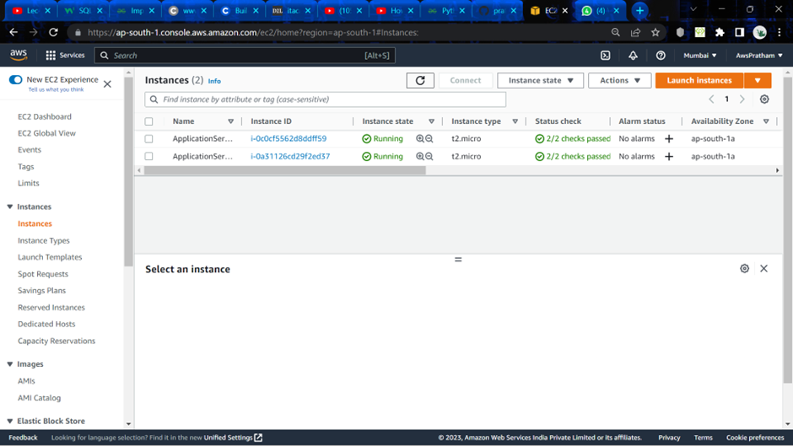

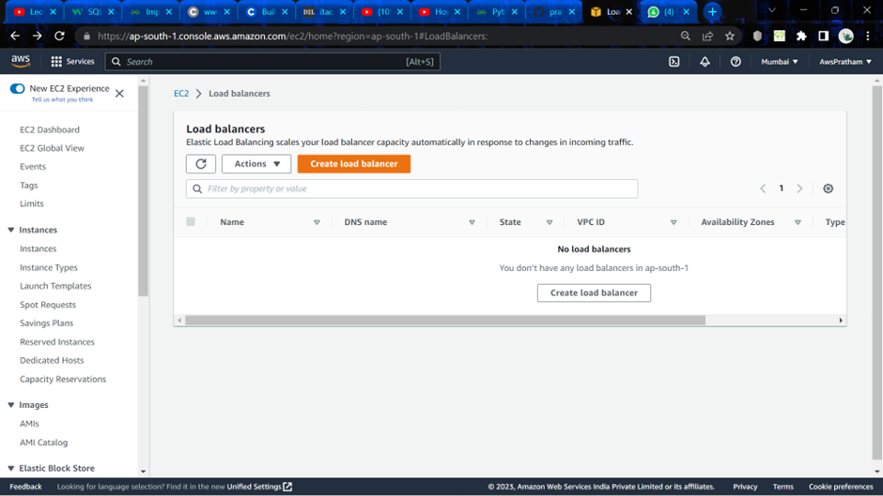

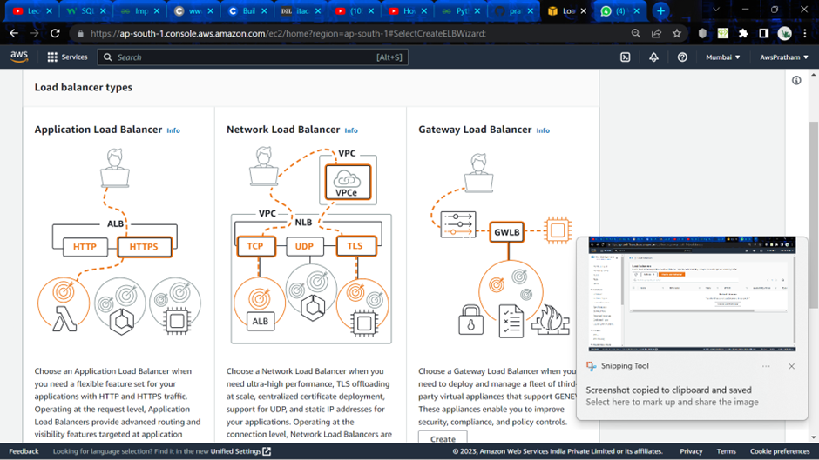

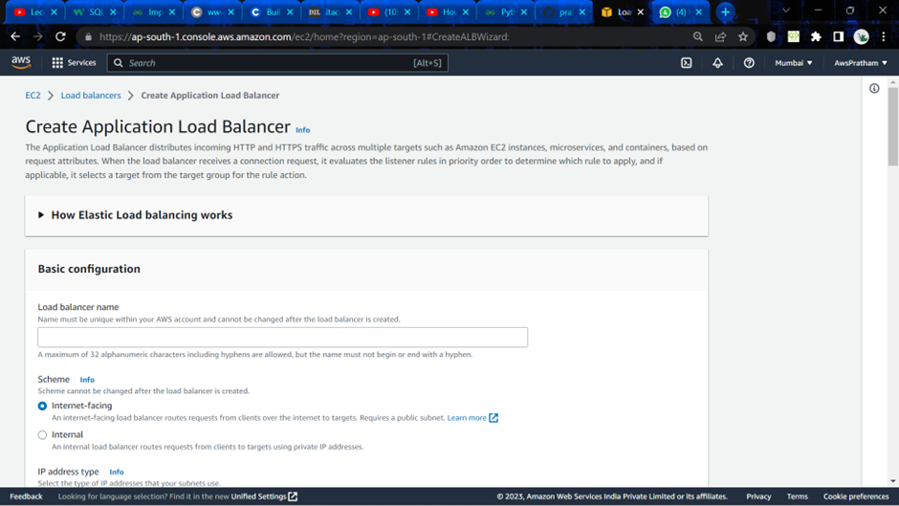

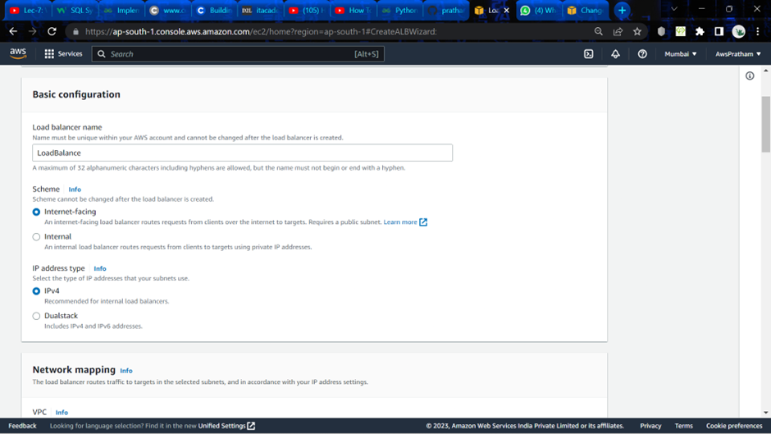

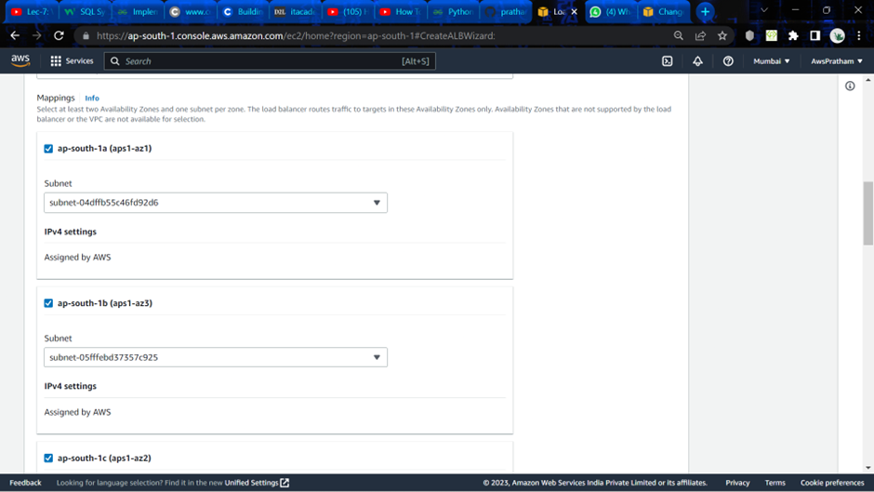

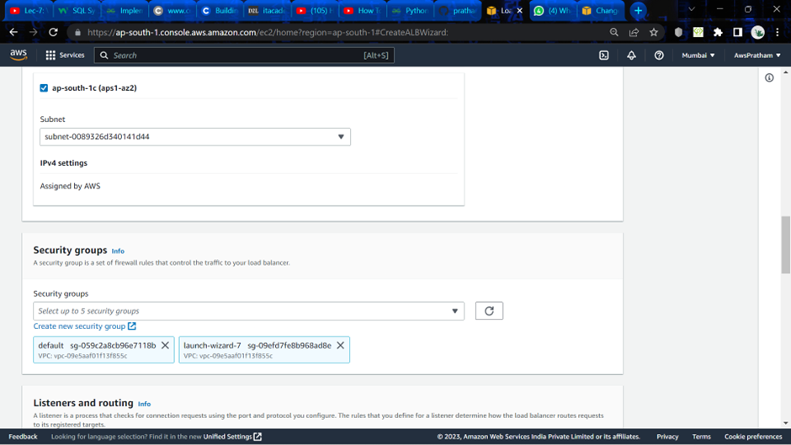

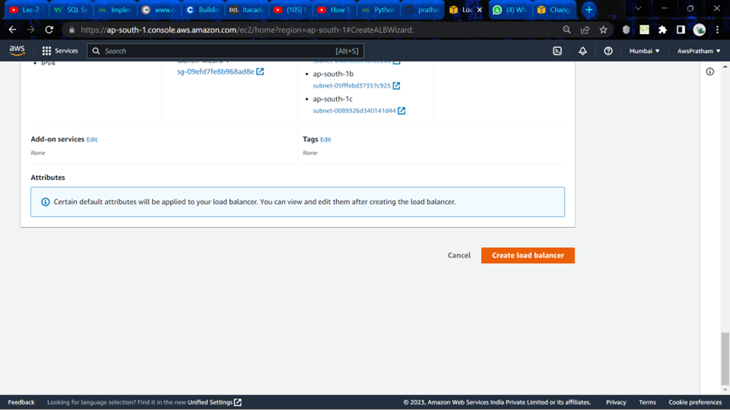

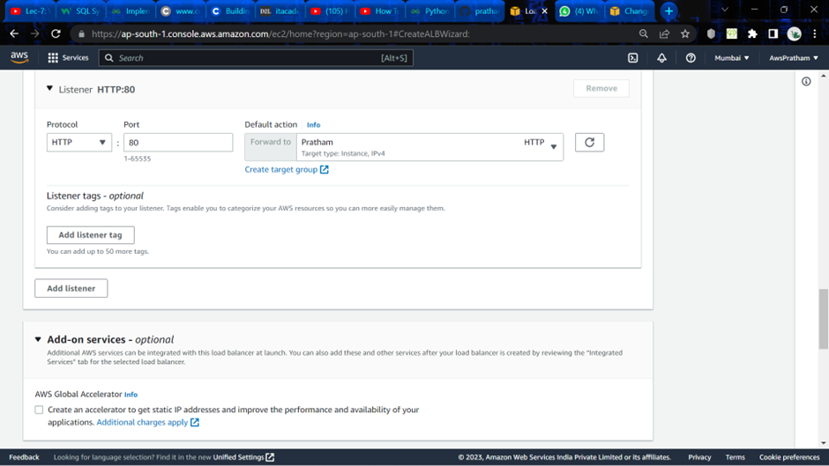

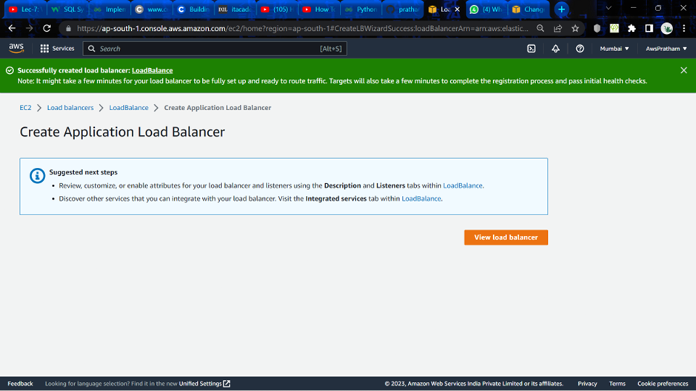

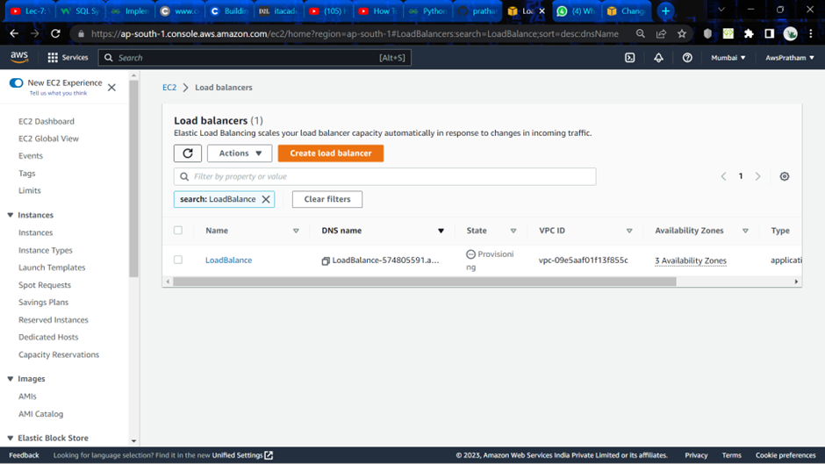

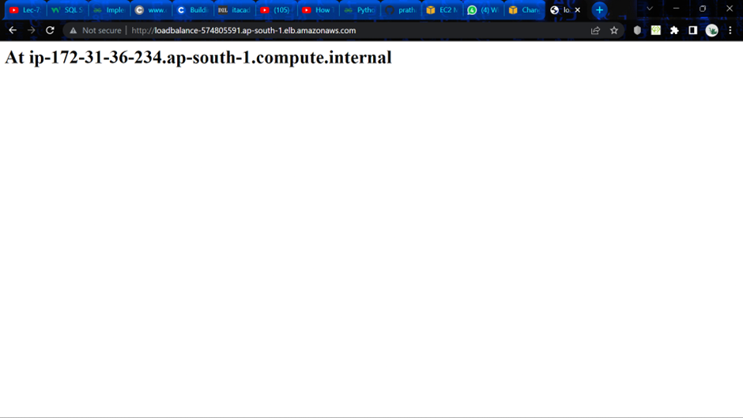

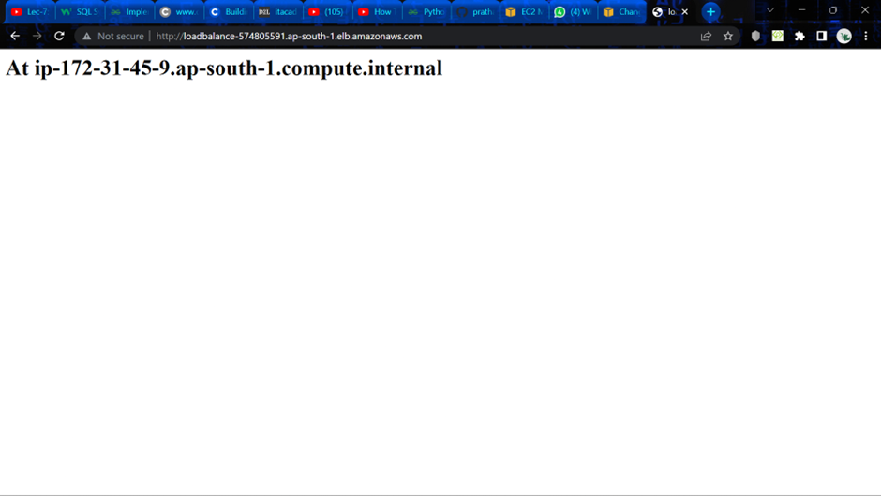

**Experiment- 5**

**Q:1.** Differentiate between EBS, EFS and S3 storage of AWS?

Ans: Amazon Web Services (AWS) provides several different storage services, including Elastic Block Store (EBS), Elastic File System (EFS), and Simple Storage Service (S3). Here's how they differ:

EBS (Elastic Block Store):

EBS is a block storage service used for EC2 instances. It provides persistent block-level storage volumes that can be attached to EC2 instances, allowing users to store data that is frequently accessed by an application running on an EC2 instance. EBS volumes are network-attached and can be detached from one EC2 instance and attached to another without losing data.

EBS is optimized for low latency and high IOPS (Input/Output Operations Per Second) and is commonly used for databases and transactional workloads.

EFS (Elastic File System):

EFS is a managed, scalable network file system that can be accessed from multiple EC2 instances at the same time. It provides a shared file system that can be used by applications running on multiple EC2 instances, making it ideal for distributed applications and content management systems.

EFS is a fully managed service and automatically scales as you add or remove files, making it easy to manage and cost-effective. It is optimized for throughput and latency and is commonly used for content management systems, big data analytics, and web serving.

S3 (Simple Storage Service):

S3 is an object storage service that provides unlimited storage for files and objects. It can be used to store and retrieve any amount of data, at any time, from anywhere in the world. S3 is designed for durability, availability, and scalability and is commonly used for backup and archive storage, as well as for serving static content such as images and videos.

S3 also provides features such as versioning, lifecycle policies, and data encryption, making it a versatile storage solution for a wide range of applications and use cases.

In summary, EBS is a block storage service for EC2 instances, EFS is a scalable file system that can be accessed from multiple EC2 instances, and S3 is an object storage service for unlimited storage and retrieval of files and objects.

**Q:2.** Write the uses cases where EBS (block storage) will be more useful than others.

Ans:

EBS (Elastic Block Store) is a block-level storage service that provides persistent storage for Amazon EC2 instances. Here are some use cases where EBS may be more useful than other storage services:

Databases: EBS is commonly used for databases, as it provides low-latency and high-IOPS block-level storage that is well-suited for transactional workloads. By using EBS, you can separate your database storage from your instance storage, making it easier to scale your database independently of your application.

Boot volumes: EBS can be used to store boot volumes, which are the volumes that contain the operating system and application software for an EC2 instance. By using EBS for boot volumes, you can easily create and manage AMIs (Amazon Machine Images) that can be used to launch new instances with the same configuration.

High-performance computing: EBS is well-suited for high-performance computing workloads, such as those used in scientific research or financial modeling. By using EBS, you can provide fast and consistent storage to your compute instances, enabling them to process large amounts of data quickly.

Backup and recovery: EBS provides a simple and cost-effective way to back up your data. By taking snapshots of your EBS volumes, you can create a point-in-time copy of your data that can be used to restore your volumes in the event of a failure.

Disaster recovery: EBS can be used as part of a disaster recovery strategy, as it allows you to create snapshots of your volumes and replicate them to another region. By doing so, you can ensure that your data is available in the event of an outage in your primary region.

In summary, EBS is particularly useful for workloads that require low-latency and high-IOPS block-level storage, such as databases, boot volumes, and high-performance computing. It is also well-suited for backup and recovery, as well as disaster recovery.

**Attaching EBS to Amazon EC2 Linux and Windows Instance**

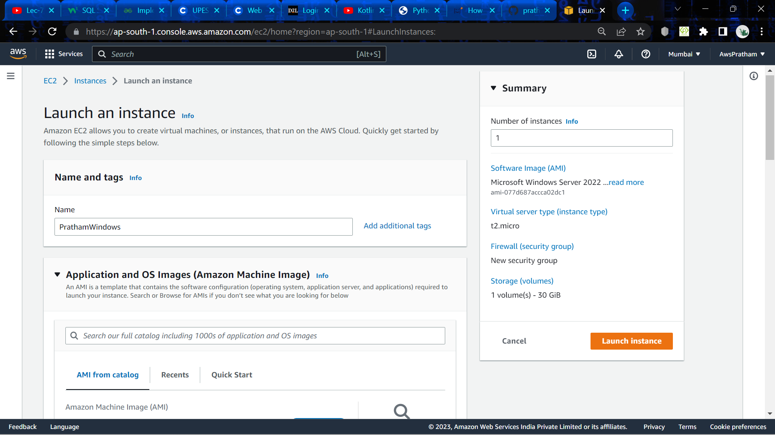

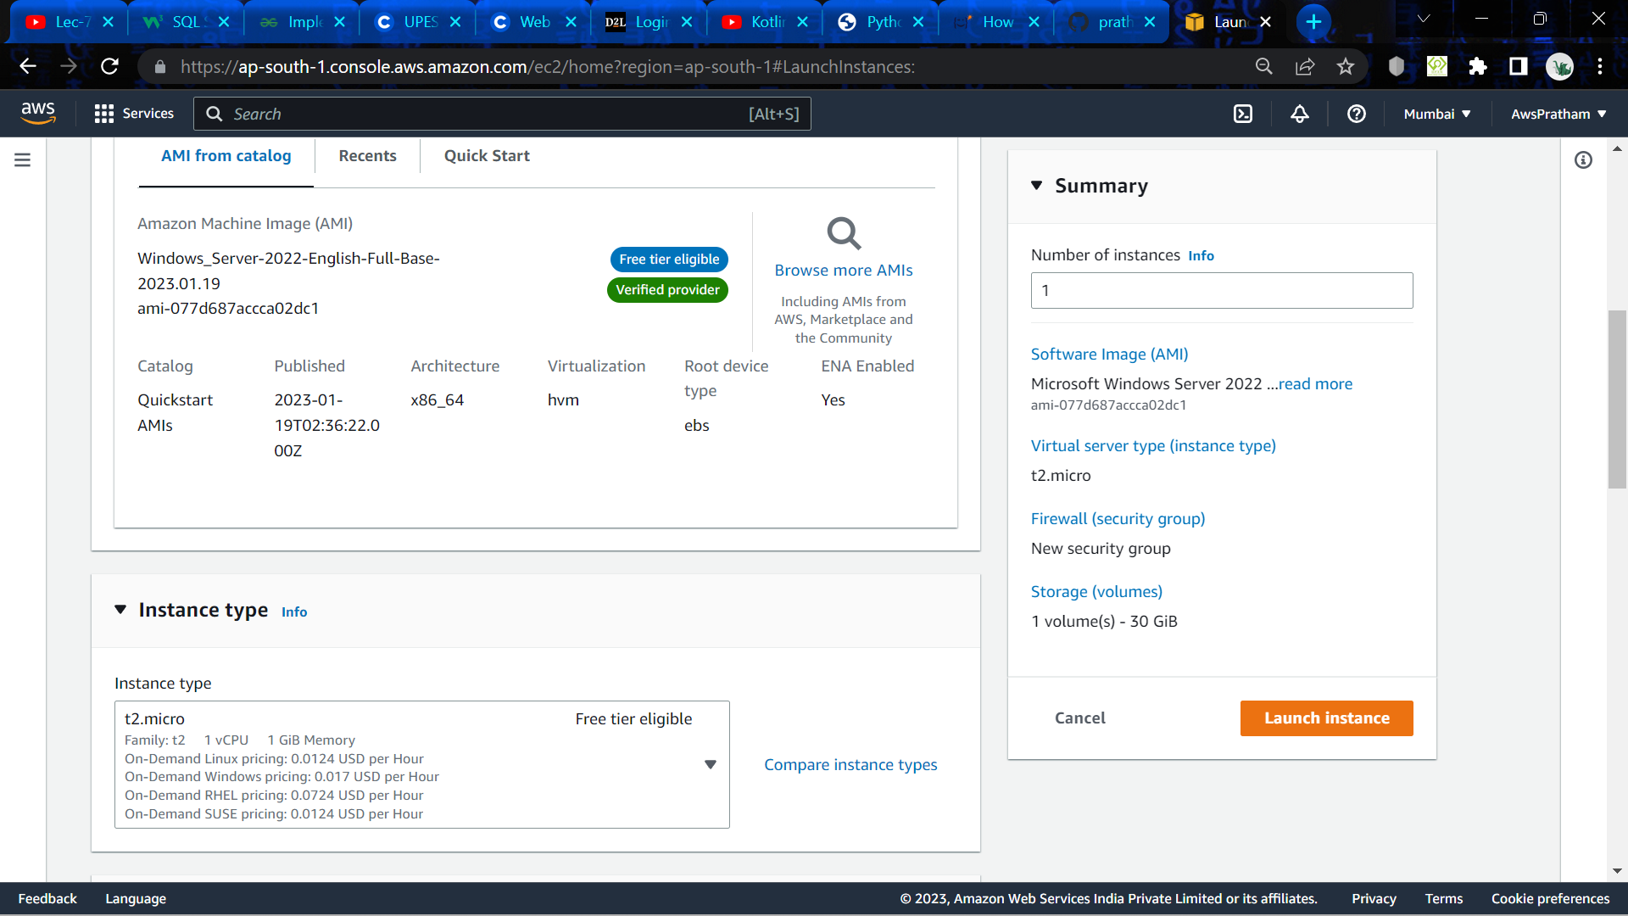

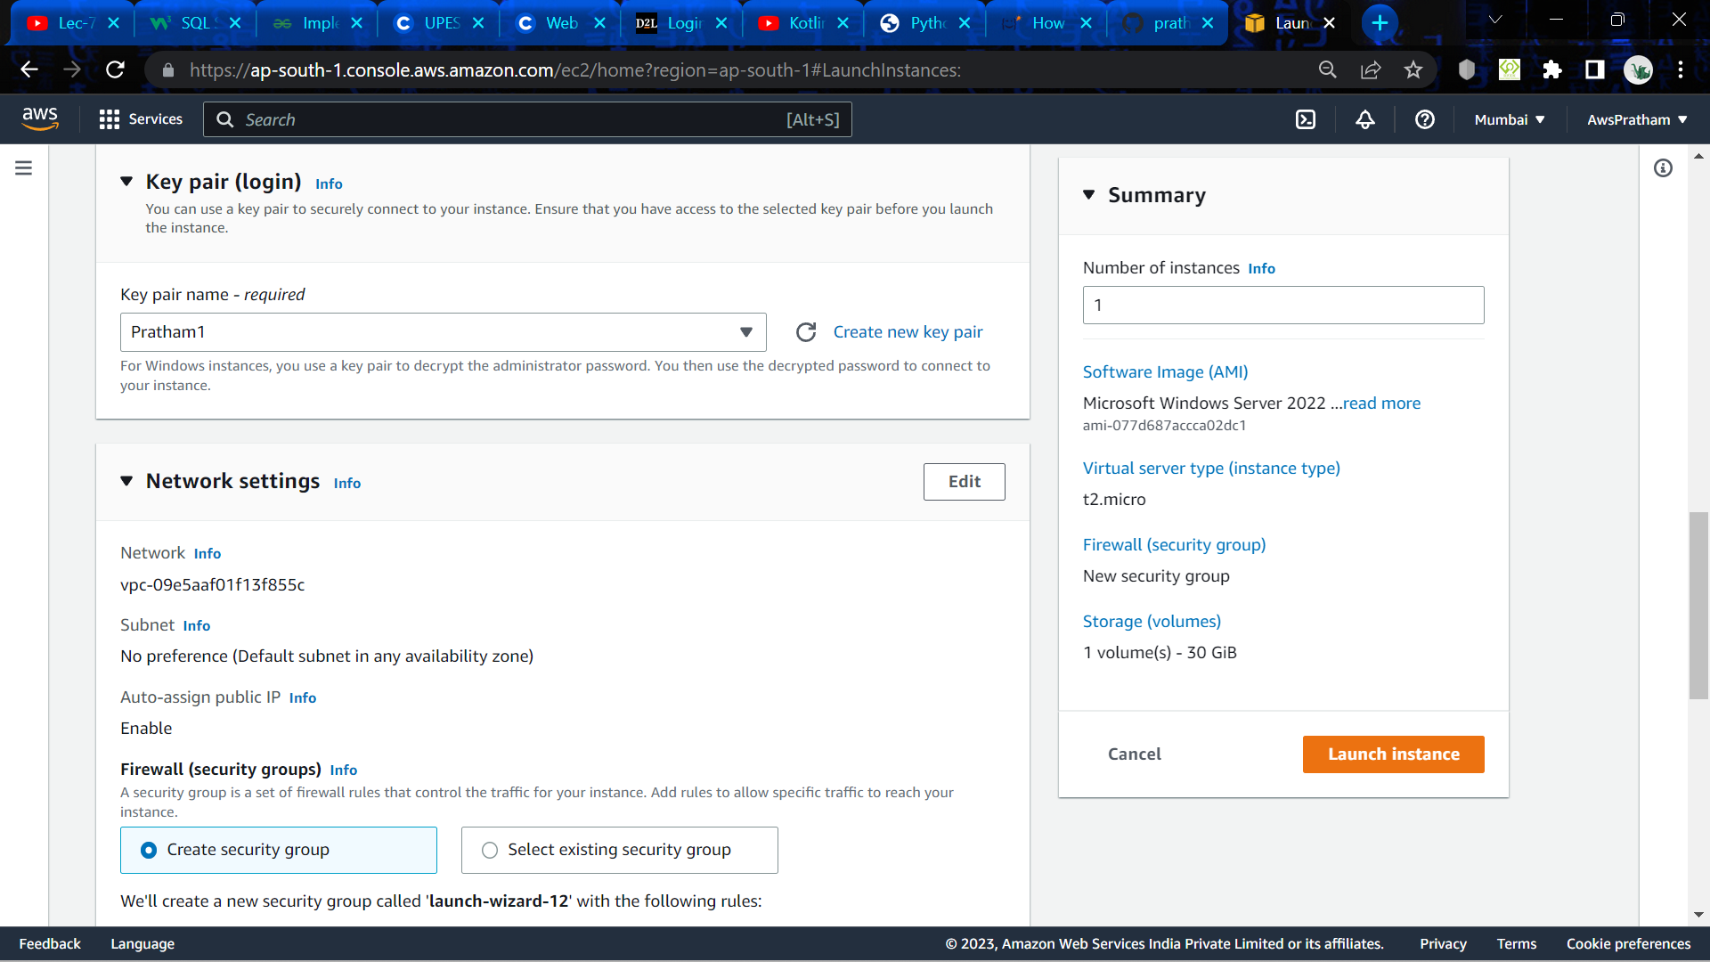

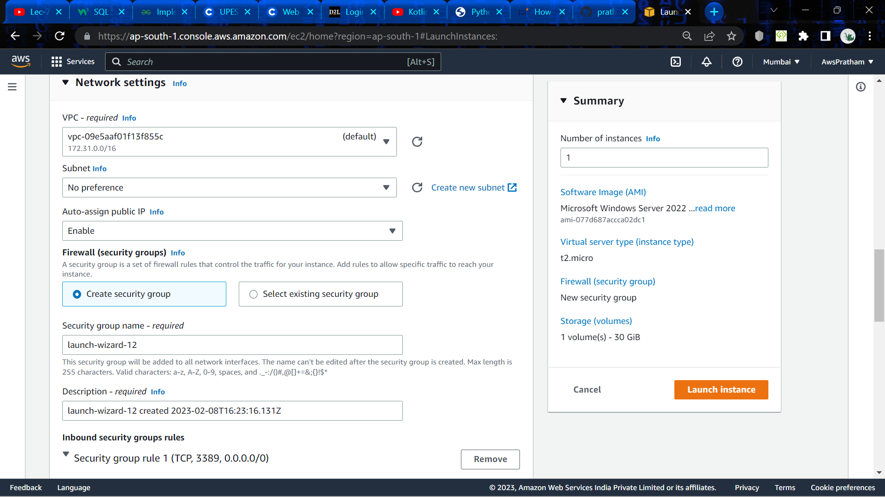

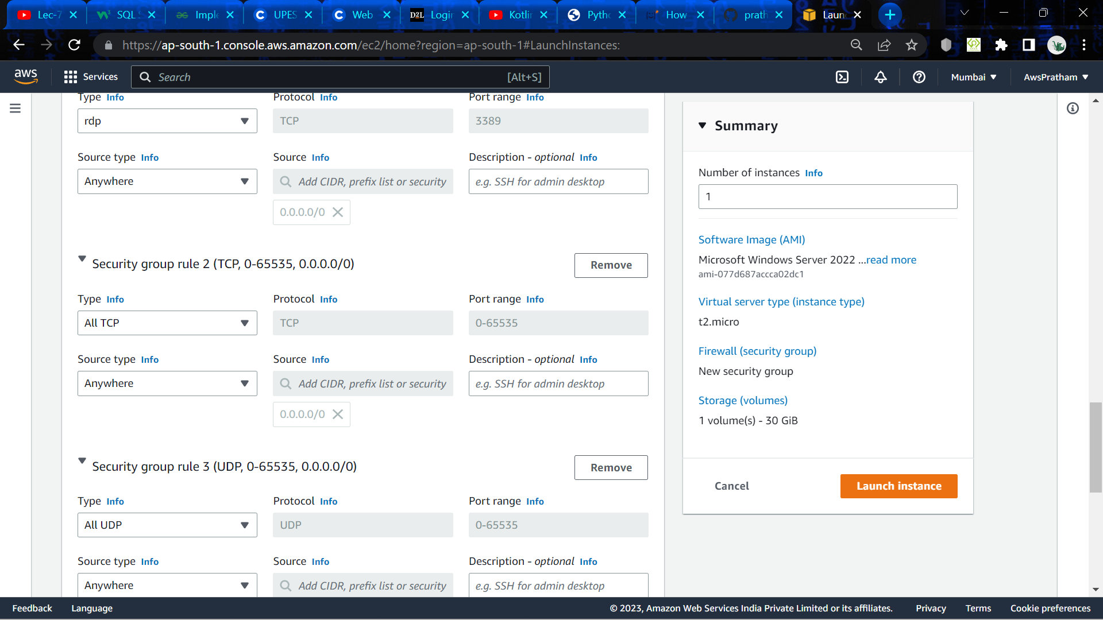

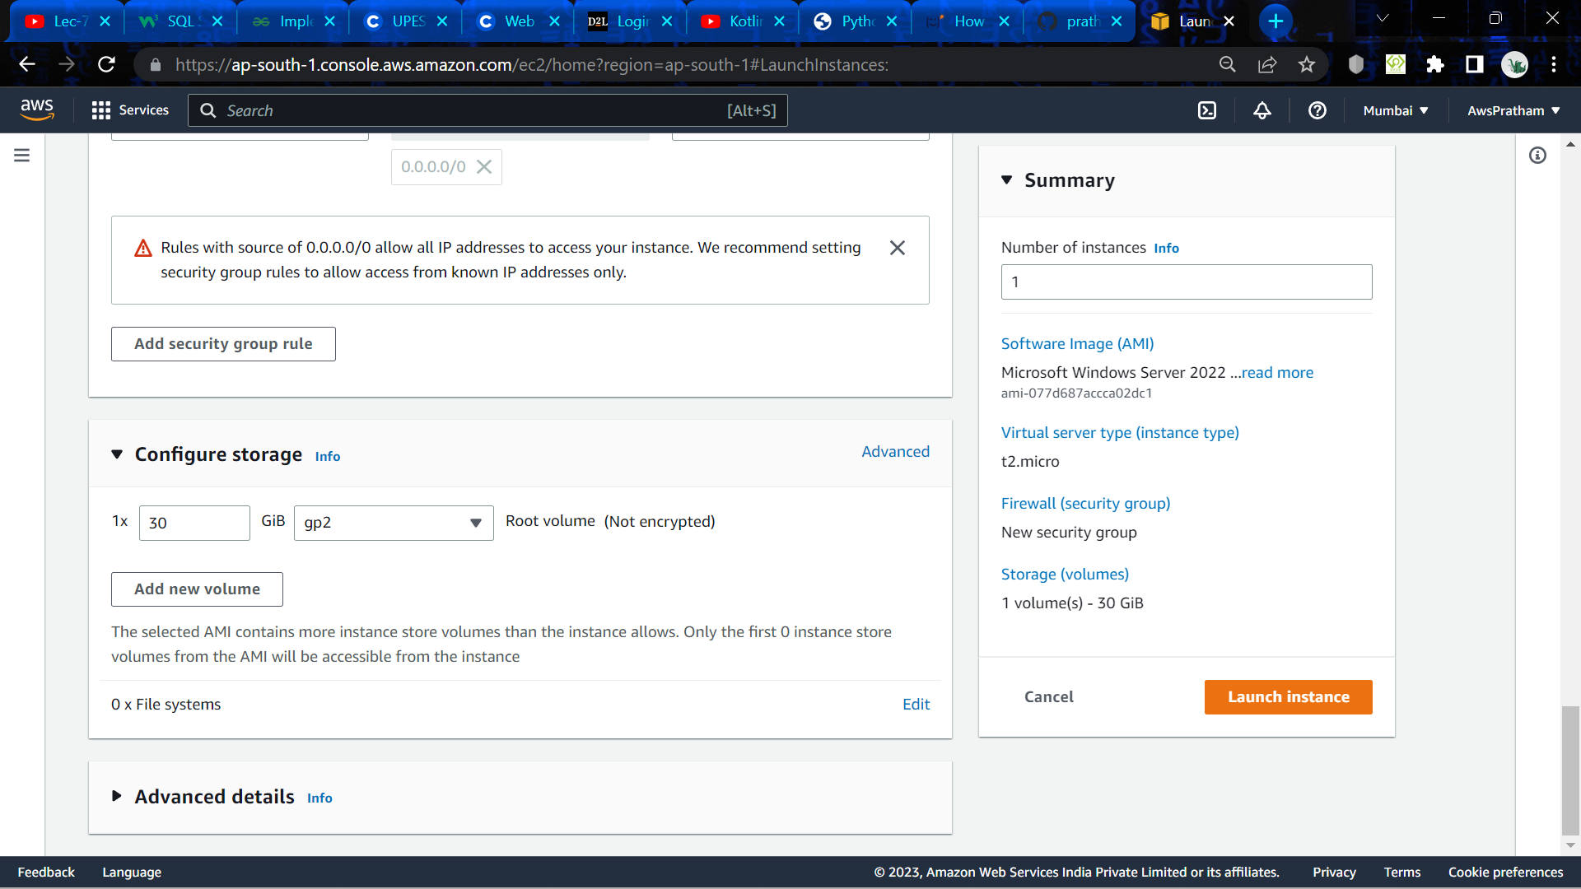

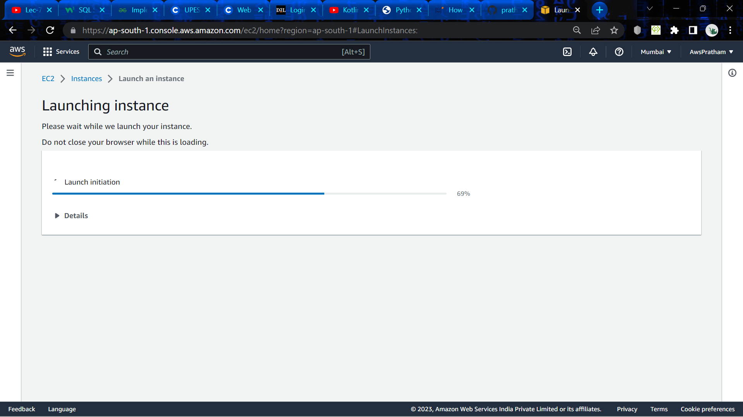

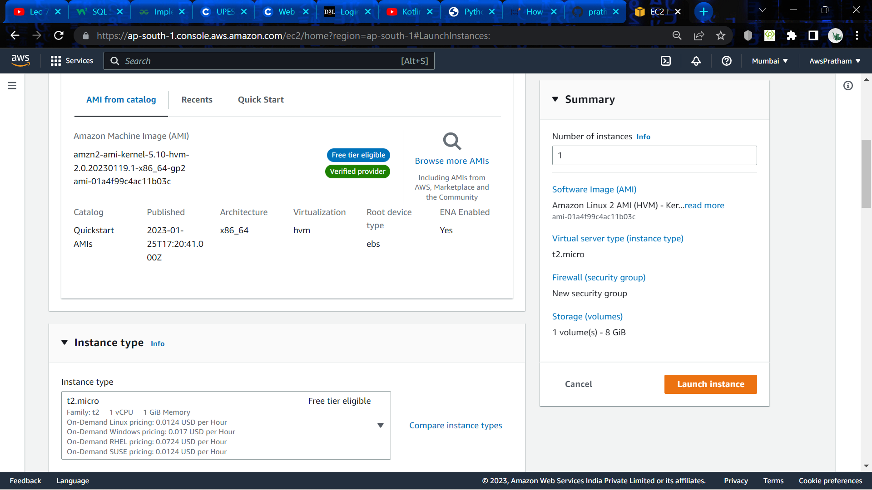

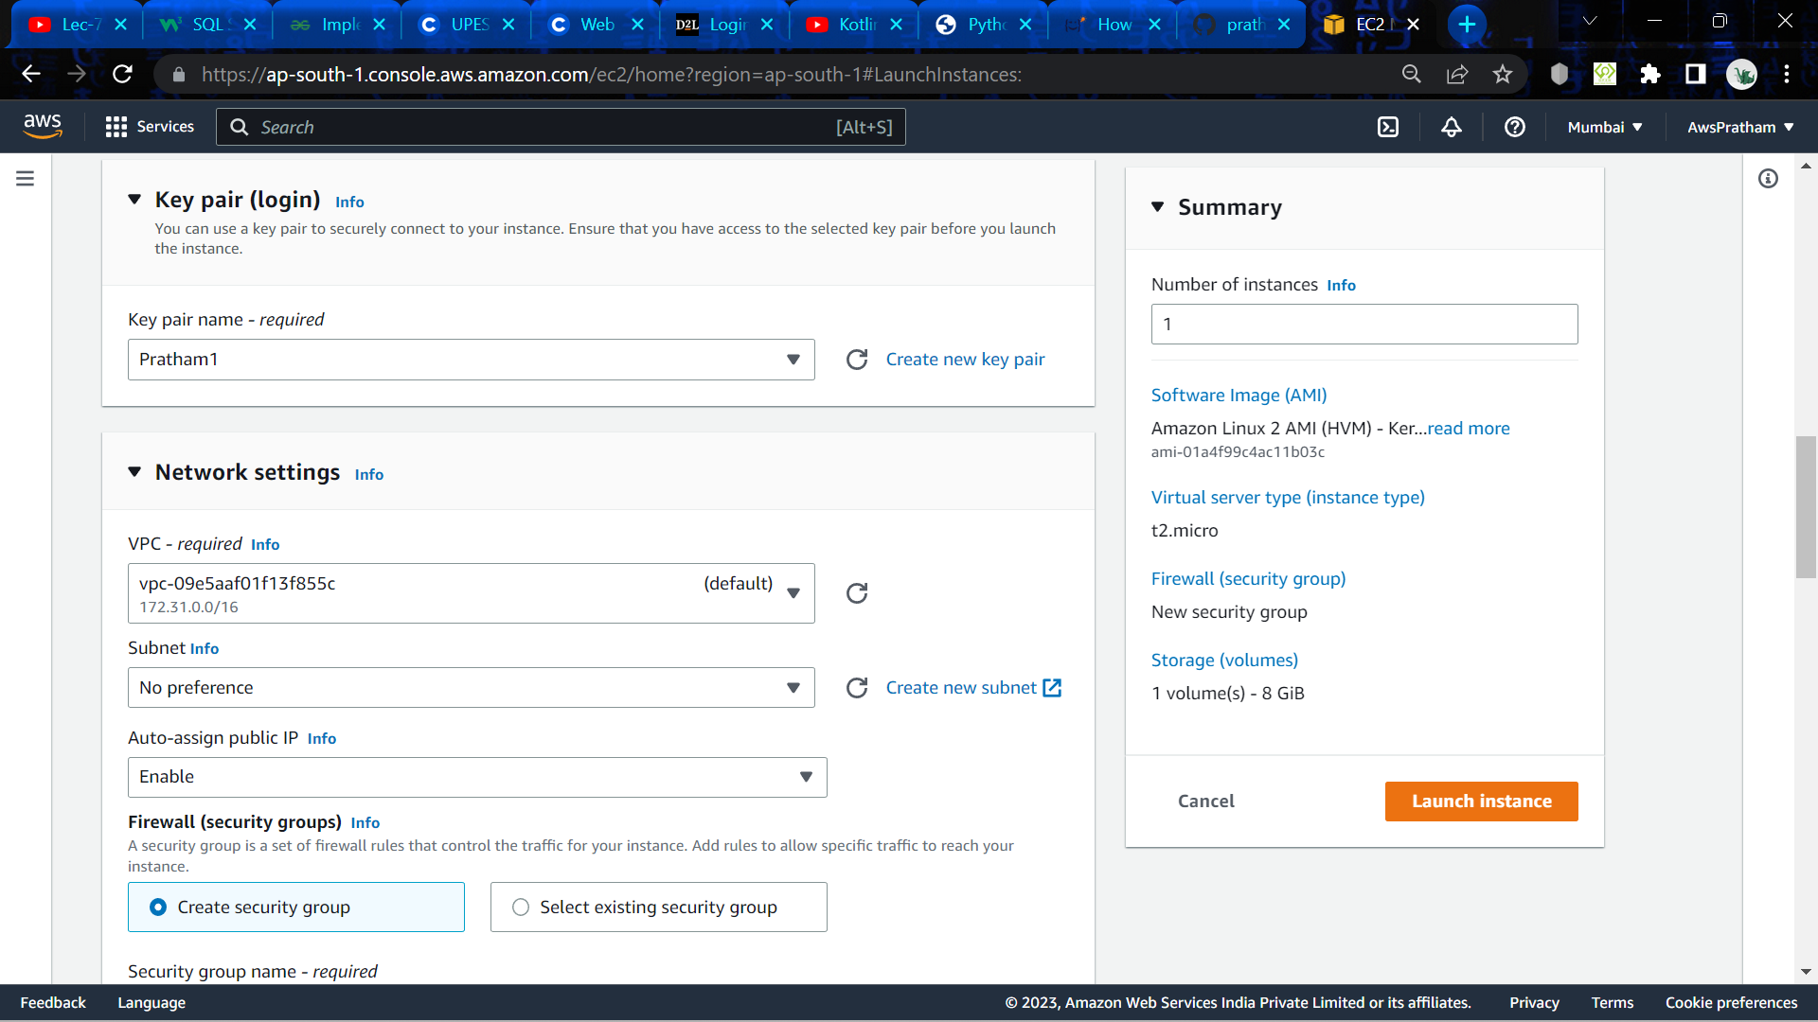

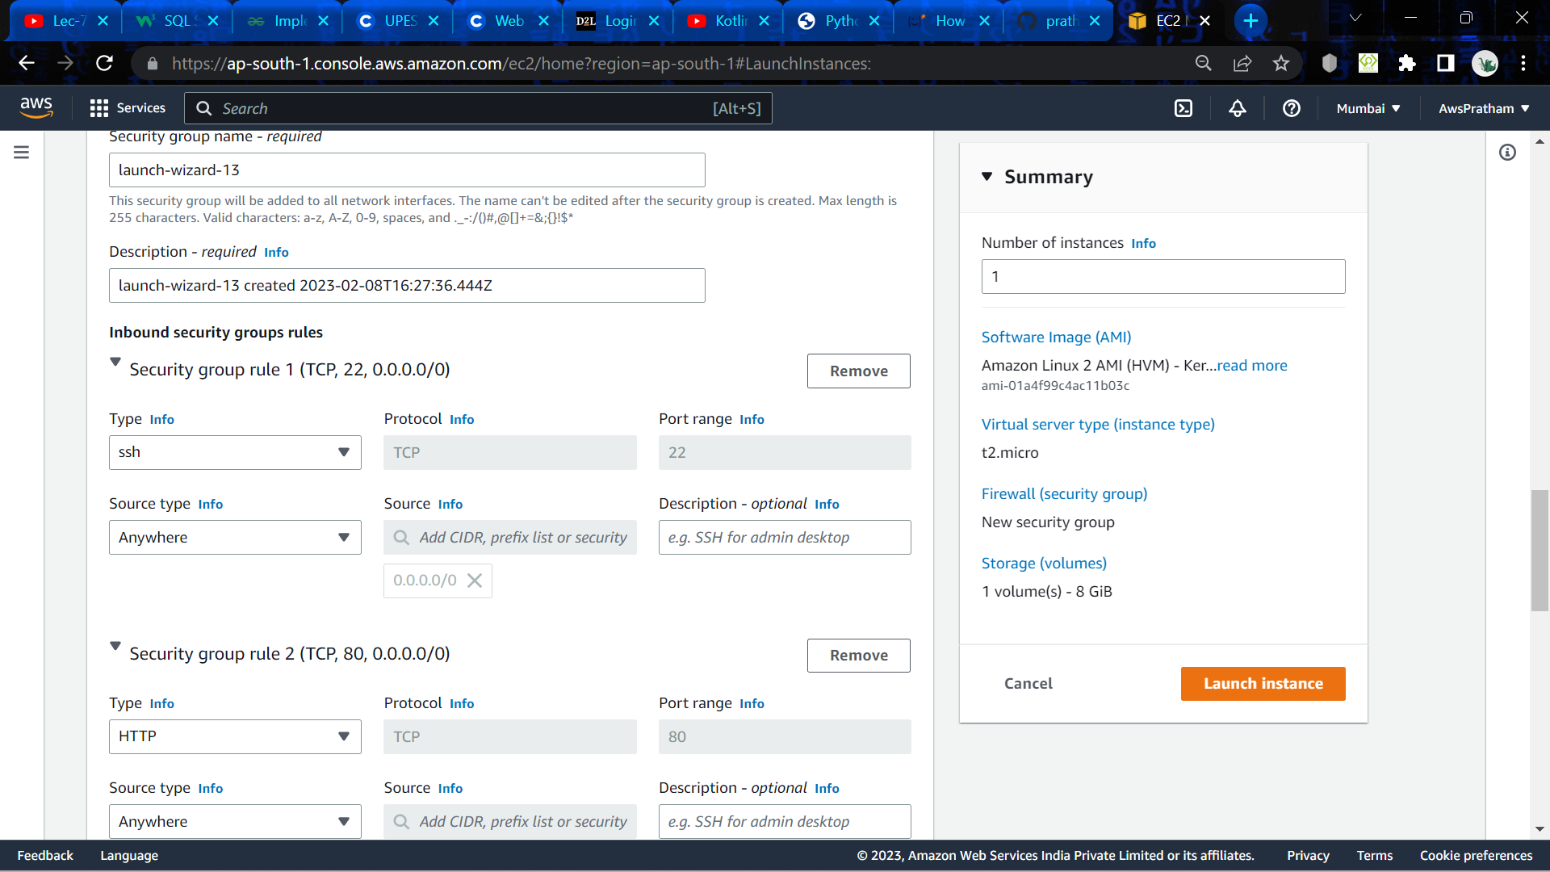

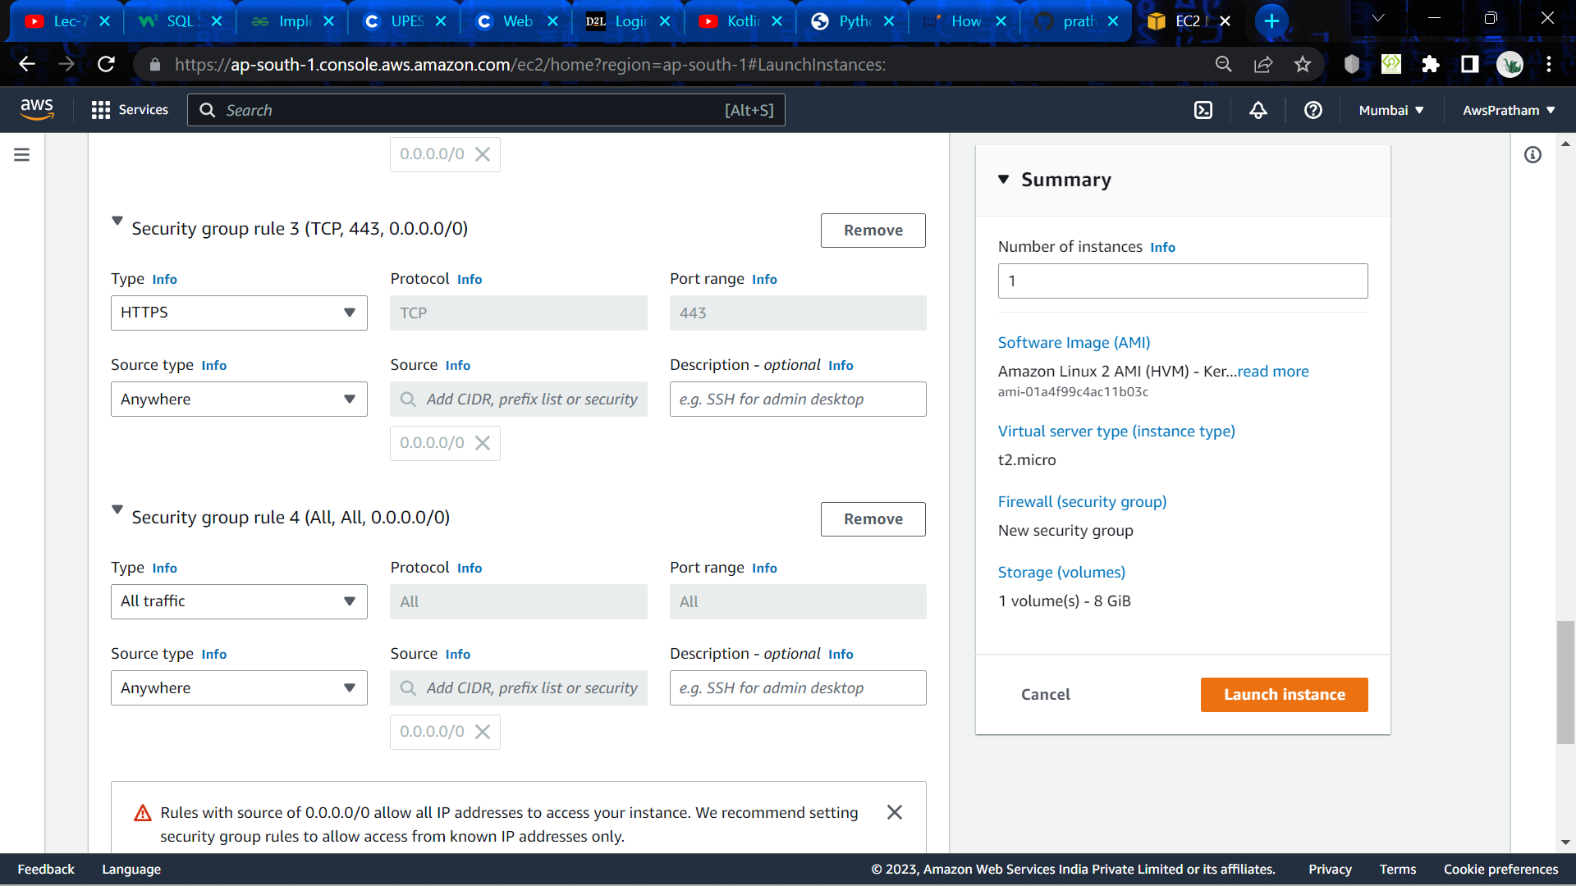

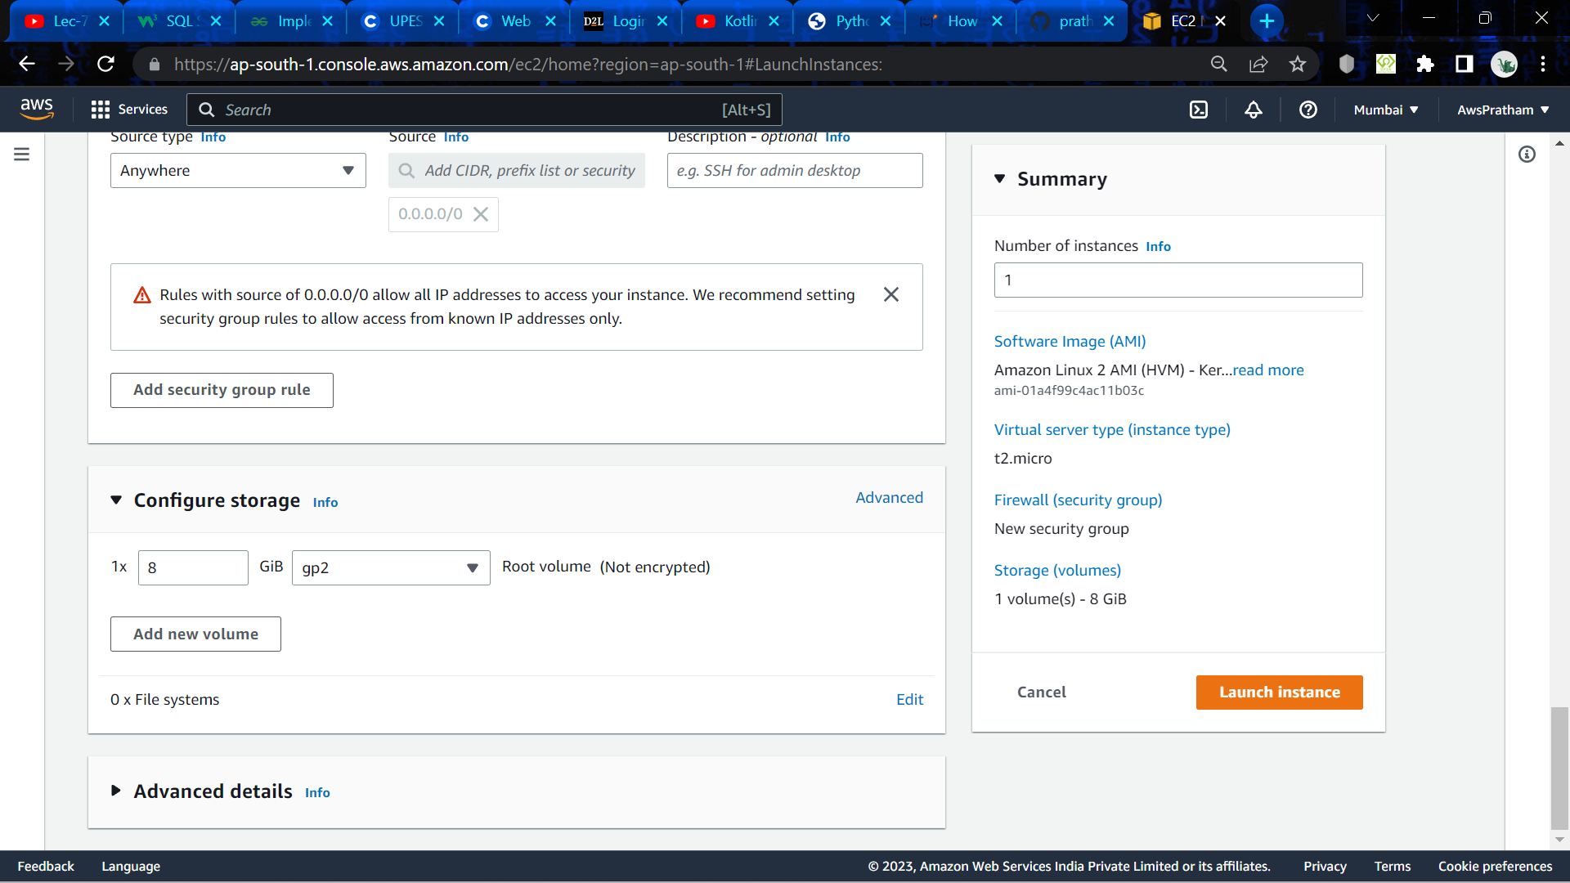

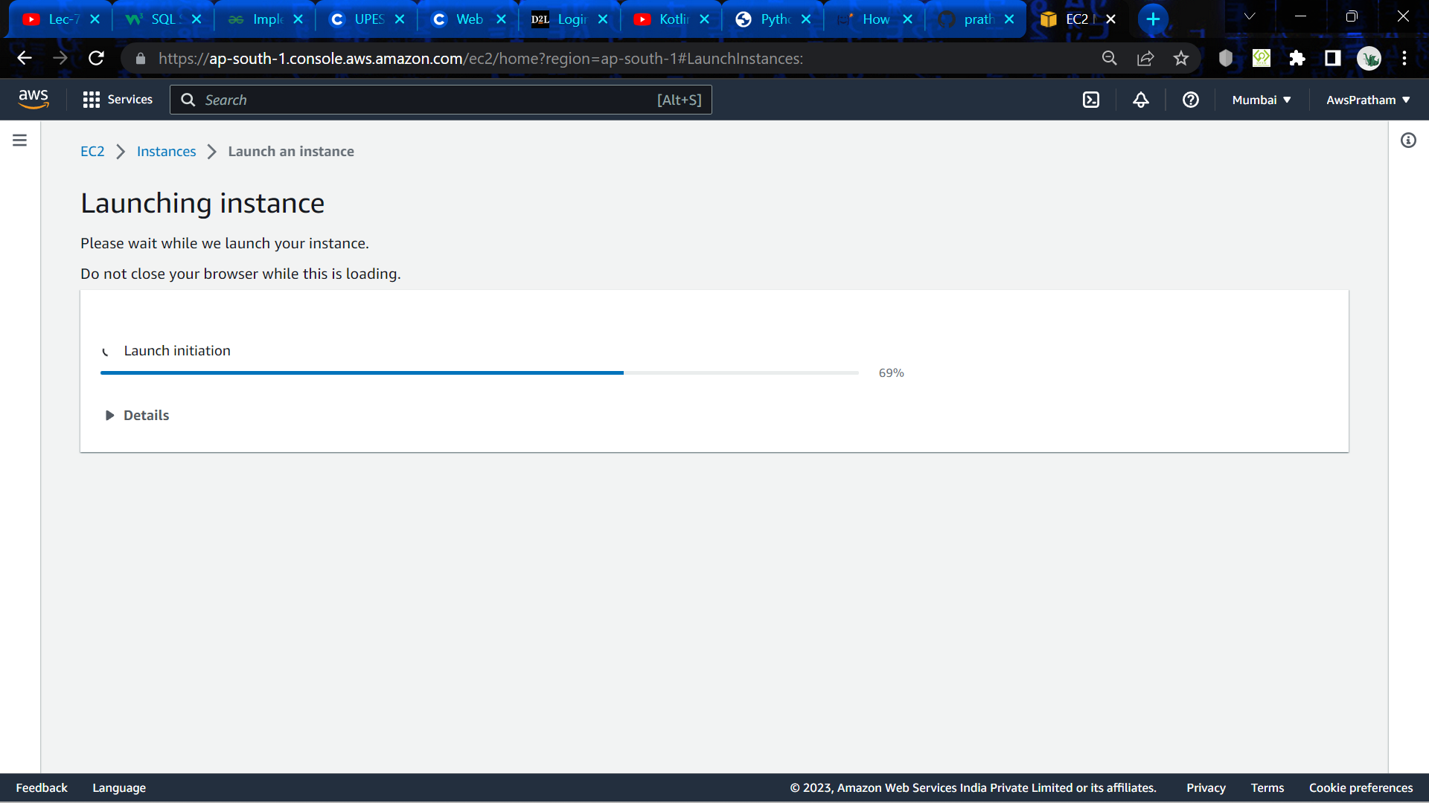

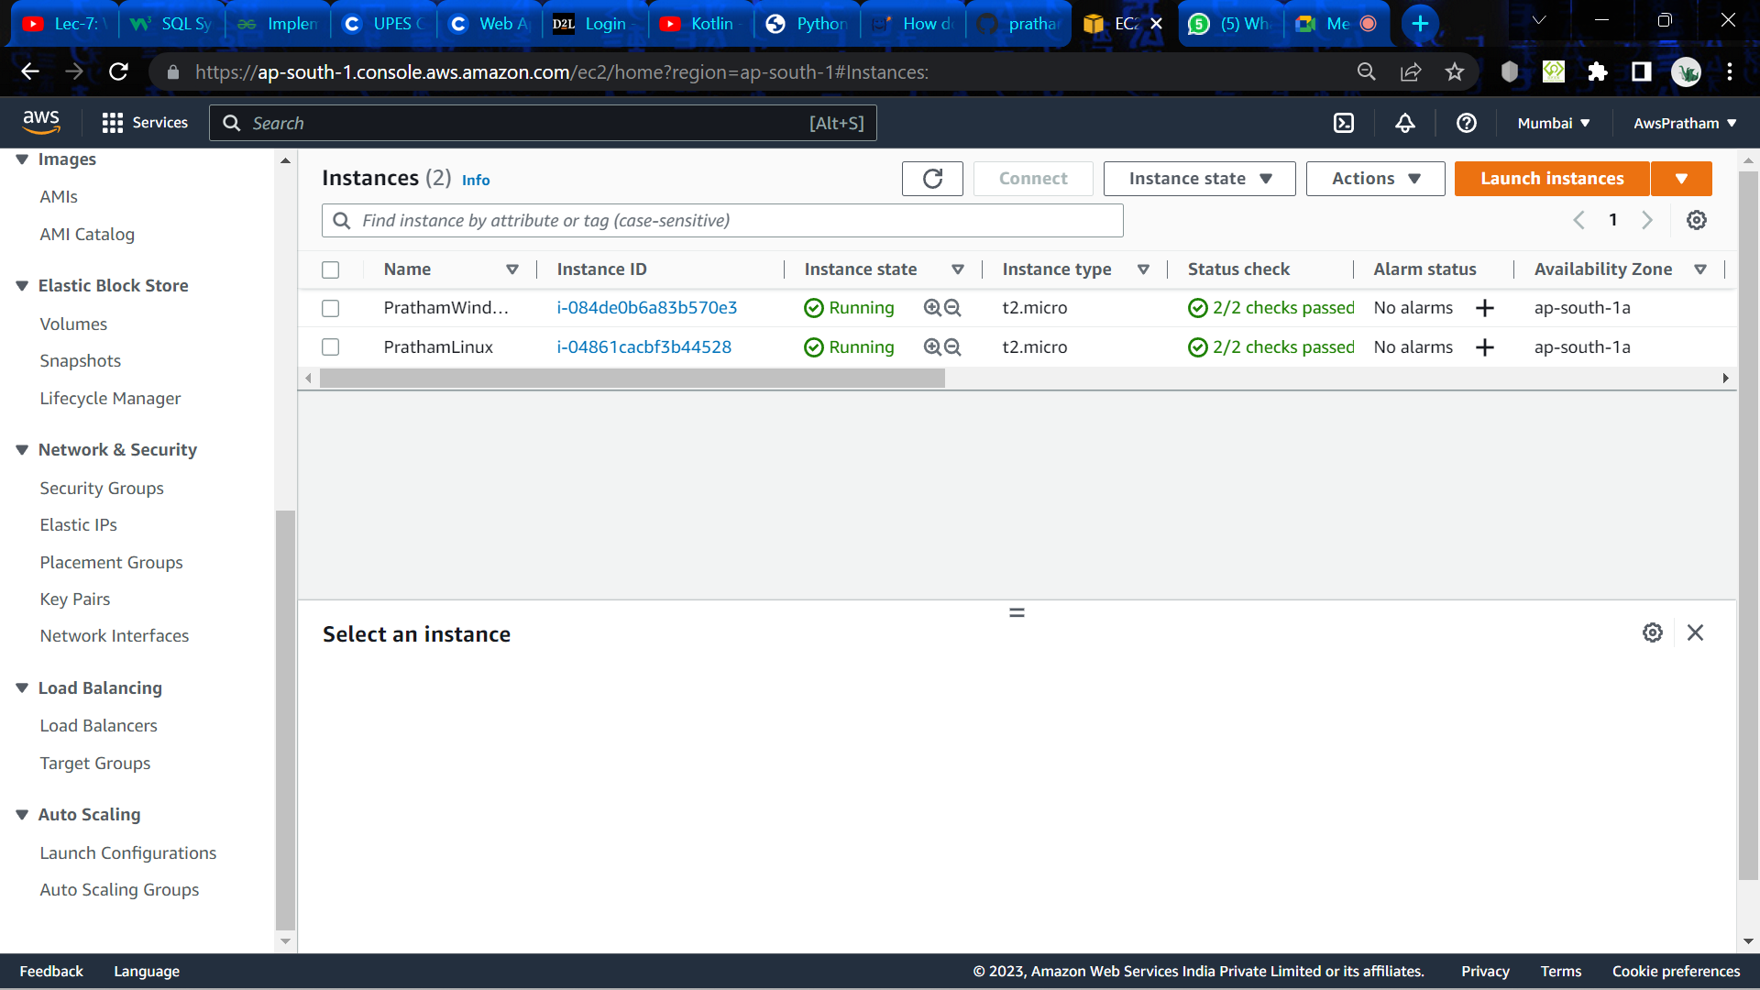

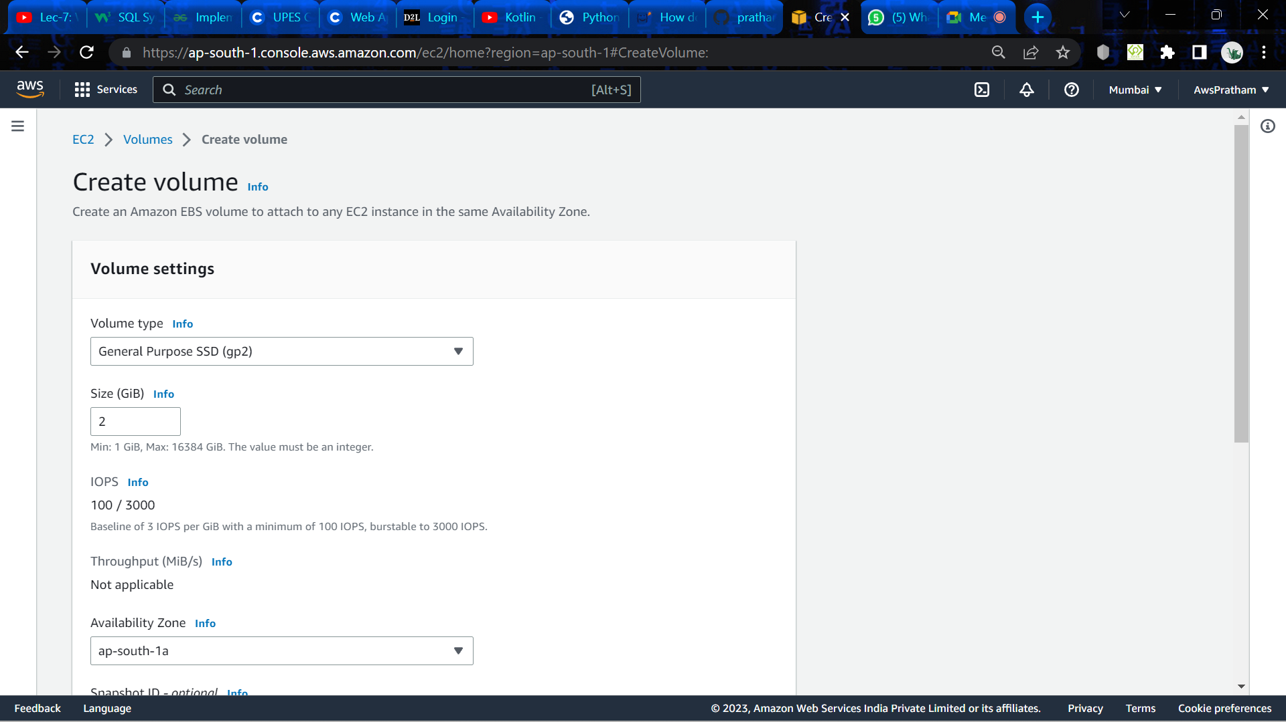

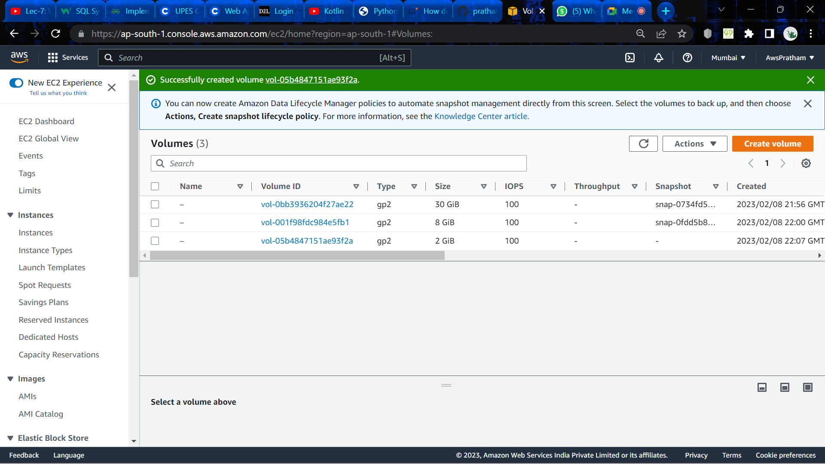

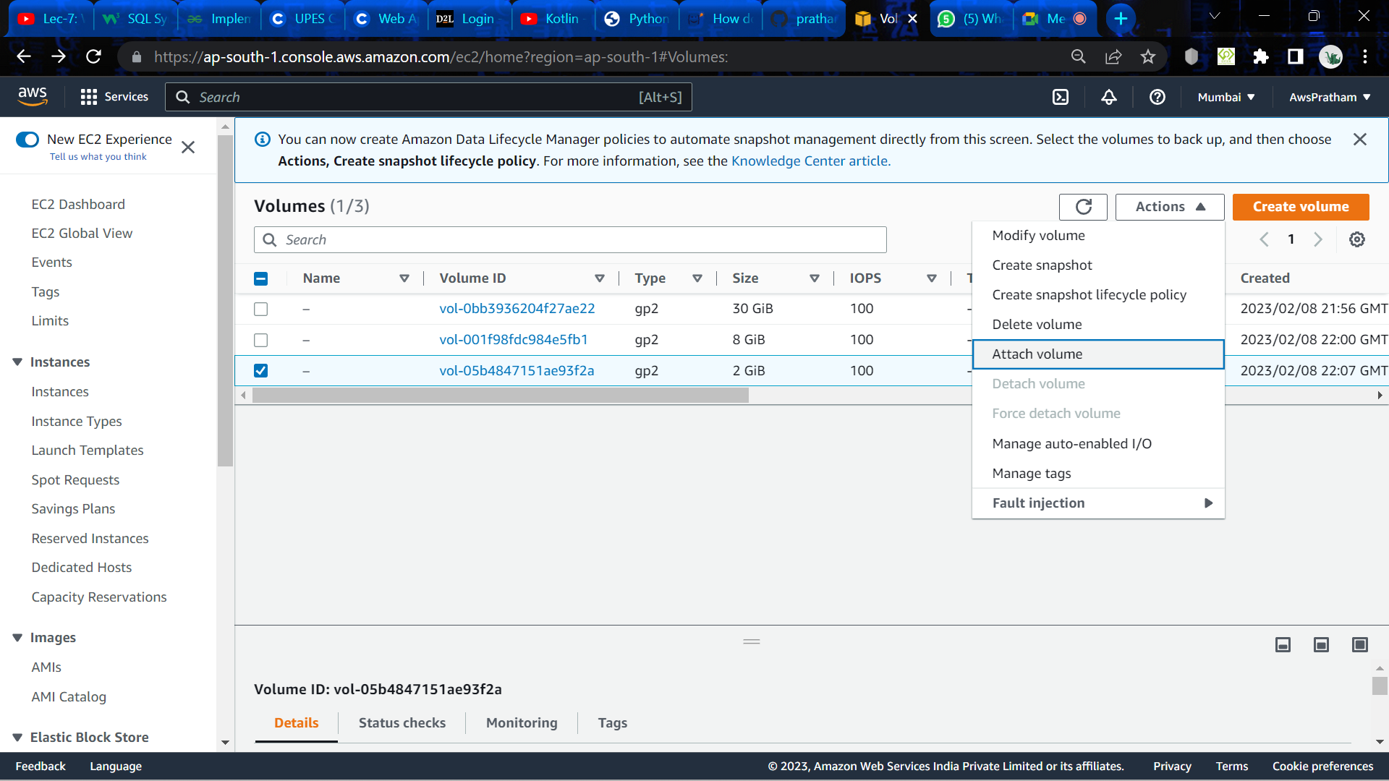

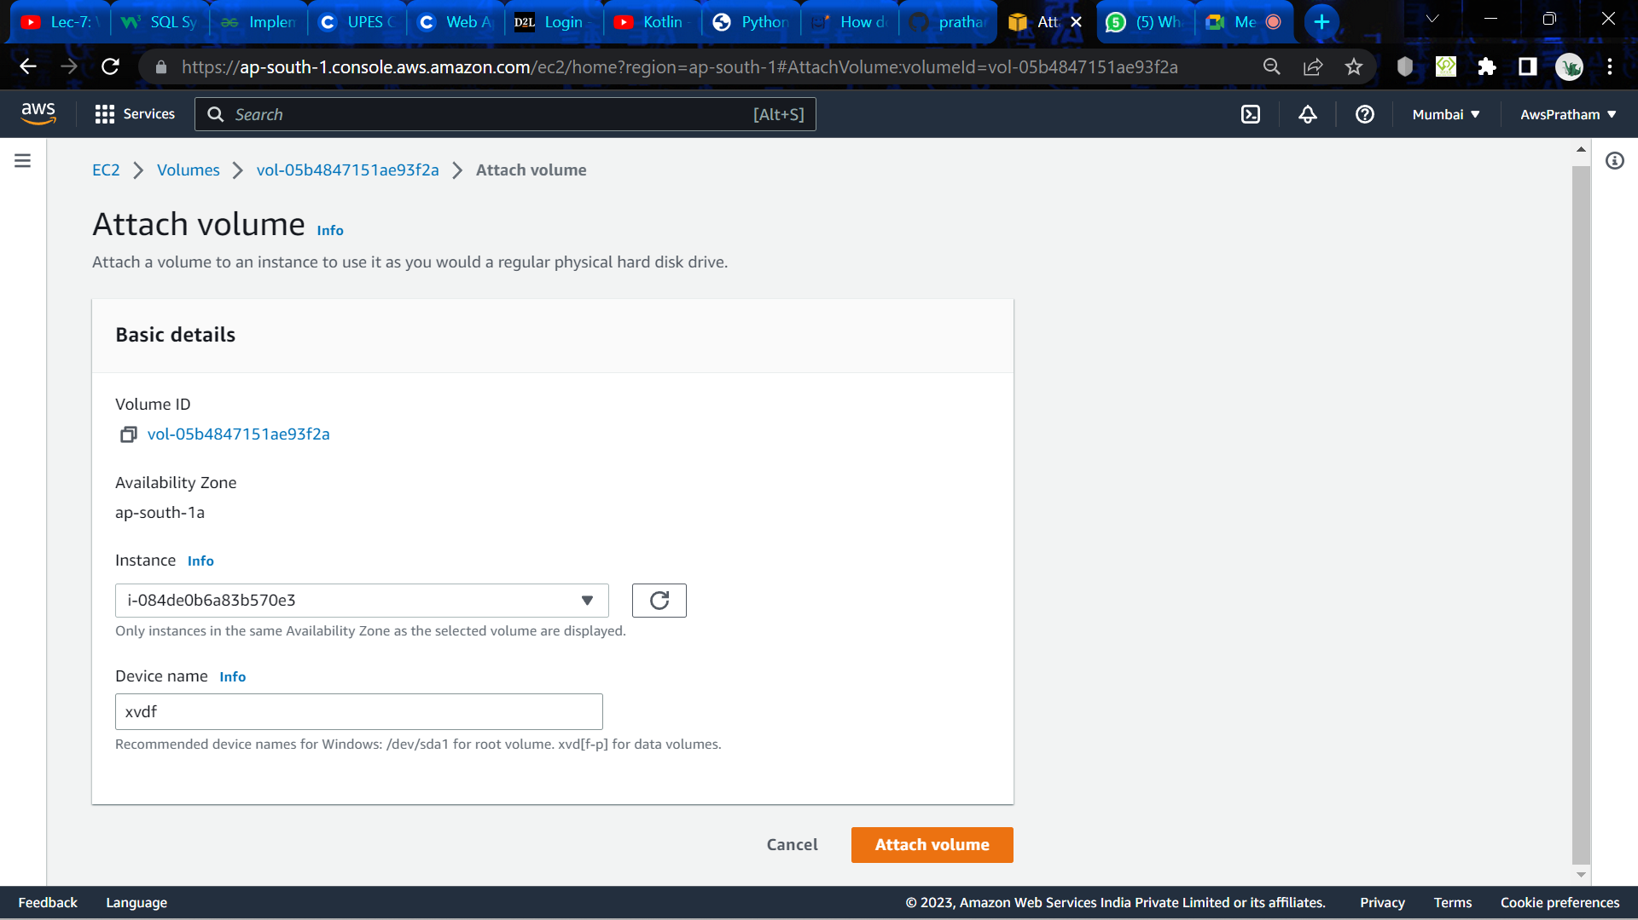

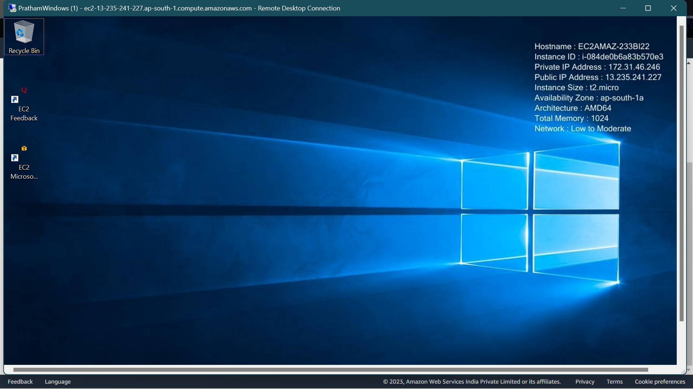

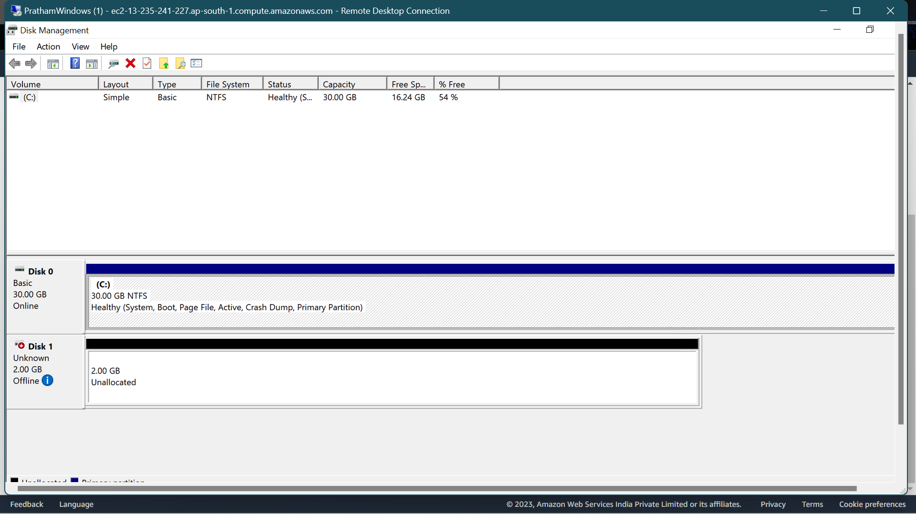

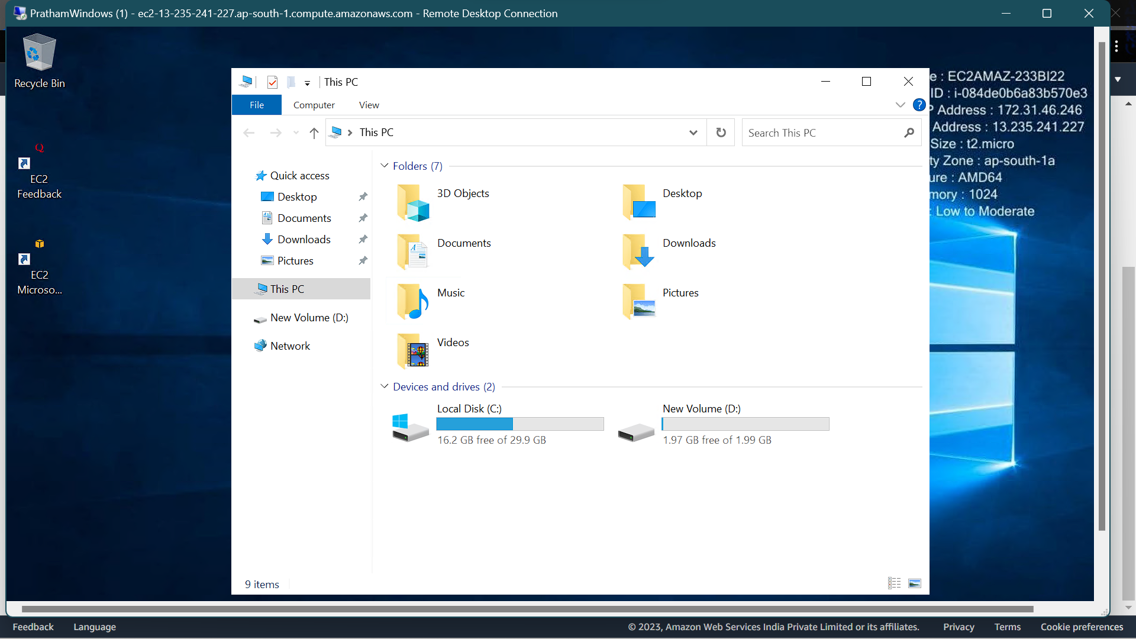

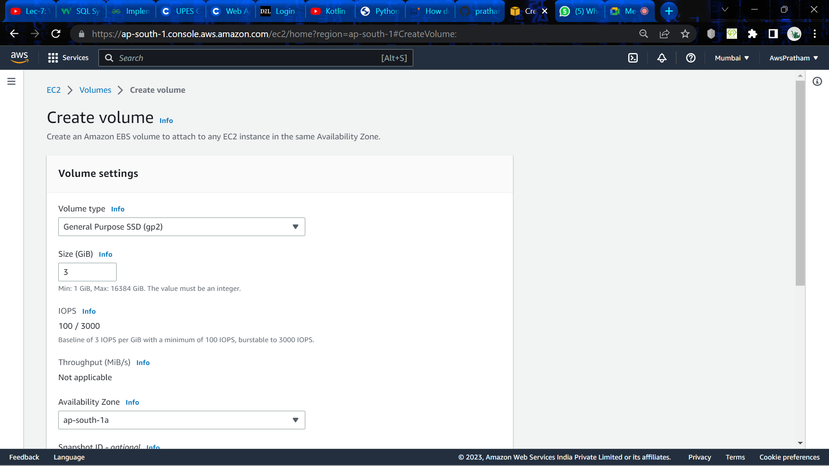

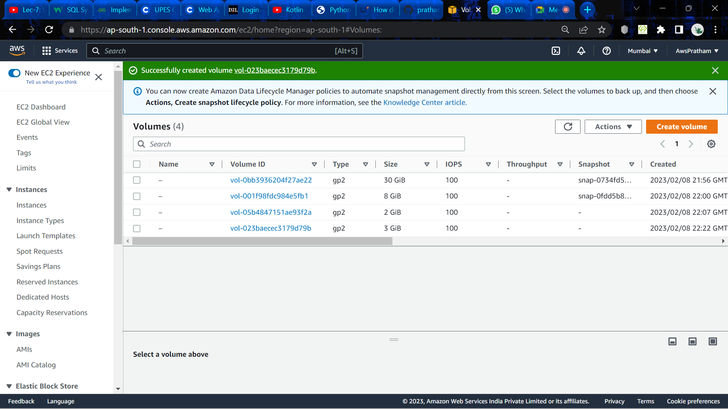

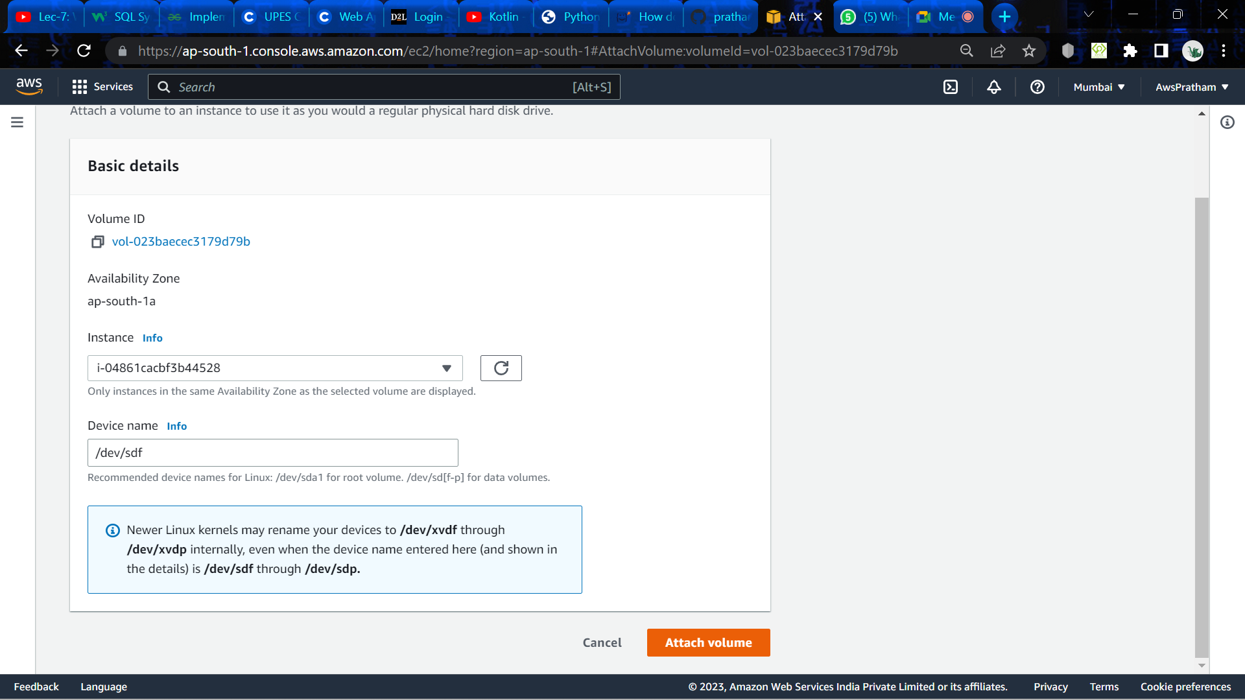

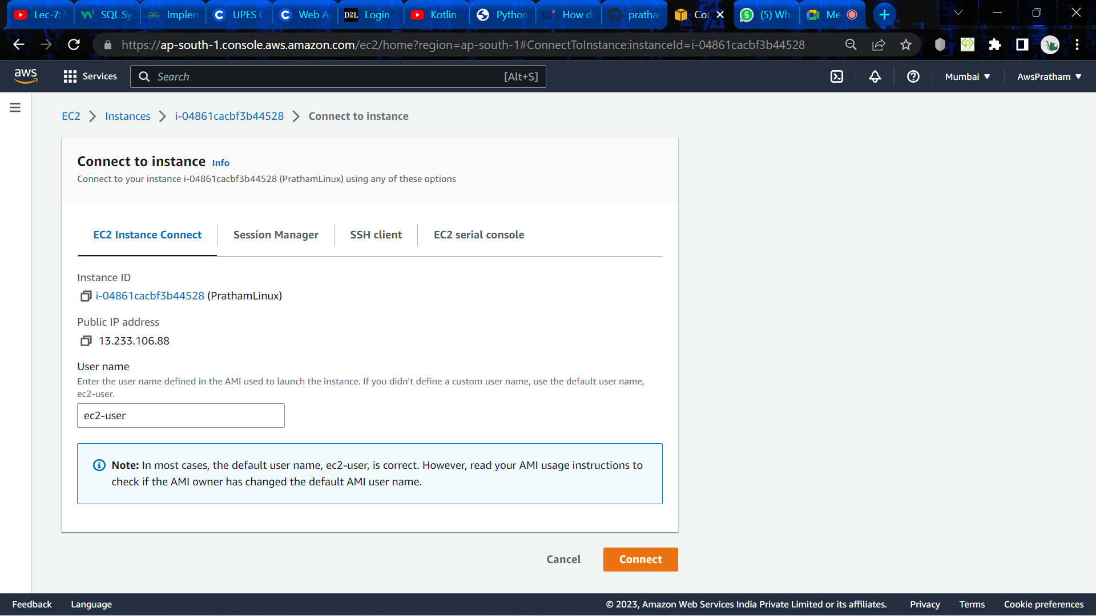

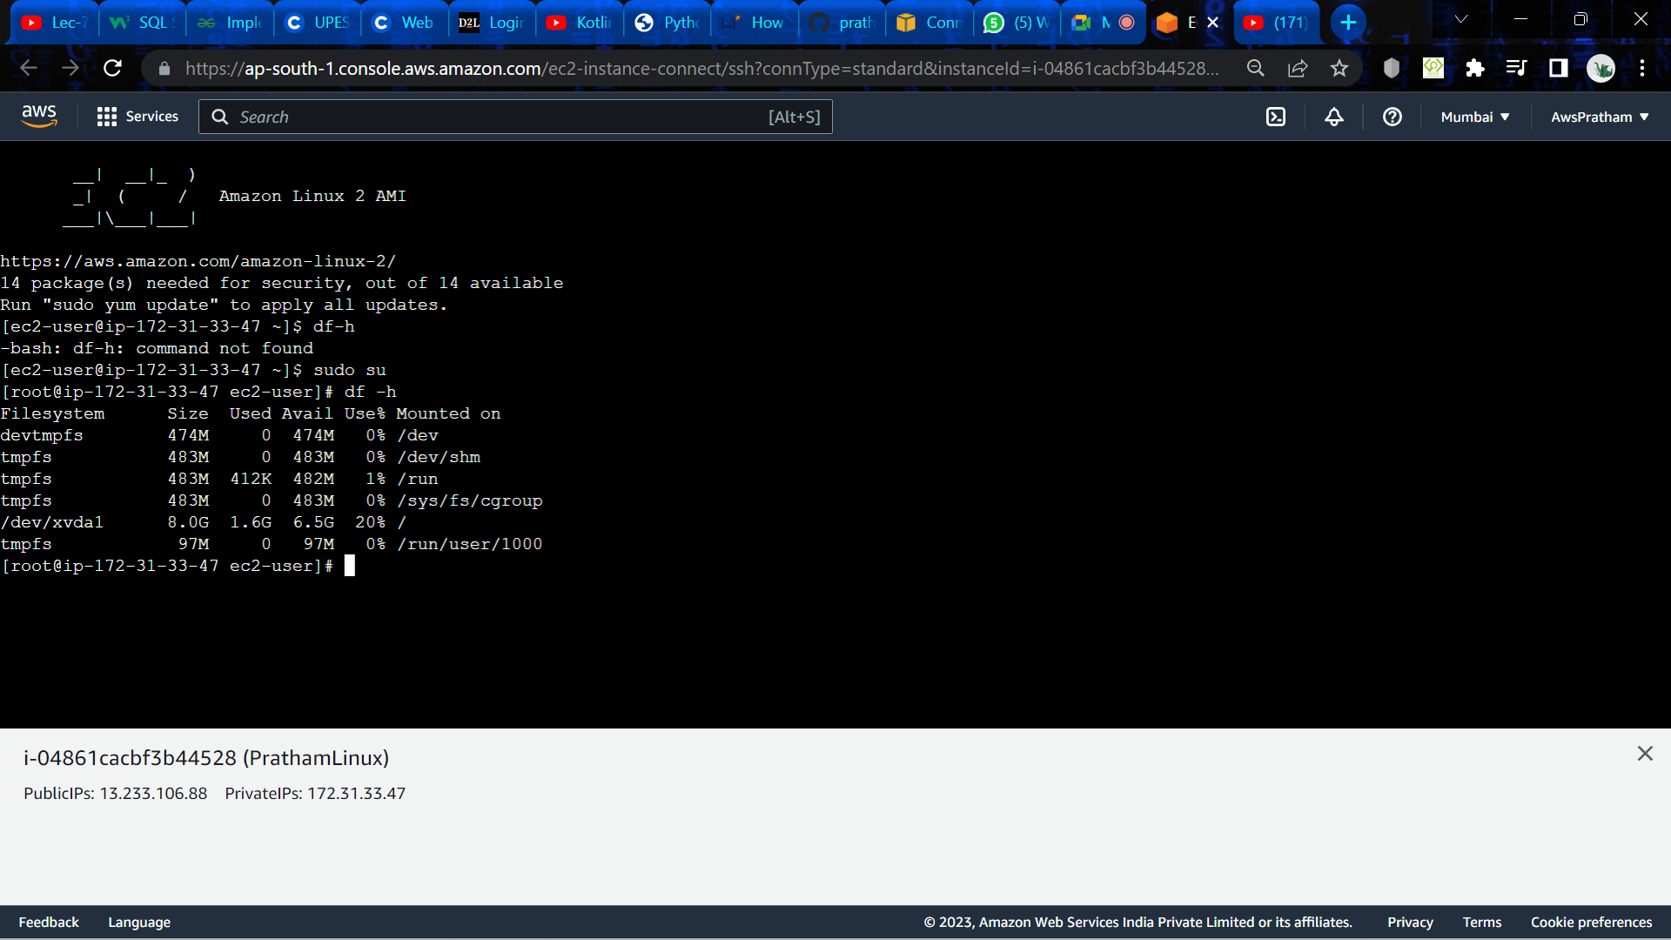

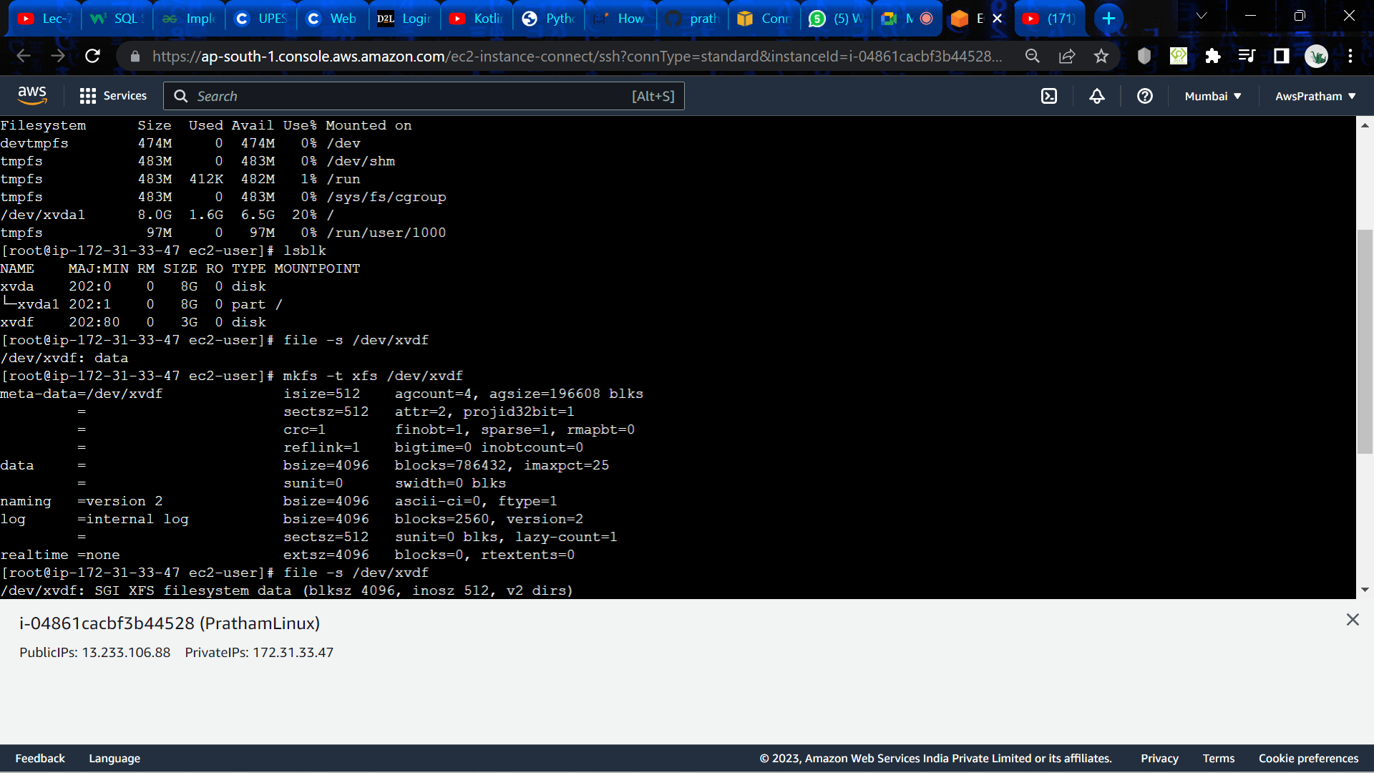

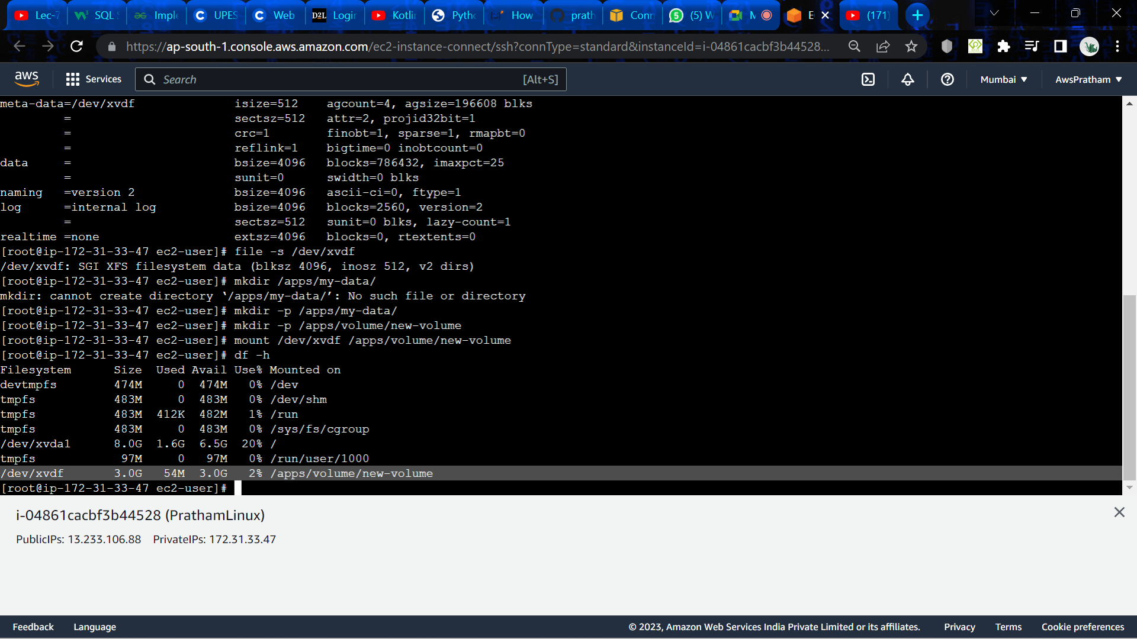

**Experiment- 6**

# Deploy an application using AWS Elastic Beanstalk (PaaS)

# Q:1. List the features and advantages of AWS Elastic Beanstalk?

# Ans:

# AWS Elastic Beanstalk is a fully-managed service that makes it easy to deploy, manage, and scale applications in the cloud. Some of its key features and advantages include:

# Easy Deployment: AWS Elastic Beanstalk simplifies the deployment process by automating infrastructure provisioning and application deployment, making it easy to get started.

# Multiple Language Support: Elastic Beanstalk supports multiple programming languages, including Java, Python, Node.js, Ruby, .NET, and PHP, allowing developers to choose the language that best suits their needs.

# Auto Scaling: Elastic Beanstalk automatically scales your application based on traffic, ensuring that your application can handle any amount of load without downtime.

# Monitoring and Alerting: Elastic Beanstalk provides built-in monitoring and alerting capabilities, so you can keep track of your application's health and performance in real-time.

# Customization: Elastic Beanstalk allows you to customize the environment to meet your specific needs, including setting up custom domains, SSL certificates, and more.

# Integrated with AWS Services: Elastic Beanstalk integrates with other AWS services, such as Amazon RDS, Amazon S3, and Amazon CloudWatch, making it easy to take advantage of these services within your application.

# Cost-Effective: Elastic Beanstalk's pay-as-you-go pricing model makes it cost-effective, as you only pay for the resources you use.

# Security: Elastic Beanstalk provides built-in security features, such as encrypted communication between the load balancer and instances, ensuring that your application is secure.

# Overall, AWS Elastic Beanstalk provides a powerful platform that allows developers to quickly and easily deploy, manage, and scale their applications in the cloud, with minimal infrastructure setup and maintenance required.

# Q:2. Explain in detail Web Server and Worker Environment of Elastic Beanstalk.

# Ans:

# AWS Elastic Beanstalk is a fully-managed service that allows developers to deploy and manage their applications in the cloud. Elastic Beanstalk provides two types of environments for running applications: web server environment and worker environment.

# Web Server Environment:

# A web server environment in Elastic Beanstalk is a type of environment that is used to run web applications, such as websites, web services, or web APIs. In a web server environment, Elastic Beanstalk provisions a load balancer, web servers, and other necessary infrastructure to run your application. The load balancer distributes incoming traffic to the web servers, ensuring that your application can handle any amount of load.

# The web server environment is further divided into two tiers:

# a. Web Tier: This tier is responsible for handling incoming requests from the internet and directing them to the application's backend.

# b. Worker Tier: This tier is responsible for handling background tasks, such as processing jobs, sending emails, or performing other asynchronous tasks.

# Worker Environment:

# A worker environment in Elastic Beanstalk is a type of environment that is used to run background tasks, such as processing jobs or performing other asynchronous tasks. In a worker environment, Elastic Beanstalk provisions a worker server, which runs the worker application and performs the required background tasks.

# The worker environment is designed to work in conjunction with a web server environment. The web server environment provides the necessary frontend and API endpoints for the application, while the worker environment handles the background processing of tasks.

# Overall, Elastic Beanstalk's web server and worker environments provide a flexible and scalable platform for running web and worker applications in the cloud. By automatically provisioning the necessary infrastructure and managing scaling and availability, Elastic Beanstalk allows developers to focus on writing and deploying their code, without having to worry about the underlying infrastructure.

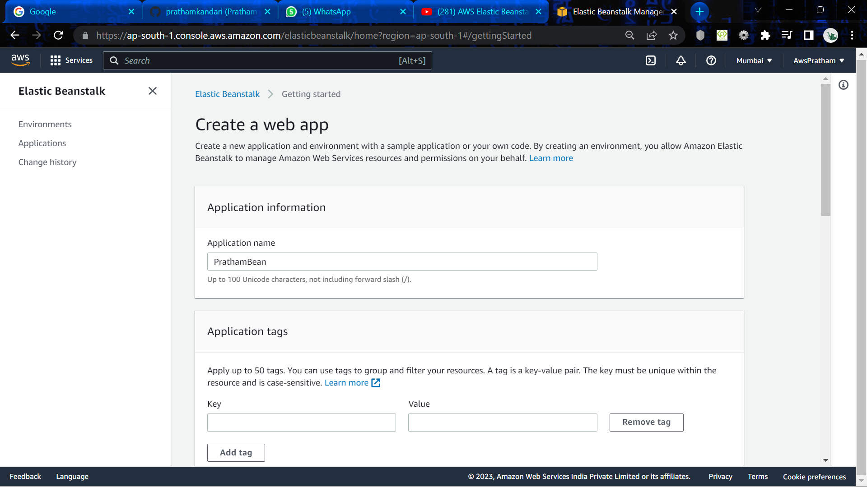

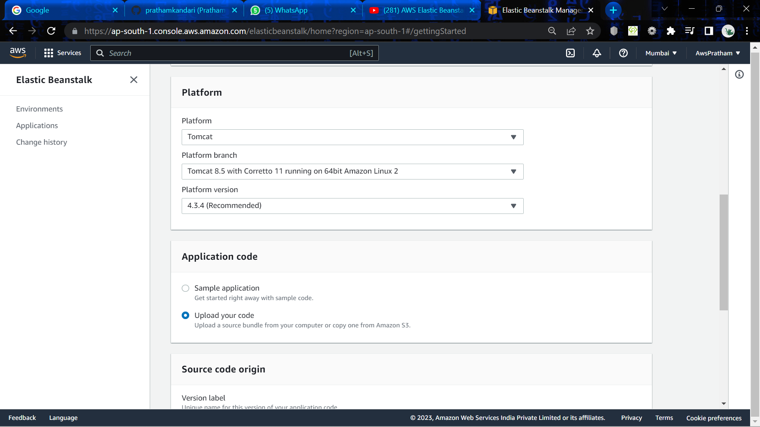

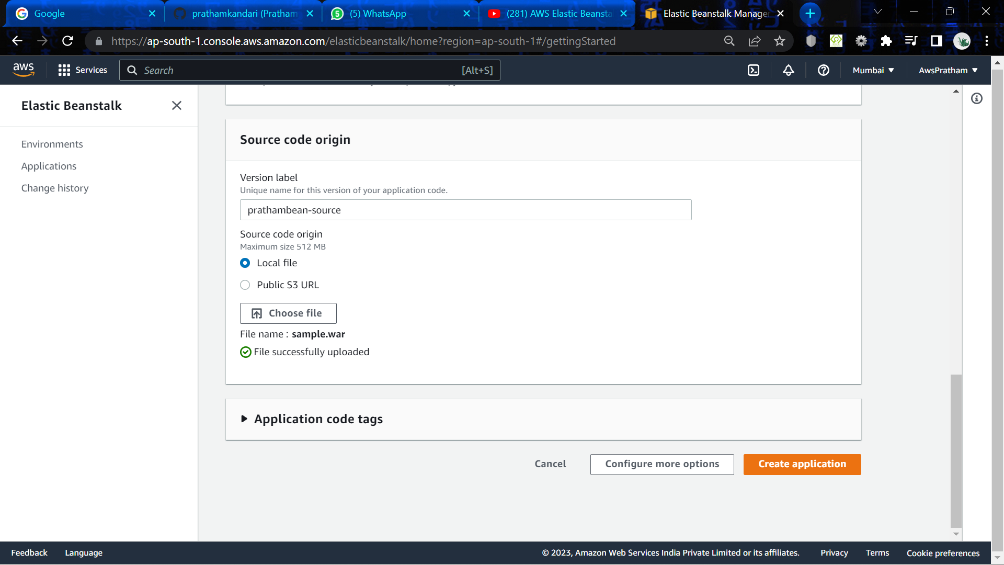

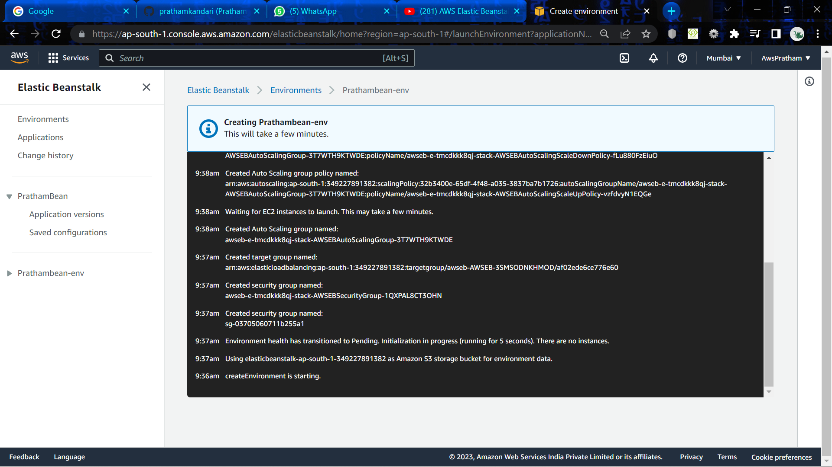

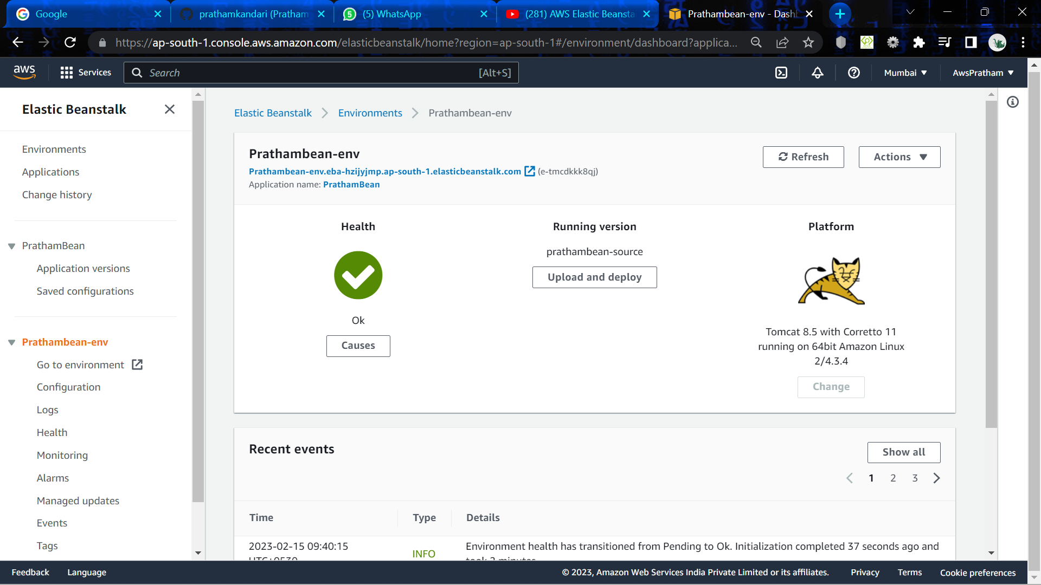

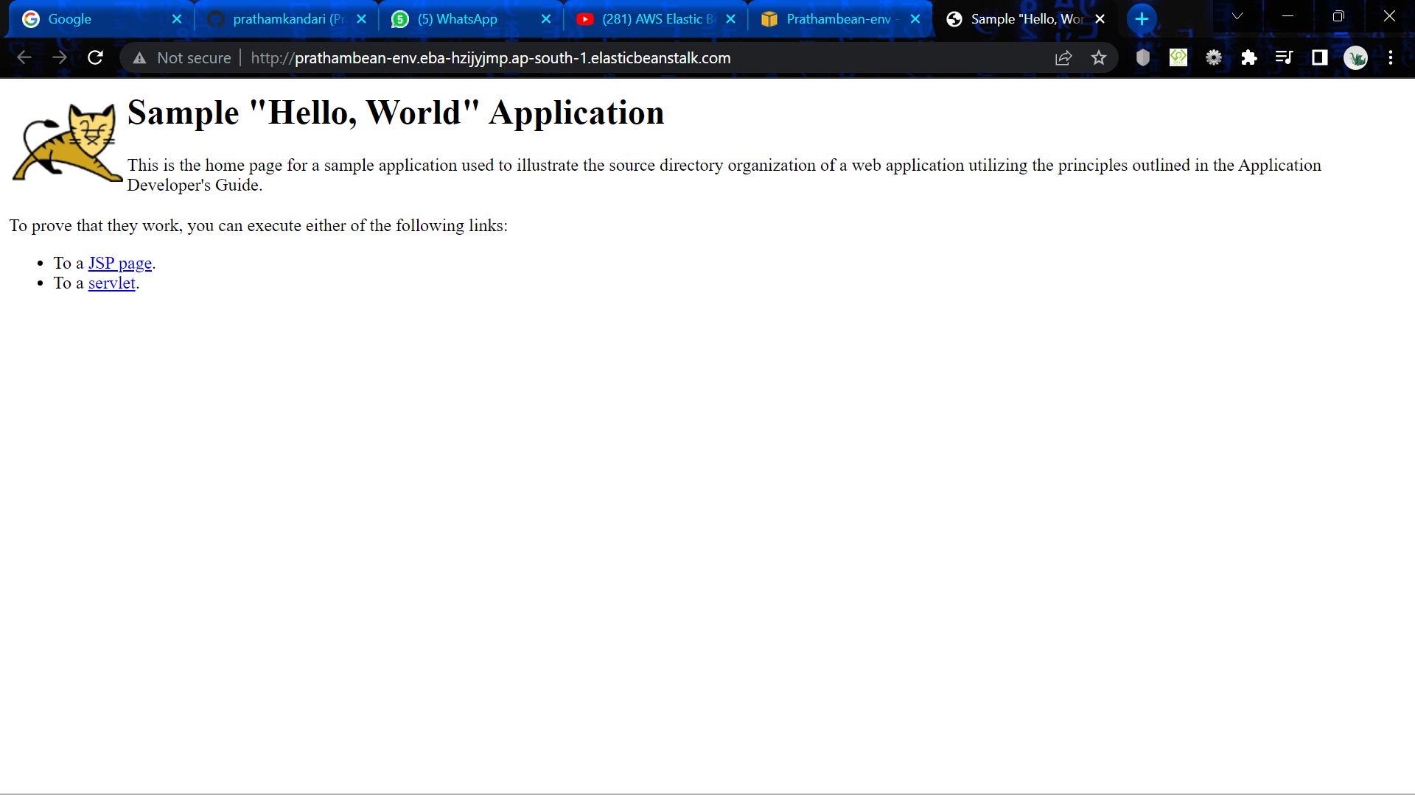

**Experiment- 7**

Q:1. Explain the features of IAM in detail?

Ans:

IAM, or Identity and Access Management, is a system that allows you to manage access to resources within your organization. It provides a centralized and secure way to control who can access what resources and what actions they can perform on those resources. Here are some of the key features of IAM:

1. User Management: IAM allows you to create and manage users within your organization. You can define their roles and permissions, and control their access to different resources. You can also create groups of users with similar roles and permissions for easier management.
2. Role-Based Access Control: IAM uses a role-based access control model, which means that users are assigned roles that define what actions they can perform on resources. This makes it easy to manage access to resources for large organizations with many users and resources.
3. Multi-Factor Authentication: IAM supports multi-factor authentication, which adds an additional layer of security to the login process. This requires users to provide two or more pieces of evidence to verify their identity, such as a password and a code sent to their phone.
4. Resource Access Policies: IAM allows you to create resource access policies, which define who can access specific resources and what actions they can perform on those resources. This provides granular control over access to resources and helps to prevent unauthorized access.
5. Audit Trails: IAM provides detailed audit trails of user activity, which allows you to monitor who is accessing resources and what actions they are performing. This helps to identify any potential security breaches or policy violations.
6. Integration with Other Services: IAM integrates with other AWS services, such as Amazon S3 and EC2, allowing you to manage access to resources across your entire organization.

Overall, IAM provides a powerful set of tools for managing access to resources within your organization, helping to ensure that your data and systems are secure and that your organization is compliant with any relevant regulations.

Q:2. What is the difference between Root account, User account, Roles and Policies?

Ans:

Root accounts, user accounts, roles, and policies are all part of AWS Identity and Access Management (IAM) and play different roles in managing access to AWS resources. Here are the key differences between these concepts:

1. Root Account: The root account is the initial account created when an AWS account is set up. The root account has complete control over all resources in the account and should be used sparingly, as any actions taken by the root account are irreversible and cannot be audited. It is recommended that the root account be used only for initial setup and emergency situations.
2. User Accounts: User accounts are created within an AWS account and are used to grant access to specific resources. User accounts can be granted permissions based on their individual needs and can be managed centrally through IAM. User accounts are created with specific access keys and secret access keys, which are used to authenticate API calls and other programmatic access.
3. Roles: Roles are similar to user accounts but are meant for use by AWS services rather than individual users. Roles are used to grant access to specific AWS resources, and the permissions associated with a role can be assumed by AWS services on behalf of a user or resource. Roles are used to delegate permissions to resources that need to access AWS resources, such as EC2 instances or Lambda functions.
4. Policies: Policies are used to define permissions for users, groups, and roles. Policies are made up of statements that define the resources and actions that are allowed or denied for specific users or groups. Policies can be attached to users, groups, or roles, and multiple policies can be attached to a single entity.

In summary, root accounts have complete control over all resources in an AWS account and should be used sparingly. User accounts are used to grant access to specific resources and can be managed centrally through IAM. Roles are used to delegate permissions to resources that need to access AWS resources, and policies are used to define permissions for users, groups, and roles.

Q:3. What is the difference between the Management Console and Programmatic access?

Ans:

The AWS Management Console and programmatic access are two different ways to interact with AWS resources and services. Here are the key differences between them:

1. Management Console: The AWS Management Console is a web-based graphical user interface that allows you to manage AWS resources and services using a web browser. The Management Console provides an easy-to-use interface for managing resources, and you can perform tasks such as launching instances, configuring security groups, and managing storage directly from the console. The Management Console requires you to log in with your AWS account credentials, and all actions are performed through the console's web interface.
2. Programmatic Access: Programmatic access refers to the ability to interact with AWS resources and services through APIs, command-line interfaces (CLIs), or SDKs (software development kits). Programmatic access allows you to automate tasks and integrate AWS services into your applications and workflows. Programmatic access requires you to authenticate using access keys and secret access keys, which are used to make API requests or CLI commands. With programmatic access, you can perform tasks such as launching instances, creating buckets in Amazon S3, or managing databases through scripts or code.

Q:4. What is MFA in AWS?

Ans:

MFA in AWS stands for Multi-Factor Authentication, which is a security feature that adds an extra layer of protection to AWS accounts. MFA requires users to provide two or more pieces of evidence to verify their identity before they can access their AWS account or perform any sensitive operations. The two factors typically include something the user knows (such as a password or PIN) and something the user has (such as a physical device or token).

In AWS, MFA can be enabled for the root account, IAM users, and federated users. When MFA is enabled for a user, the user must provide a valid MFA code in addition to their password when they log in to their AWS account or perform any sensitive operations. The MFA code is typically generated by a hardware token, a software token on a mobile device, or received through a text message.

Enabling MFA is an important security best practice for AWS accounts, as it helps to protect against unauthorized access and security breaches. It is particularly important for high-risk operations, such as accessing sensitive data, making changes to security settings, or performing administrative tasks. AWS provides a range of options for implementing MFA, including hardware tokens, software tokens, and SMS-based MFA.

**Identity Access Management in AWS**

1. Create user, role and policies and access it through Management Console and CLI
2. Show how to use MFA in IAM?

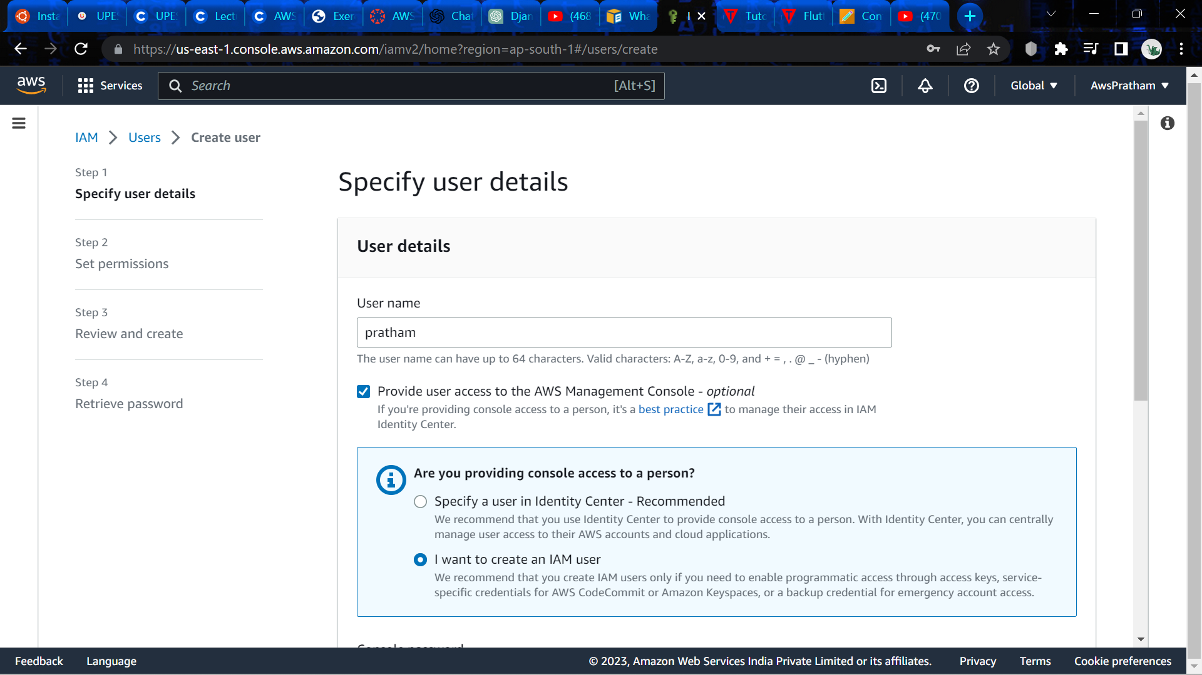

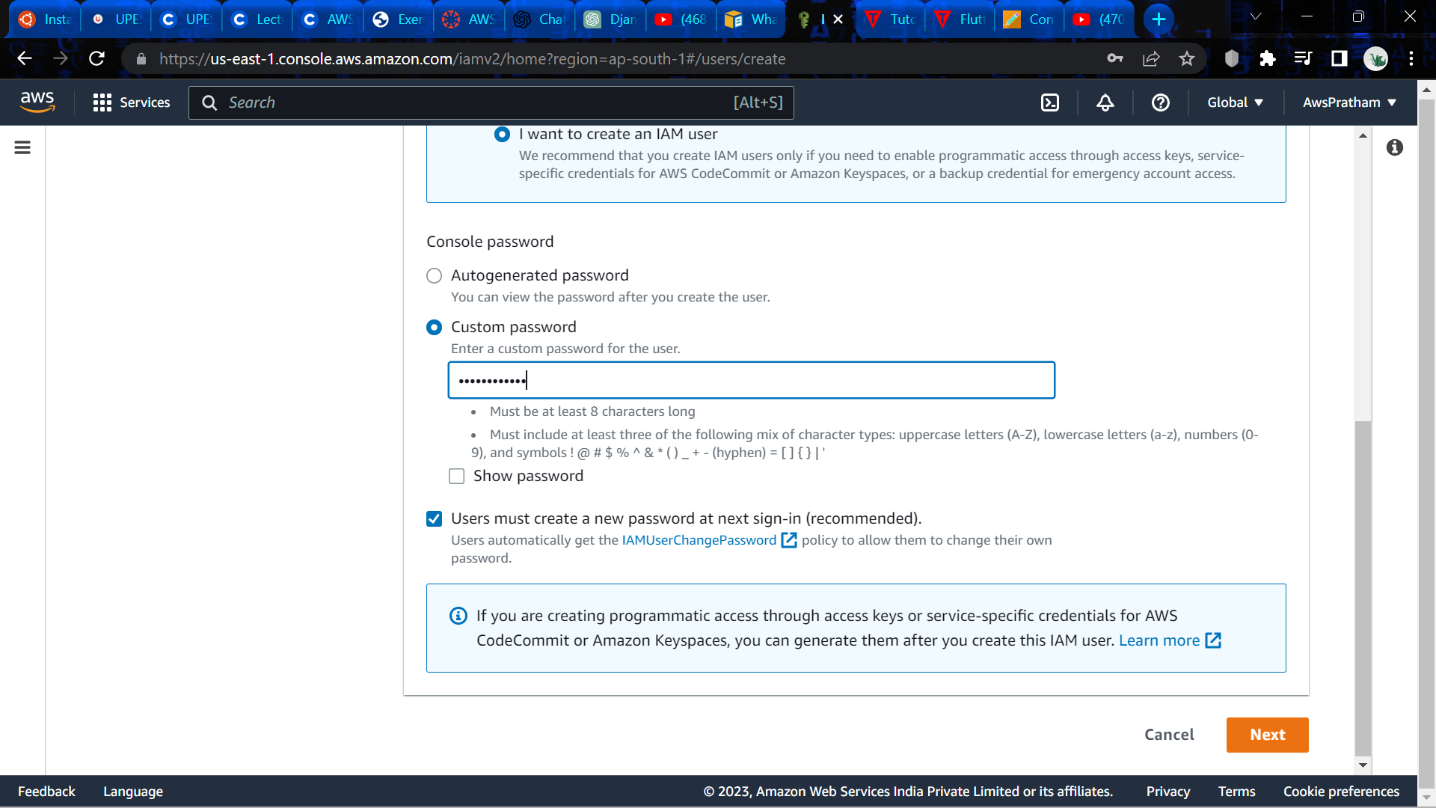

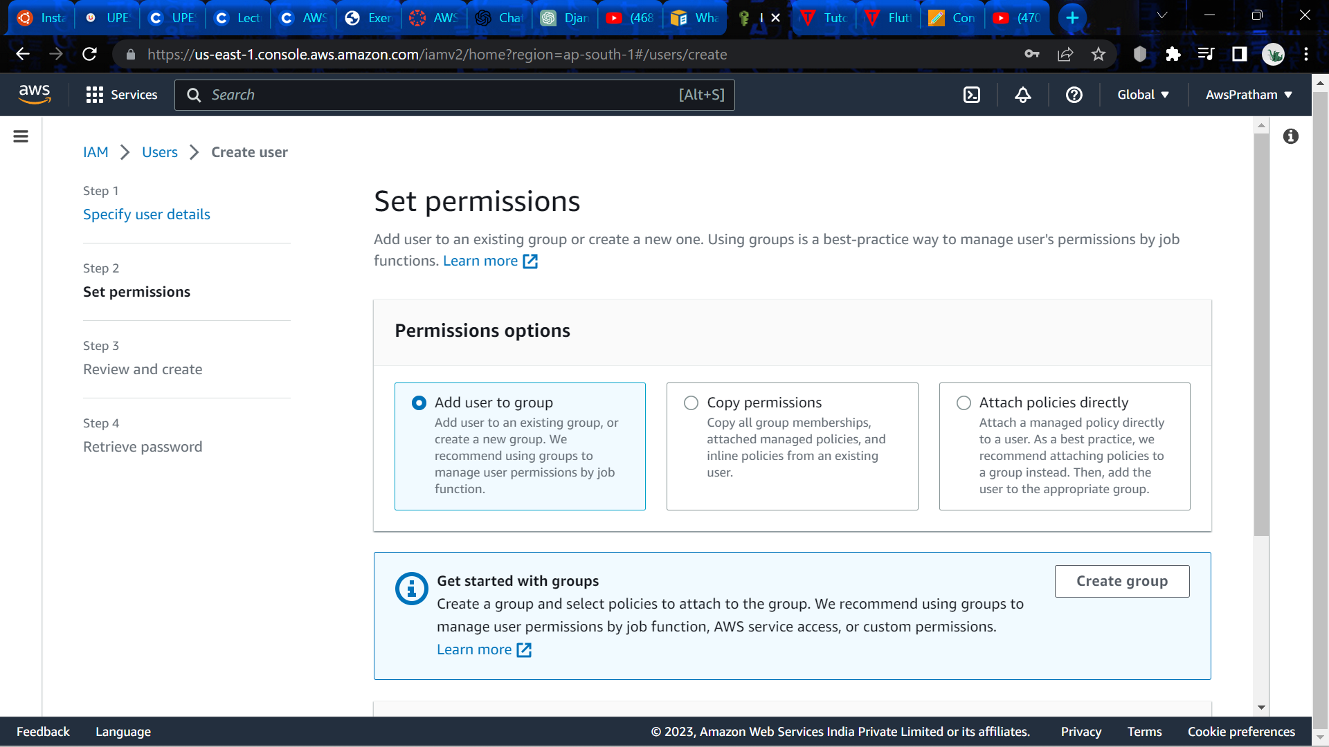

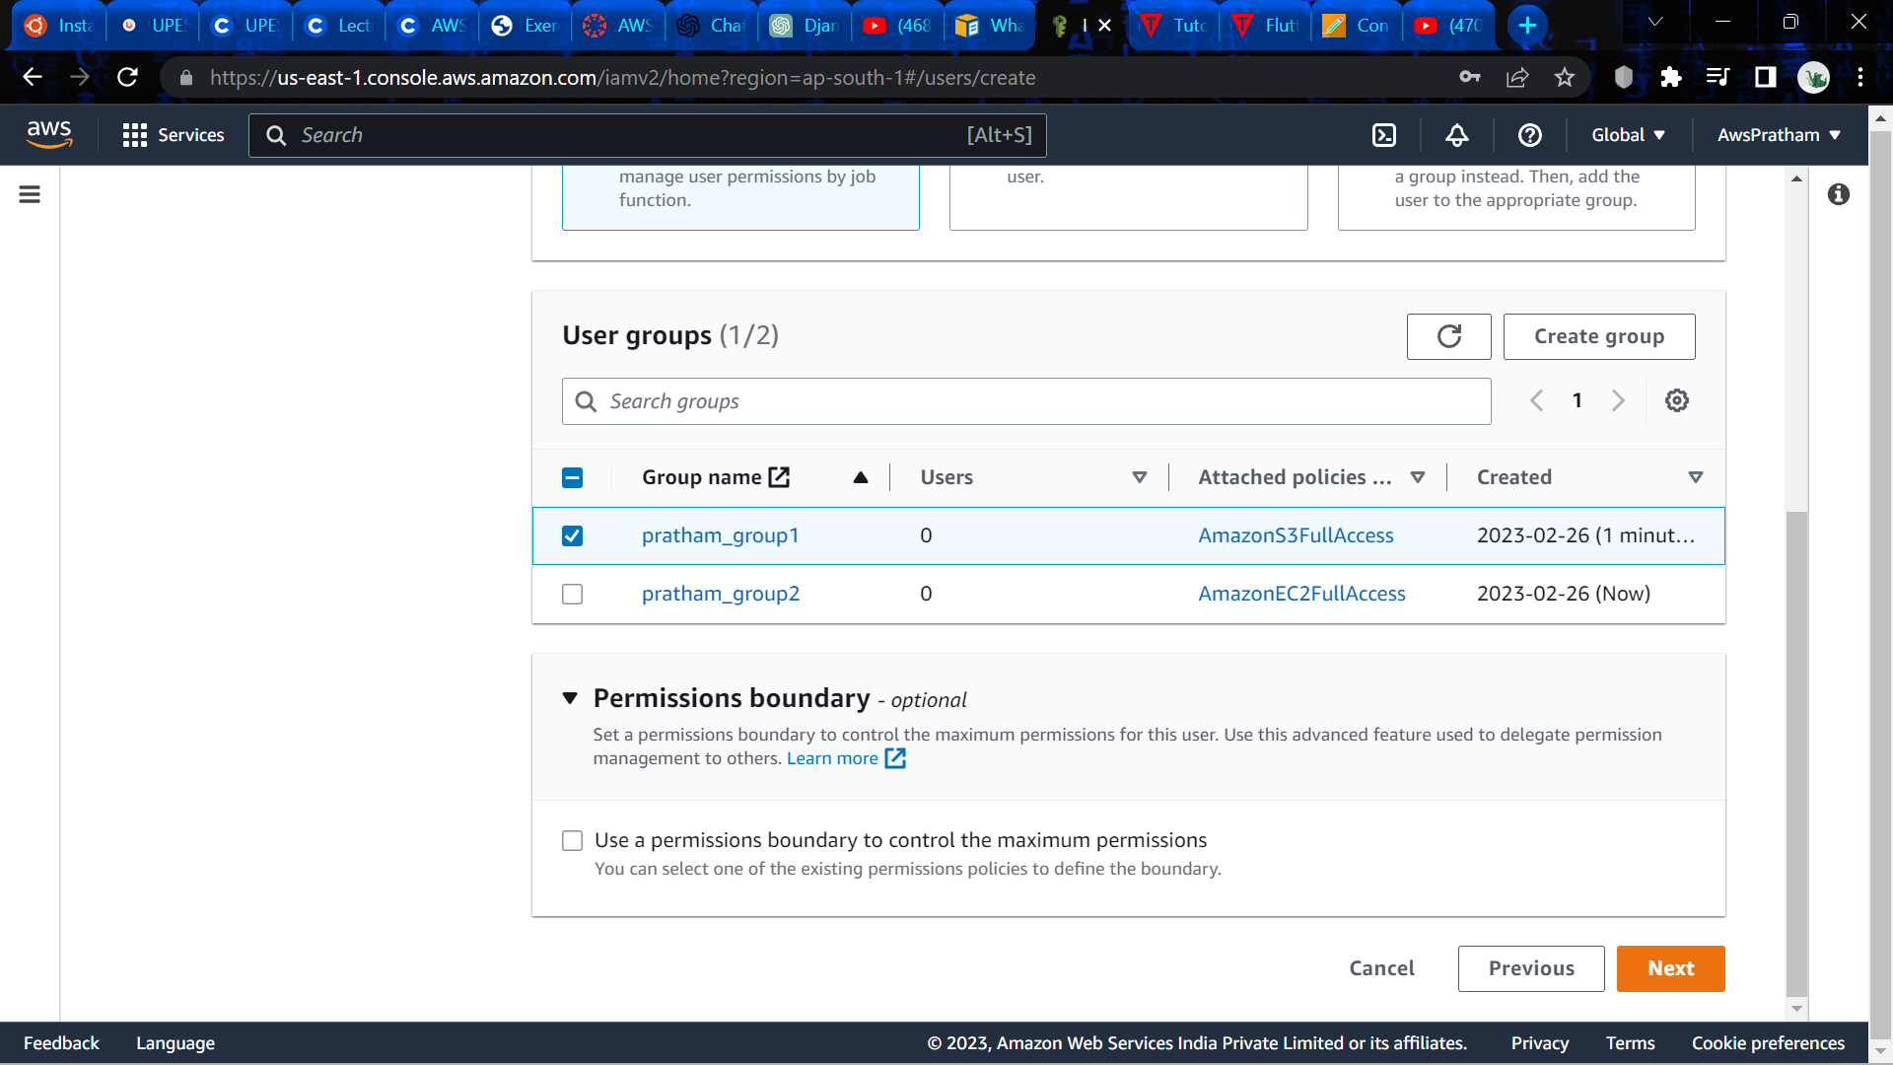

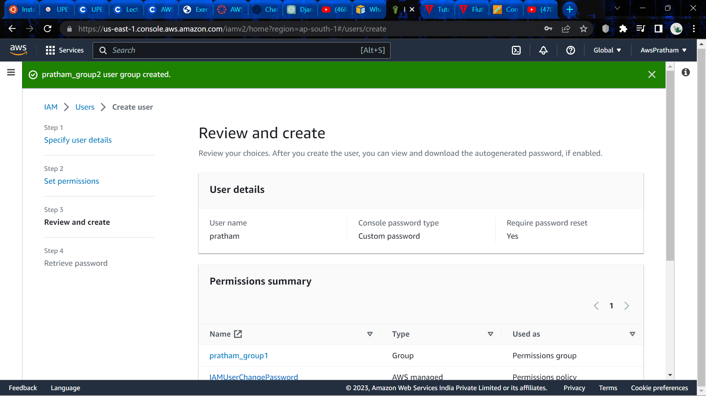

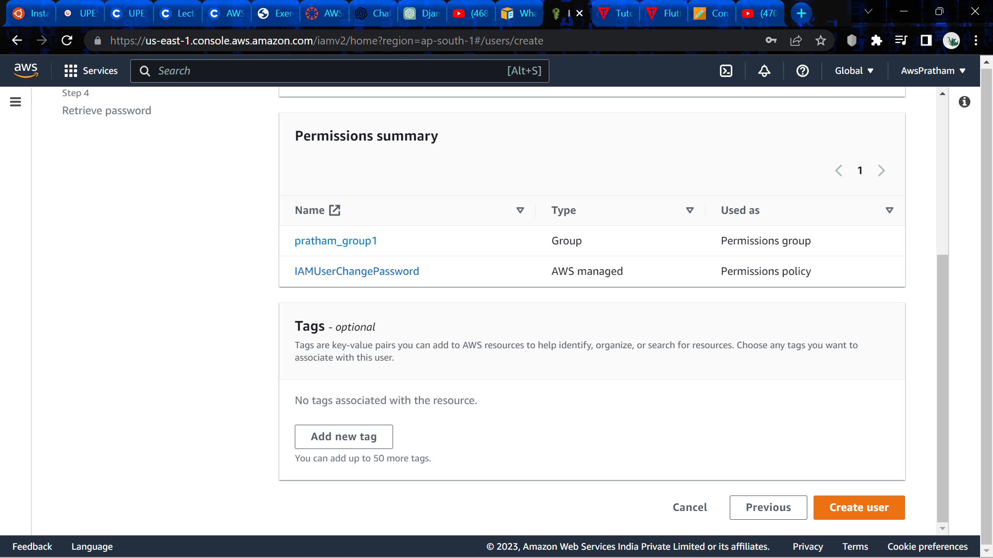

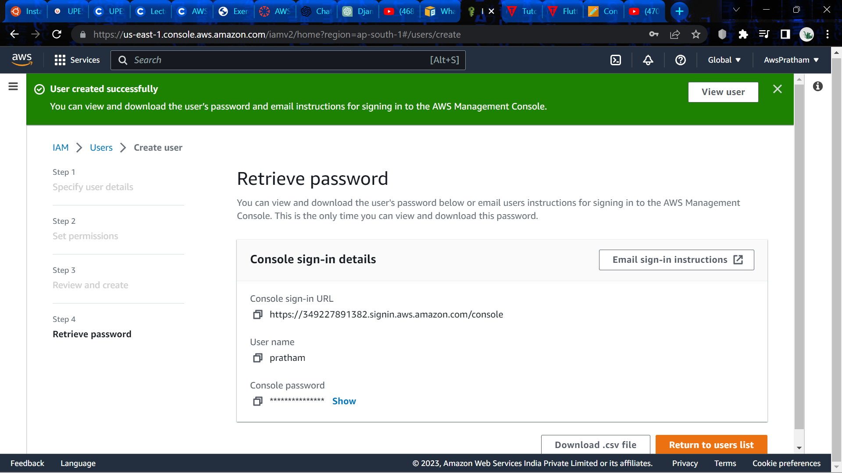

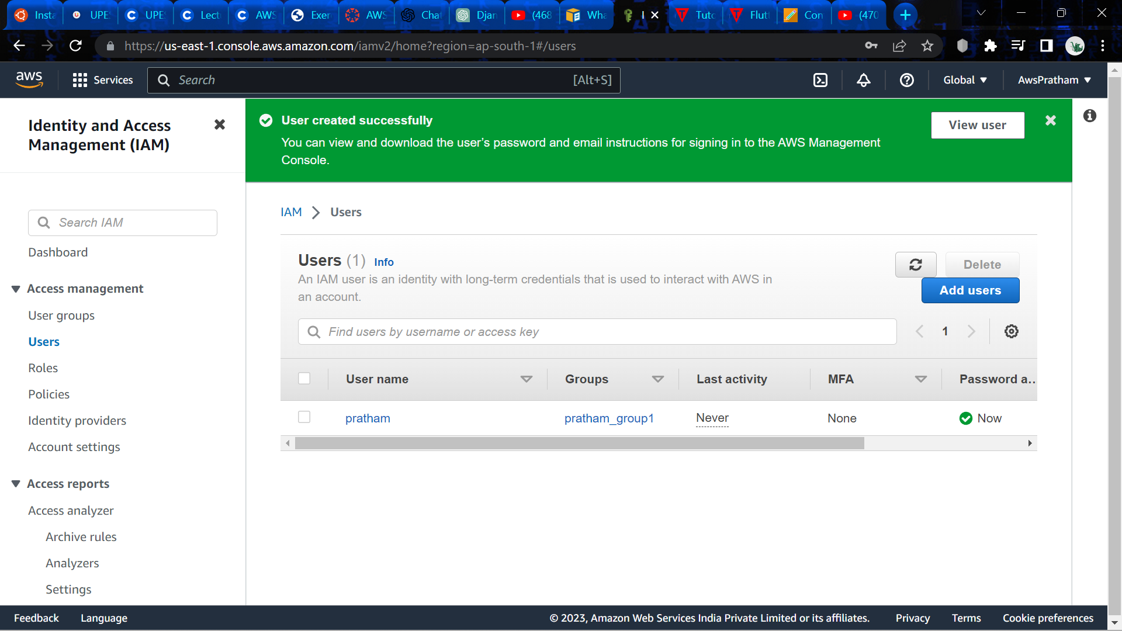

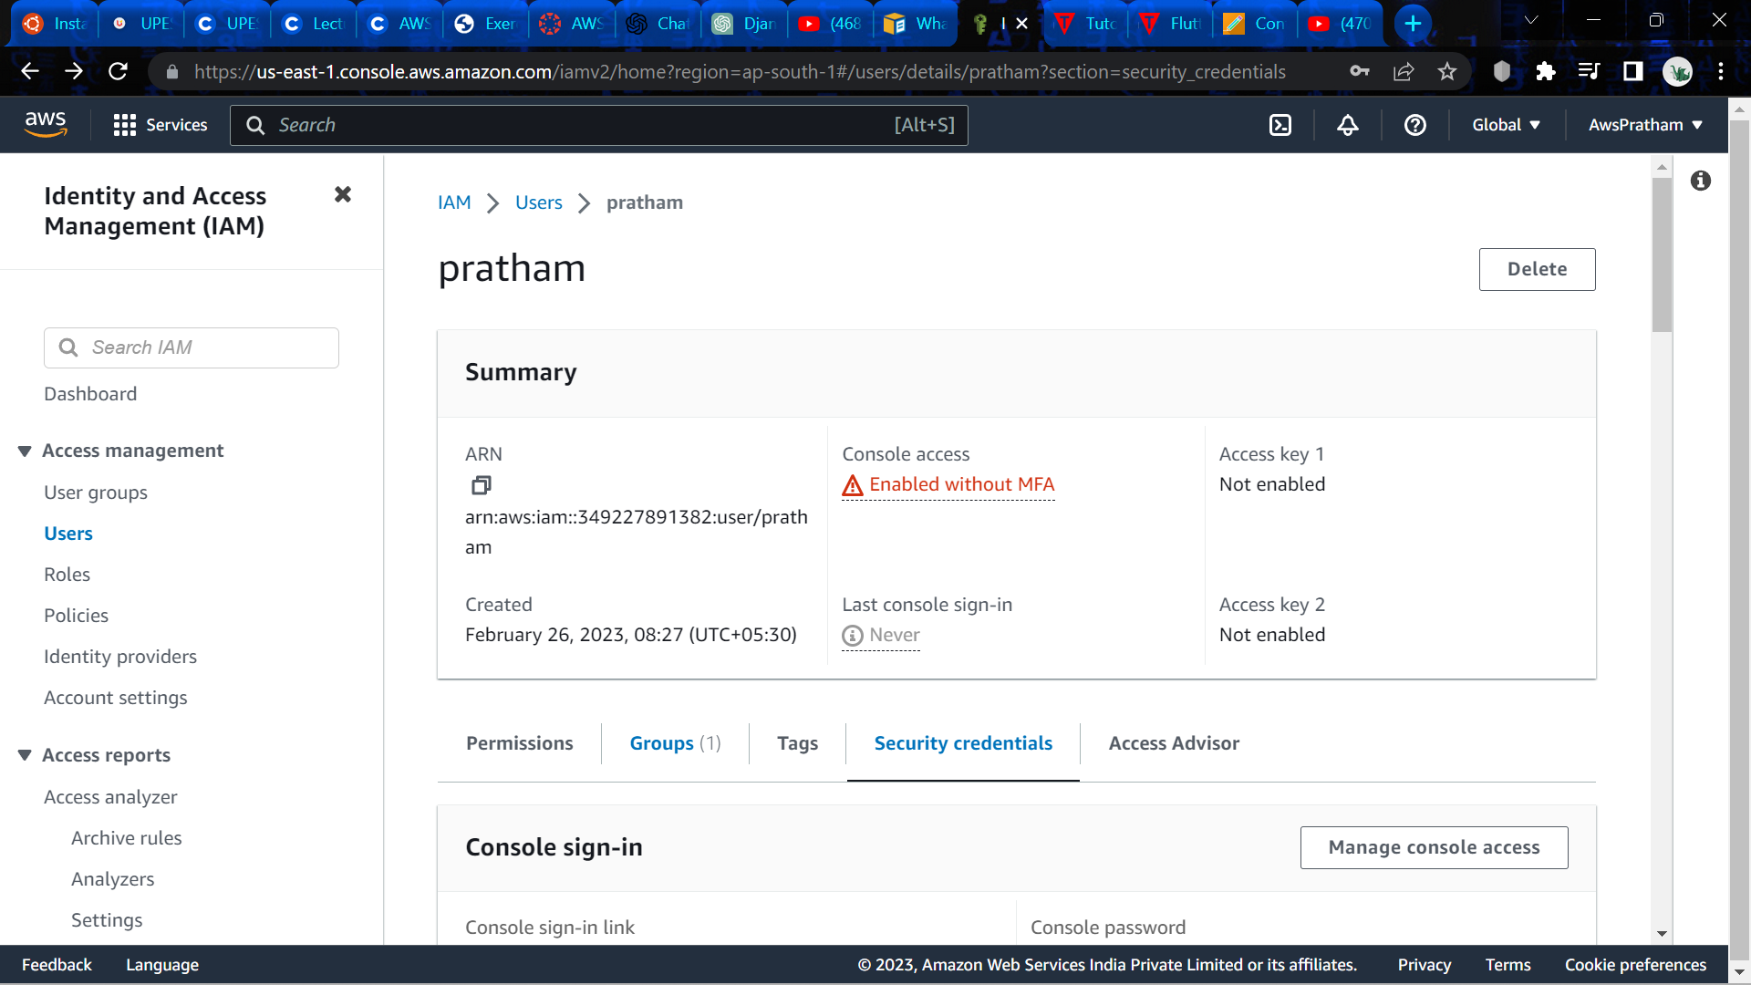

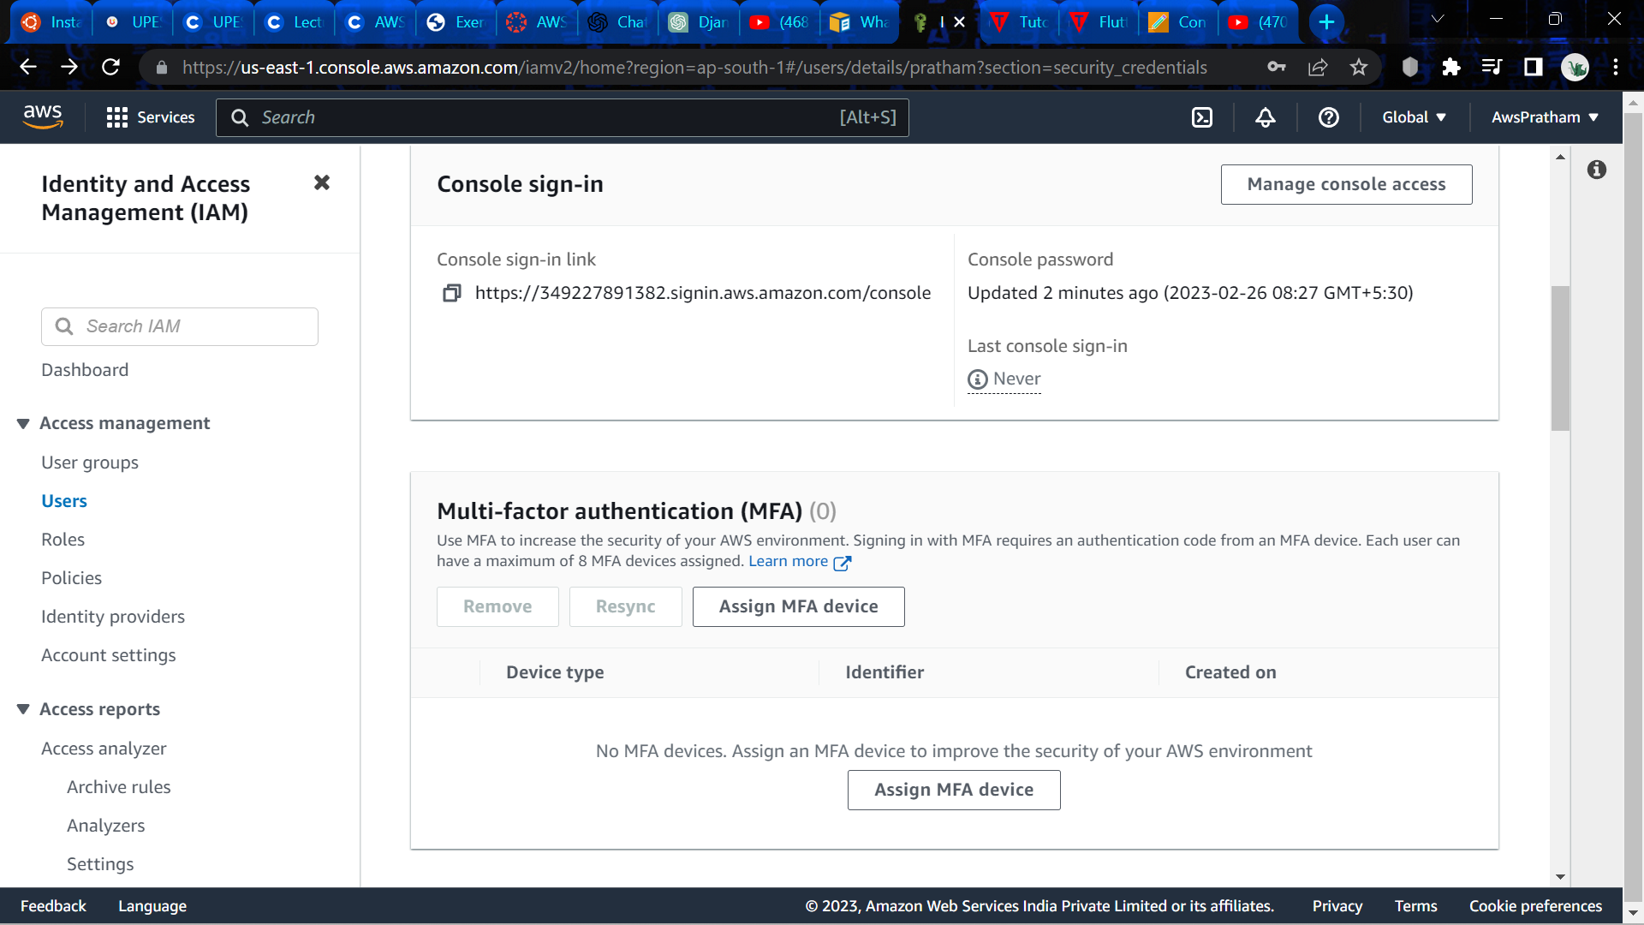

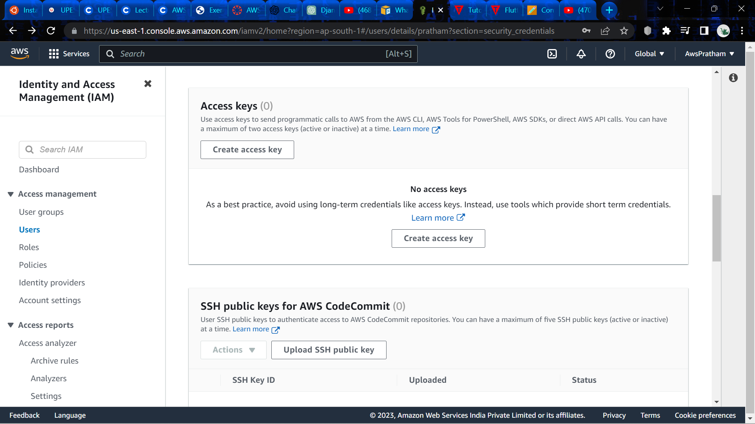

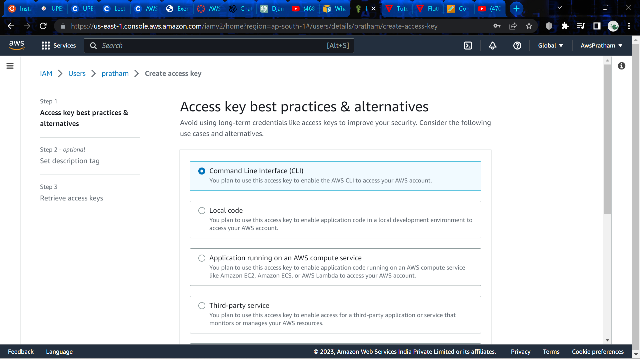

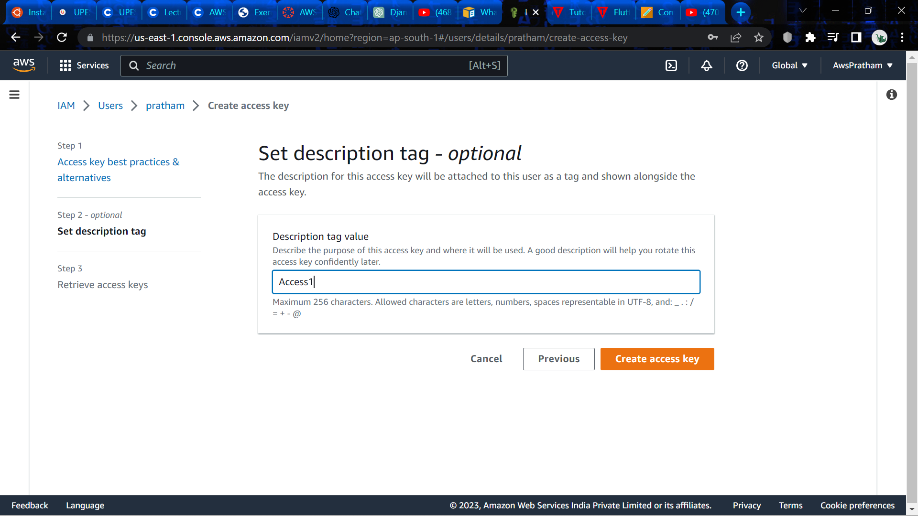

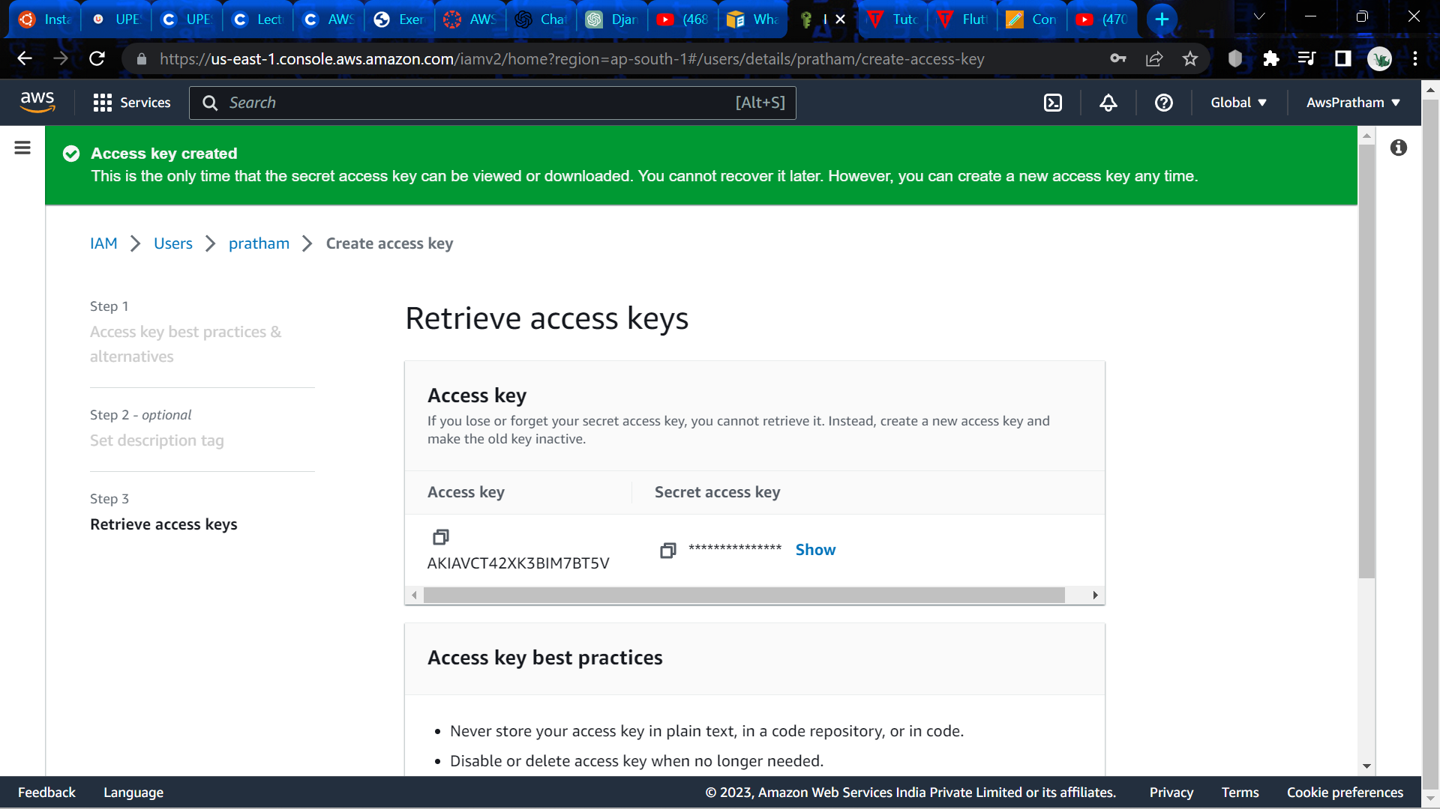

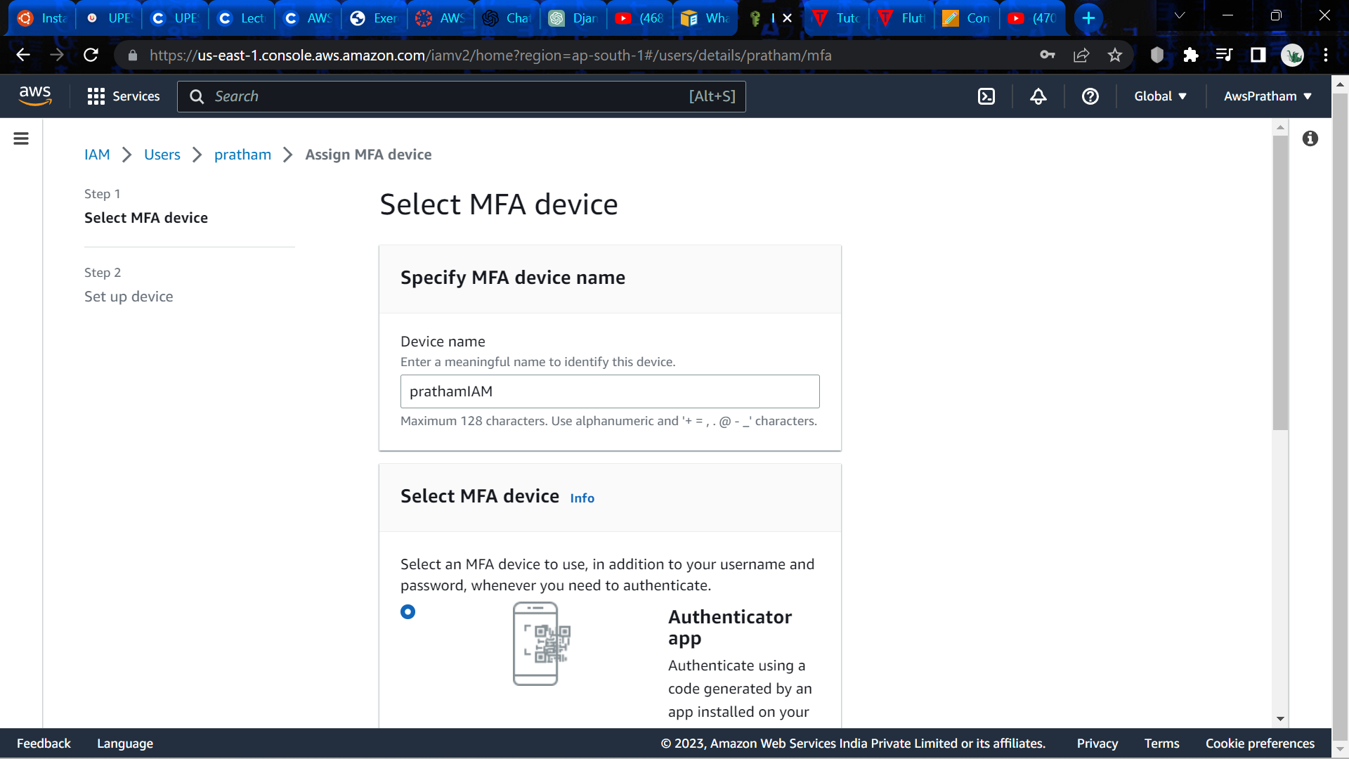

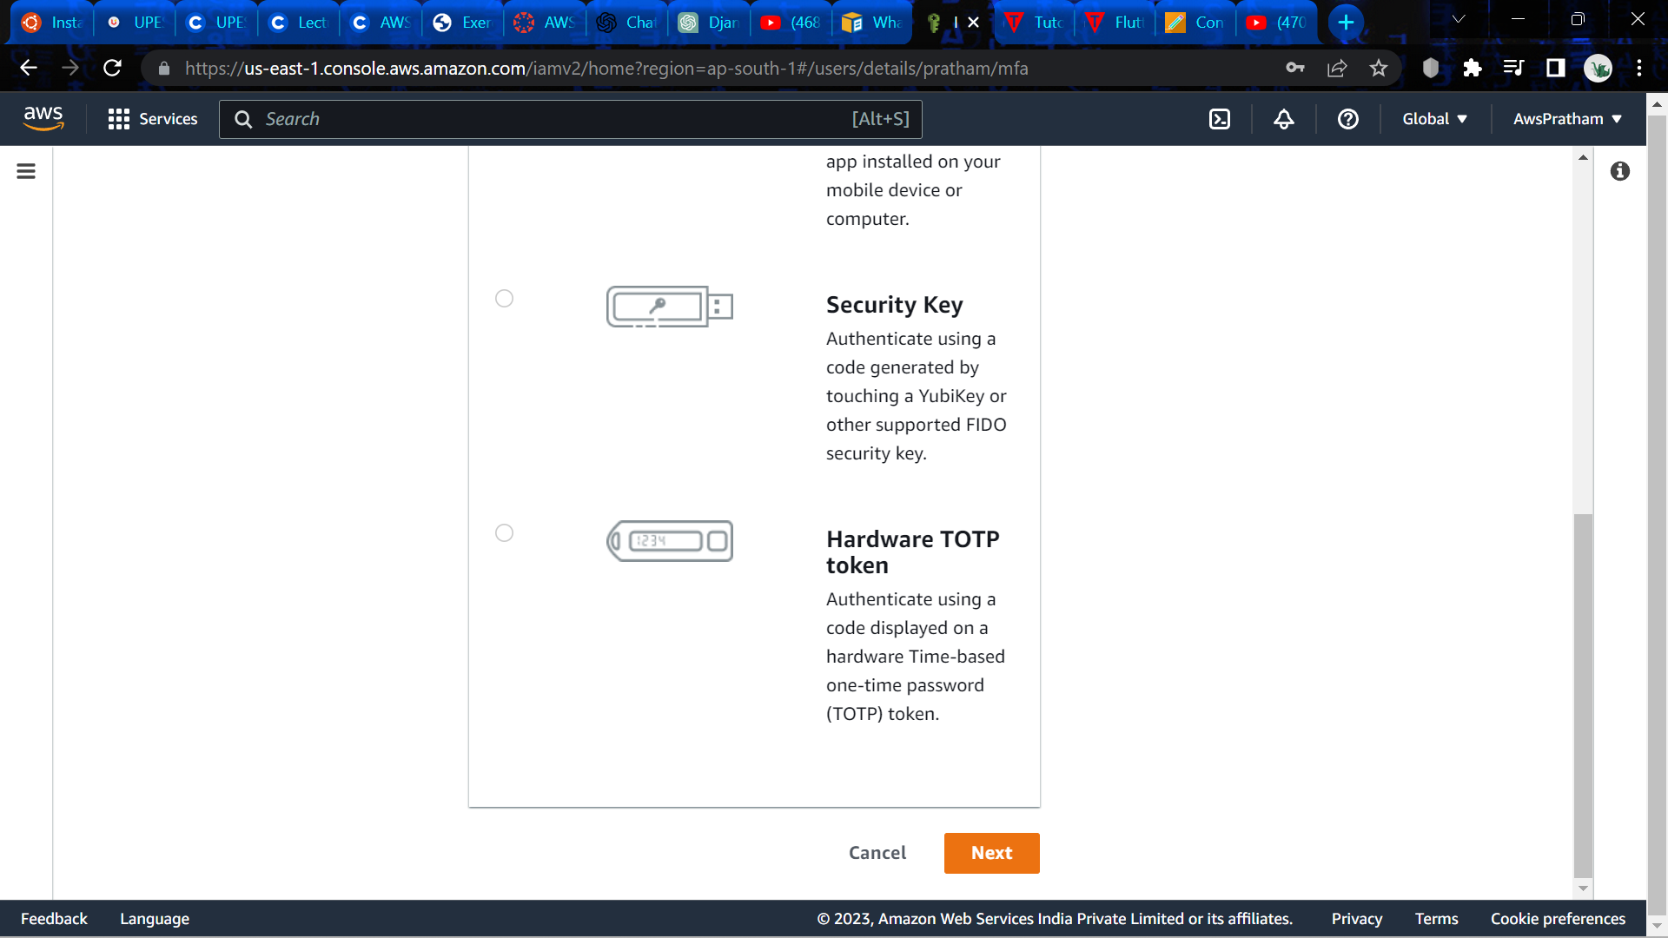

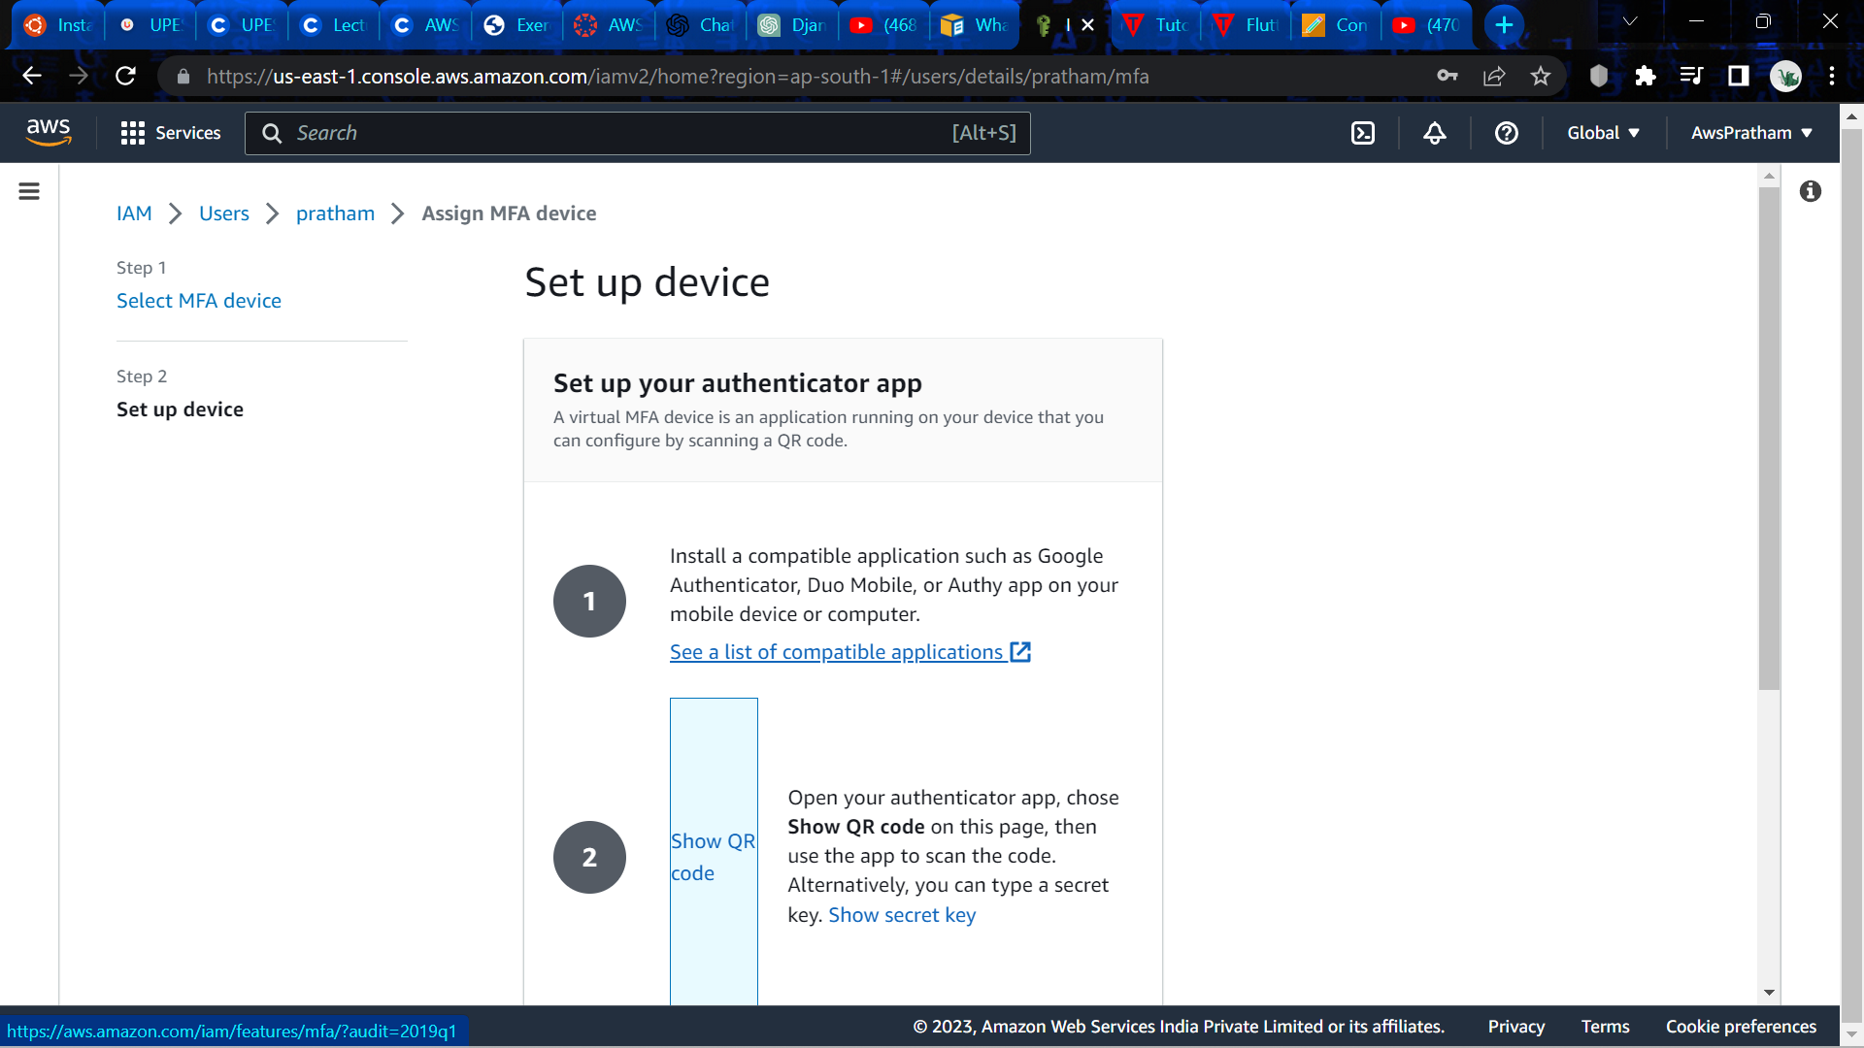

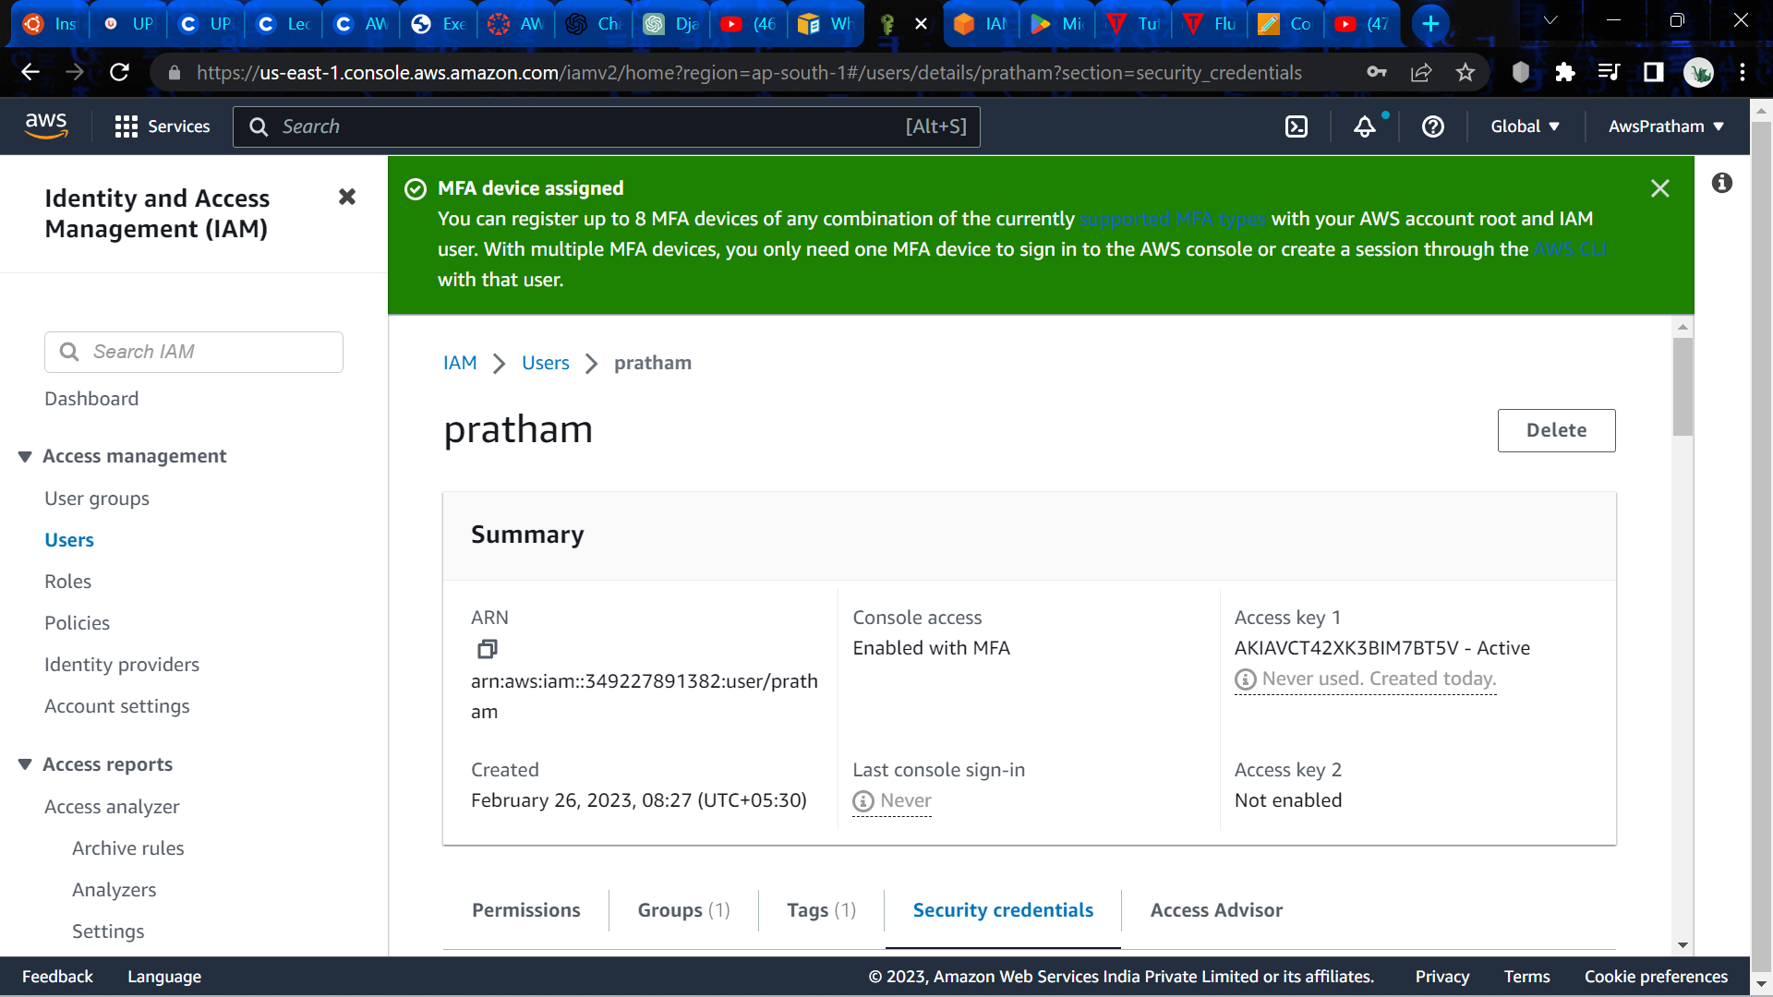

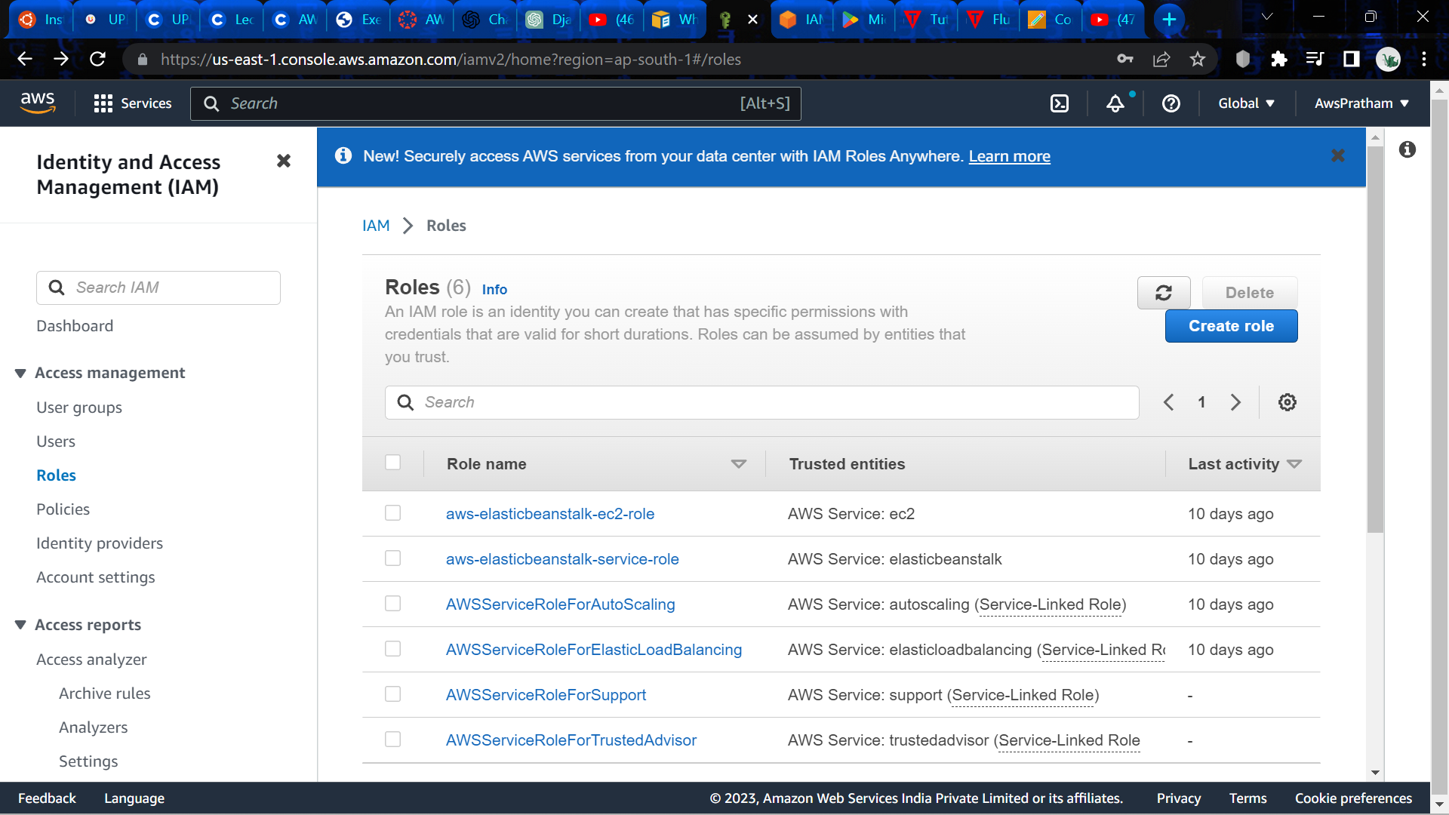

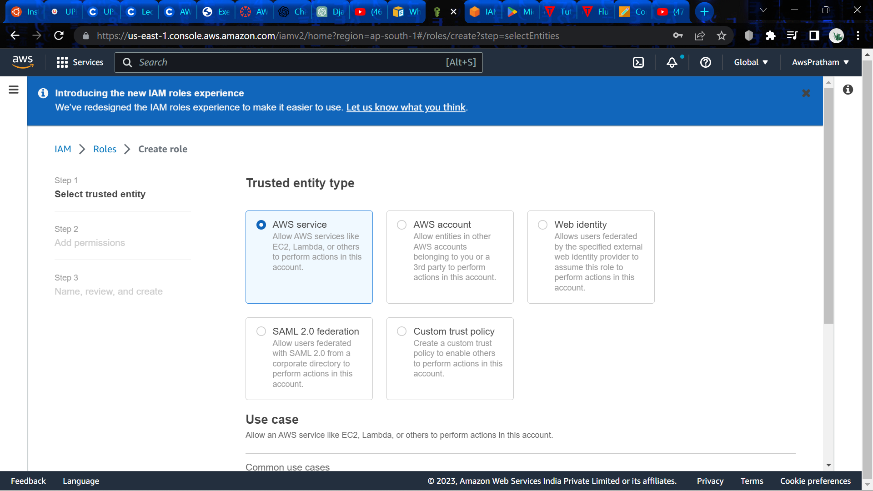

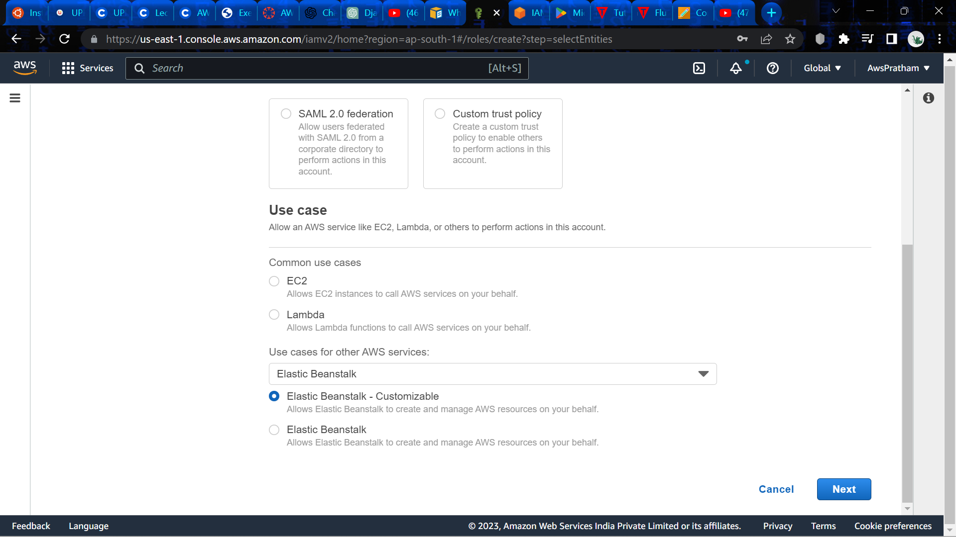

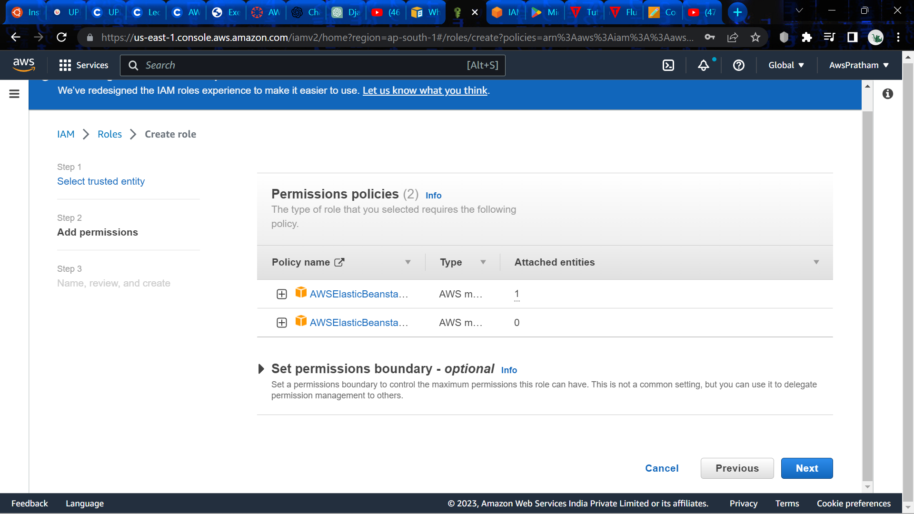

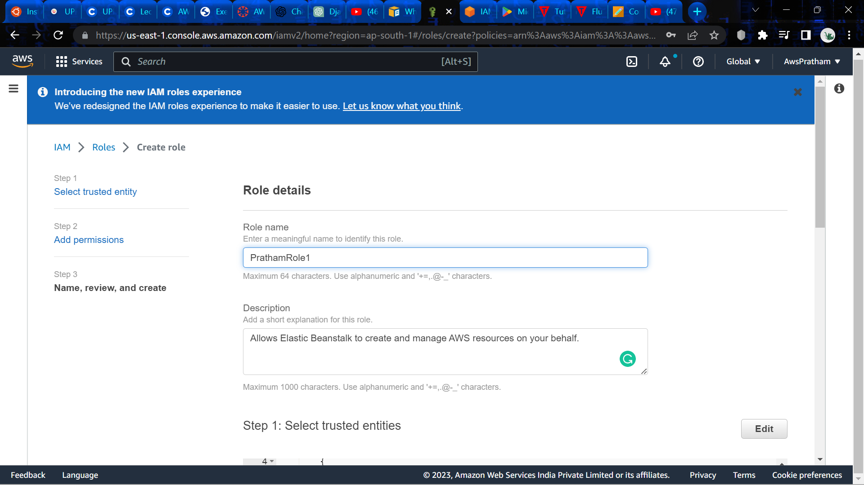

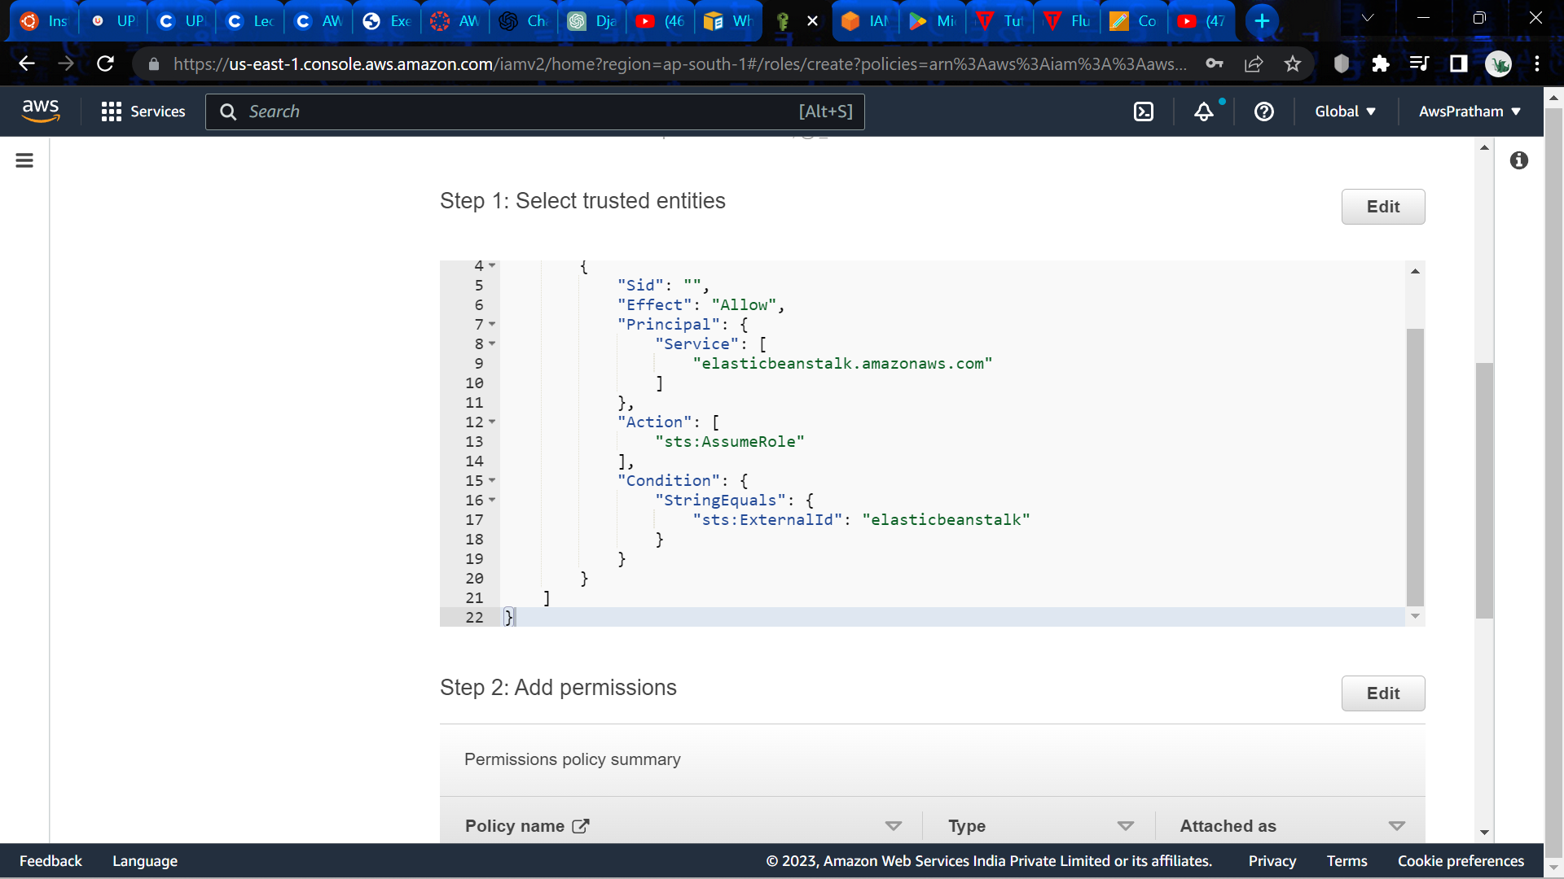

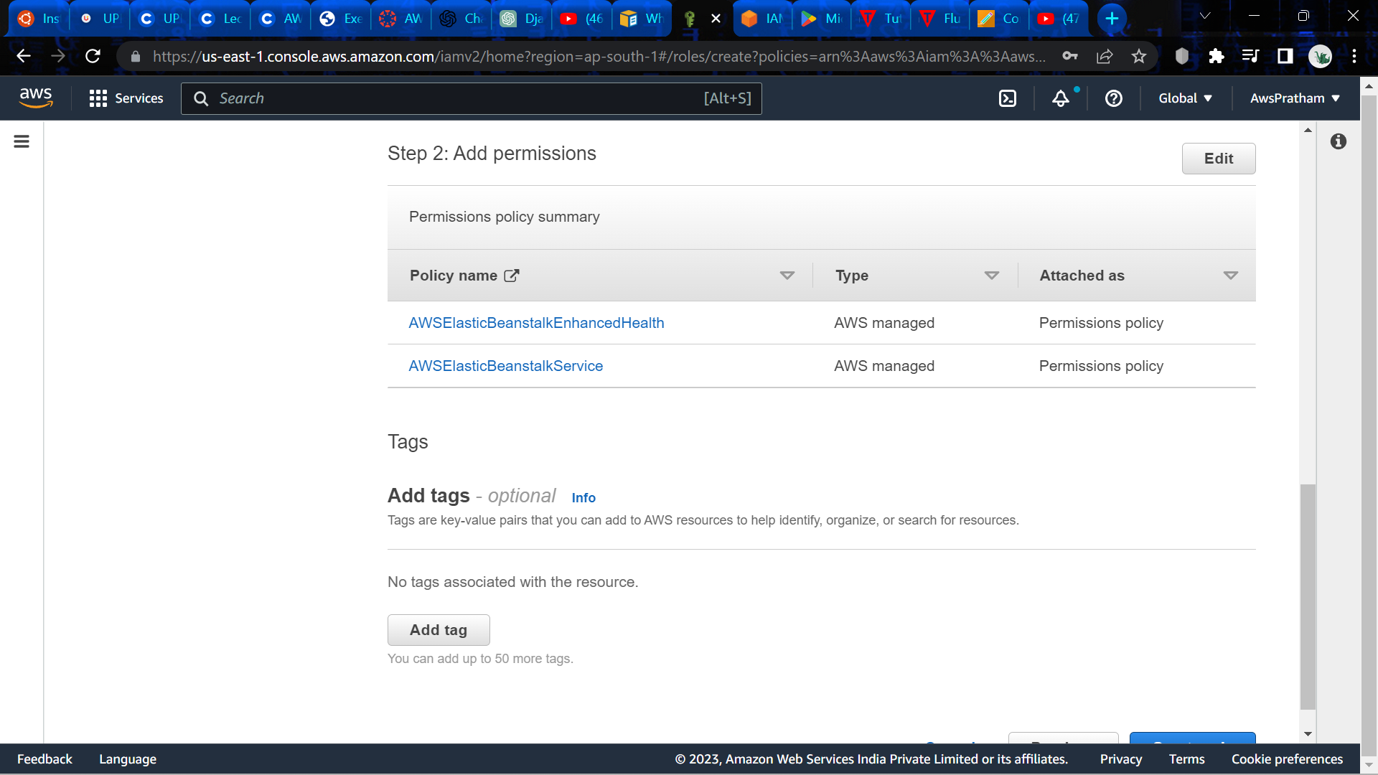

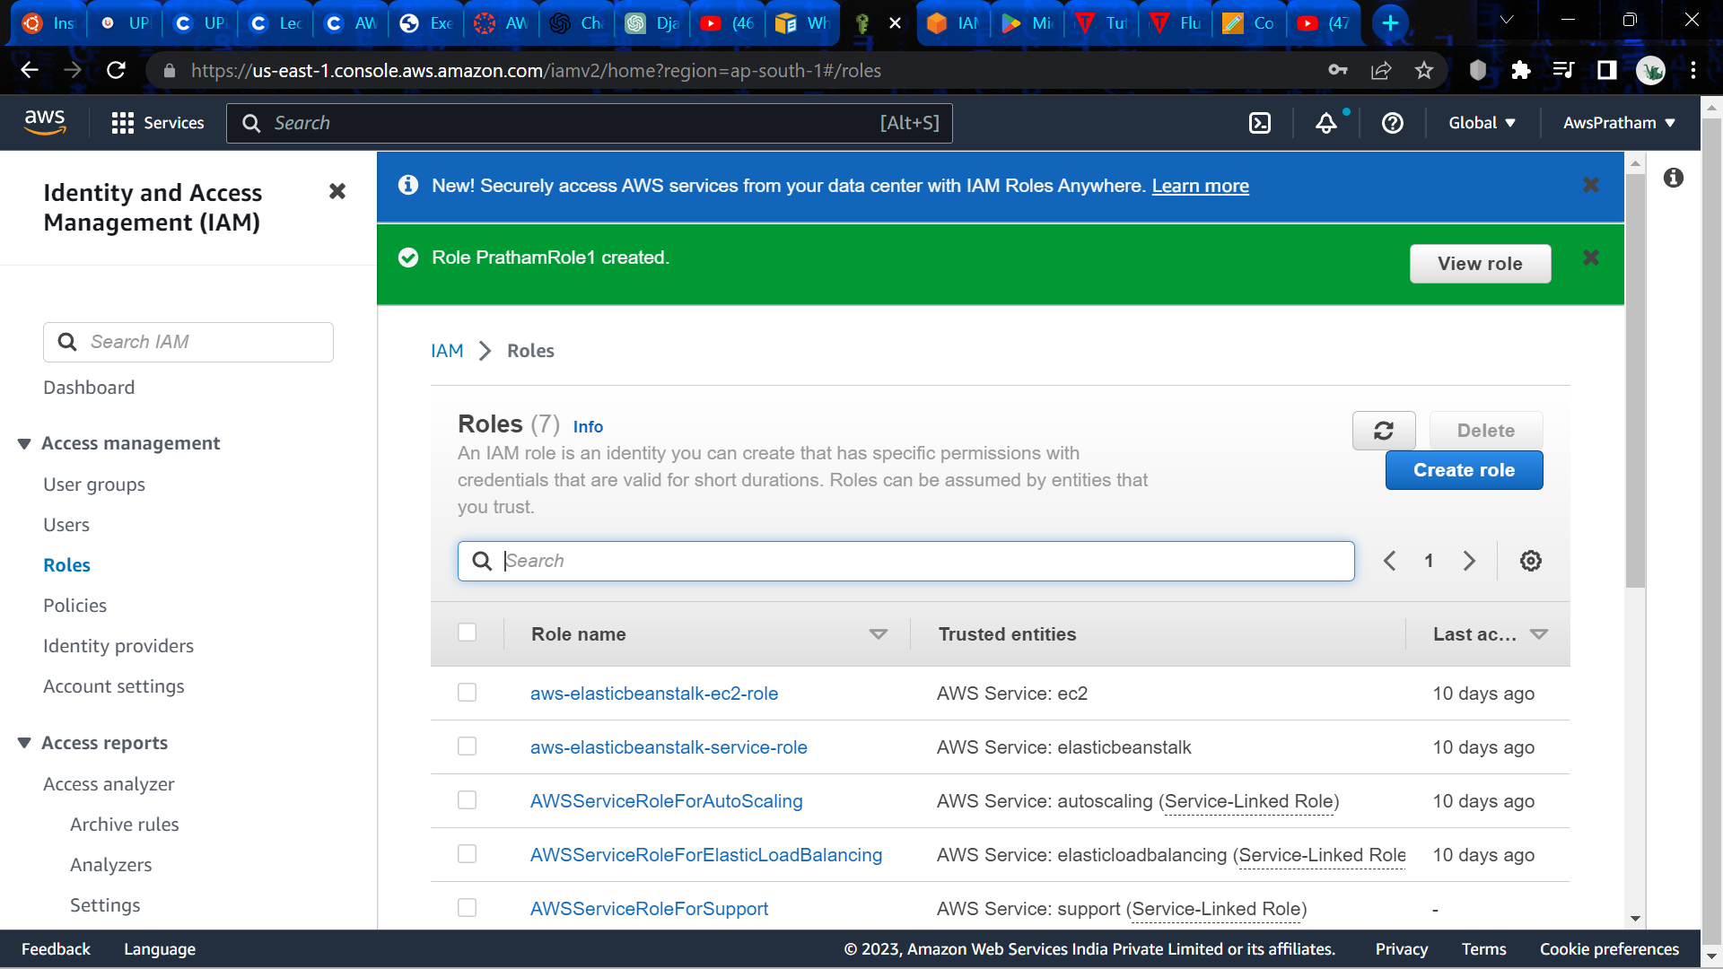

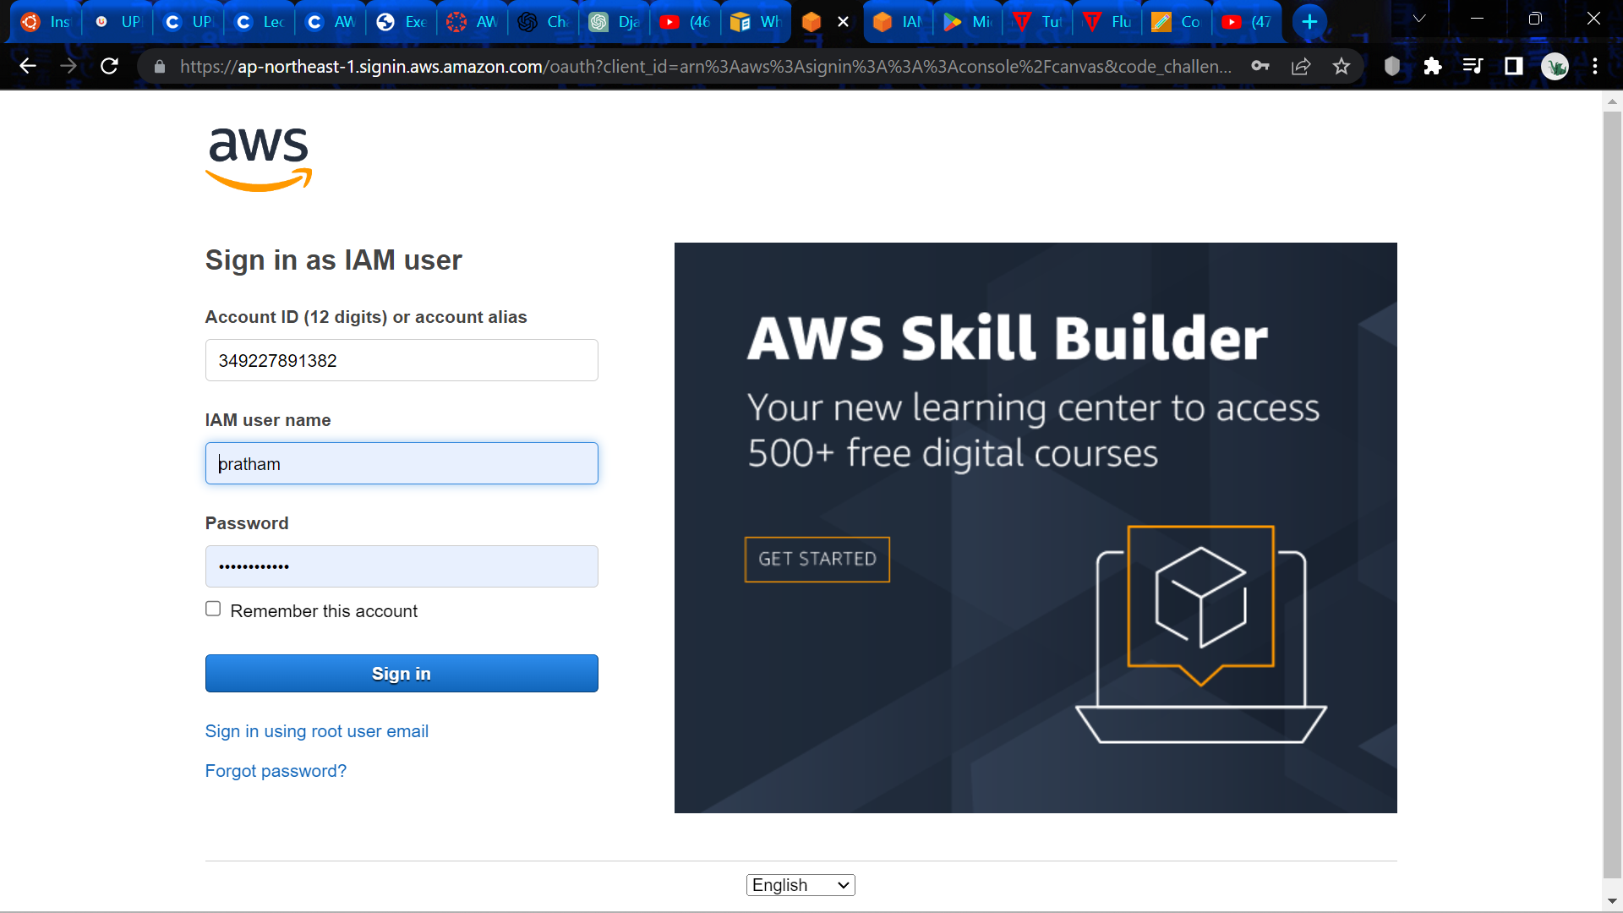

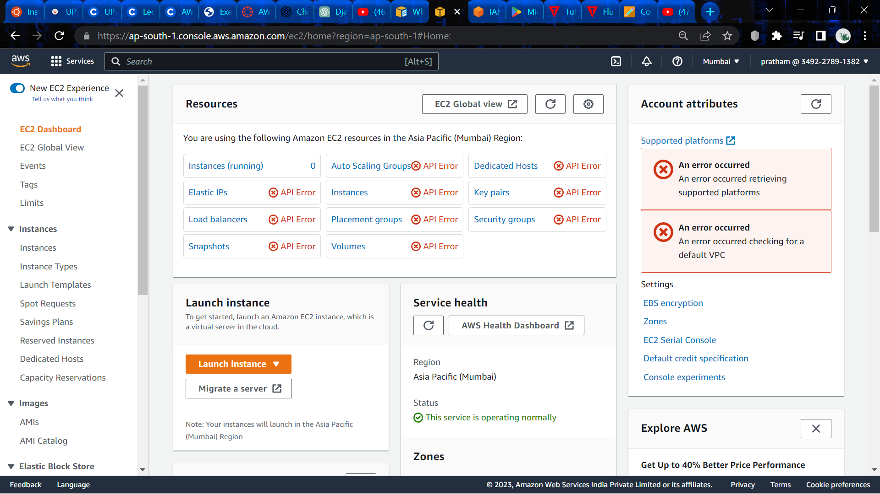

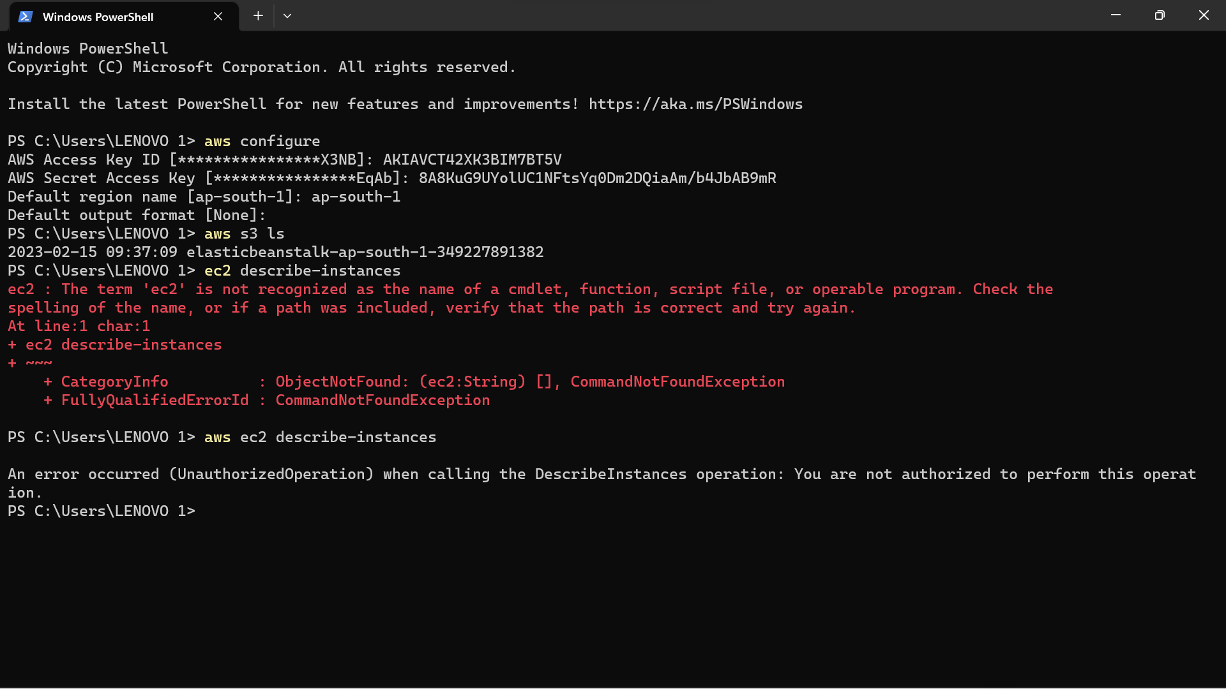

**Experiment -8**

Q:1. Differentiate between EBS, EFS and S3 storage?

Ans: Customers of Amazon Web Services (AWS) have access to a variety of storage choices. Elastic Block Store (EBS), Elastic File System (EFS), and Simple Storage Service are three of the most popular storage services (S3).

Here is a quick breakdown of how EBS, EFS, and S3 storage services differ from one another:

1. EBS, or elastic block store:

Persistent storage volumes are offered by EBS, a block-level storage service, for use with Amazon Elastic Compute Cloud (EC2) instances. Operating systems, databases, and applications can all use EBS volumes as their primary storage by attaching them to EC2 instances. To offer high availability and durability, EBS volumes are kept in a single Availability Zone (AZ), and data is replicated inside that AZ.

1. Elastic File System (EFS): For usage with Amazon EC2 instances, EFS is a file-level storage service that offers scalable, elastic, and shared storage. Several EC2 instances can have EFS volumes attached at once, allowing for concurrent access to shared data. Data is duplicated across several Availability Zones (AZs) for high availability and durability, and EFS automatically scales storage capacity up and down as needed.
2. Simple Storage Service(S3):

S3 is an object-level storage service that offers secure, dependable, and scalable storage for any kind of data. Data can be saved, retrieved, and managed by a web-based interface or API in S3 buckets, which are accessible from anywhere. S3 provides a variety of storage classes, including S3 Standard, S3 Intelligent-Tiering, S3 Standard-Infrequent Access, S3 One Zone-Infrequent Access, and Glacier, to maximise prices and performance.

Q:2. List the features of S3 storage?

Ans: When it comes to storing and retrieving data, Amazon S3 (Simple Storage Service) is a cloud storage service offered by Amazon Web Services (AWS). S3 storage has a number of important features, including:

1. Scalability: From little files to petabytes of data, S3 can scale to store and retrieve any quantity of data.
2. Durability: Data is extremely resilient and safeguarded against loss because to S3's 99.999999999% (11 9's) durability design.
3. Accessibility: S3 is built for 99.99% availability, which means that data is always available and retrievable.
4. Security: S3 offers a number of security features, including bucket policies, access control lists (ACLs), and server-side encryption.
5. Cost-effectiveness: S3 offers a variety of storage options at affordable prices, including S3 Standard, S3 Infrequent Access, S3 One Zone-Infrequent Access, S3 Intelligent-Tiering, S3 Glacier, and S3 Glacier Deep Archive. These options offer varying degrees of availability, durability, and retrieval times.
6. Integration: A wide range of AWS services, such as AWS Lambda, AWS CloudTrail, AWS CloudFormation, and many others, are compatible with S3.
7. Data management: S3 offers tools for managing data, including cross-region replication, lifecycle controls, and versioning.
8. Performance: S3 supports a variety of use cases, including big data analytics, backup and restore, and content delivery, thanks to its quick data transfer speeds and low latency.

Q:3. What are the different types of storage classes available in S3?

Ans:

Amazon S3 (Simple Storage Service) provides several storage classes, each designed to meet specific performance, durability, availability, and cost requirements. The different storage classes available in S3 are:

1. S3 Standard: This is the default storage class for S3 objects, providing high durability, availability, and performance. It is suitable for frequently accessed data that requires low-latency and high throughput.
2. S3 Intelligent-Tiering: This storage class automatically moves objects between two access tiers: frequent and infrequent access tiers. It is ideal for data with unknown or changing access patterns.
3. S3 Standard-Infrequent Access (S3 Standard-IA): This storage class is designed for long-lived and infrequently accessed data that still requires fast access when needed. It offers lower storage costs than S3 Standard, but with a retrieval fee.
4. S3 One Zone-Infrequent Access (S3 One Zone-IA): This storage class is similar to S3 Standard-IA, but stores data in a single availability zone, making it less durable but more cost-effective.
5. S3 Glacier: This storage class is designed for long-term storage of archival data. It offers low storage costs but with a retrieval time of minutes to hours.
6. S3 Glacier Deep Archive: This is the lowest-cost storage class for long-term storage of archival data. It provides retrieval times of 12 hours or more, making it suitable for data that is rarely accessed but needs to be retained for compliance or legal reasons.

Q:4. Explain the lifecycle management in S3 and different action associated with it.

Ans: Amazon S3 (Simple Storage Service) provides a Lifecycle Management feature that allows you to automate the process of moving objects between different storage classes or deleting them based on their age or other criteria. This helps you optimize your storage costs and ensure that you only pay for the storage you need.

The Lifecycle Management feature in S3 is configured using rules that define the transition or expiration actions to be taken on objects. The different actions associated with Lifecycle Management in S3 are:

1. Transition actions: These actions move objects from one storage class to another based on their age or other criteria. For example, you can configure a rule to move objects that are older than 30 days from the S3 Standard storage class to the S3 Standard-Infrequent Access (S3 Standard-IA) storage class to reduce storage costs.
2. Expiration actions: These actions delete objects that have exceeded their lifetime or retention period. For example, you can configure a rule to delete objects that are older than 365 days to ensure that you are not retaining data that is no longer needed.
3. Versioning actions: These actions enable you to manage object versions based on their age or other criteria. For example, you can configure a rule to permanently delete previous versions of an object that is updated frequently to save on storage costs.
4. Cross-region replication: This action replicates objects to another S3 bucket in a different region, providing additional data durability and availability. You can configure a rule to replicate objects that are stored in the S3 Standard storage class to an S3 bucket in a different region for disaster recovery purposes.

**AWS S3**

1. Create a bucket, add an object to the bucket and delete the bucket. Make the object publicly accessible
2. Host a static website on S3.

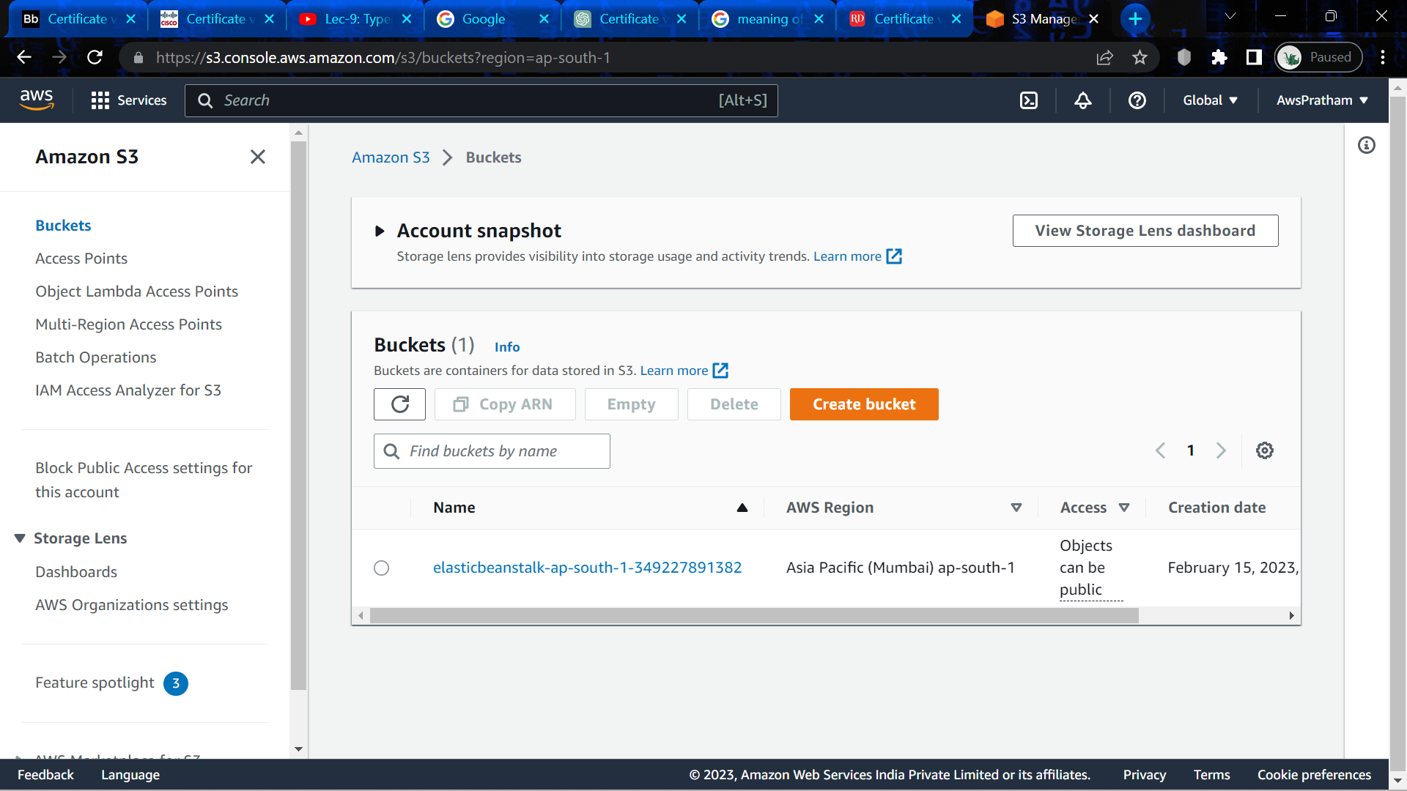

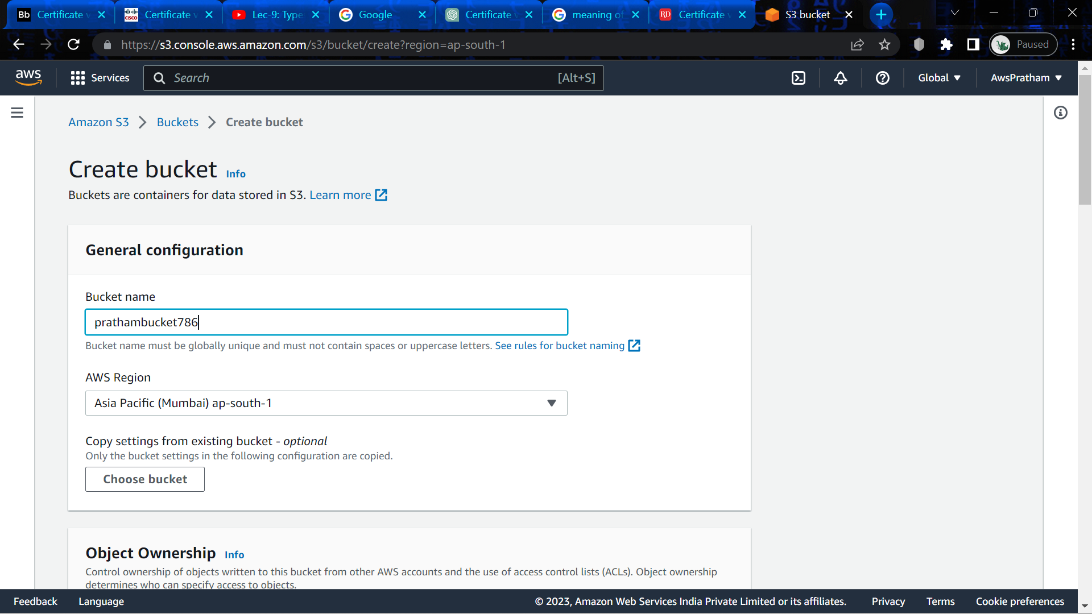

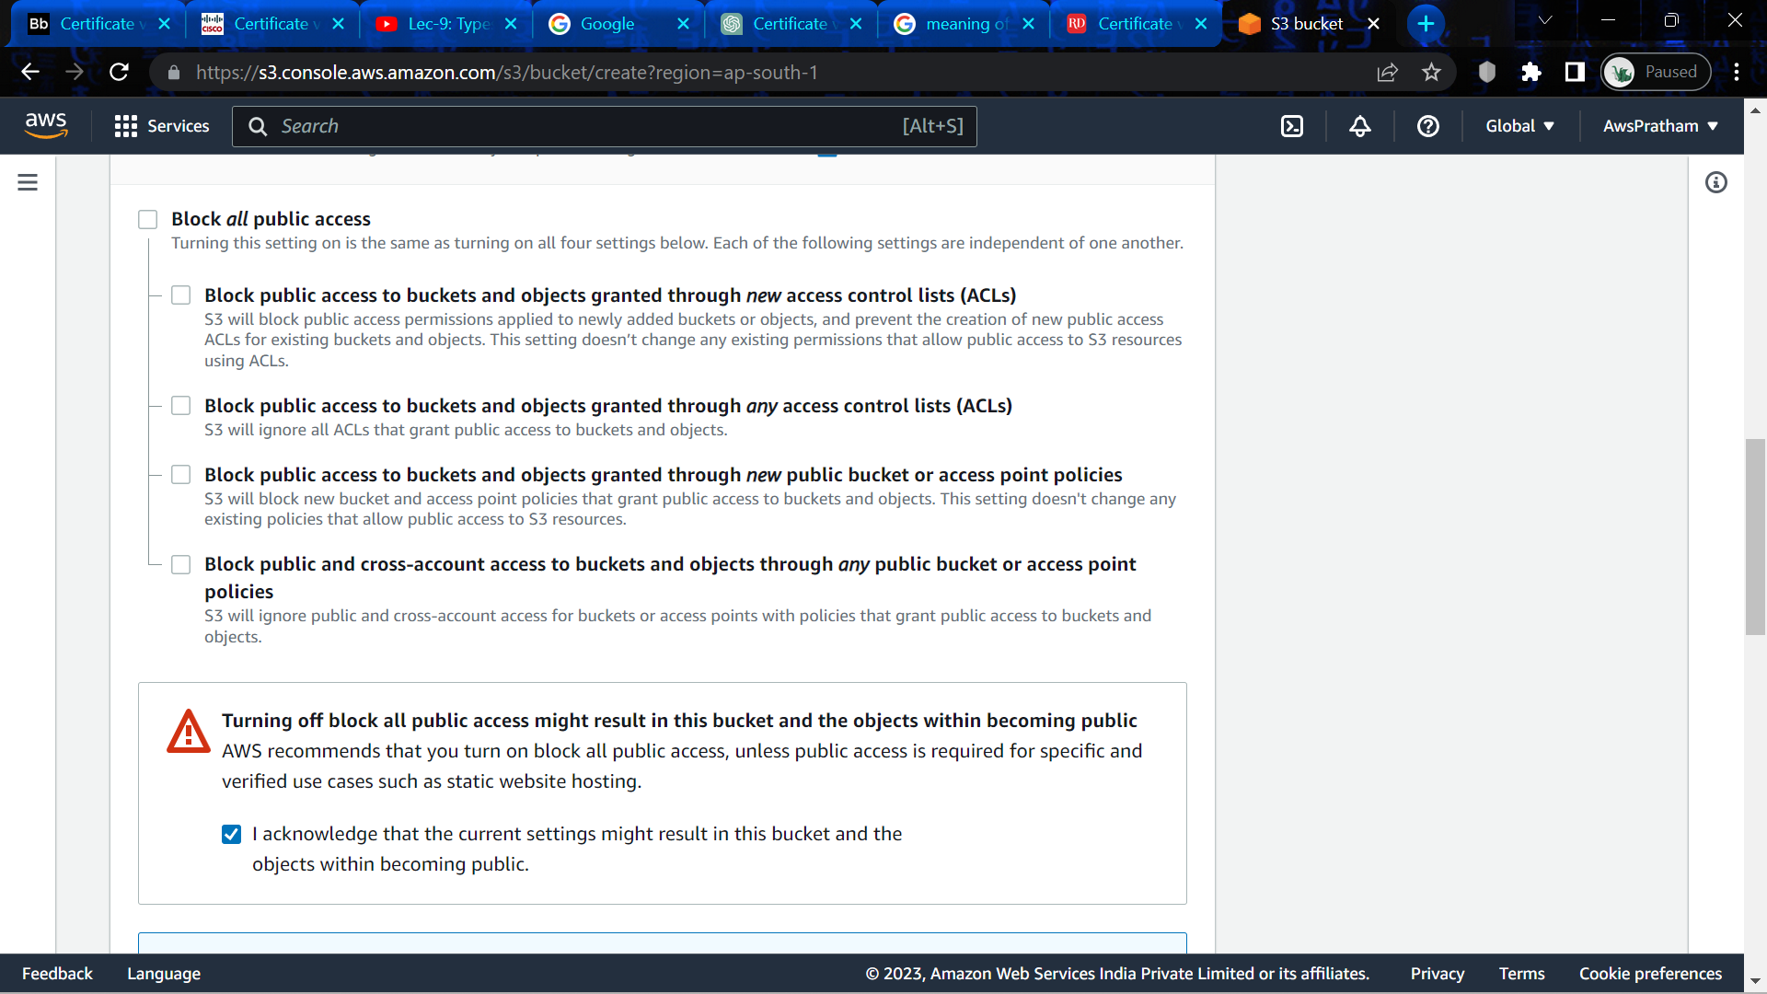

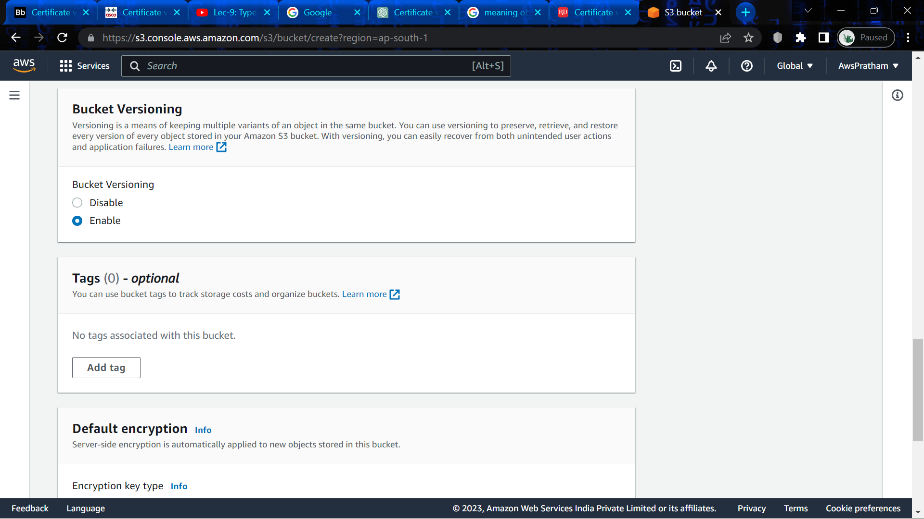

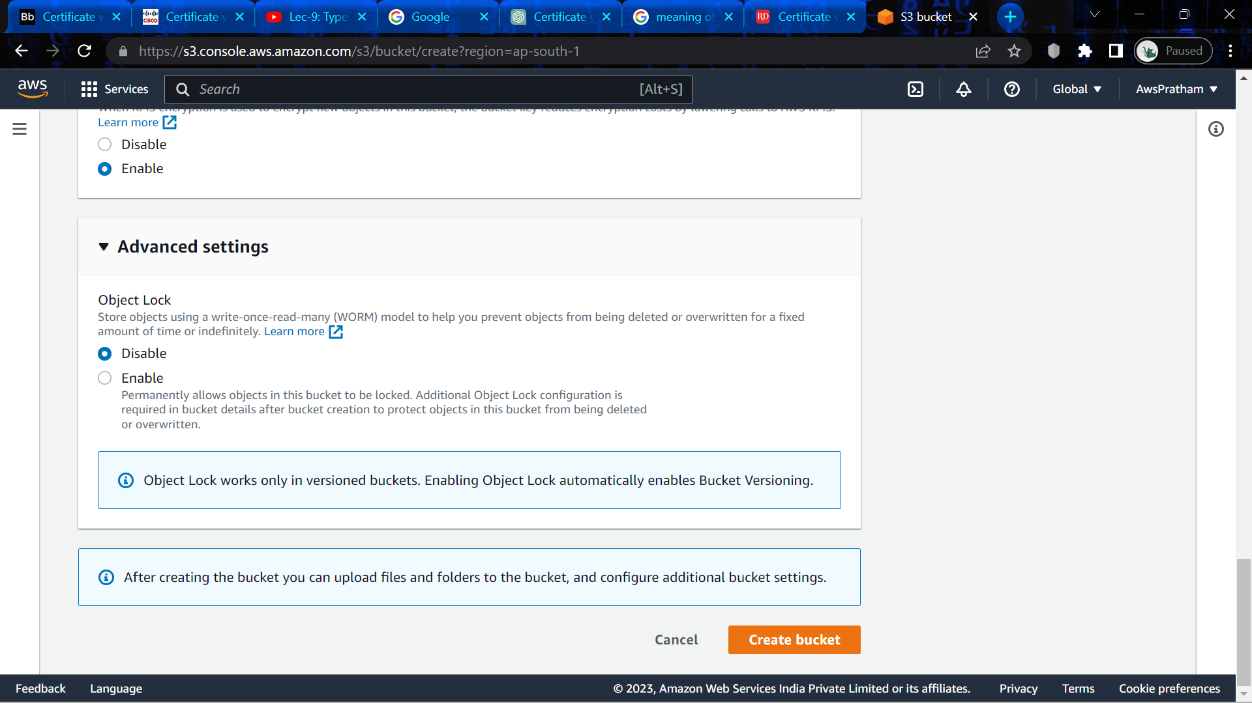

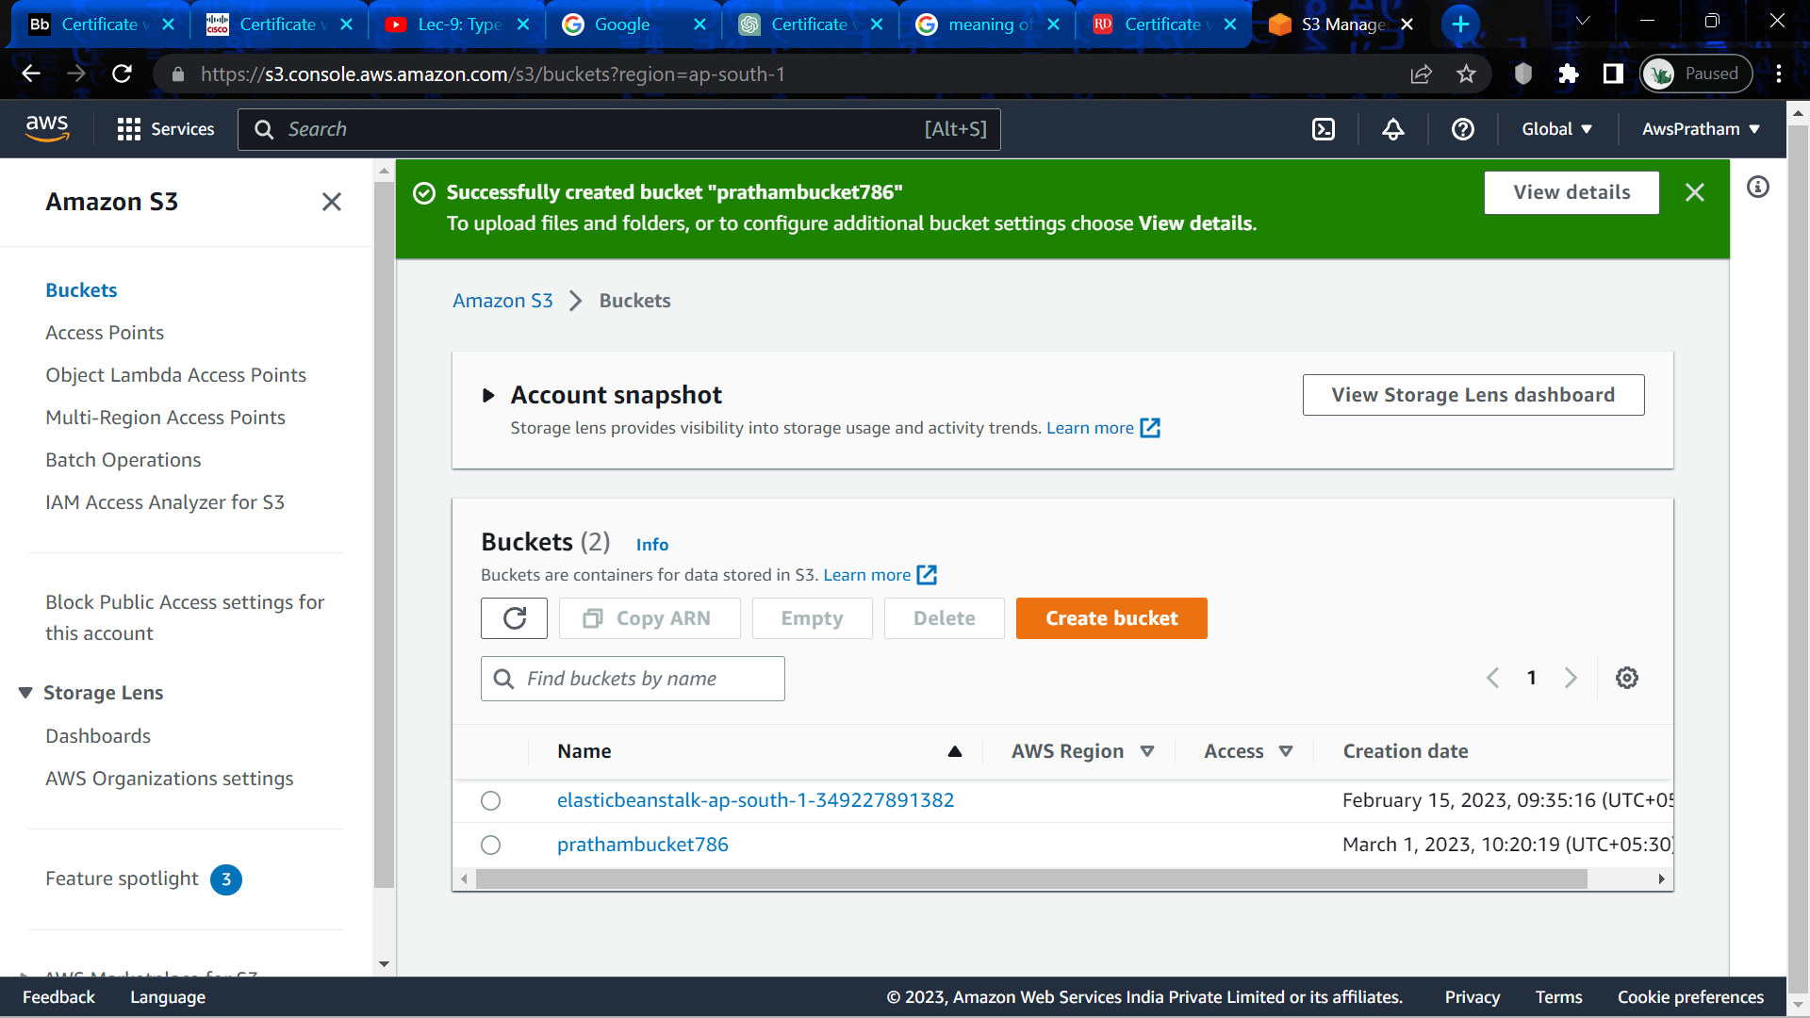

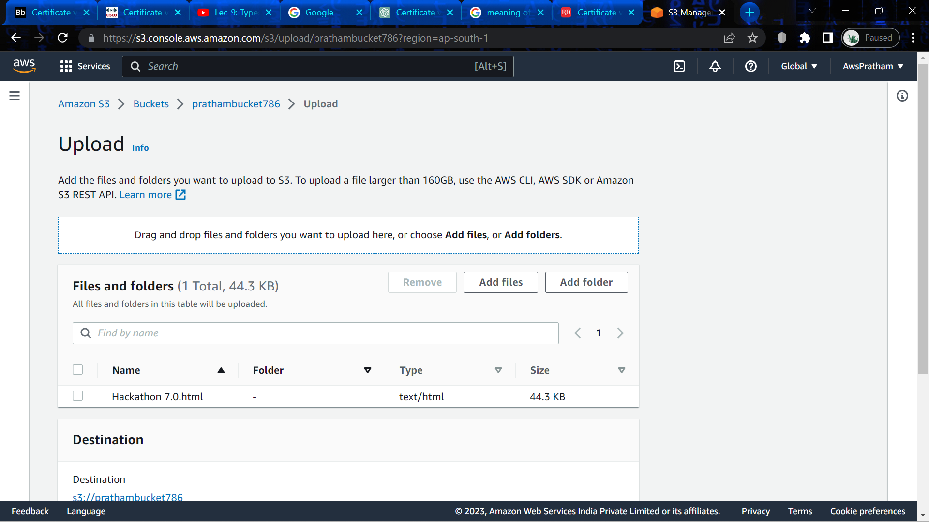

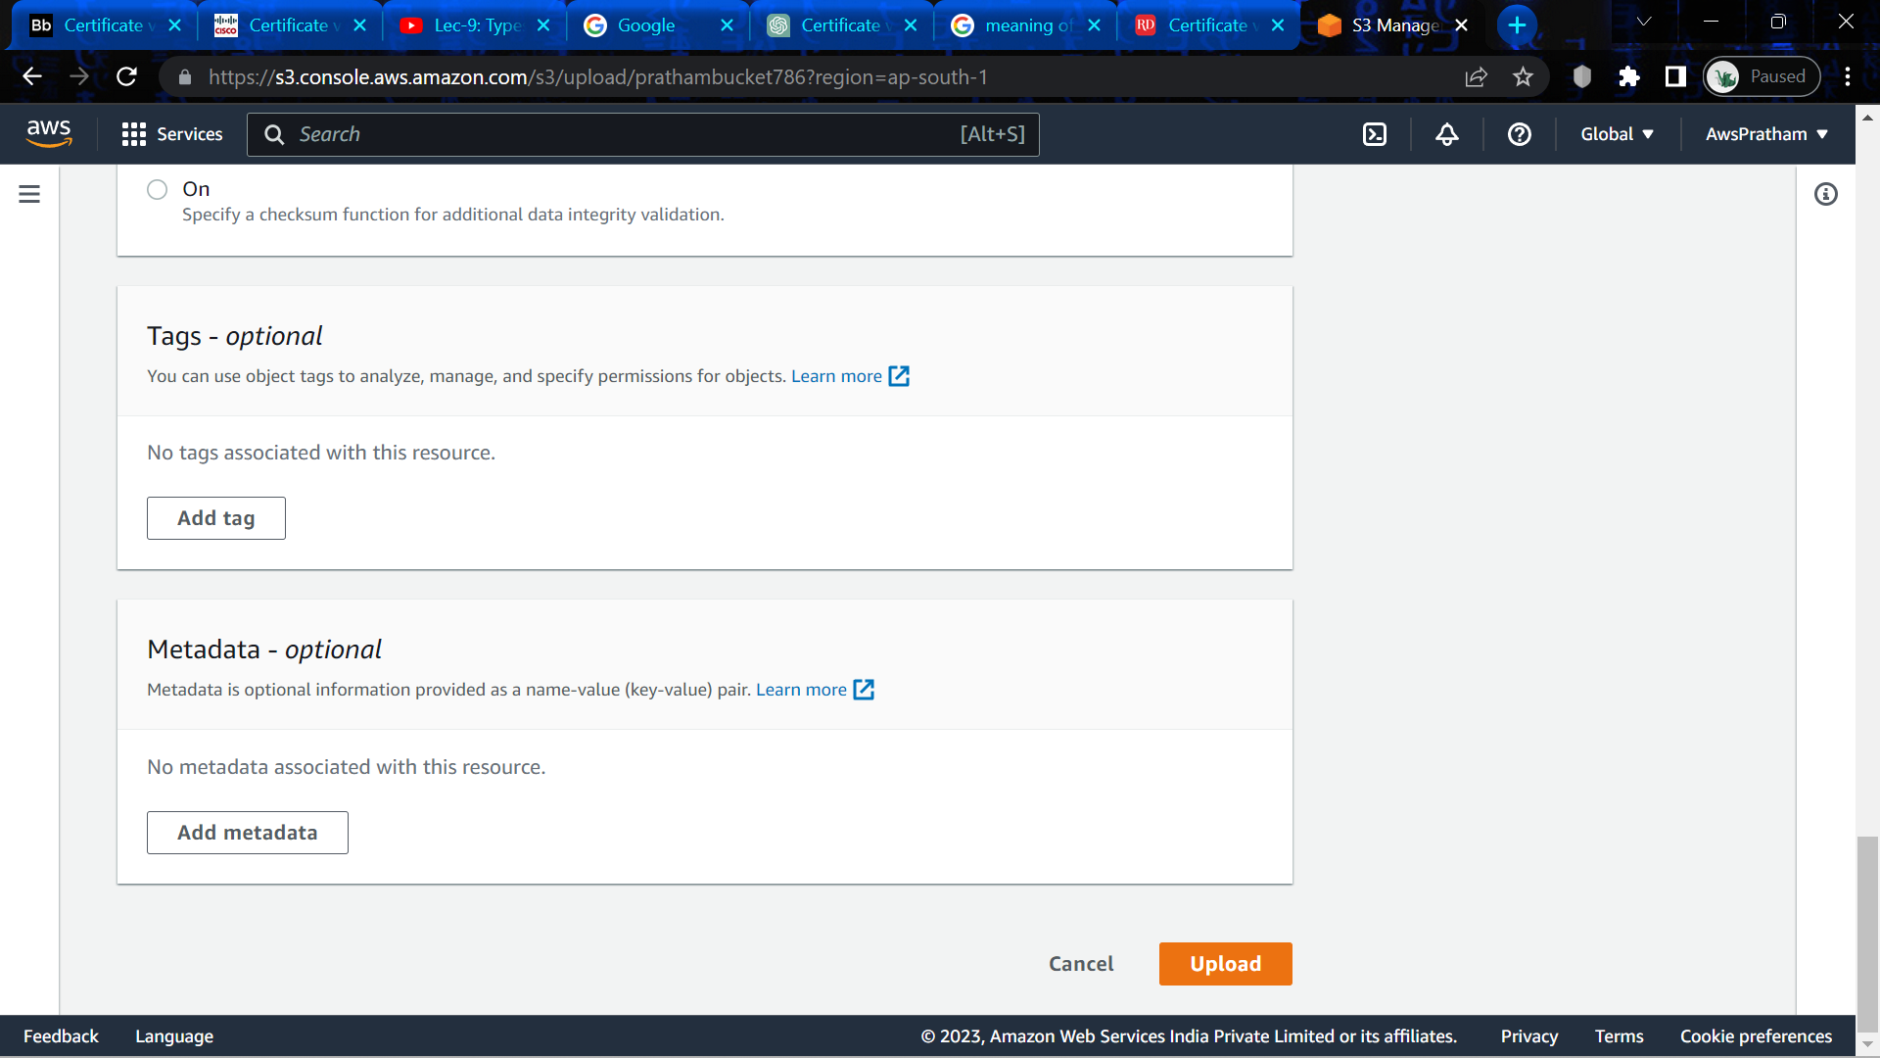

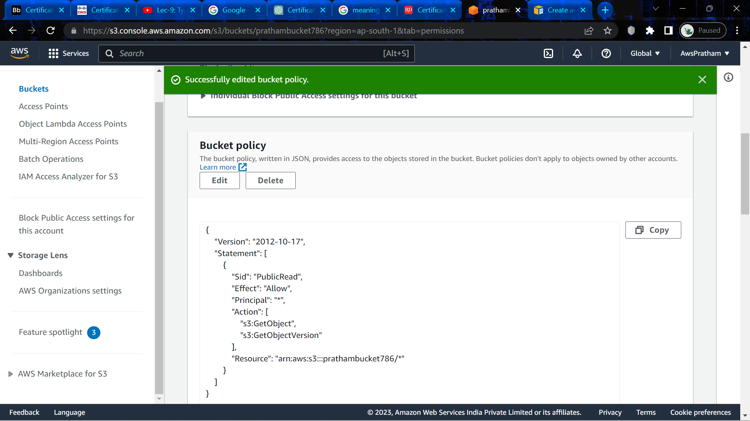

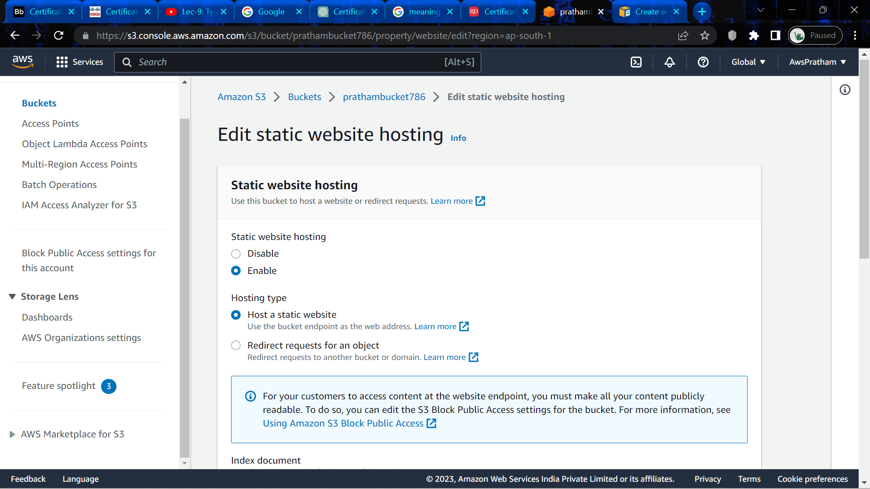

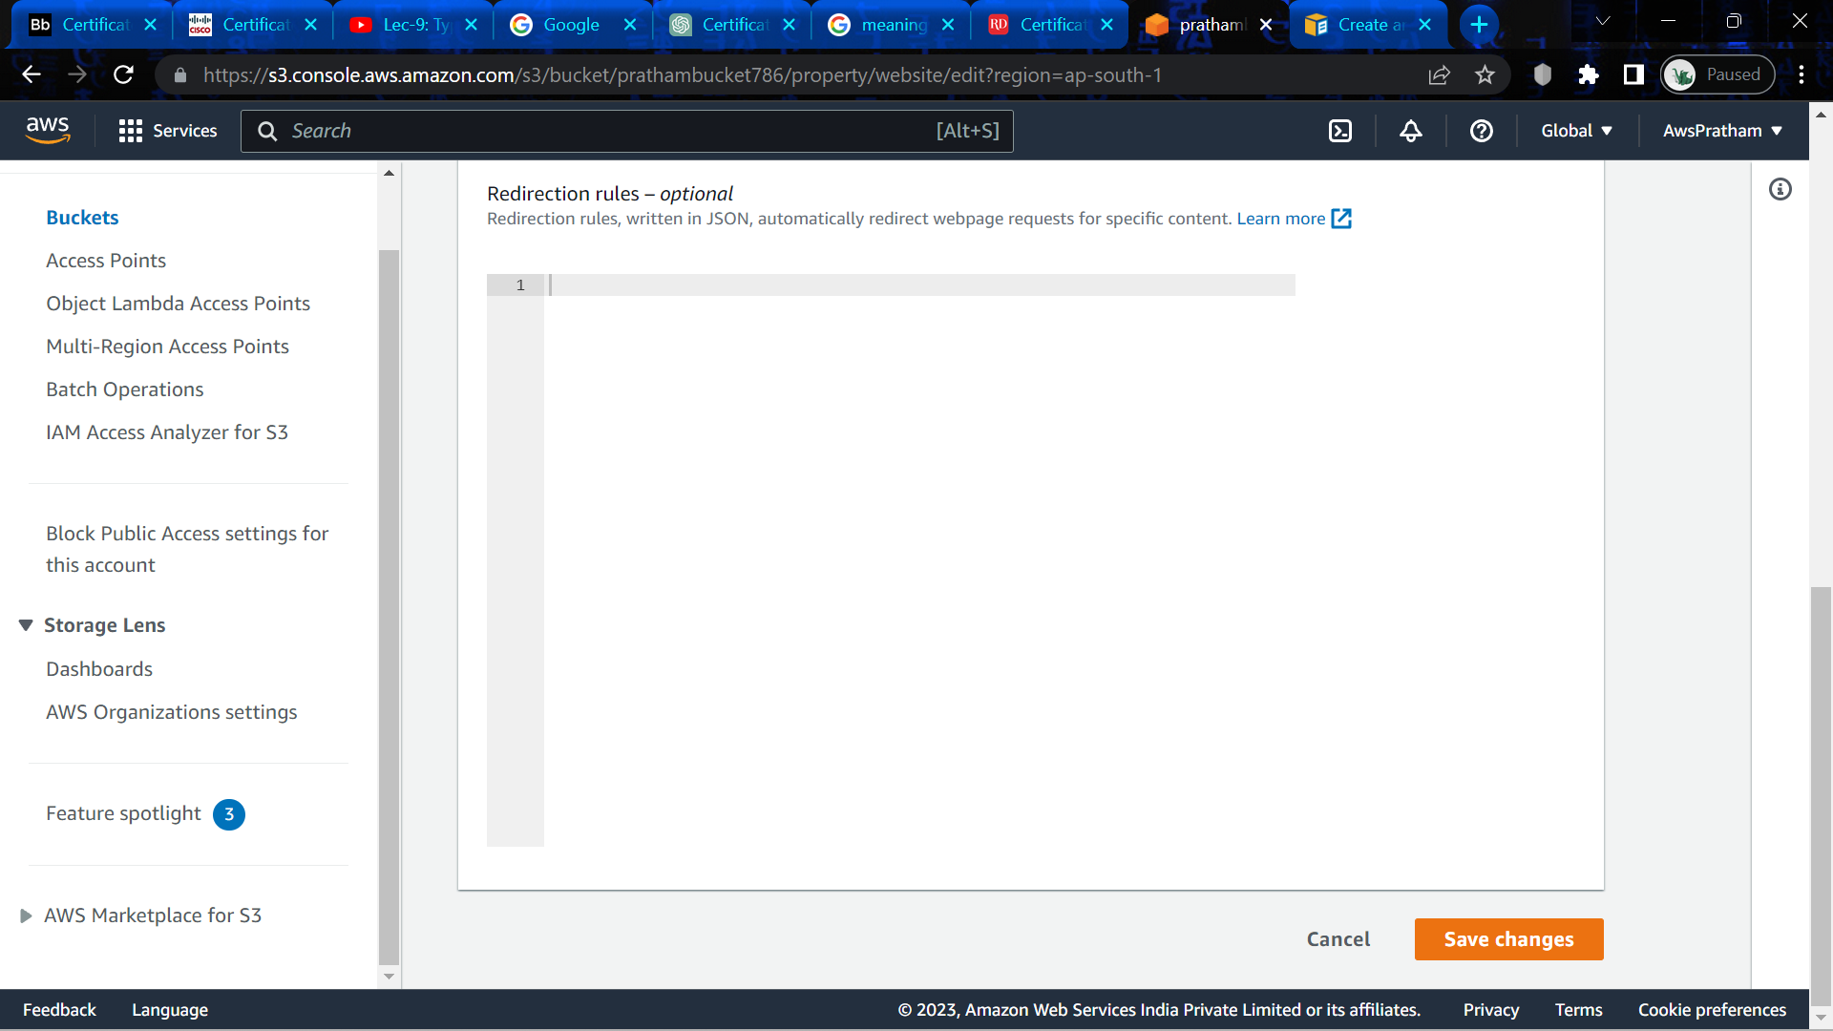

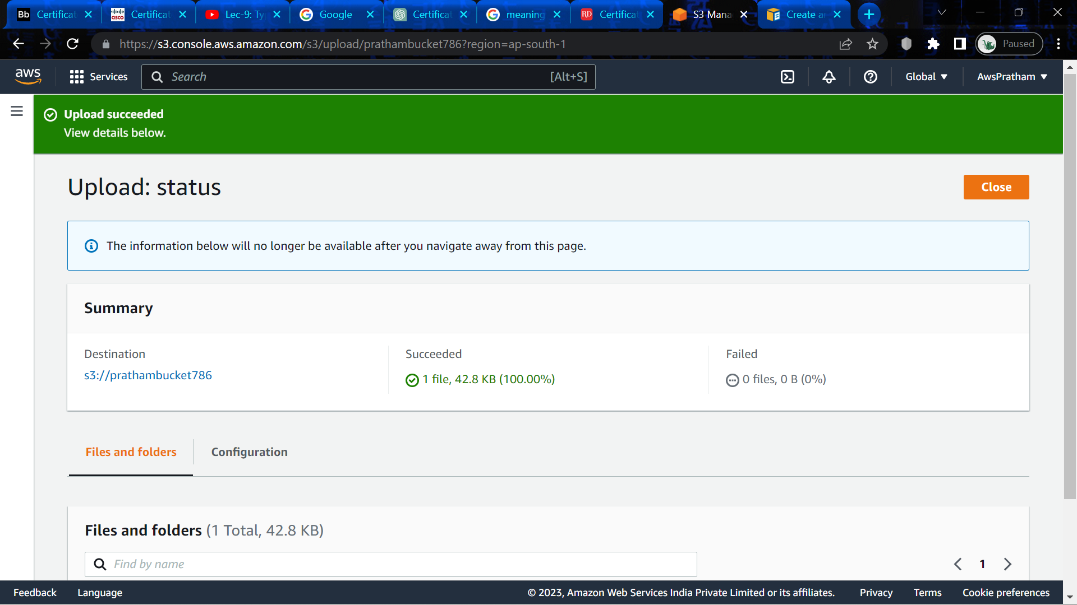

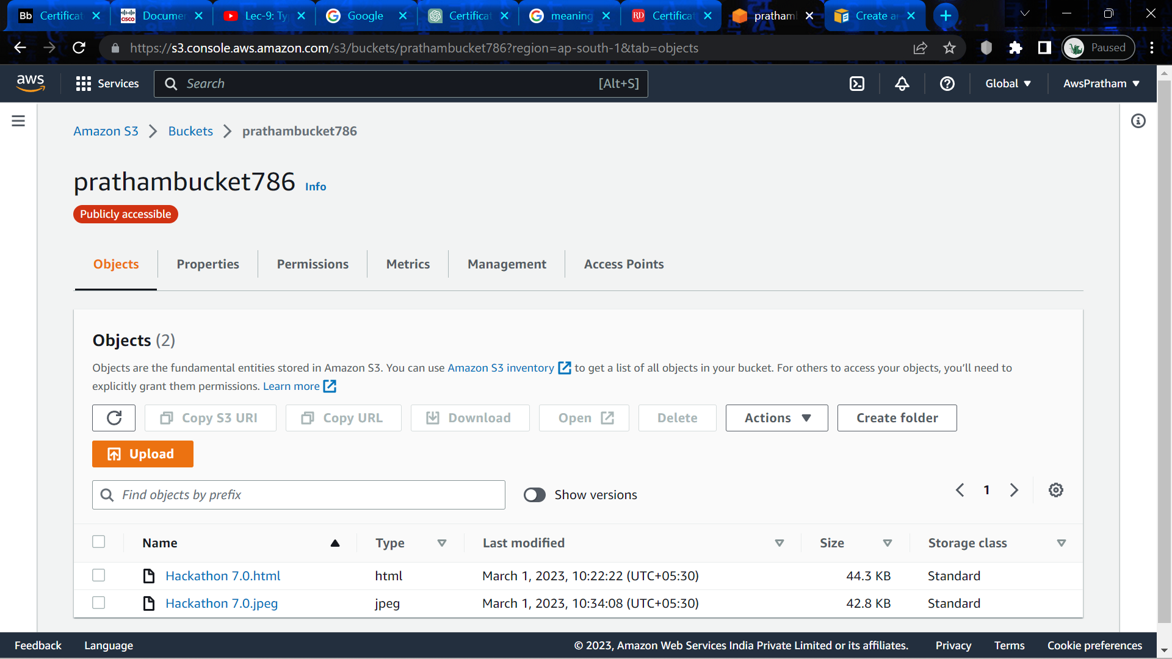

**Experiment -9**

**i)Replicate the bucket in the same region and different region. ii) Delete the object through Lifecycle rule creation. iii) Create a transition action to move the object from one storage class to another.**

**Q1)** **Why we have different storage classes in S3 and explain these in detail.**

**ANS)** Amazon S3 offers several different storage classes designed to help customers optimize their costs and performance based on the specific needs of their data. Each storage class has its own characteristics and access patterns, and choosing the right one can significantly impact the cost and performance of your S3 usage.

The following are the different storage classes available in S3, along with a brief description of each:

1.     S3 Standard: This is the default storage class for S3. It provides high durability, availability, and performance for frequently accessed data. S3 Standard is suitable for a wide range of use cases, including big data analytics, mobile and gaming applications, content distribution, and backup and recovery.

2.     S3 Intelligent-Tiering: This storage class is designed to automatically move objects between two access tiers based on changing access patterns. It uses machine learning algorithms to analyze usage patterns and optimize costs while maintaining high performance and availability. S3 Intelligent-Tiering is ideal for workloads with unknown or unpredictable access patterns.

3.     S3 Standard-Infrequent Access (S3 Standard-IA): This storage class provides the same high durability, availability, and performance as S3 Standard, but at a lower cost for infrequently accessed data. S3 Standard-IA is suitable for long-term storage, backups, and disaster recovery data.

4.     S3 One Zone-Infrequent Access (S3 One Zone-IA): This is a lower-cost version of S3 Standard-IA that stores data in a single availability zone, rather than across multiple zones. It offers the same durability and performance as S3 Standard-IA but with a lower availability guarantee. S3 One Zone-IA is suitable for data that can be recreated if lost.

5.     S3 Glacier: This storage class provides extremely low-cost storage for data archiving and long-term backup. It offers low retrieval times (within minutes) for archived data and can be used for regulatory compliance and other use cases that require long-term data retention.

6.     S3 Glacier Deep Archive: This is the lowest-cost storage class in S3, designed for long-term data retention and archiving. Retrieval times can take several hours, but the cost per GB is significantly lower than any other S3 storage class. S3 Glacier Deep Archive is suitable for compliance, historical, and other low-cost, infrequently accessed data.

In summary, choosing the right storage class in S3 depends on your specific needs, access patterns, and budget. By understanding the characteristics of each storage class, you can optimize your costs and performance to meet your business requirements.

**Q2) What do you understand by lifecycle management in S3.**

**ANS)** Lifecycle management in Amazon S3 is a feature that allows you to automate the process of moving objects between different storage classes or deleting them based on predefined rules. This feature can help you optimize your storage costs and simplify data management by automating the transition of objects to different storage classes or deleting them at the end of their lifecycle.

With S3 lifecycle management, you can define lifecycle policies that apply to a specific bucket or a subset of objects within a bucket. You can define lifecycle policies to transition objects to different storage classes based on their age or based on other criteria such as their size, whether they are encrypted or not, or whether they have been accessed recently.

For example, you might define a lifecycle policy that automatically moves objects to the S3 Standard-Infrequent Access (S3 Standard-IA) storage class after 30 days and to the S3 Glacier storage class after 90 days. This policy would help you reduce storage costs by automatically transitioning less frequently accessed objects to lower-cost storage classes.

You can also define lifecycle policies that automatically delete objects after a certain period of time or after they have reached a specific age or size. This can help you ensure that objects are deleted at the end of their lifecycle, reducing storage costs and improving data security.

In summary, S3 lifecycle management is a powerful feature that enables you to automate the process of moving objects between different storage classes or deleting them based on predefined rules. By defining lifecycle policies, you can optimize your storage costs, simplify data management, and ensure that objects are deleted at the end of their lifecycle.

**Q3) What do you understand by replication rules in S3.**

**ANS)** Replication rules in Amazon S3 is a feature that allows you to automatically replicate your data from one S3 bucket to another S3 bucket in a different AWS region or within the same region. This feature can help you to increase the durability of your data and provide data protection and disaster recovery in case of data loss or service disruption.

With S3 replication rules, you can define replication policies that specify the source and destination buckets, the objects to replicate, and the frequency and priority of replication. You can also specify the storage class of the replicated objects, the encryption options, and the metadata to be included with the replicated objects.

For example, you can define a replication rule to replicate all objects in a production bucket to a backup bucket in a different region. You can specify that objects should be replicated every 15 minutes, and you can choose to replicate only objects that have changed since the last replication. You can also specify that the replicated objects should be stored in a lower-cost storage class, such as S3 Standard-Infrequent Access (S3 Standard-IA).

S3 replication rules provide several benefits, including:

1.     Increased durability and data protection: Replicating your data to another S3 bucket can help ensure that your data is protected against data loss or service disruption.

2.     Disaster recovery: Replicating your data to another AWS region can help provide disaster recovery in case of regional outages.

3.     Compliance: S3 replication rules can help you comply with regulatory requirements by replicating your data to another location.

In summary, S3 replication rules is a powerful feature that allows you to automatically replicate your data from one S3 bucket to another. By defining replication policies, you can increase the durability of your data, provide data protection and disaster recovery, and comply with regulatory requirements.

i)Replicate the bucket in the same region and different region.

Step 1) Go to S3 and click on create bucket.

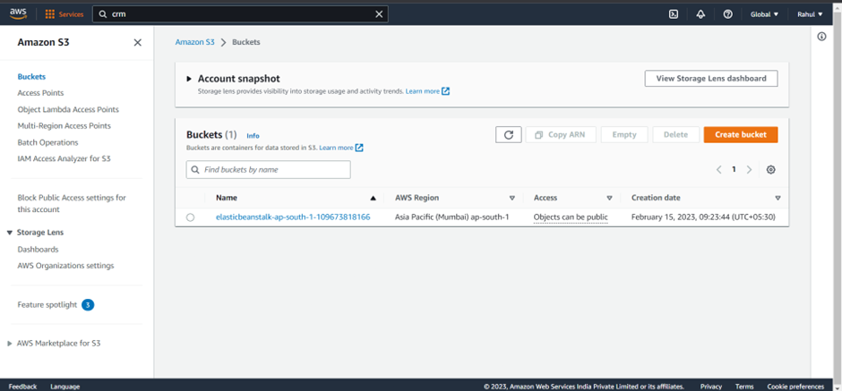

Step 2) Give it a name (Sourcebucket).

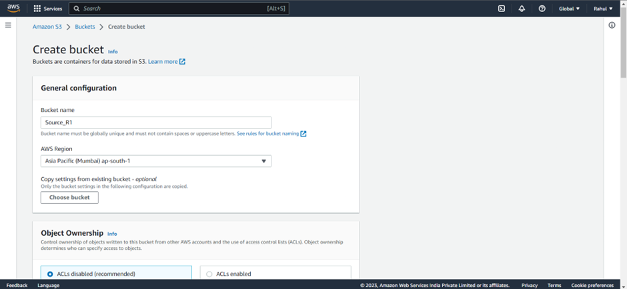

Step 3) Unblock public access.

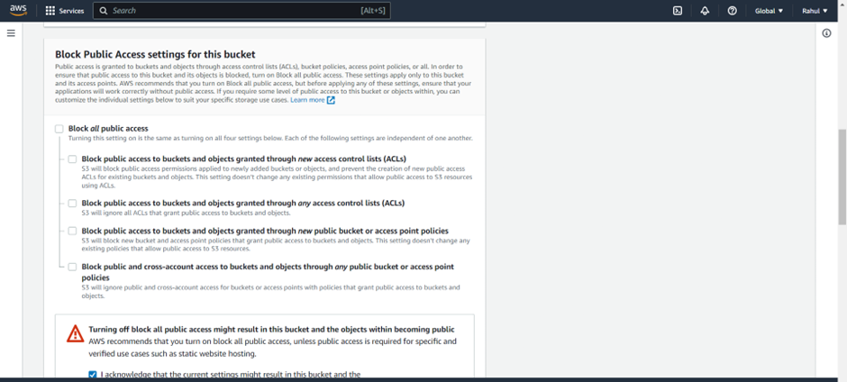

Step 4) Enable bucket versioning.

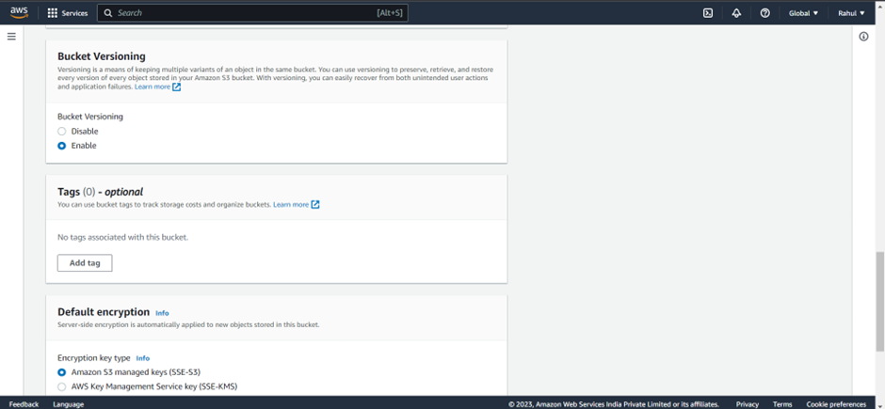

Step 5) Click on the bucket created.

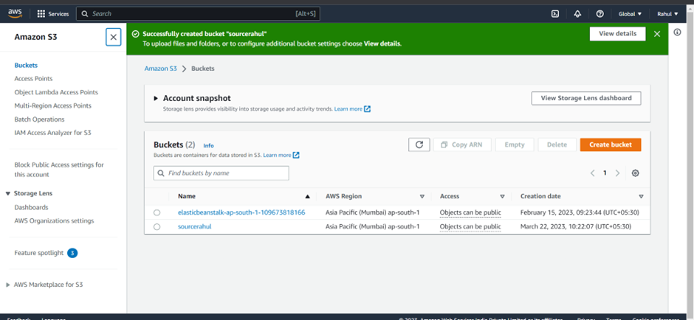

Step 6) Click on upload.

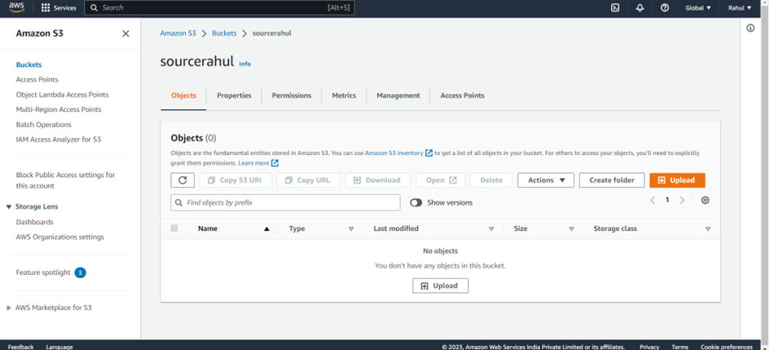

Step 7) Upload any image.

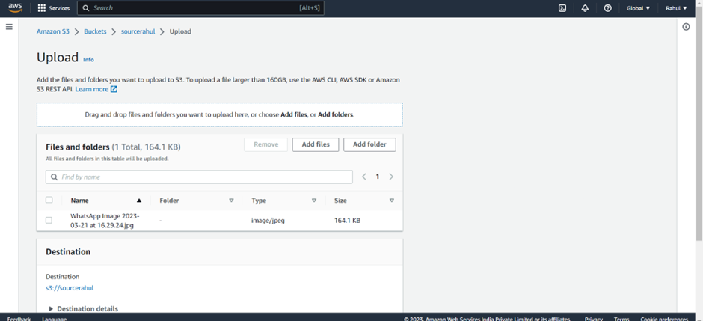

Step 8) Image will be uploaded.

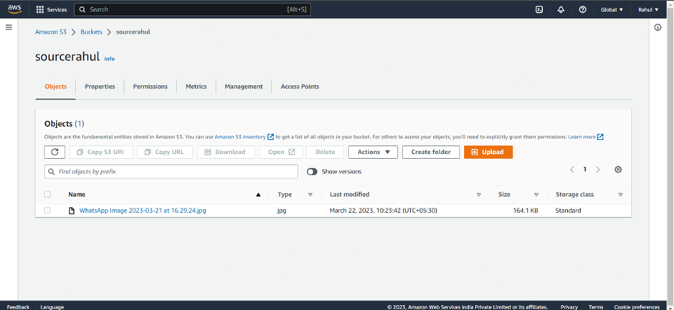

Step 9) Create another destination bucket, and give it a name(destinationbucket).

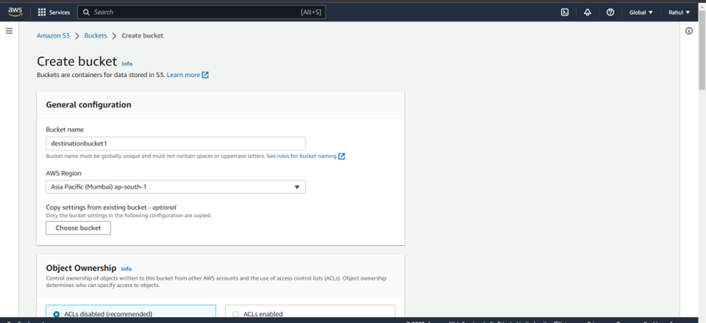

Step 10) Unblock public access.

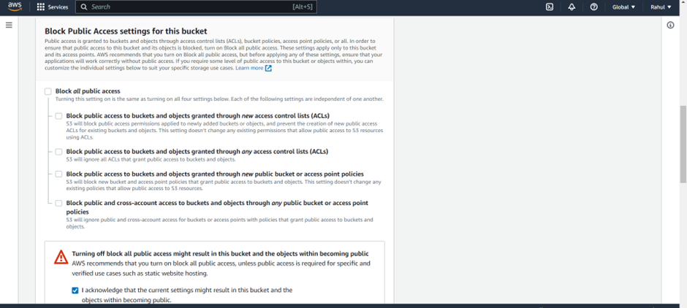

Step 11) Enable bucket versioning.

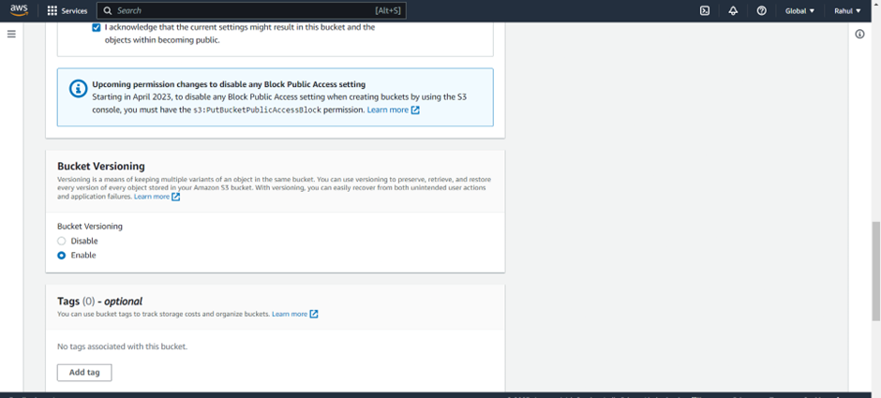

Step 12) Destination bucket will be created.

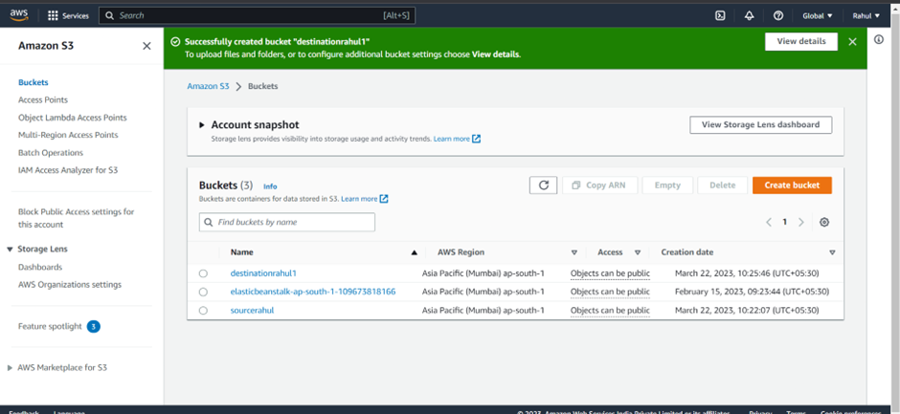

Step 13) Now, go to IAM -> Role -> Create Role.

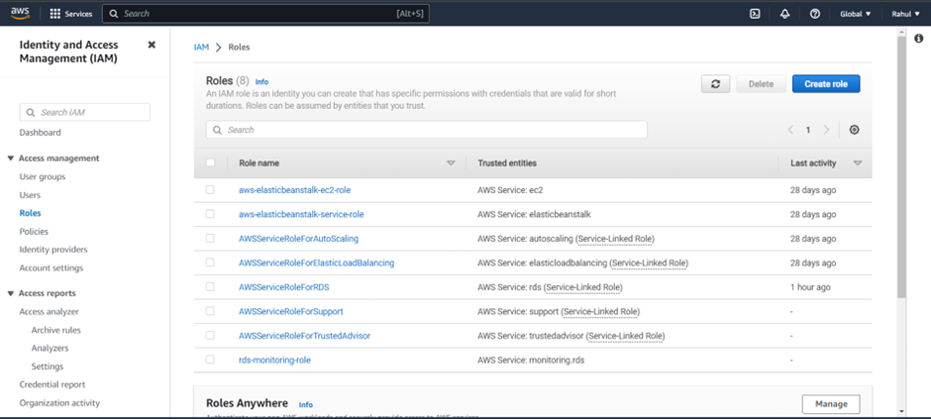

Step 14) Entity type – AWS Service.

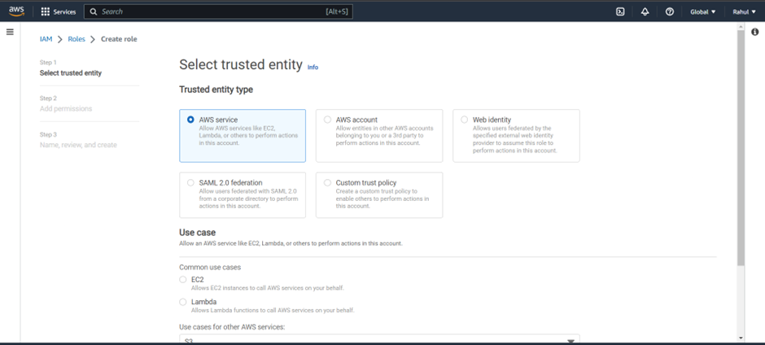

Step 15) Use case -> S3 and click on next.

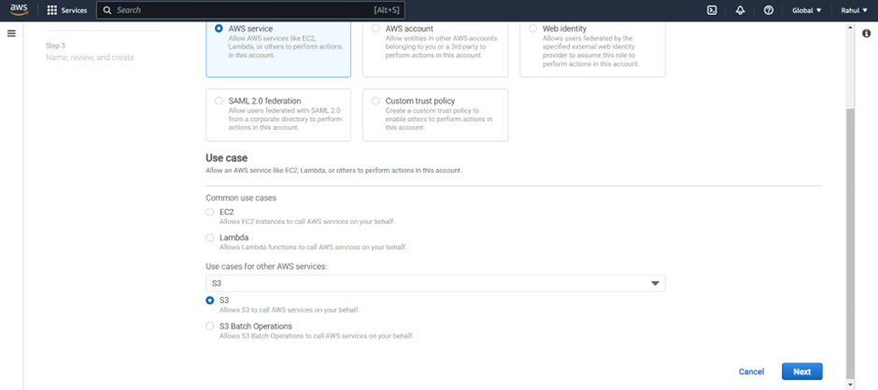

Step 16) Add permissions -> AWS S3 Full Access.

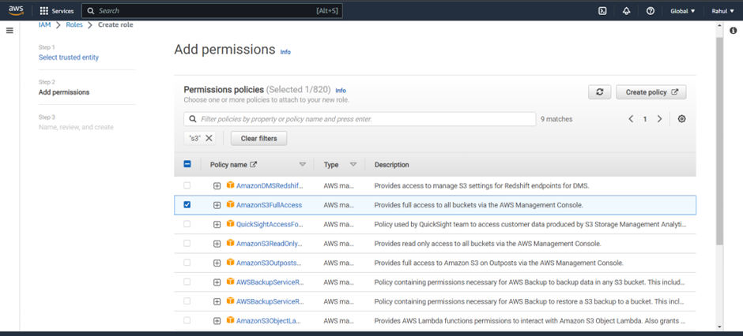

Step 17) Give it a name.

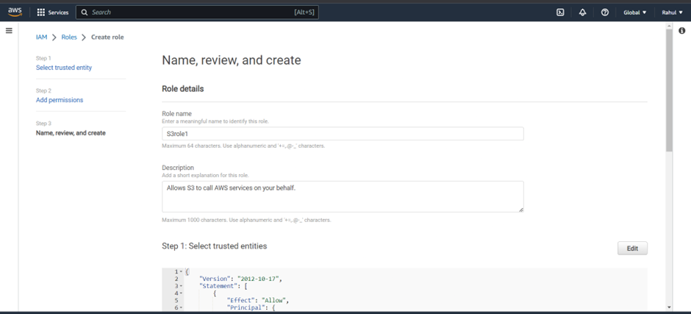

Step 18) Go back to S3, click on source bucket.

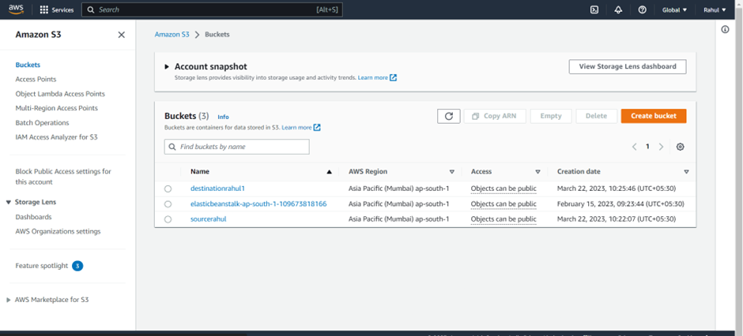

Step 19) Go to management.

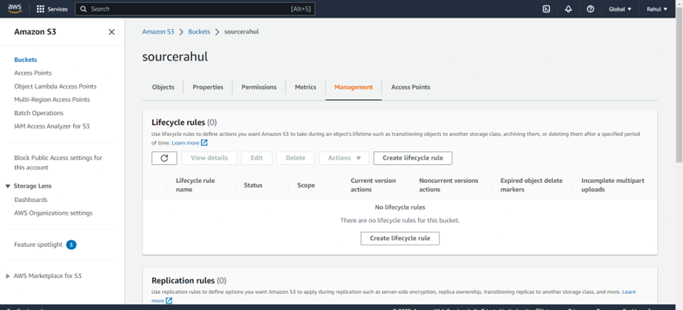

Step 20) Replication rules -> create replication rule.

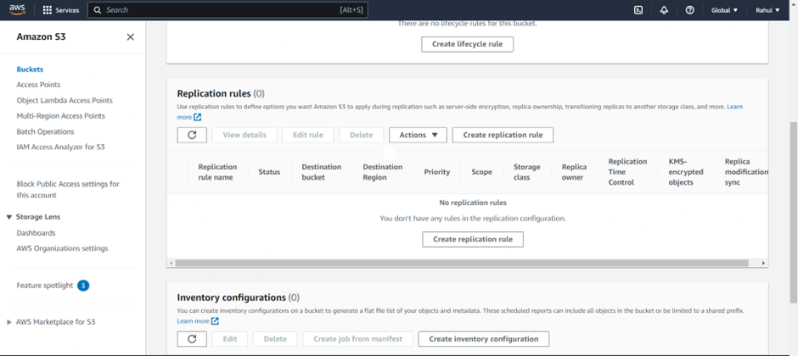

Step 21) Give it a name and status -> enabled.

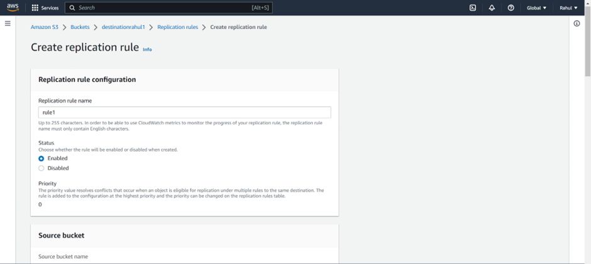

Step 22) Under rule scope select -> Apply to all objects in bucket.

Under Destination browse and select destination bucket.

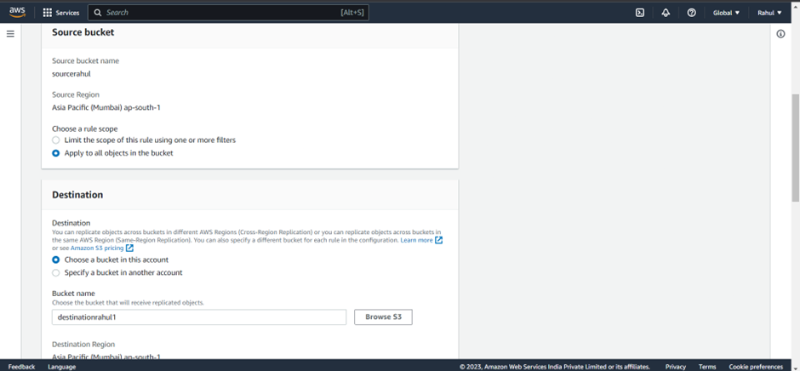

Step 23) Under IAM role select the role created.

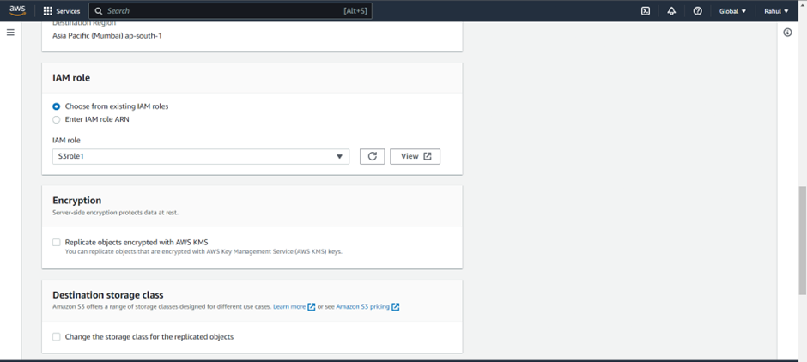

Step 24) Click next and select yes to replicate existing object.

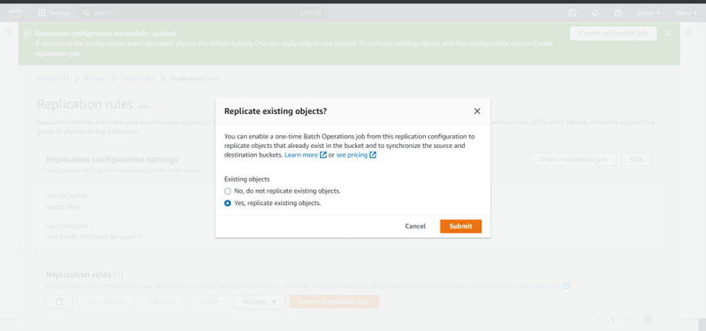

Step 25) Job settings -> automatically run the job when ready.

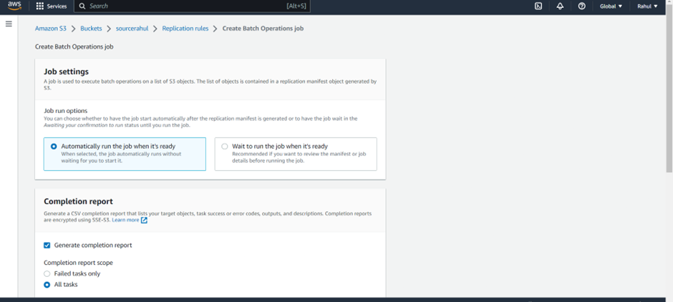

Step 26) Under Completion report, select Generate completion report and all tasks.

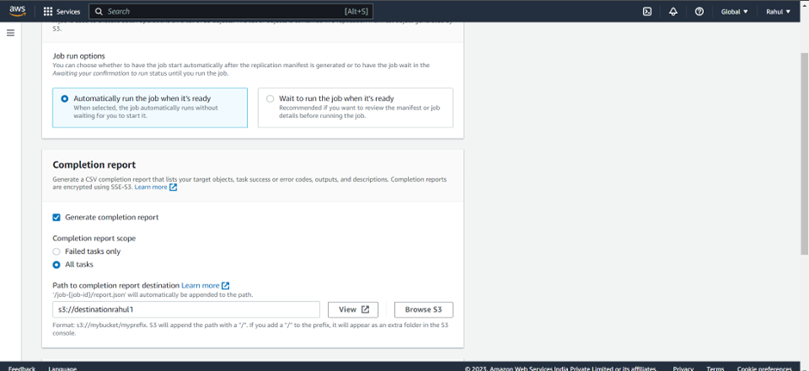

Step 27) Under permissions Choose IAM role created.

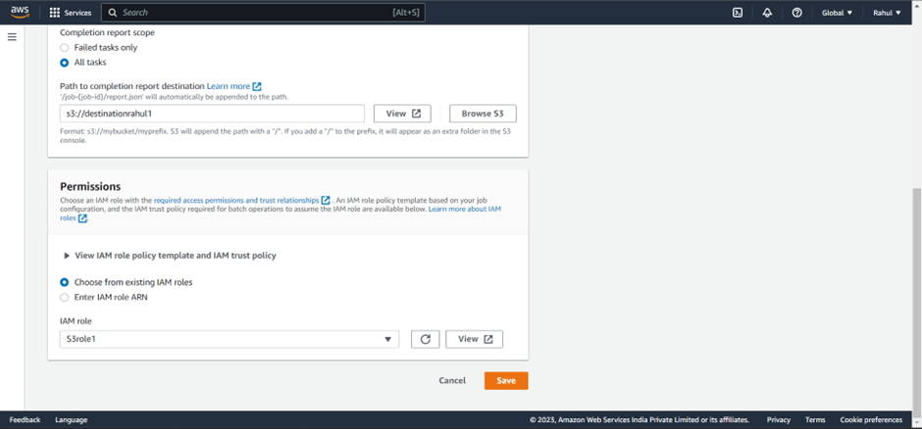

Step 28) The batch operation will take place.

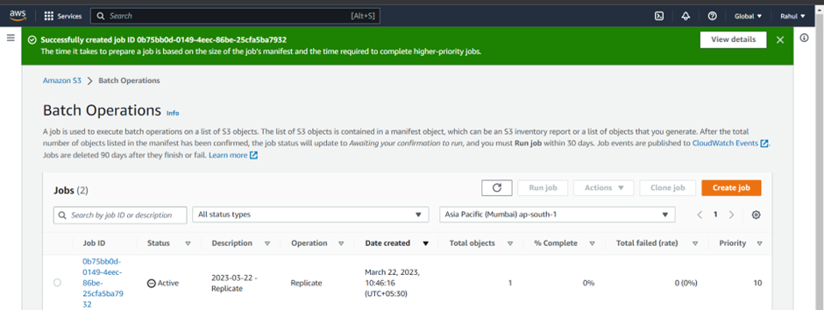

Step 29) After batch operation is completed, go to destination bucket and as we can see the replication has been performed.

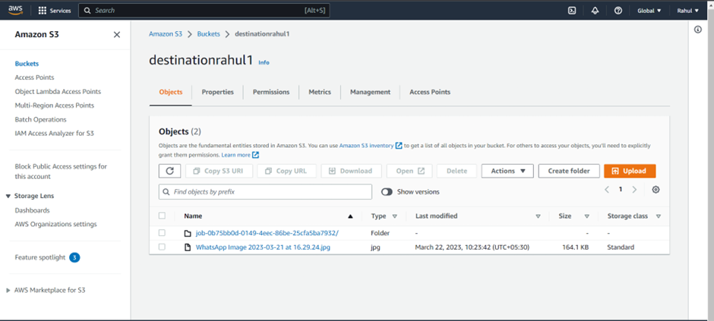

Step 30) Job report.

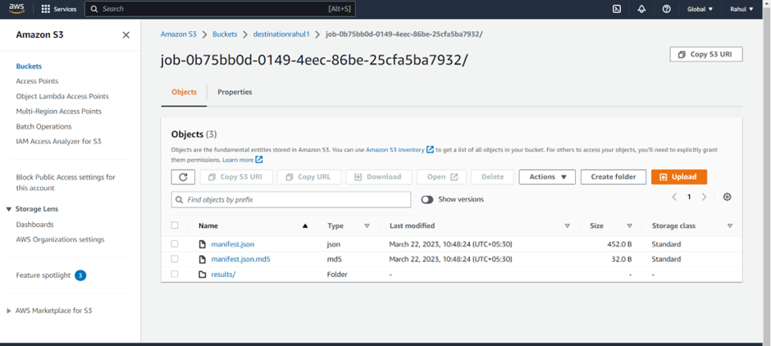

Step 31) Now for a different region, create another bucket in a different region.

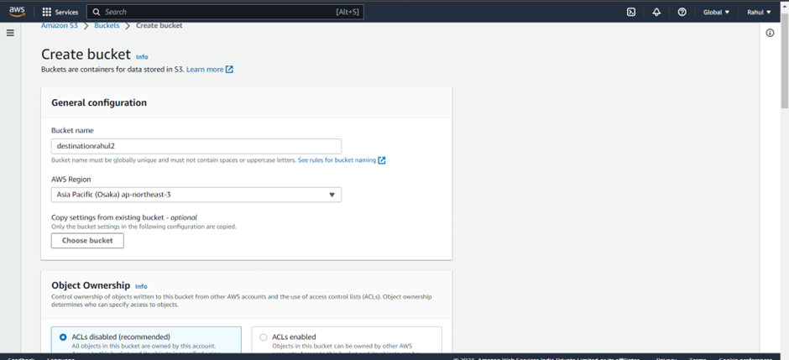

Step 32) As you can see we have created bucket in a different region.

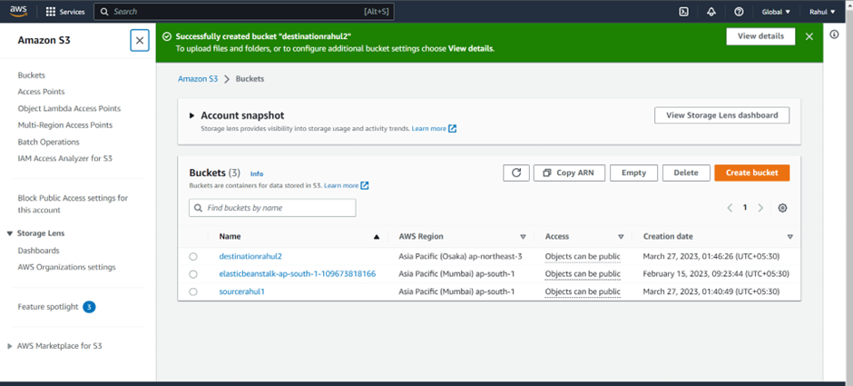

Step 33) Again create replication rule in sourcebucket.

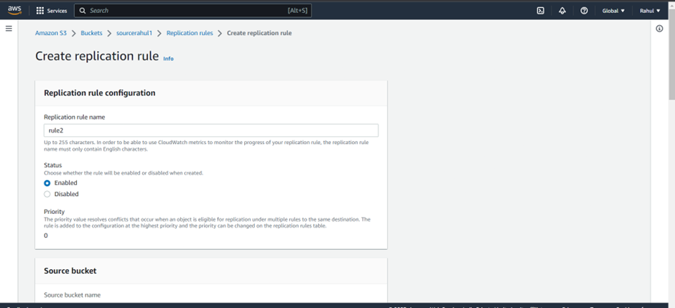

Step 34) Create the same replication rule.



ii) Delete the object through Lifecycle rule creation.

Step 35) Go to Source bucket -> management -> Create lifecycle rule.

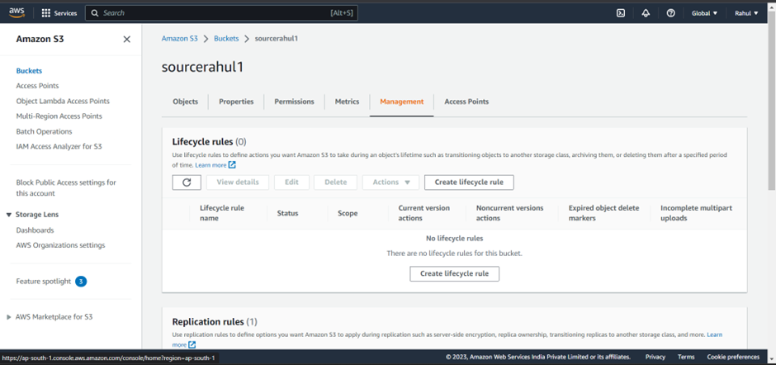

Step 36) Give the role a name, select Apply to all objects.

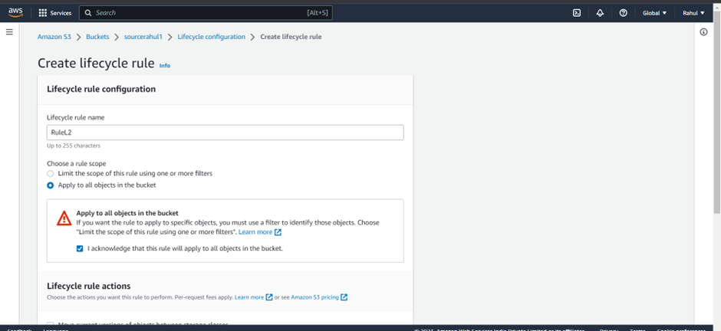

Step 37) Under Lifecycle rule actions select –

• Expire current versions of objects.

• Permanently delete noncurrent versions of objects.

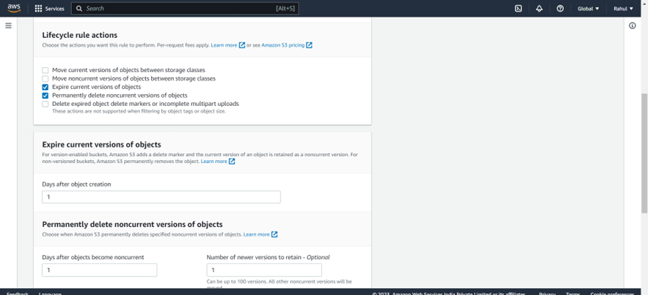

Step 38) Select days after objects will delete.

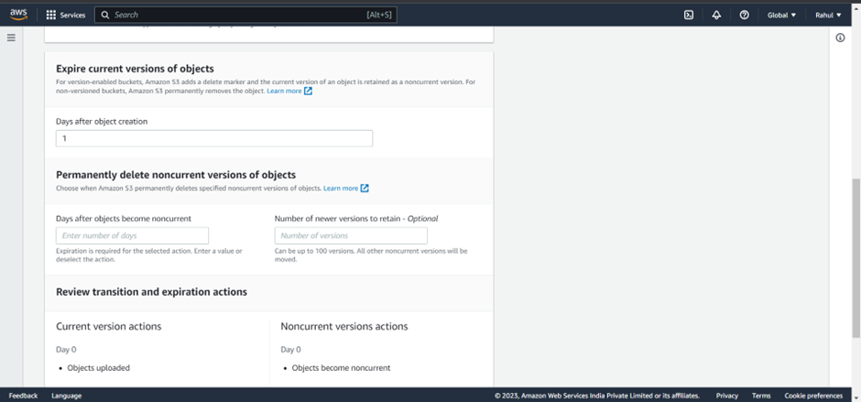

Step 39) Rule created.

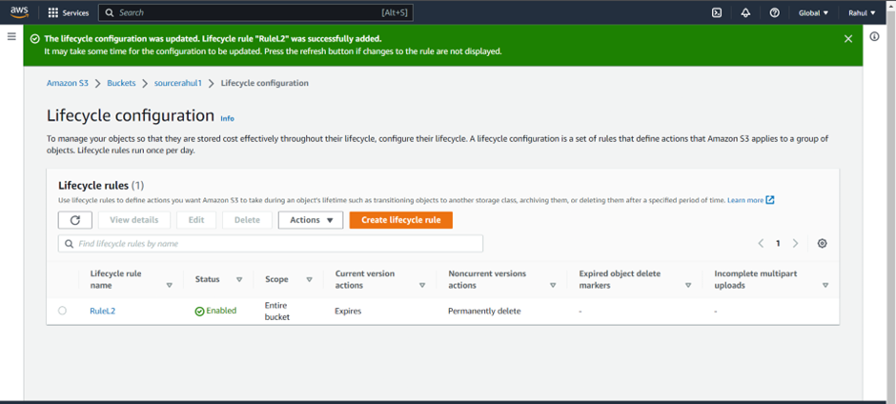

iii) Create a transition action to move the object from one storage class to another.

Step 40) Create another lifecycle rule.

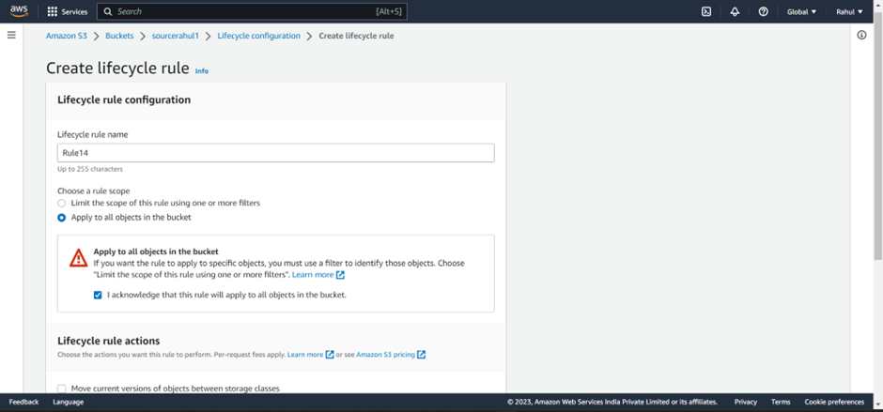

Step 41) Under Lifecycle rule actions, select - Move current versions of objects between storage classes.

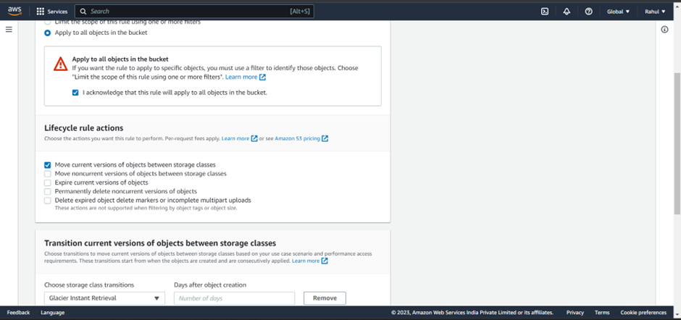

Step 42) Under Transition current versions of objects between storage classes,

Select storage class – Glacier instant retrieval, days and create rule.

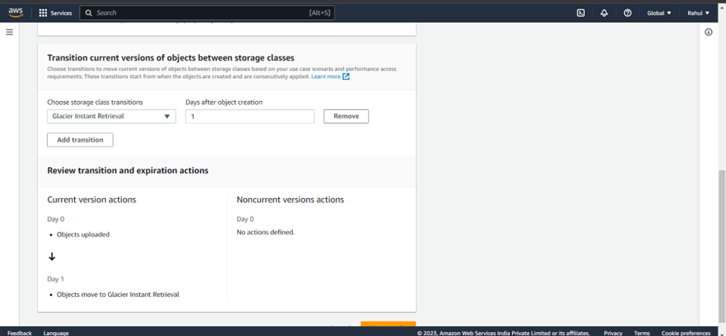

Step 43) Rule created.

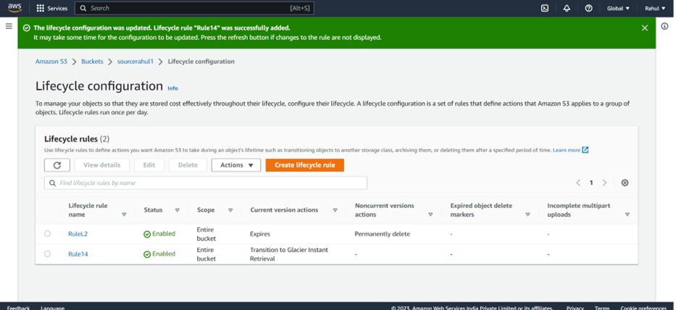

**Experiment -10**

Creating, Starting and Stopping EC2 instances using AWS Lambda

**Q:1.** What is AWS Lambda? Explain the working and benefits of AWS lambda in detail.

**Ans:** AWS Lambda is a serverless compute service offered by Amazon Web Services (AWS) that allows developers to run code without having to manage servers or infrastructure. It is a popular choice for building event-driven applications and microservices because it can automatically scale up or down to handle changes in application traffic.

The basic working of AWS Lambda is that it allows developers to write code in a variety of programming languages, including Node.js, Python, Java, C#, and Go, and then upload that code to AWS Lambda. The developer can then specify when and how that code should be executed by creating a trigger for the Lambda function. Triggers can be anything from changes to an S3 bucket, a new message in an SQS queue, or a new event in an Amazon EventBridge event bus. Once the trigger condition is met, AWS Lambda executes the code and returns the results to the calling application.

One of the key benefits of AWS Lambda is its scalability. Because Lambda automatically scales up or down to handle changes in application traffic, developers don't need to worry about provisioning and managing servers. This makes it easier to build and deploy event-driven applications and microservices that can quickly and seamlessly respond to changes in application usage.

Another benefit of AWS Lambda is its cost-effectiveness. With traditional server-based architecture, developers have to pay for servers whether they are being used or not. With AWS Lambda, developers only pay for the compute time that their code actually uses. This means that they can build and run applications at a much lower cost, which makes it more accessible for small businesses and startups.

Additionally, AWS Lambda supports a wide variety of integrations with other AWS services, such as Amazon S3, Amazon DynamoDB, and Amazon EventBridge. This makes it easier to build complex, event-driven applications that can leverage the power of AWS's entire suite of cloud services.

**Q:2.** Explain in detail the use cases of AWS Lambda.

**Ans:** AWS Lambda is a serverless compute service that offers a wide range of use cases for developers. Here are some of the most common use cases for AWS Lambda:

1. Event-driven applications: AWS Lambda is designed for building event-driven applications that respond to changes in data or user behavior. For example, developers can use Lambda to automatically process new data uploaded to an S3 bucket, to trigger a notification when a new record is added to a DynamoDB table, or to analyze log data in real-time.
2. Microservices: AWS Lambda is well-suited for building microservices that can be used in a variety of different applications. Developers can build small, independent functions that can be reused across multiple applications, which makes it easier to maintain and update code over time.
3. Data processing: AWS Lambda can be used for processing large amounts of data, such as image or video files. Developers can write code to process data in parallel, which can help reduce processing time and improve performance.
4. Chatbots: AWS Lambda is commonly used for building chatbots that can be integrated with messaging platforms like Slack or Facebook Messenger. Developers can write code that listens for new messages, processes the text input, and returns a response.
5. IoT applications: AWS Lambda is well-suited for building IoT applications that can process data from sensors and other devices. Developers can write code that listens for new data from devices, processes that data, and triggers actions based on the results.
6. Mobile backends: AWS Lambda can be used to build mobile backends that can process data from mobile devices and trigger actions based on that data. For example, developers can write code that processes location data from a mobile device and triggers notifications based on that data.
7. Batch processing: AWS Lambda can be used for batch processing of large data sets. Developers can write code to process data in batches, which can help reduce processing time and improve performance.

Step 1) Go to IAM and Create a policy .

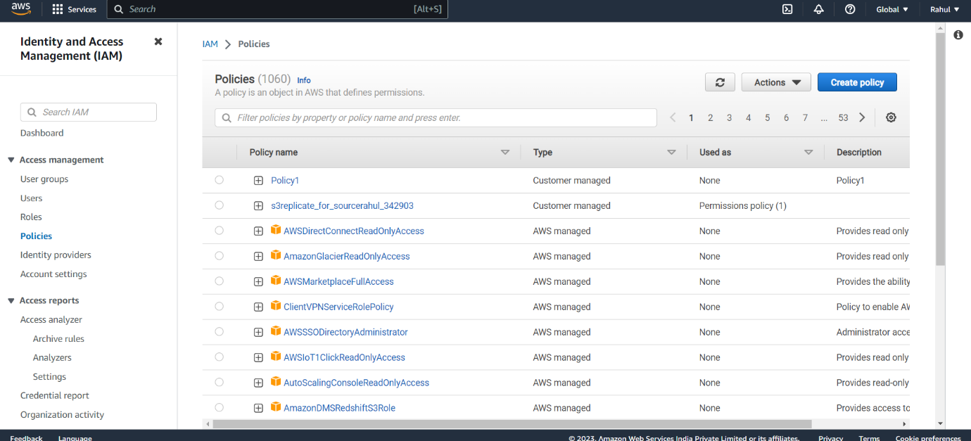

Step 2) Under Json paste the following script.

{

"Version": "2012-10-17",

"Statement": [

{

"Effect": "Allow",

"Action": [

"logs:CreateLogGroup",

"logs:CreateLogStream",

"logs:PutLogEvents"

],

"Resource": "arn:aws:logs:*:*:*"

},

{

"Action": [

"ec2:RunInstances"

],

"Effect": "Allow",

"Resource": "*"

}

]

}

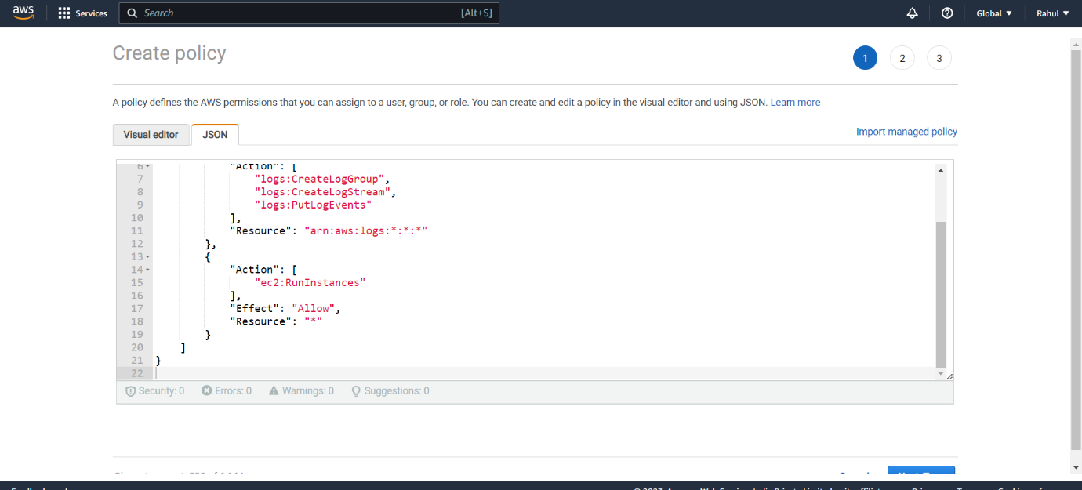

Step 3) And Create the Policy

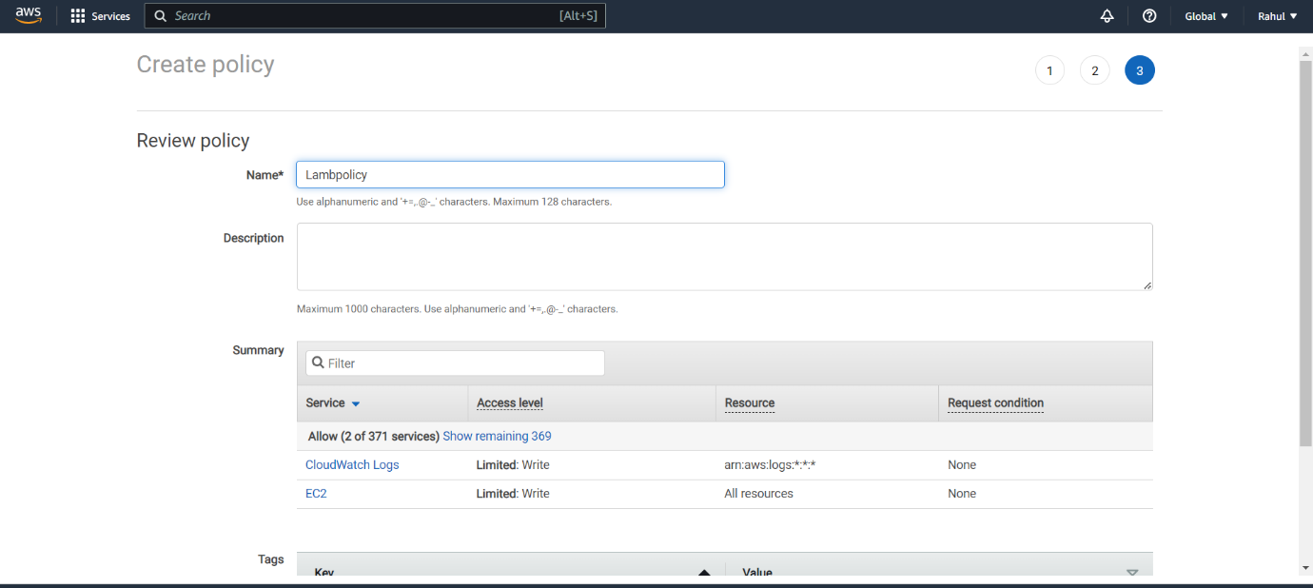

Step 4) Go to roles -> create Role.

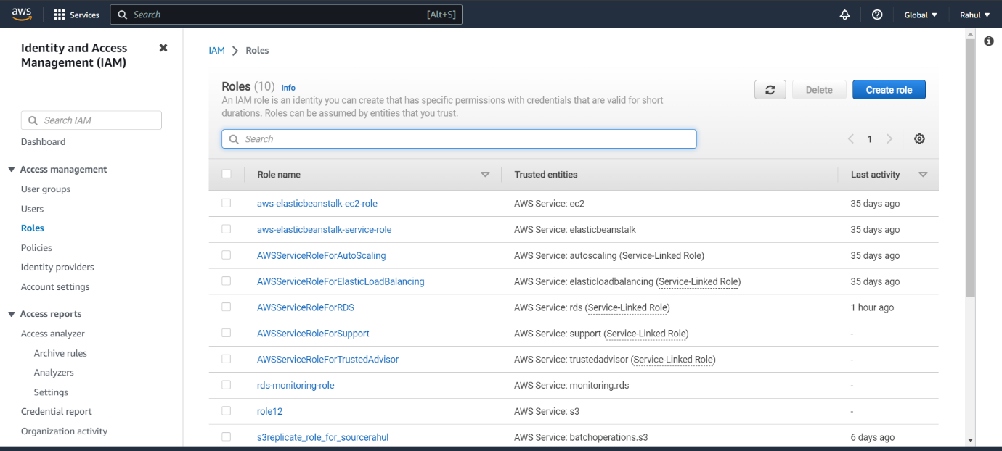

Step 5) Entity type -> AWS Service.

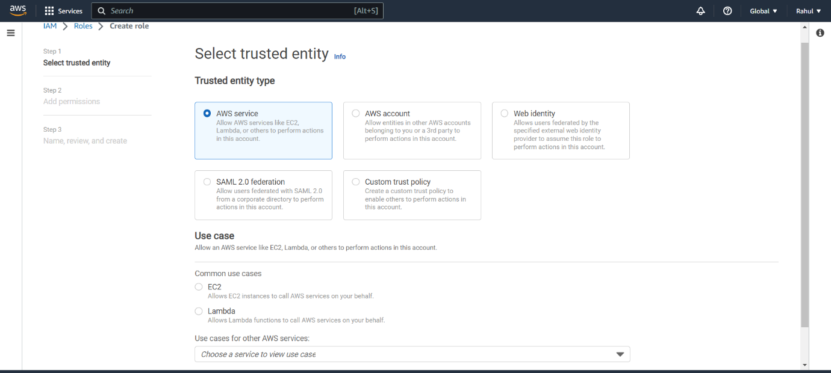

Step 6) Use case -> Lambda.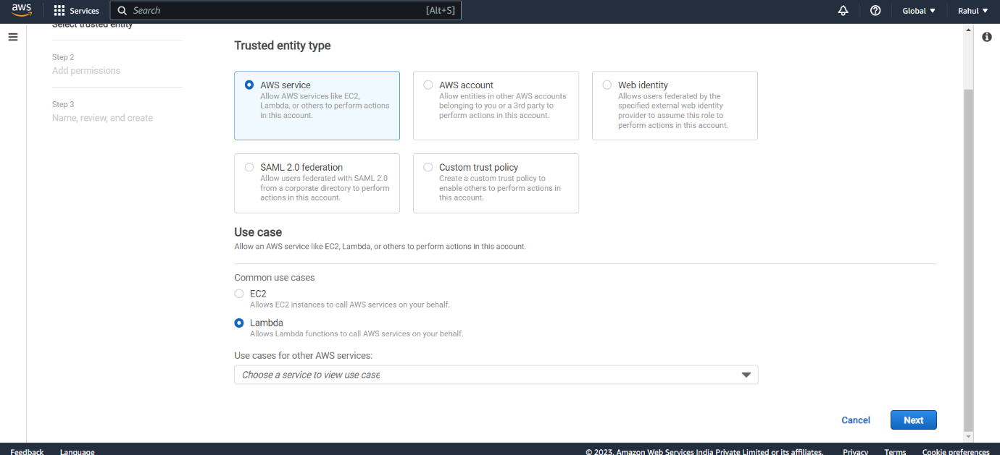

Step 7) Attach the policy created before.

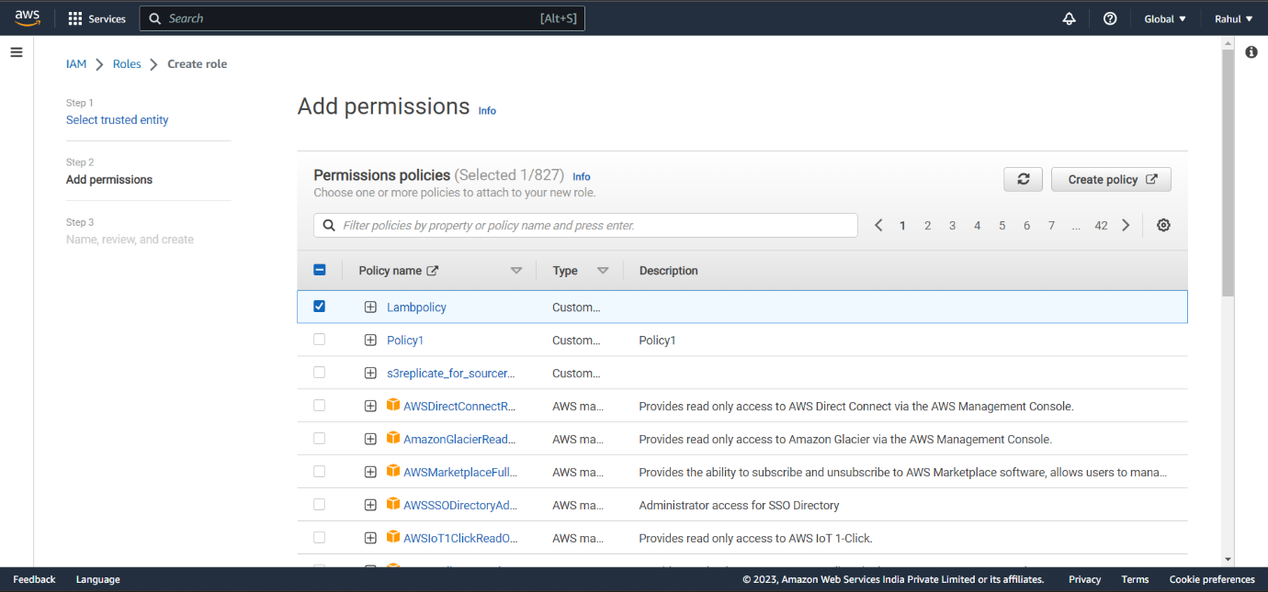

Step 8) Give it a name and create Role.

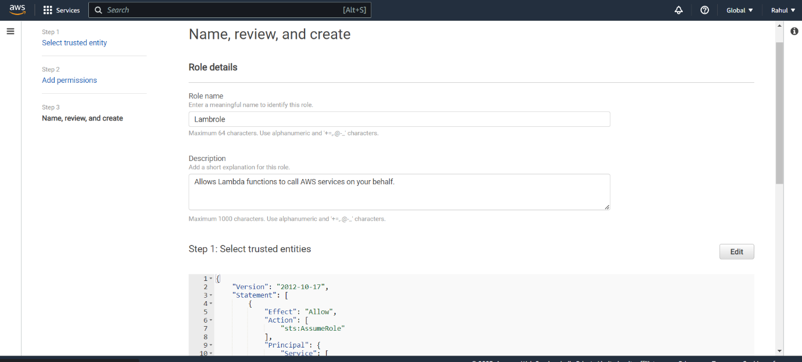

Step 9) Go to AWS Lambda -> Create a function.

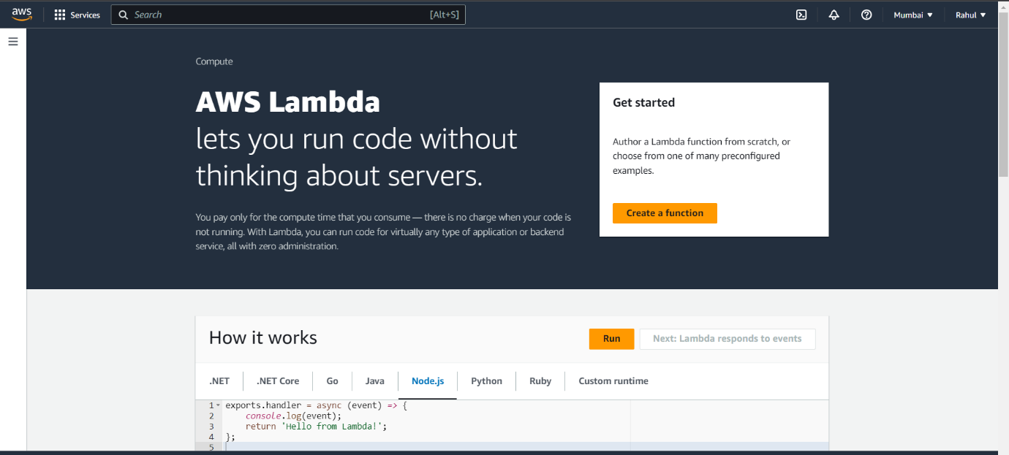

Step 10) Let everything be default , give it a name, Runtime -> Python.

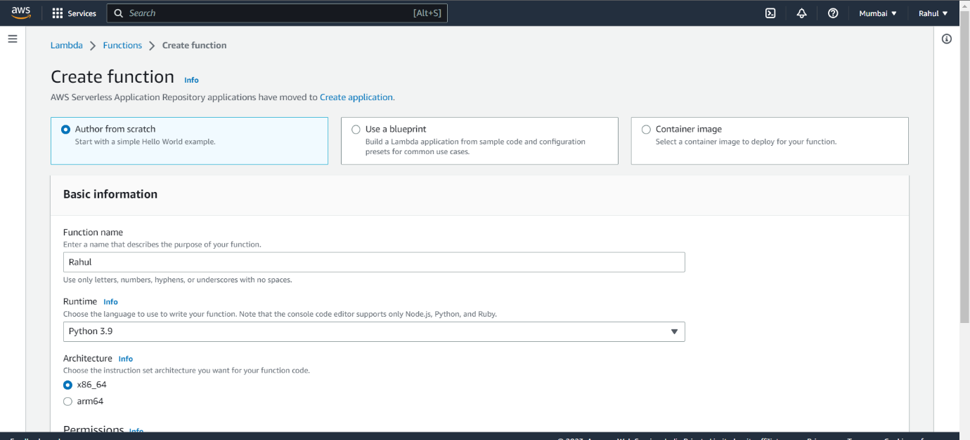

Step 11) Under permissions select the role you created and create the function.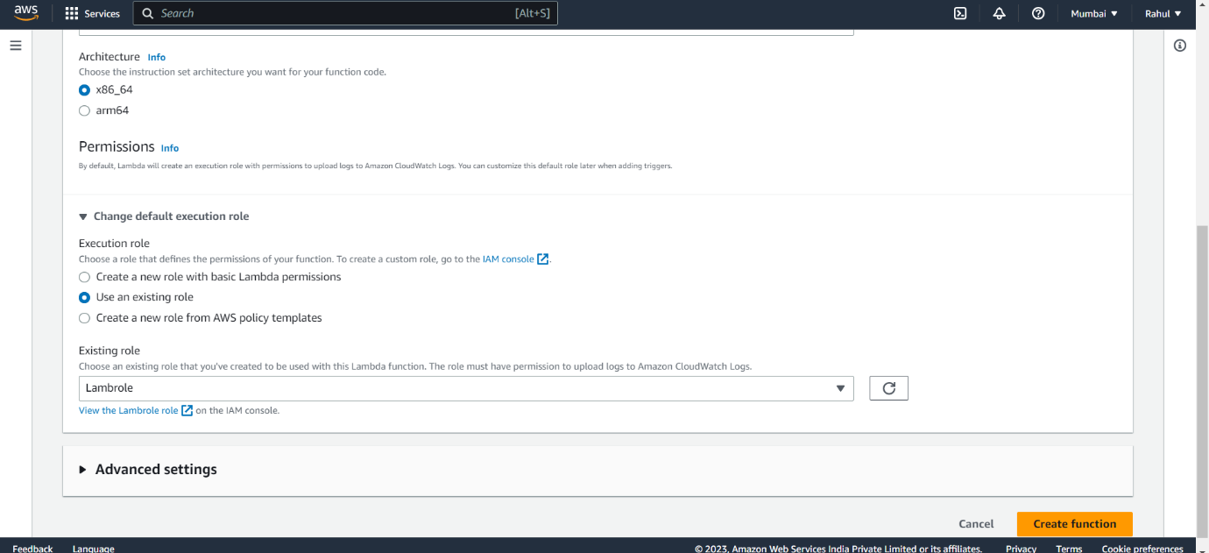

Step 12) Function created.

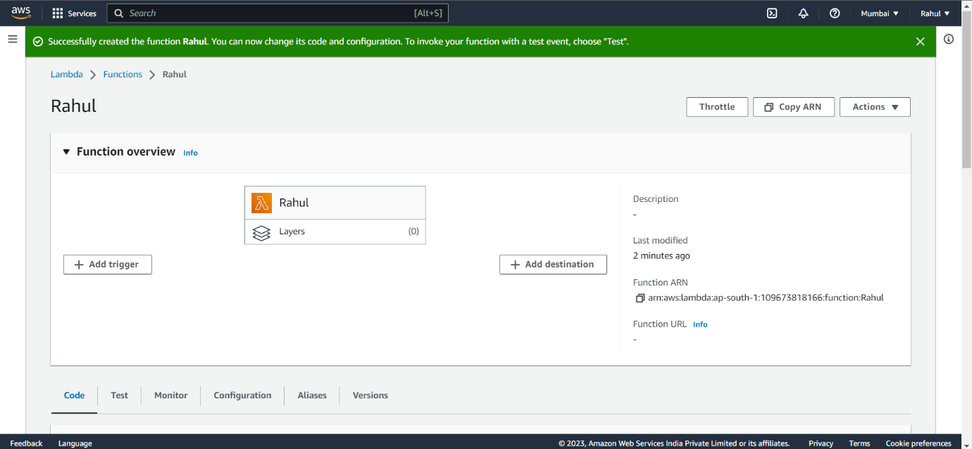

Step 13) Go to CODE and paste the following code.

import os

import boto3

AMI = os.environ['AMI']

INSTANCE_TYPE = os.environ['INSTANCE_TYPE']

KEY_NAME = os.environ['KEY_NAME']

SUBNET_ID=os.environ['SUBNET_ID']

REGION=os.environ['REGION']

ec2 = boto3.resource('ec2',region_name=REGION)

def lambda_handler(event, context):

instance = ec2.create_instances(

ImageId=AMI,

InstanceType=INSTANCE_TYPE,

KeyName=KEY_NAME,

SubnetId=SUBNET_ID,

MaxCount=1,

MinCount=1

)

print("New instance created:", instance[0].id)

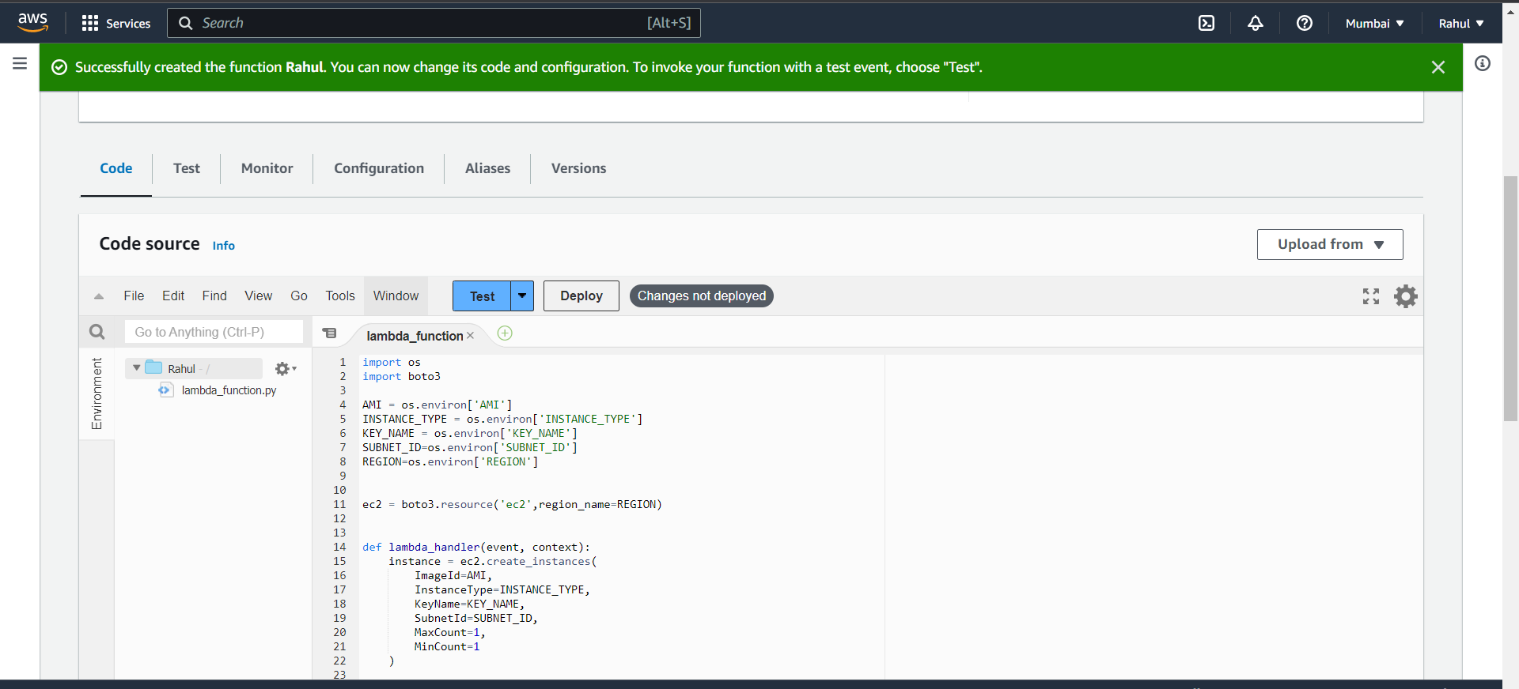

Step 14) Go to configuration -> Environment variables -> edit.

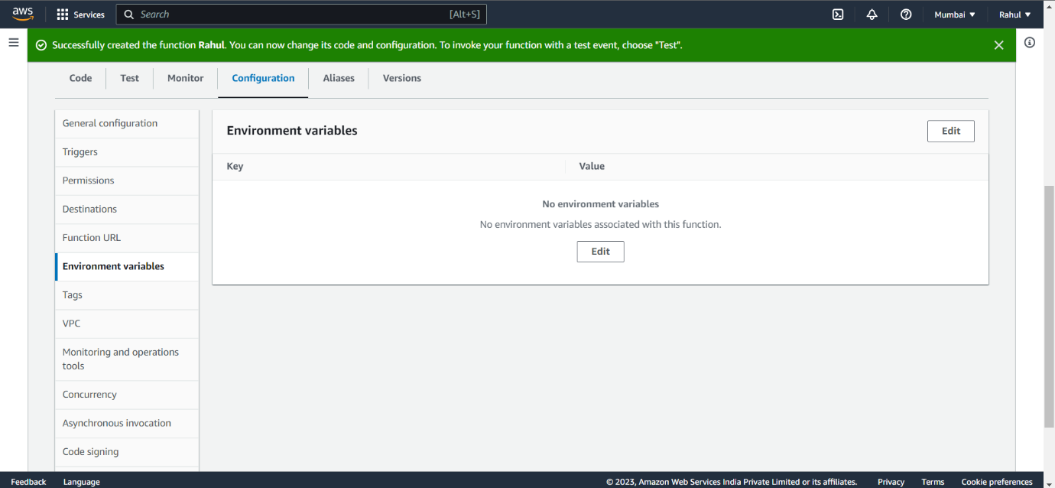

Step 15) Add environment variables.

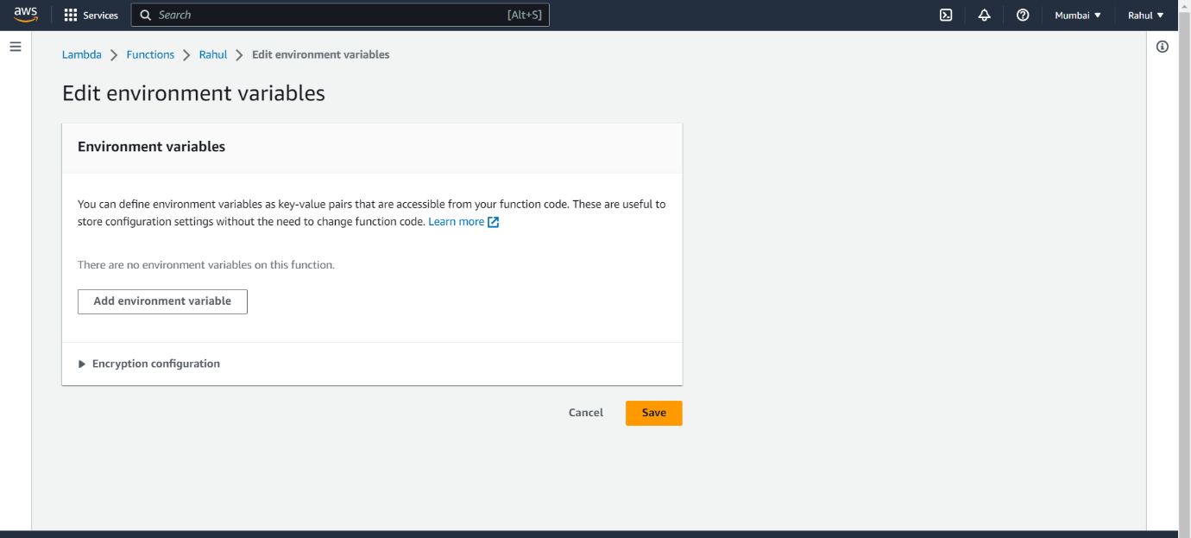

Step 16) Copy a Windows AMI ID from AMI Catalog.

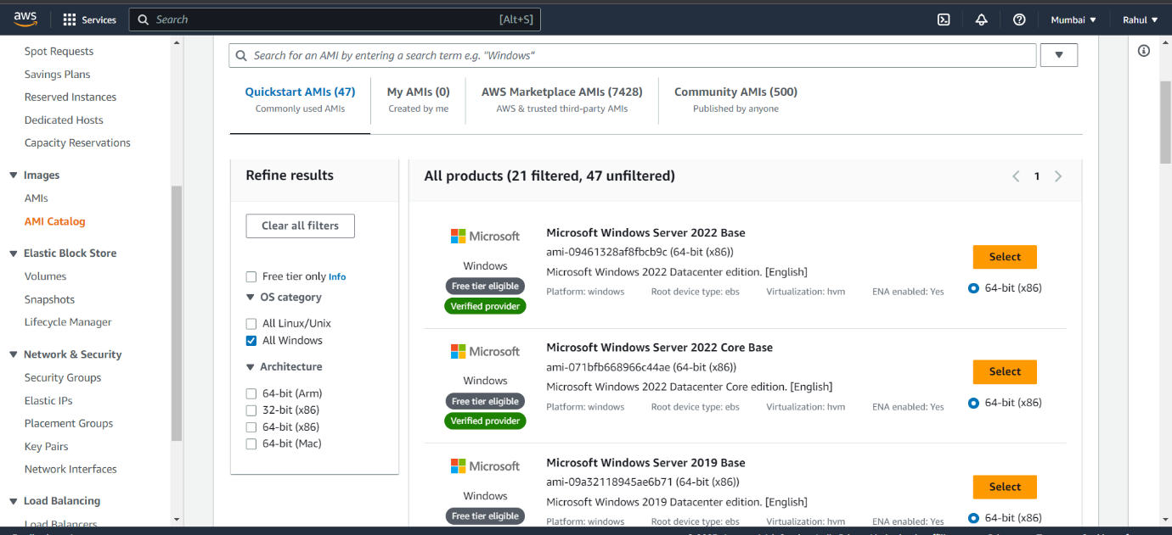

Step 17) For subnet ID, go to VPC-> Subnet and select the vpc in your region.

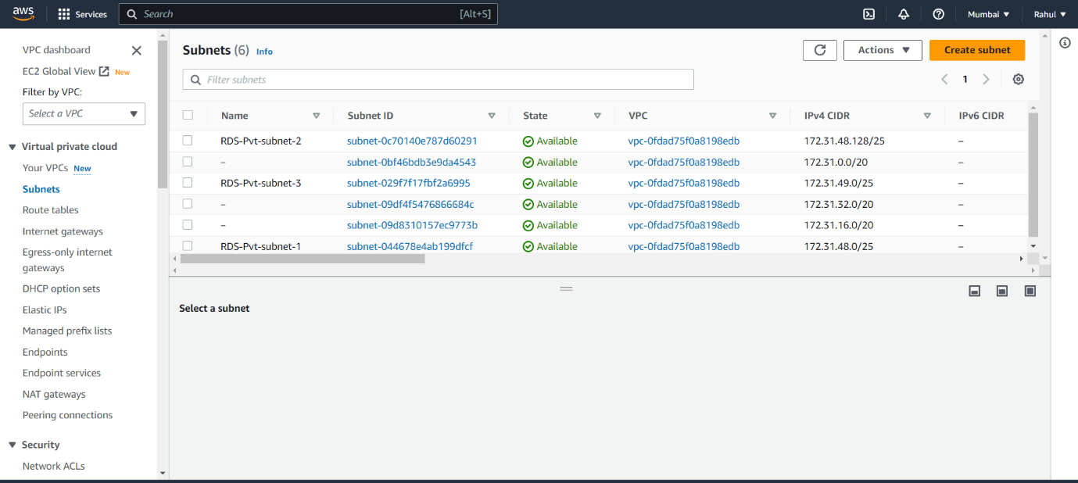

Step 18) Add the following environment variables

* AMI - ami-09461328af8fbcb9c
* INSTANCE_TYPE - t2.micro
* KEY_NAME - (Any key you created)
* SUBNET_ID – (Subnet copied from VPC->Subnets)
* REGION – (The region you’re in)

And save it.

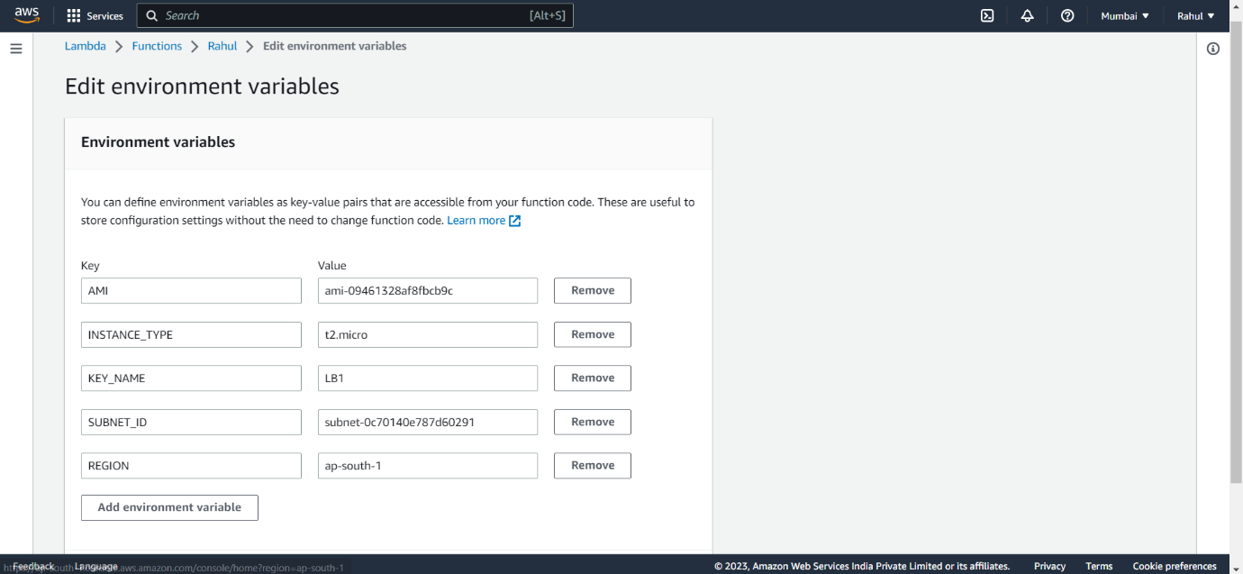

Step 19) Go back to CODE and click on Deploy.

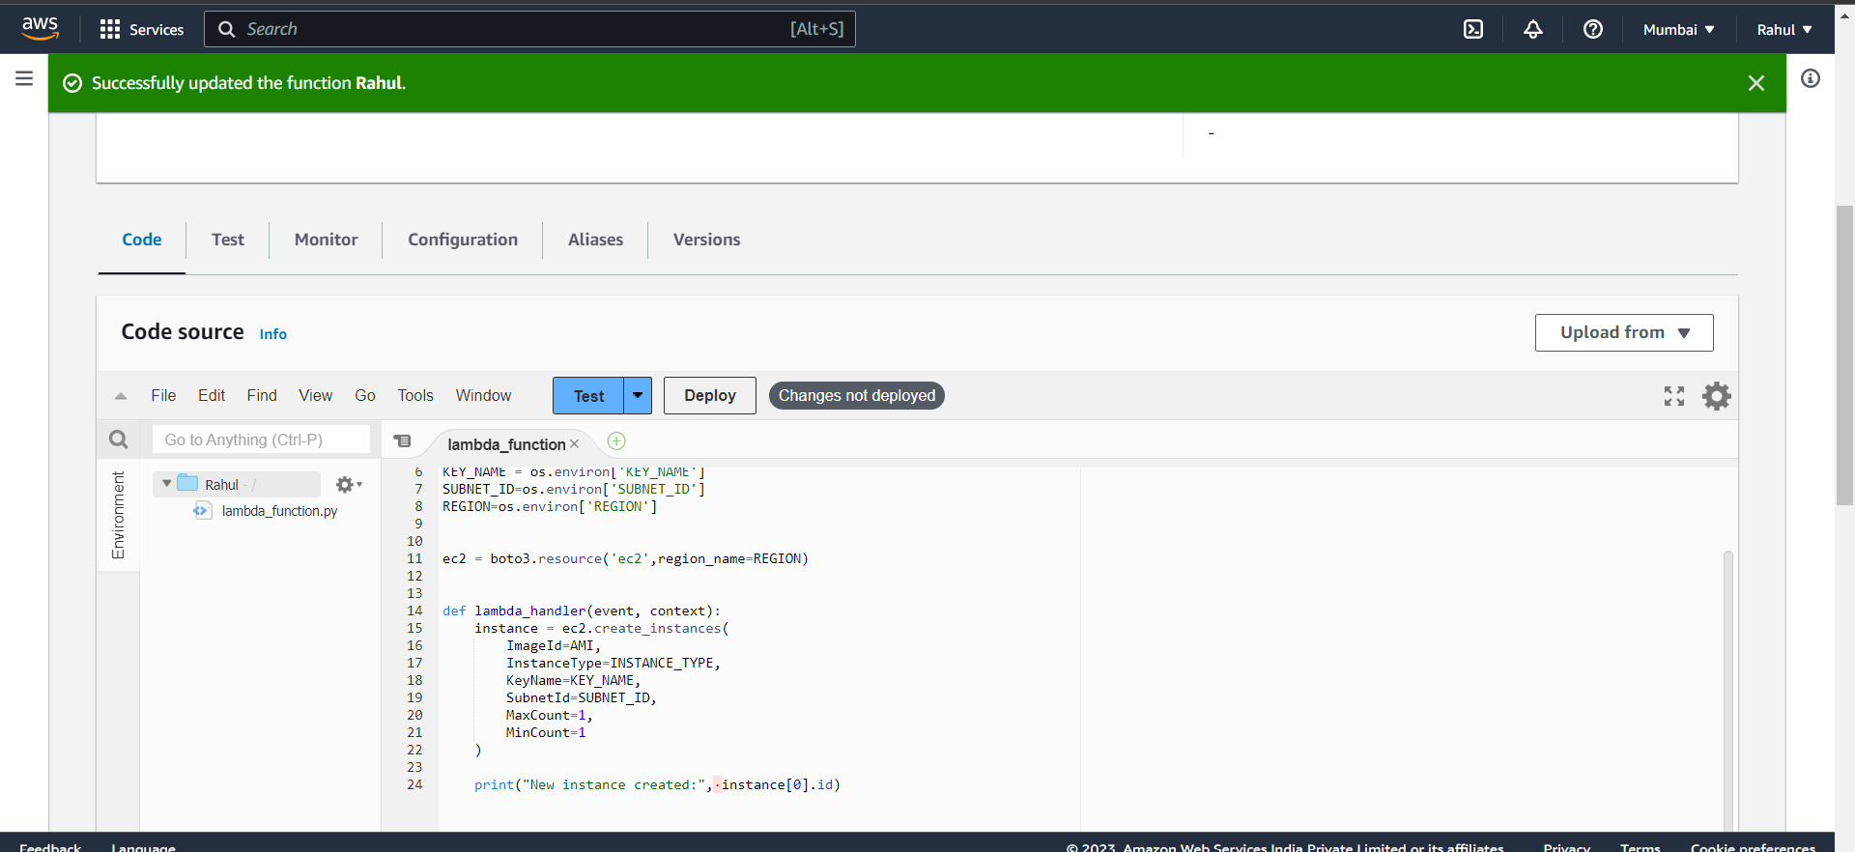

Step 20) Now after deploying click on test, give it a name, and select sharable.

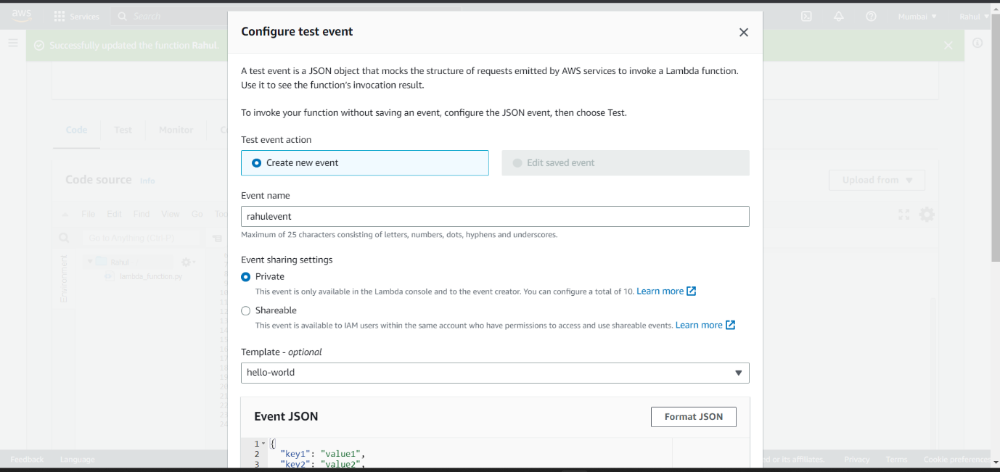

Step 21) Successfully executed.

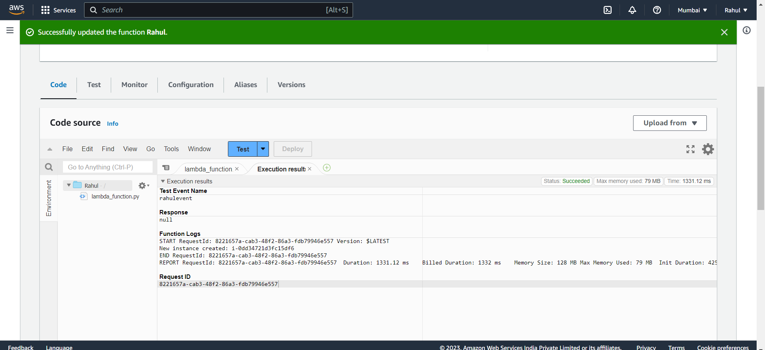

Step 22) As you can see instance created.

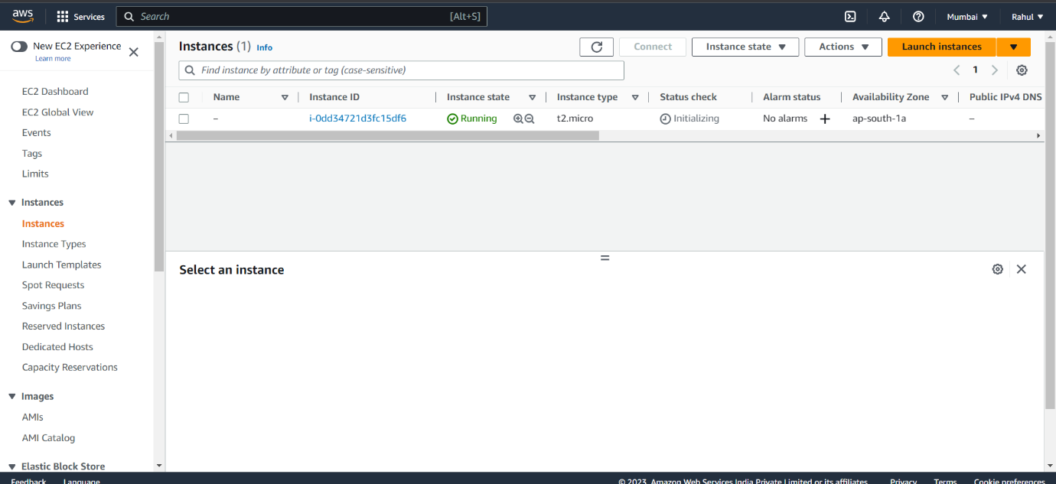

**To stop the instance**

Step 23) Now go back to IAM -> policies -> Create policy.

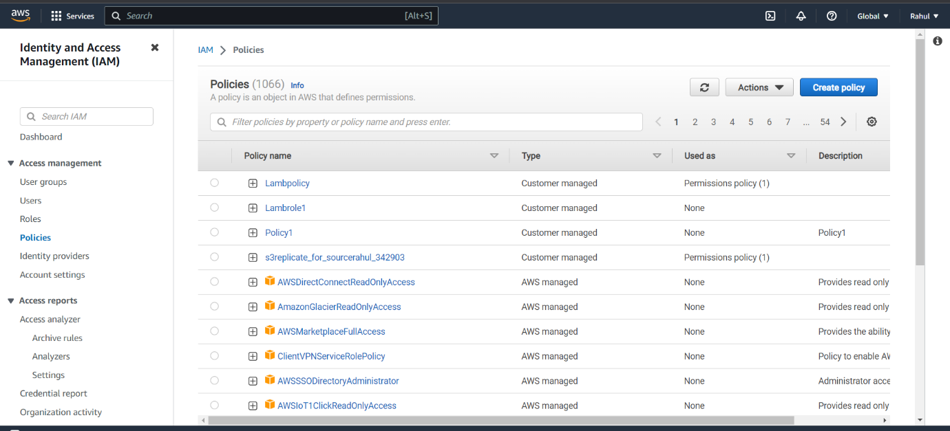

Step 24) And under JSON Paste the following script.

{

"Version": "2012-10-17",

"Statement": [

{

"Effect": "Allow",

"Action": [

"logs:CreateLogGroup",

"logs:CreateLogStream",

"logs:PutLogEvents"

],

"Resource": "arn:aws:logs:*:*:*"

},

{

"Effect": "Allow",

"Action": [

"ec2:Start*",

"ec2:Stop*"

],

"Resource": "*"

}

]

}

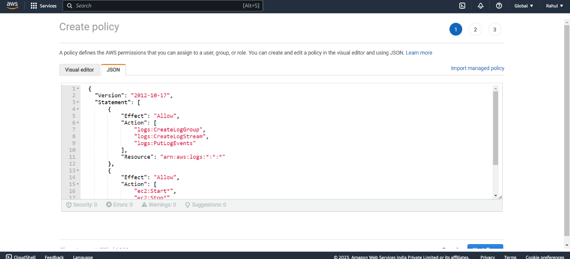

Step 25) Give it a name and save.

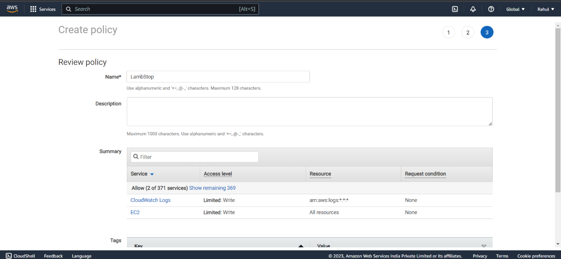

Step 26) Go to roles -> Create role.

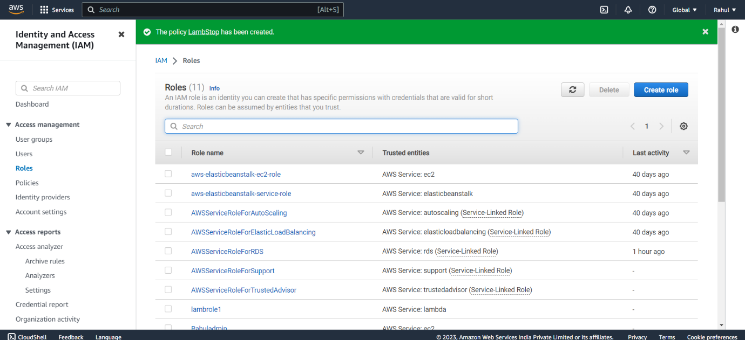

Step 27) Entity type -> AWS service, use case -> Lambda.

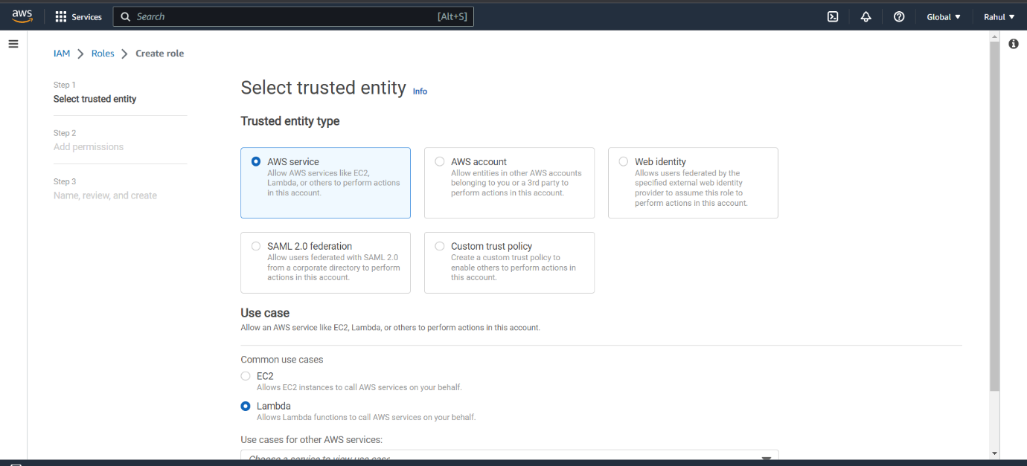

Step 28) Attach the stop policy created before.

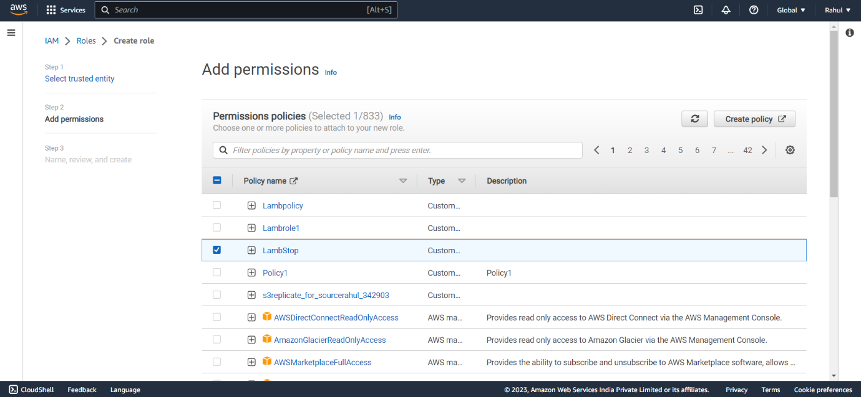

Step 29) Give it a name and create role.

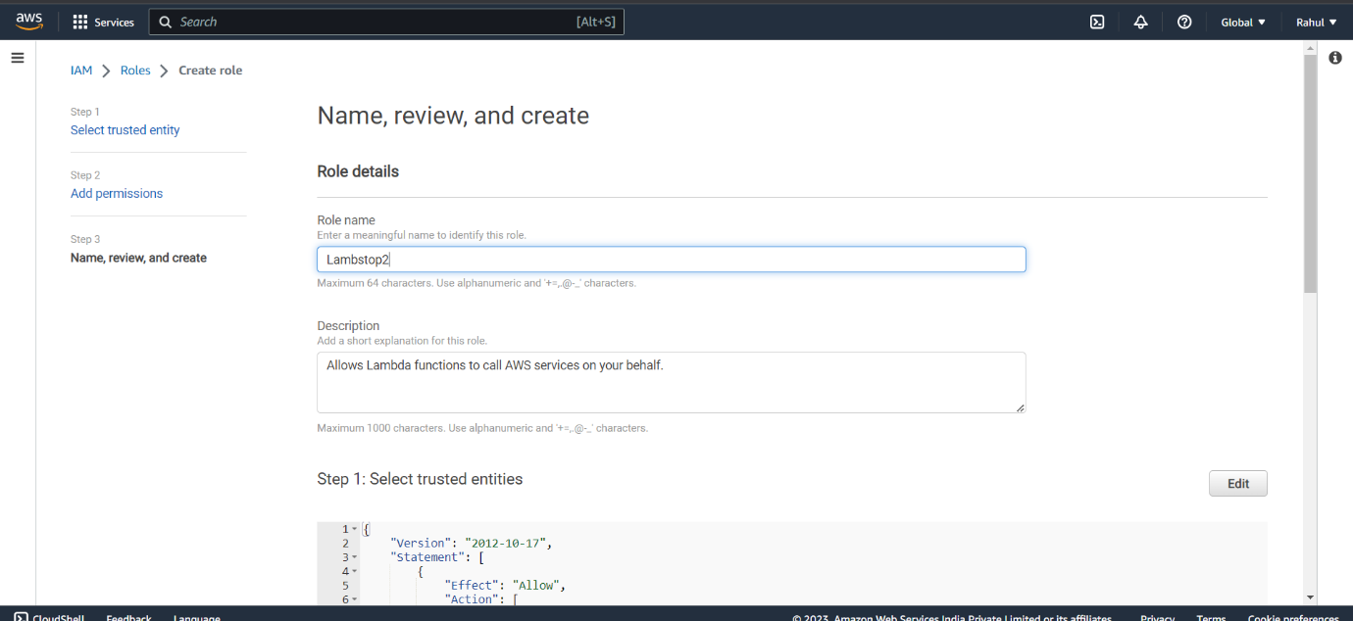

Step 30) Go to Lambda- >Create function,

Give the function a name, runtime - > Python.

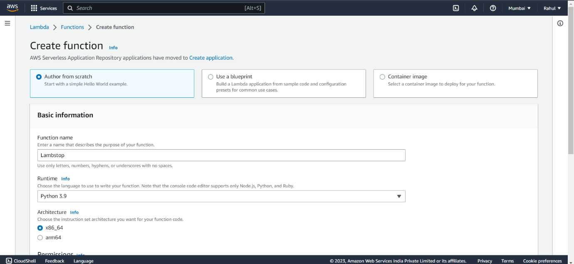

Step 31) Select the stop role created and create function.

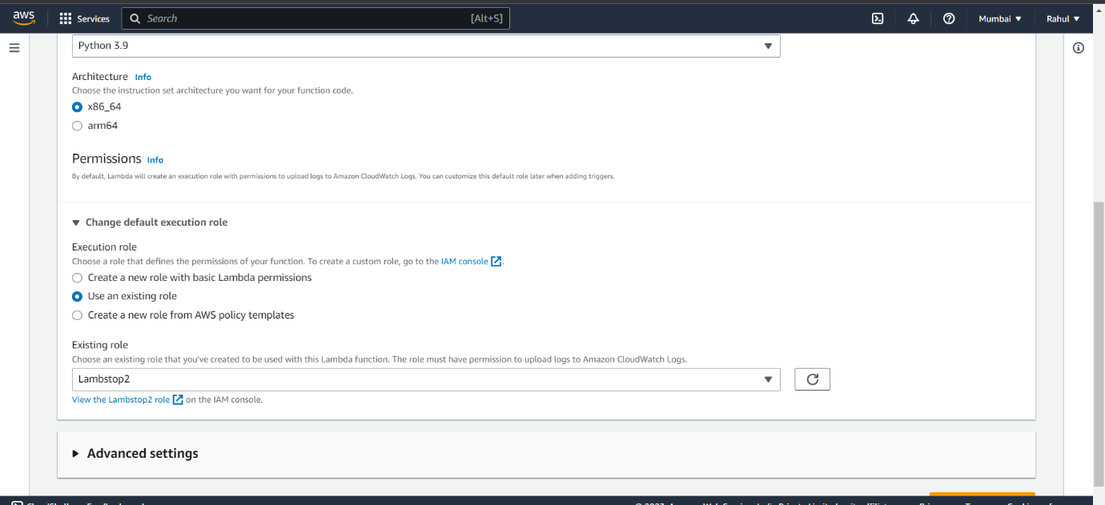

Step 32) After function is created, go to CODE and paste the following script.

import boto3

region = 'ap-south-1'

instances = ['i-0f89ee6c8705f2e61']

ec2 = boto3.client('ec2', region_name=region)

def lambda_handler(event, context):

ec2.stop_instances(InstanceIds=instances)

print('stopping your instances: ' + str(instances))

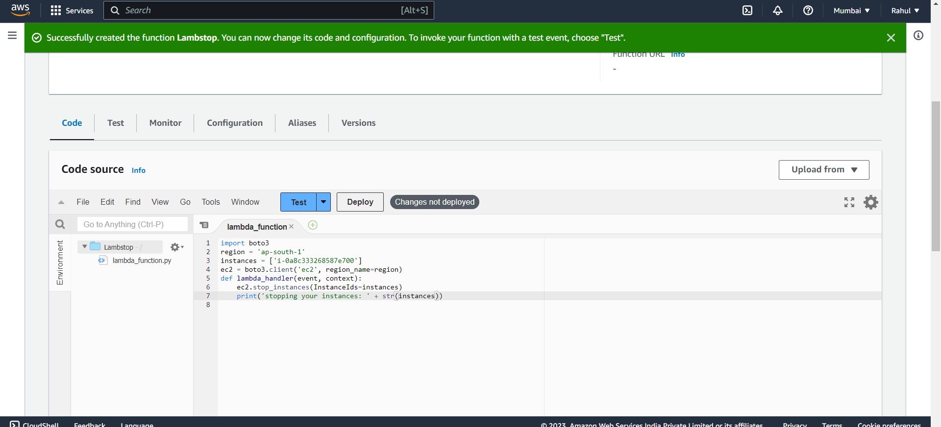Step 33) Deploy and test the code.

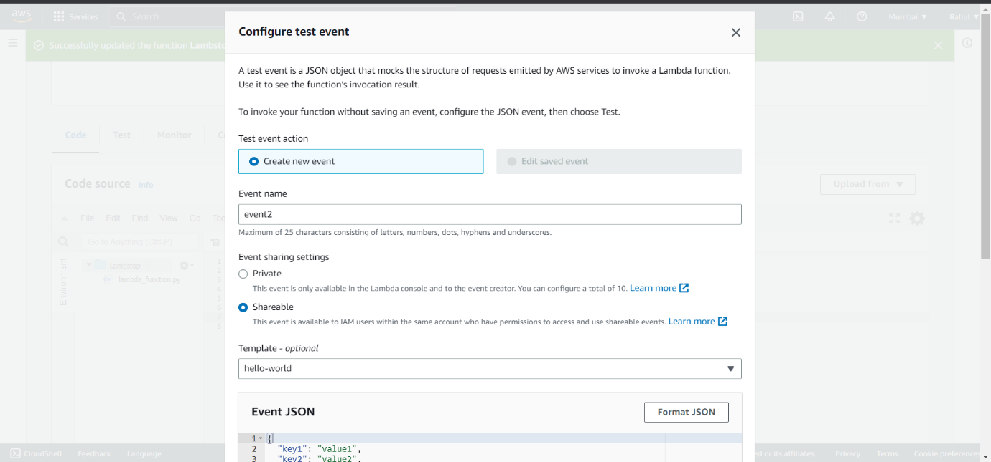Step 34) Code successfully tested.

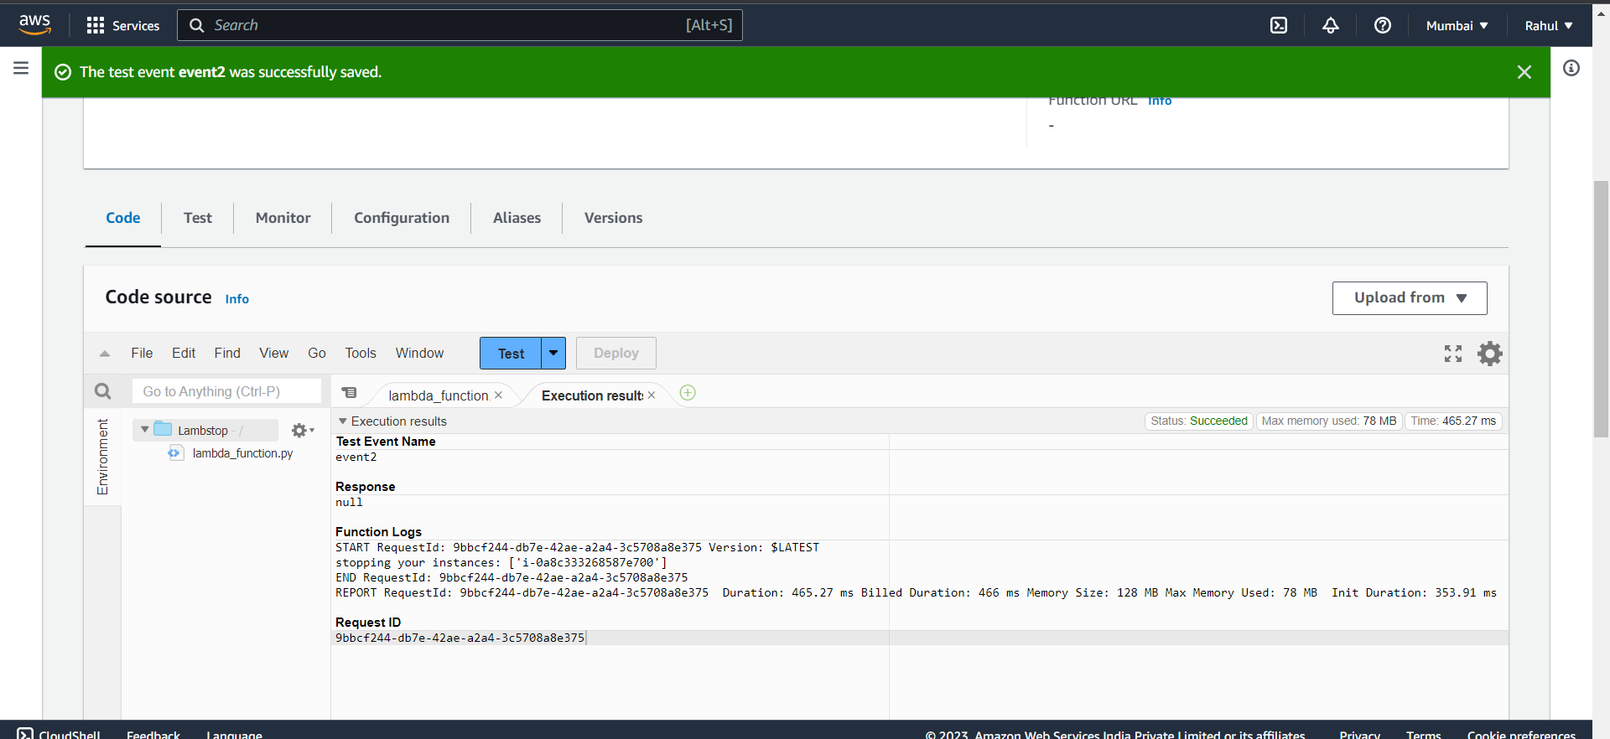

Step 35) As you can see instance has stopped.

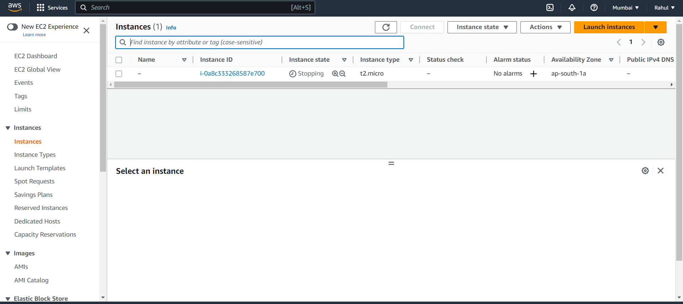

**Experiment -11**

**Create Windows and Ubuntu machine Virtual Machine in Azure and connect to it.**

**Ubuntu**

Step 1) Go to Azure dashboard, click on Virtual Machine.

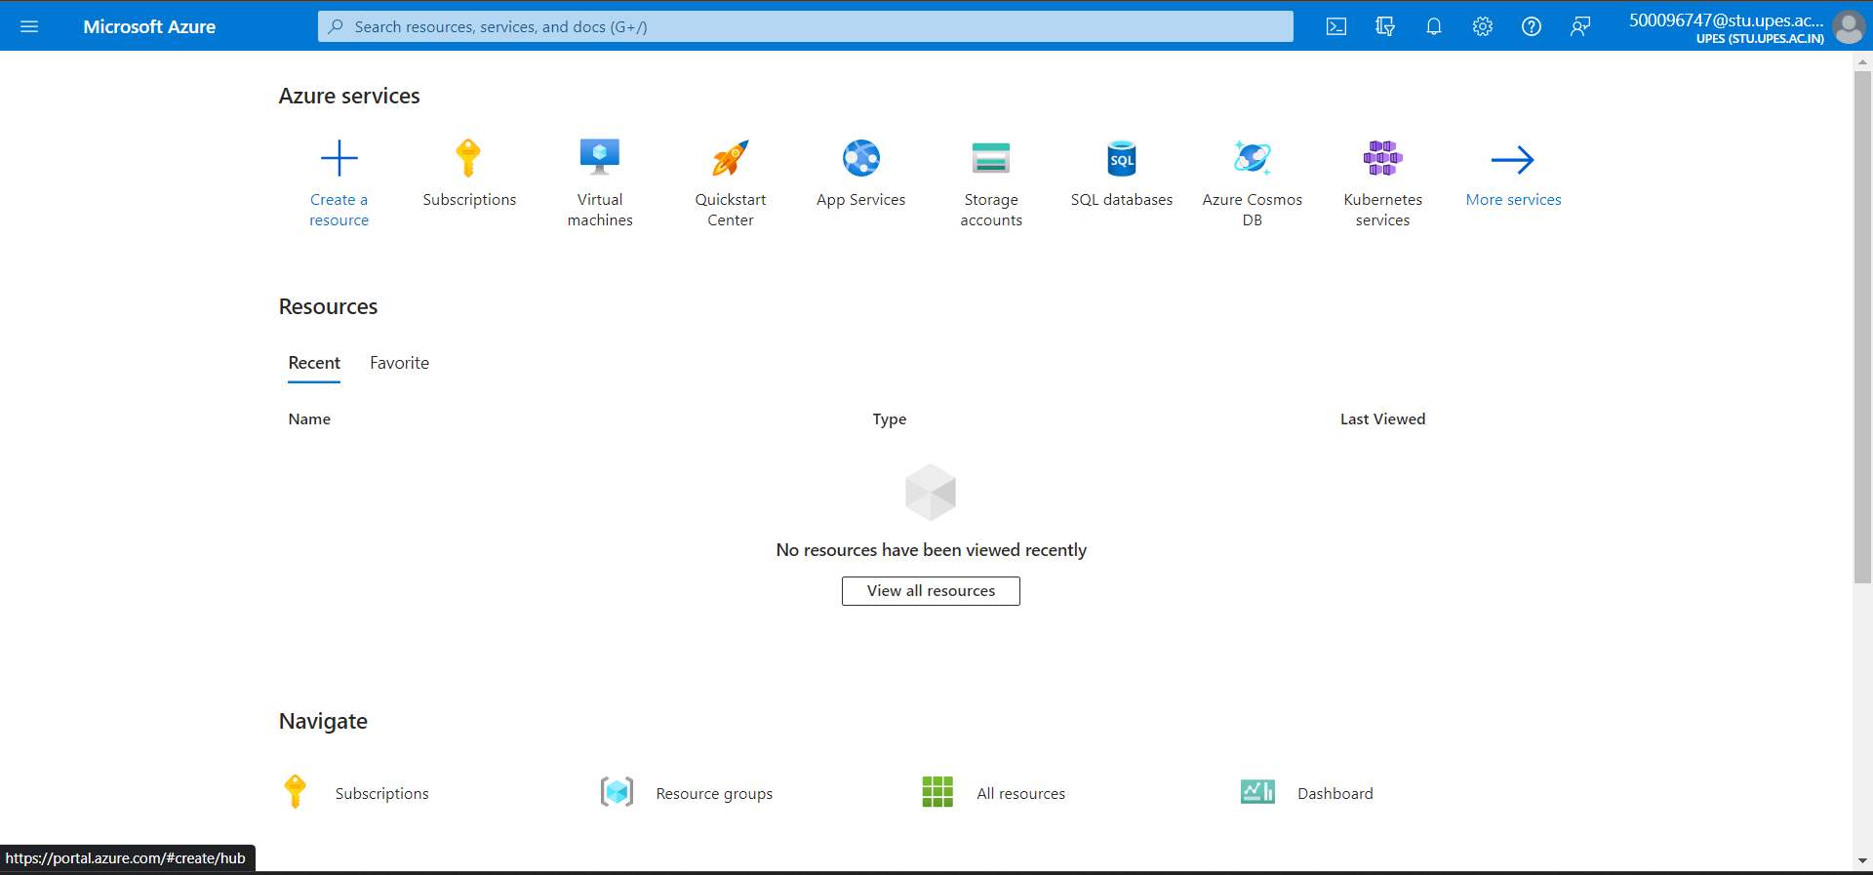

Step 2) Click on create.

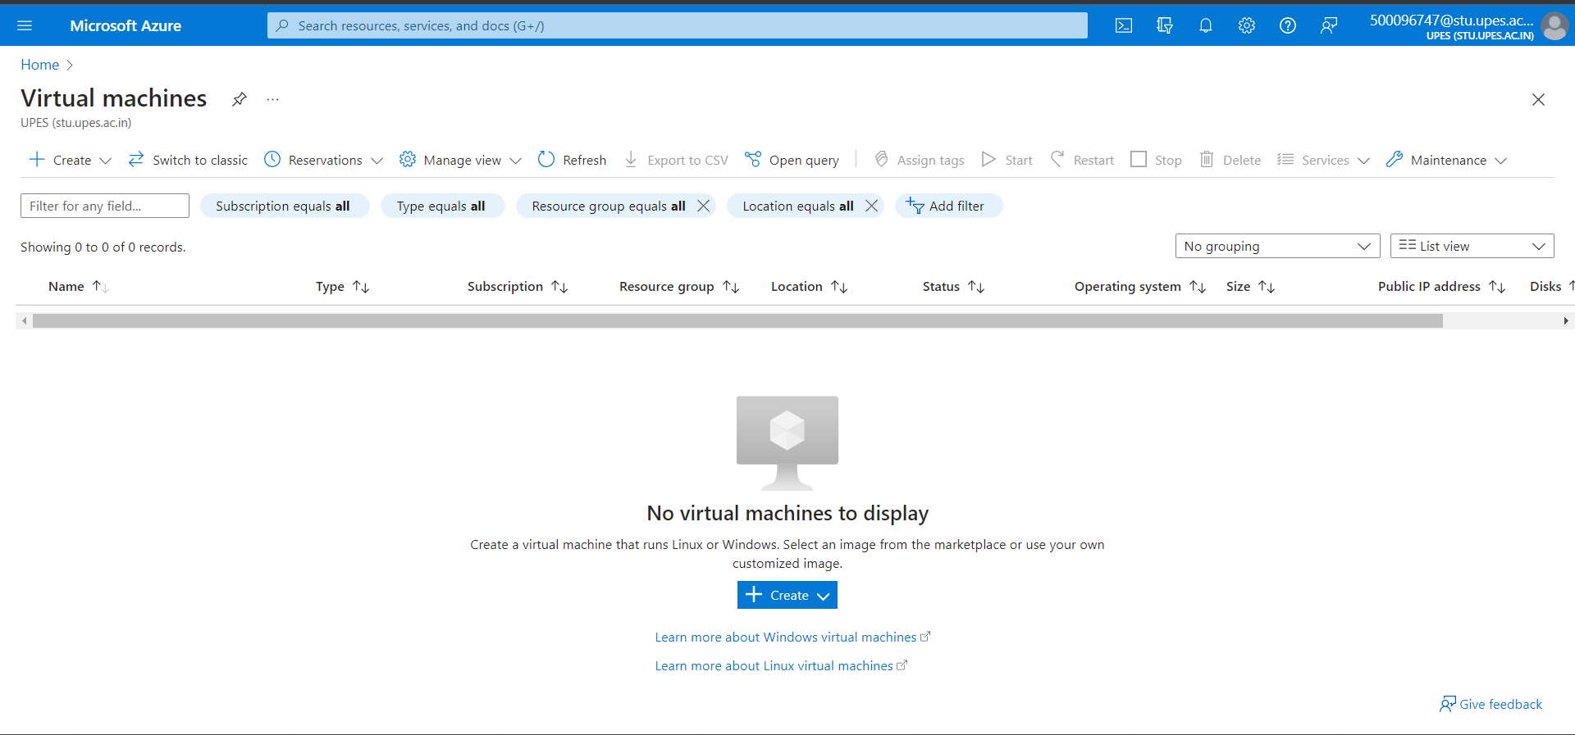

Step 3) Select Azure virtual machine.

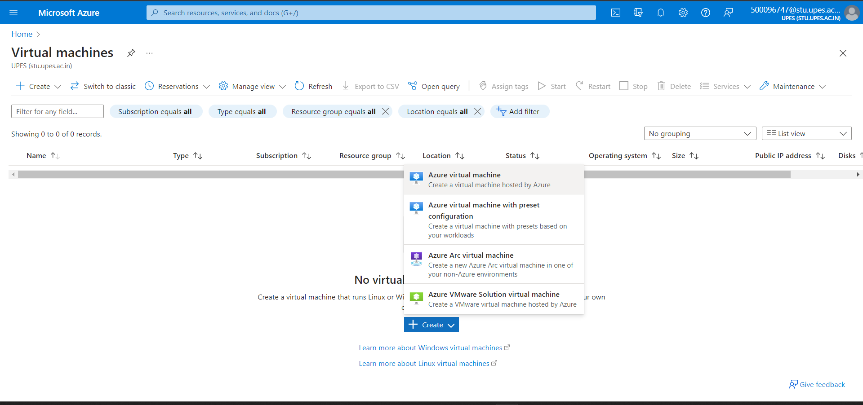

Step 4) Create a new resource group.

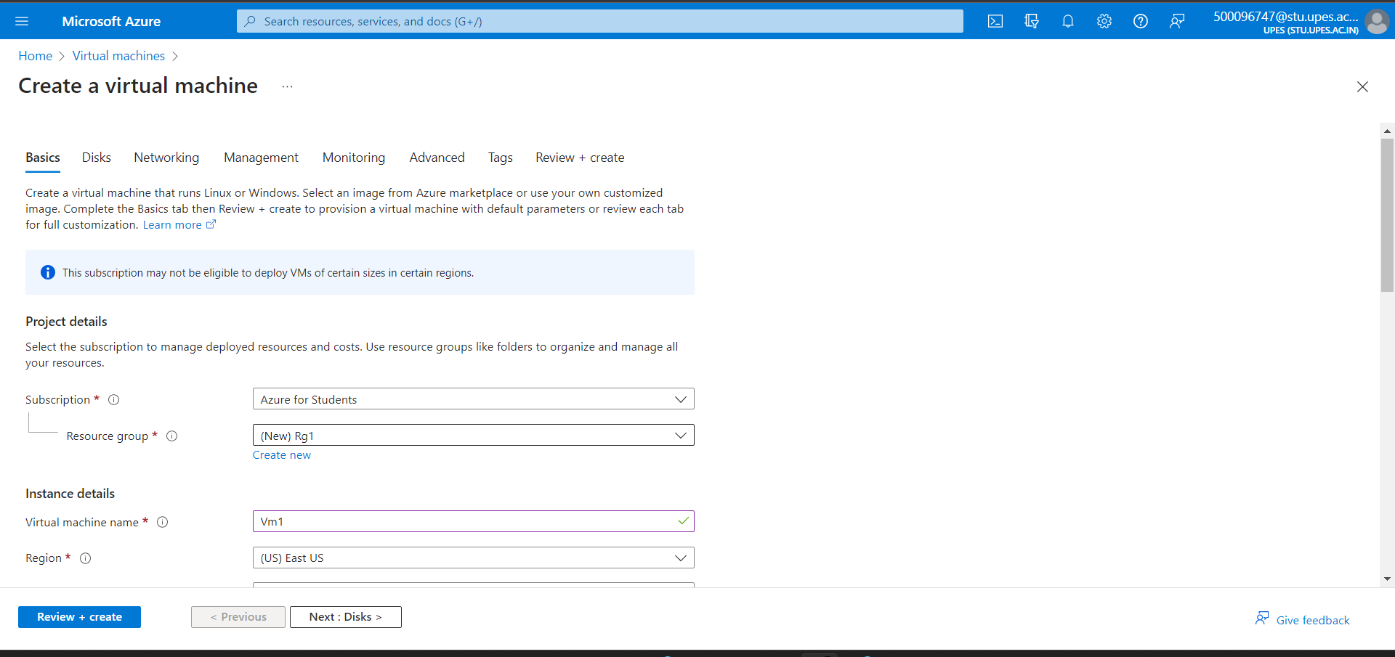

Step 5) Give it a name or let it be default, select image -> ubuntu.

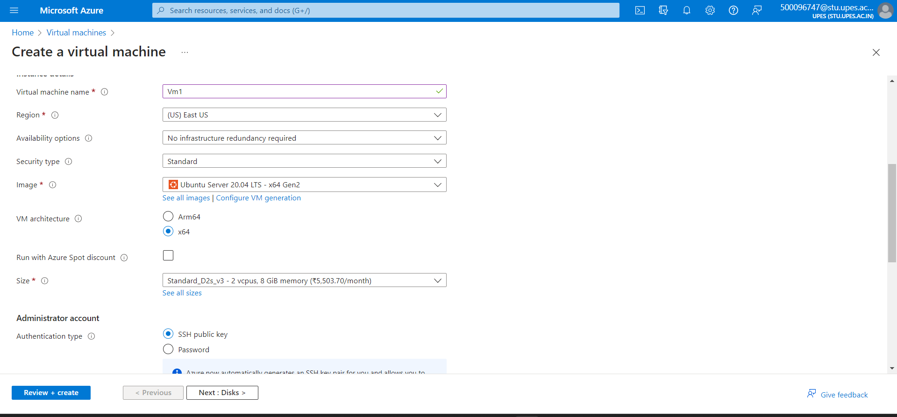

Step 6) Give it a username, password, and key pair name.

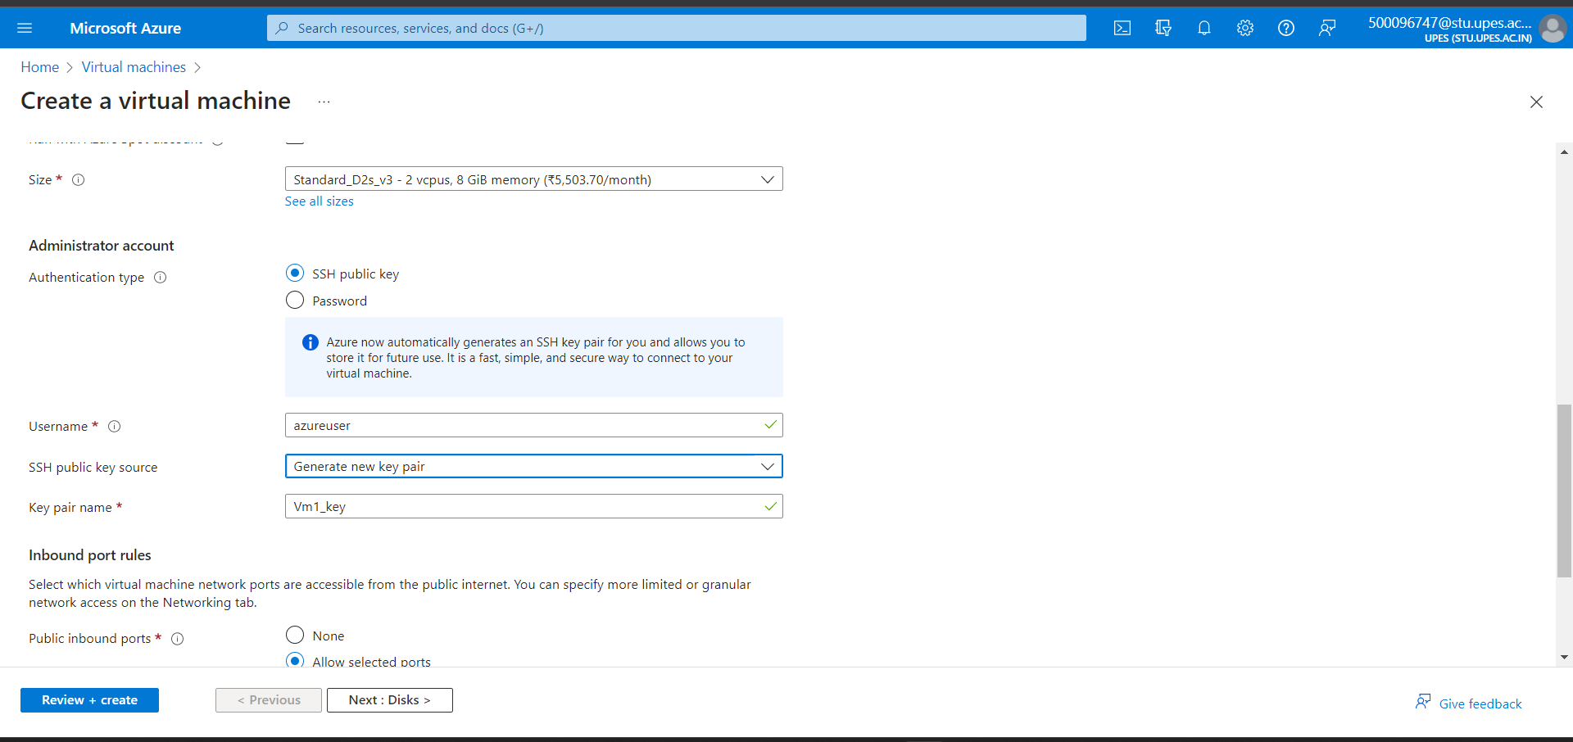

Step 7) Under disks select the standard disk type and let everything else be default.

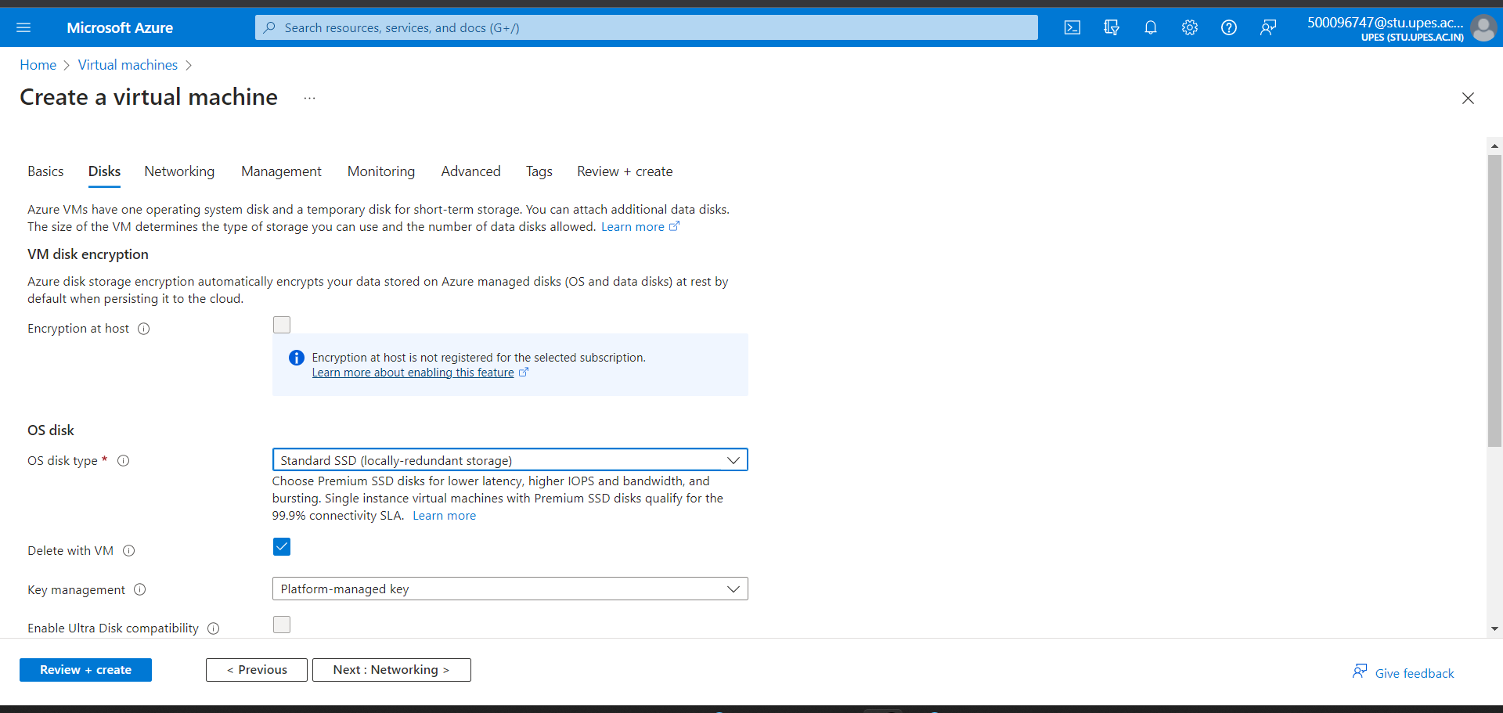

Step 8) Under networking let everything be default and click on next.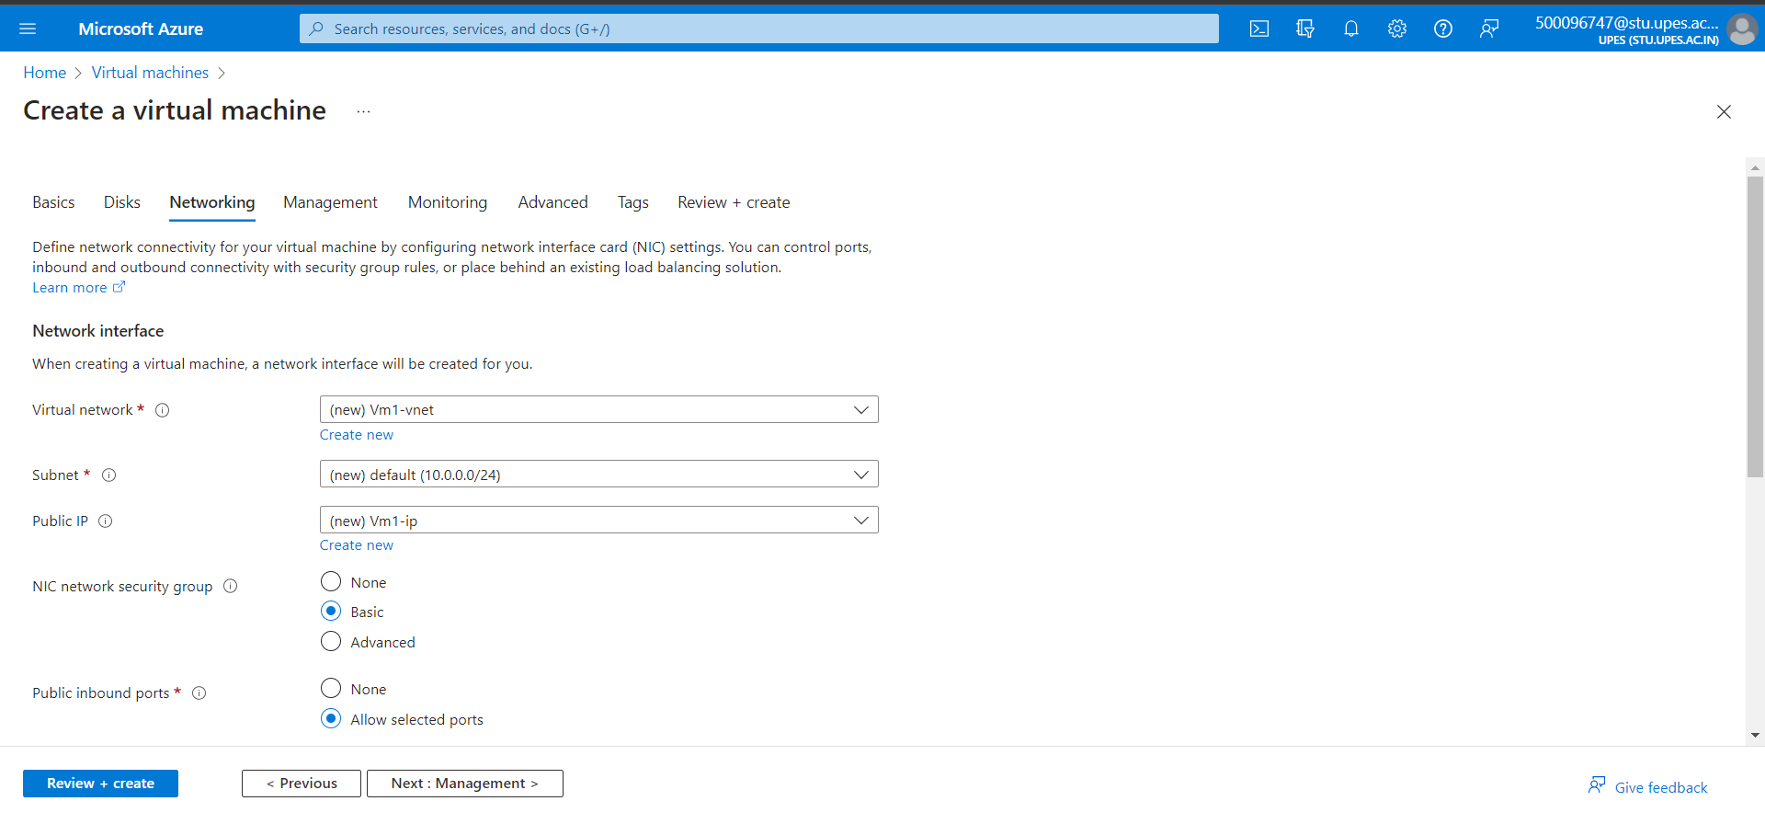

Step 9) Under the management let everything be default and click on next.

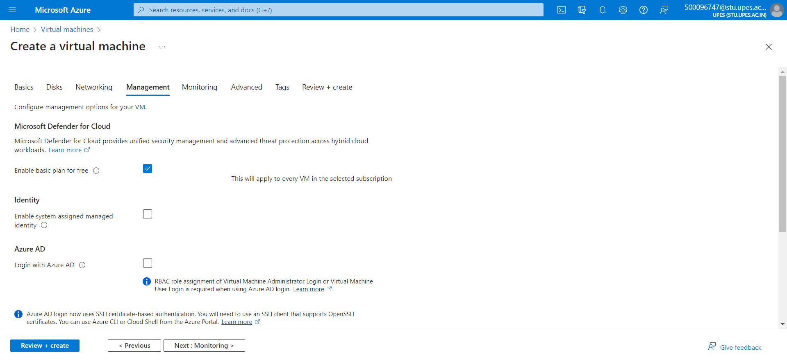

Step 10) Under monitoring let everything be default and click on next.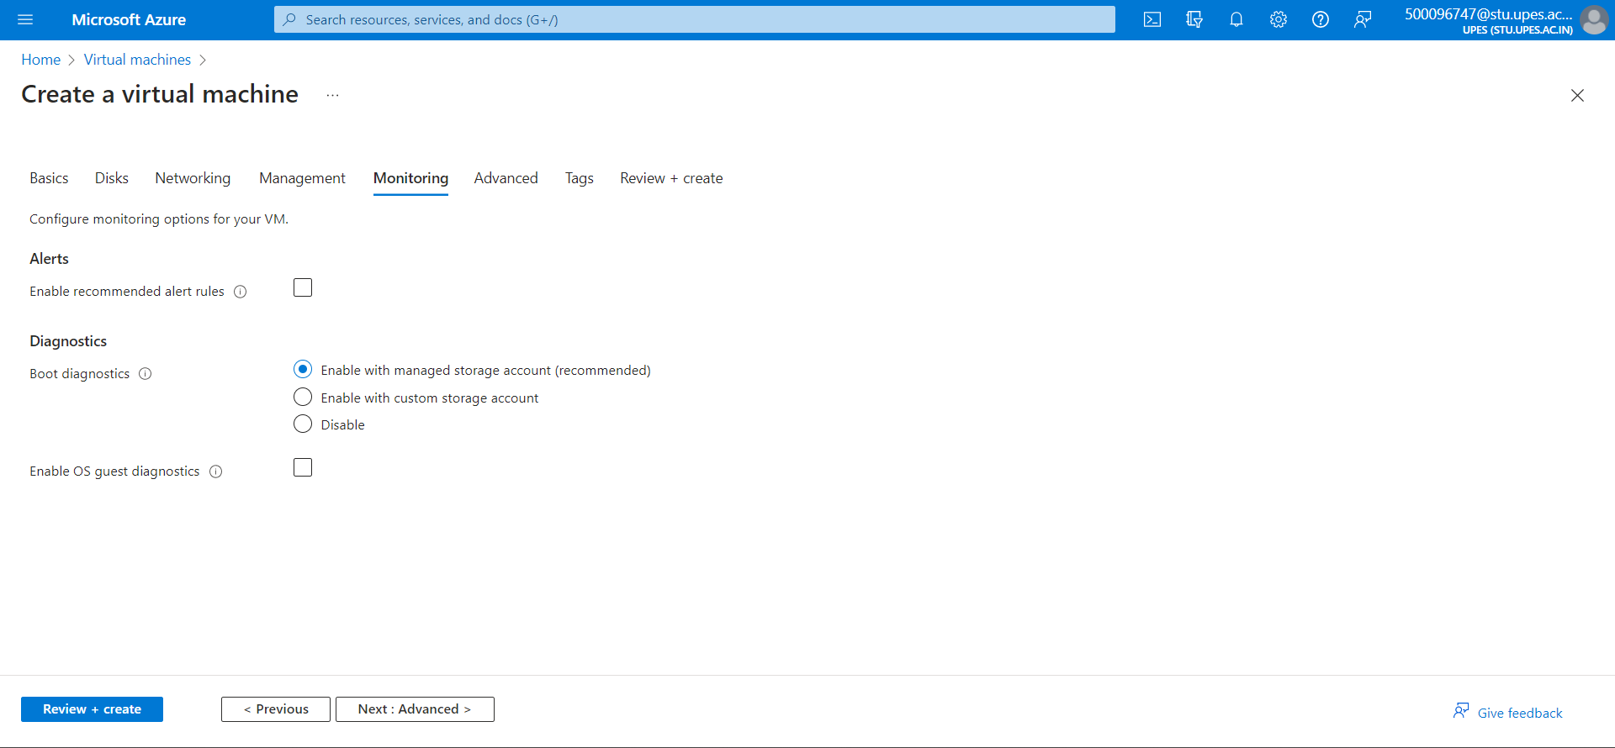

Step 11) Under advanced let everything be default and click on next.

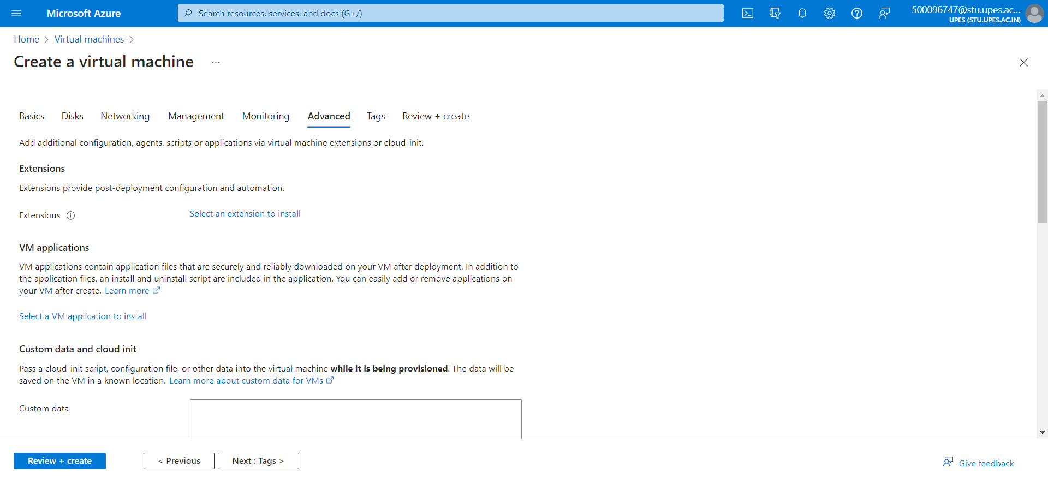

Step 12) Under review+ create review your VM configuration and click on create.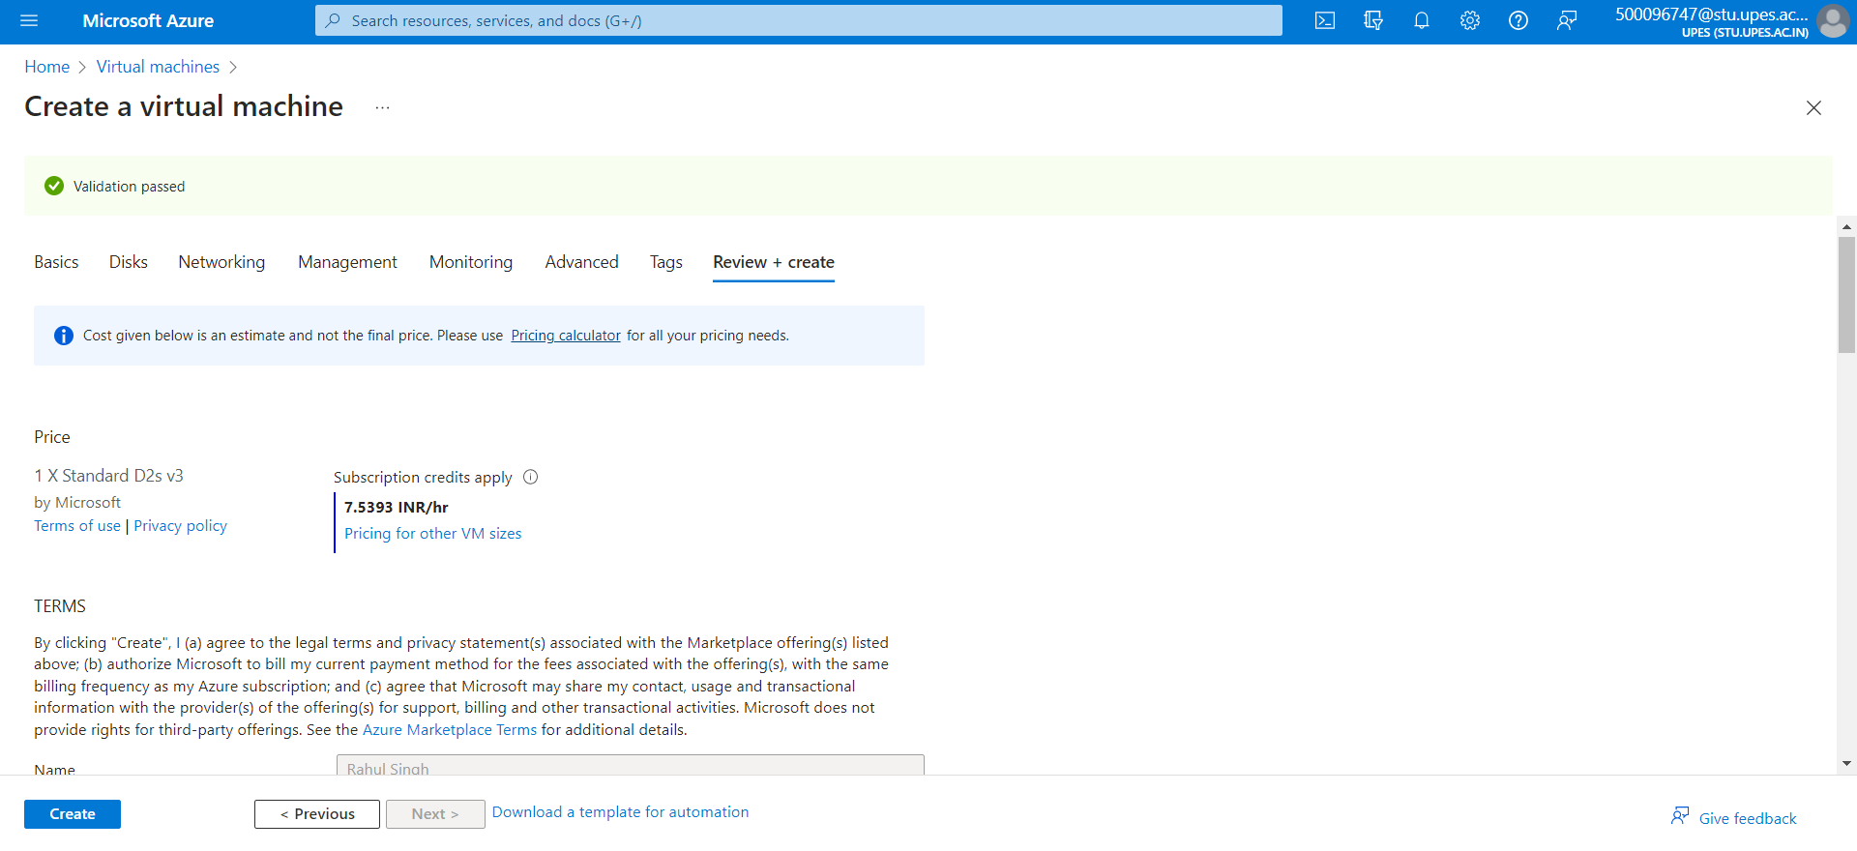

Step 13) Your Vm will be created, click on go to resource.

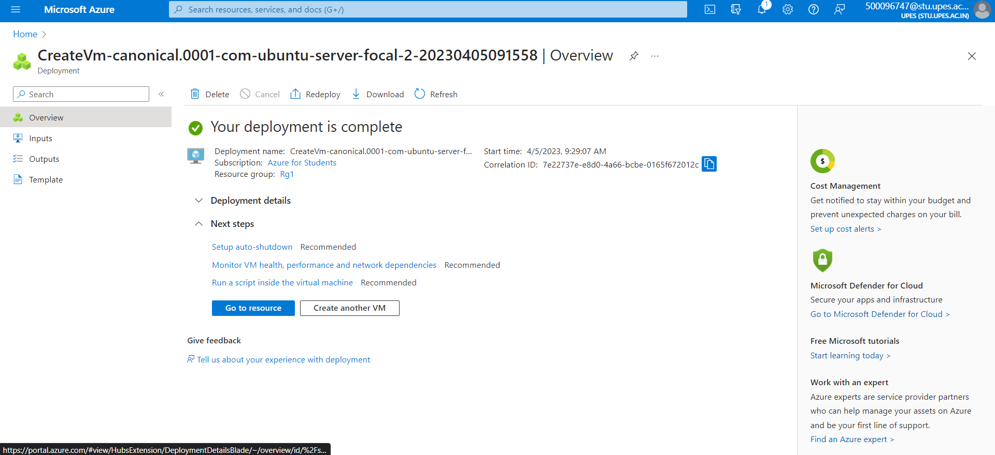

Step 14) Click on Connect.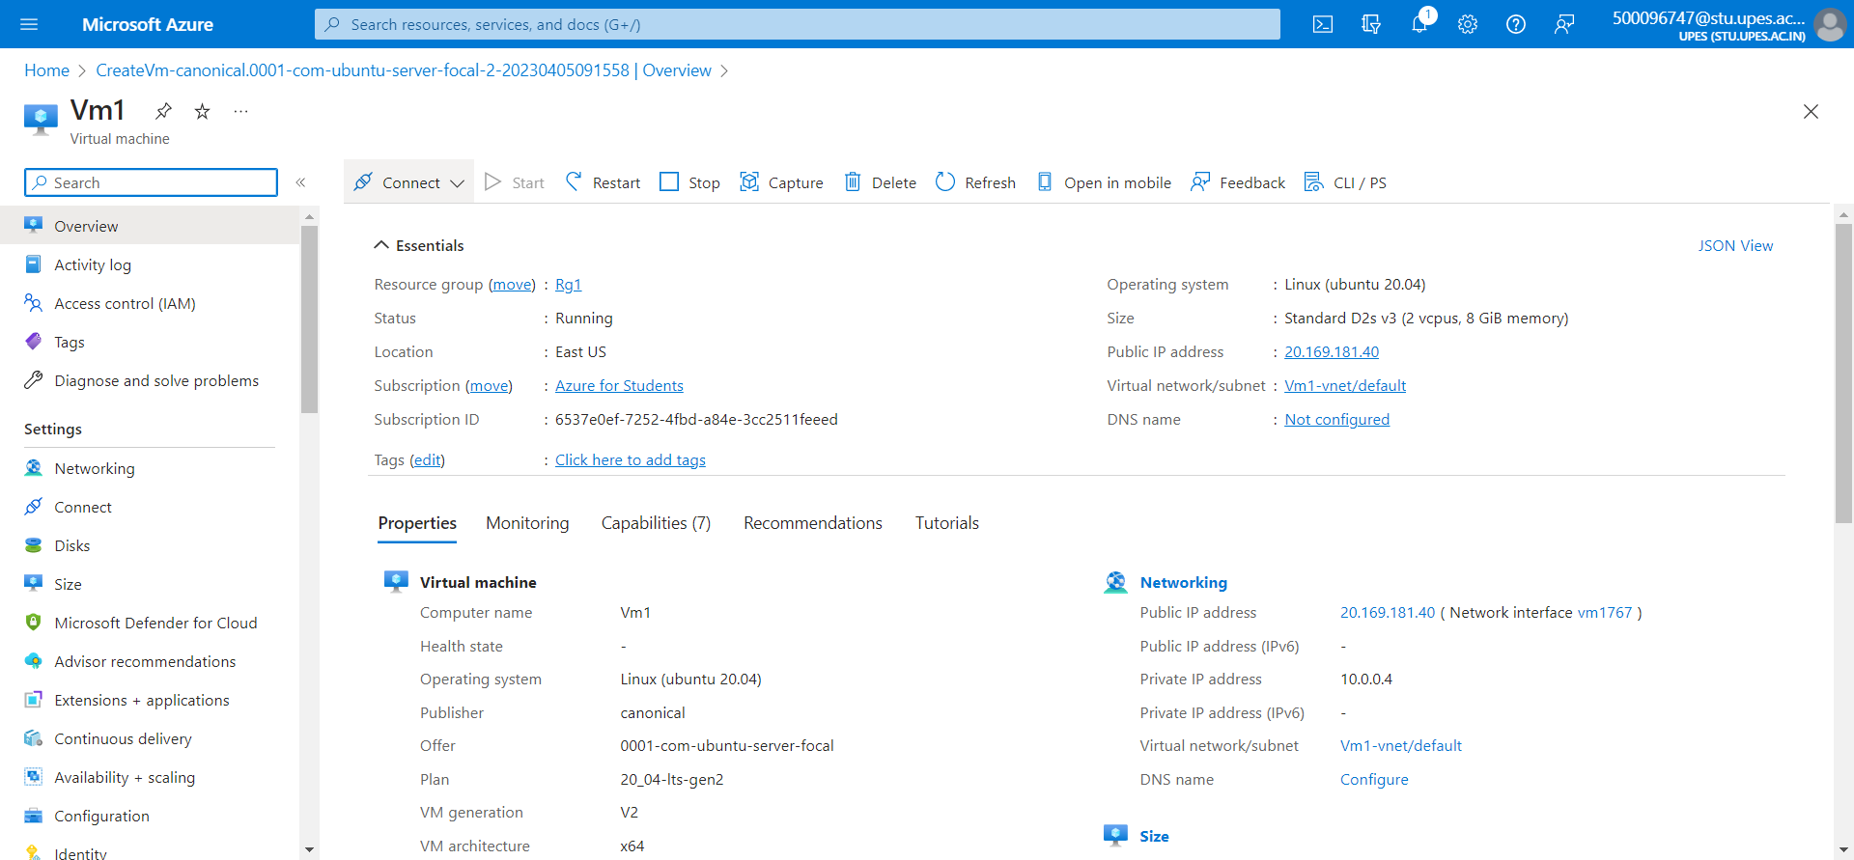

Step 15) Click on Bastian.

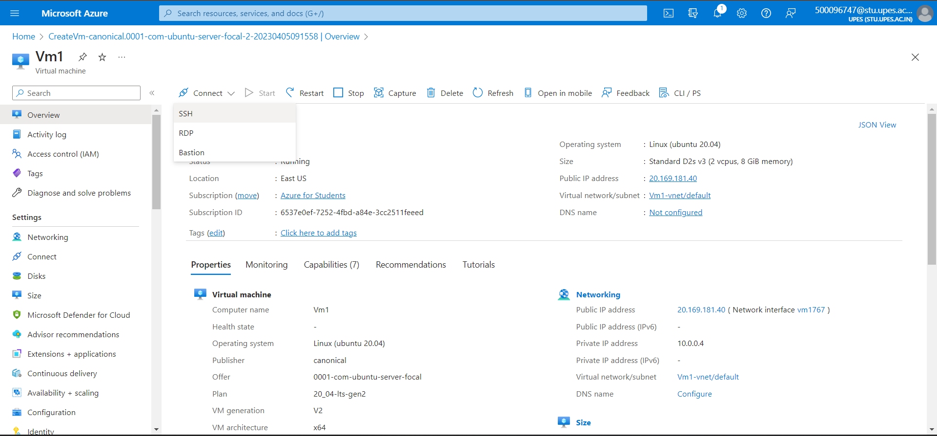

Step 16) And deploy a Bastian.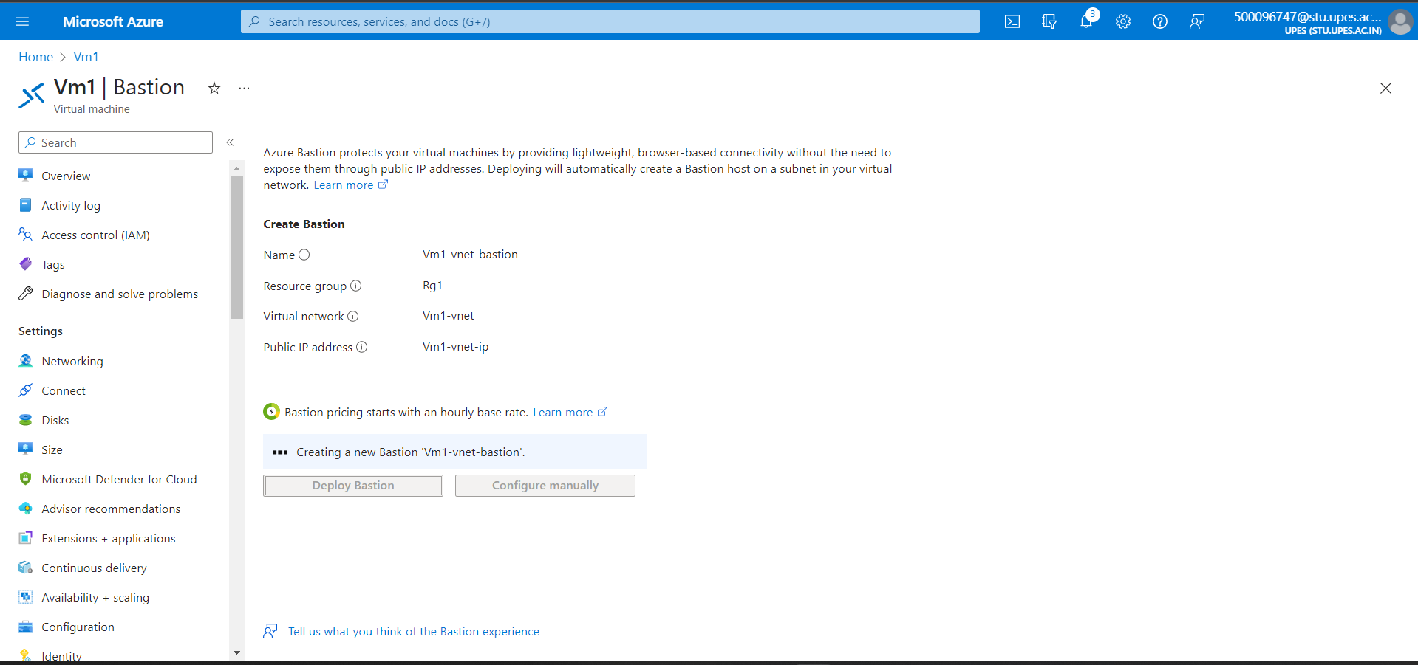

Step 17) Enter the username and browse the local key file and click on connect.

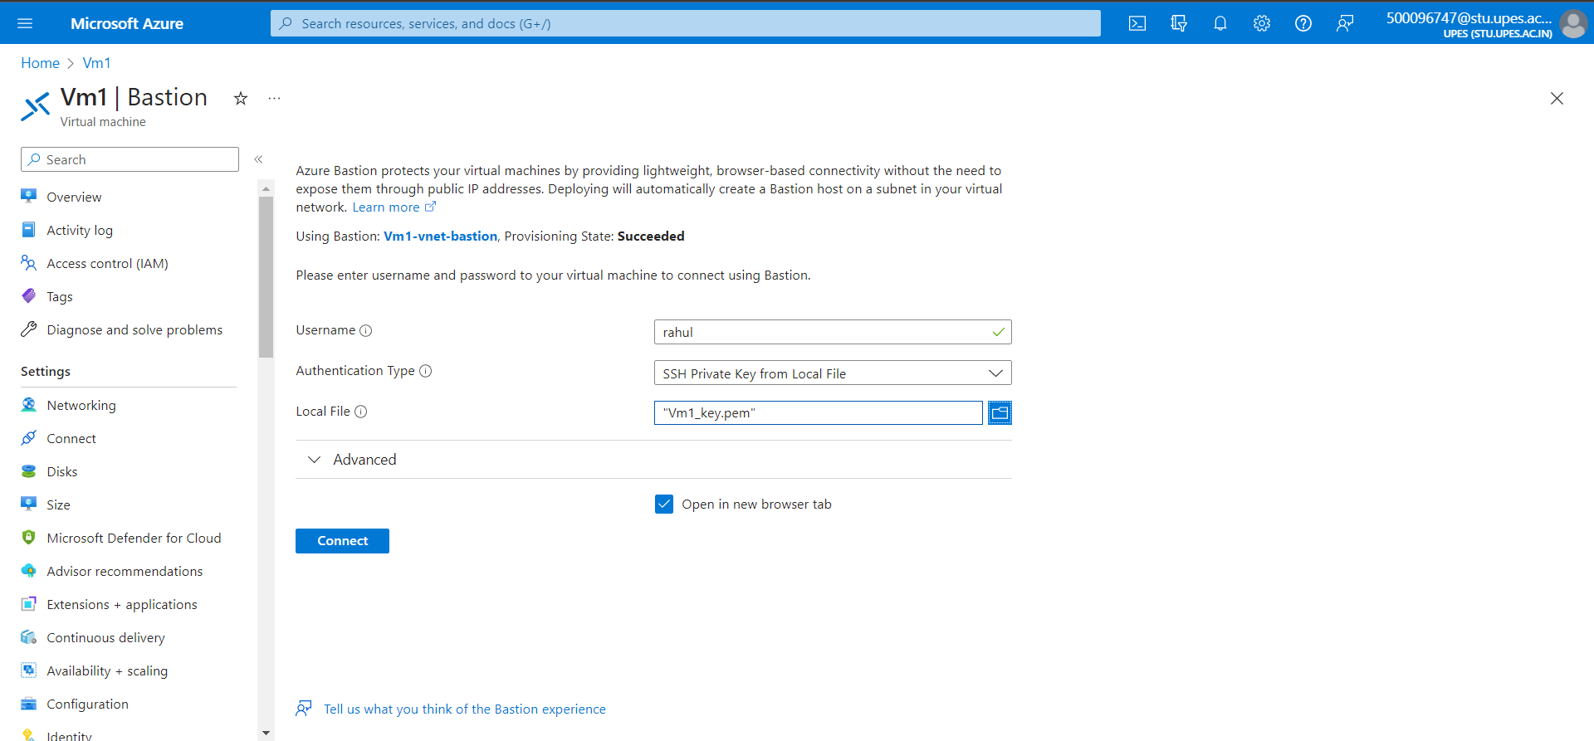

Step 18) Your ubuntu will be launched.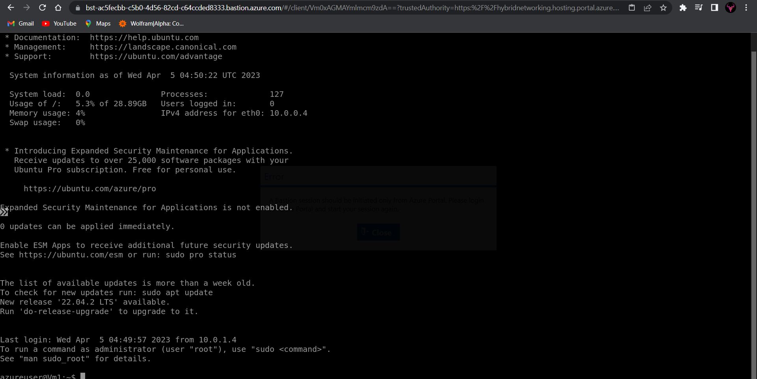

**Windows**

Step 19) Go back to VM and click on create.

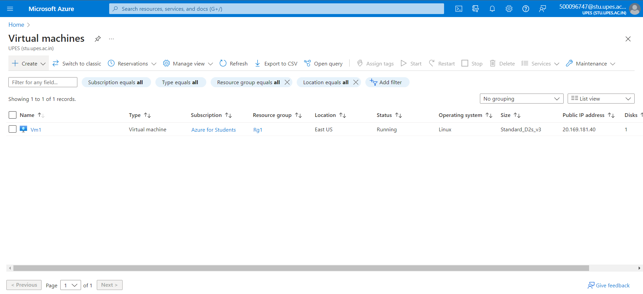

Step 20) Select a resource group.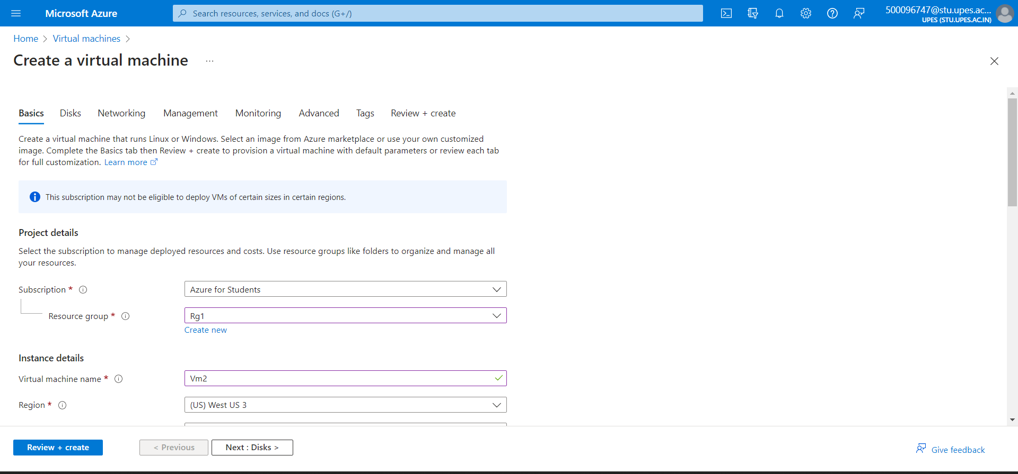

Step 21) Give it a name and select image as windows.

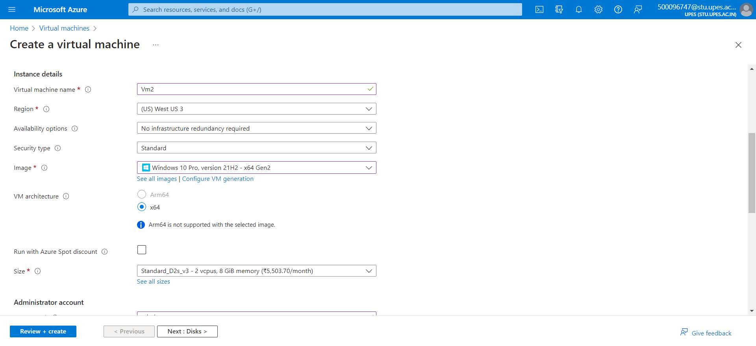

Step 22) Give it a username, password and click on next.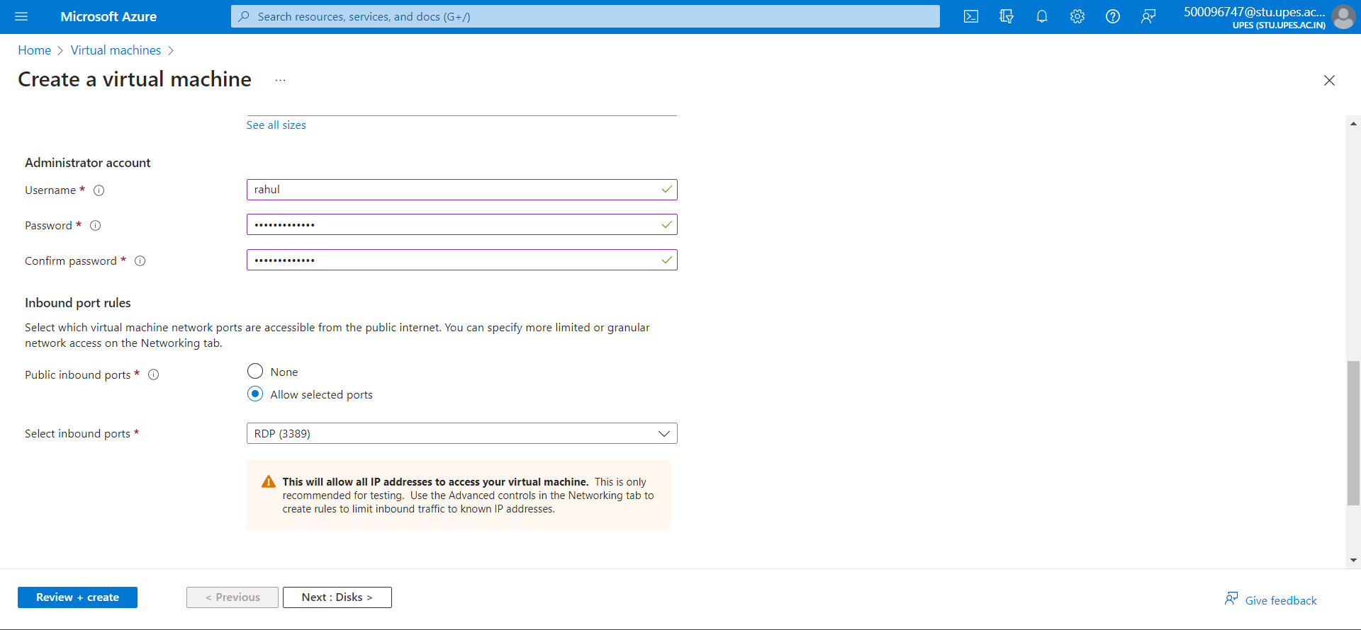

Step 23) Under disks let everything be default and click on next.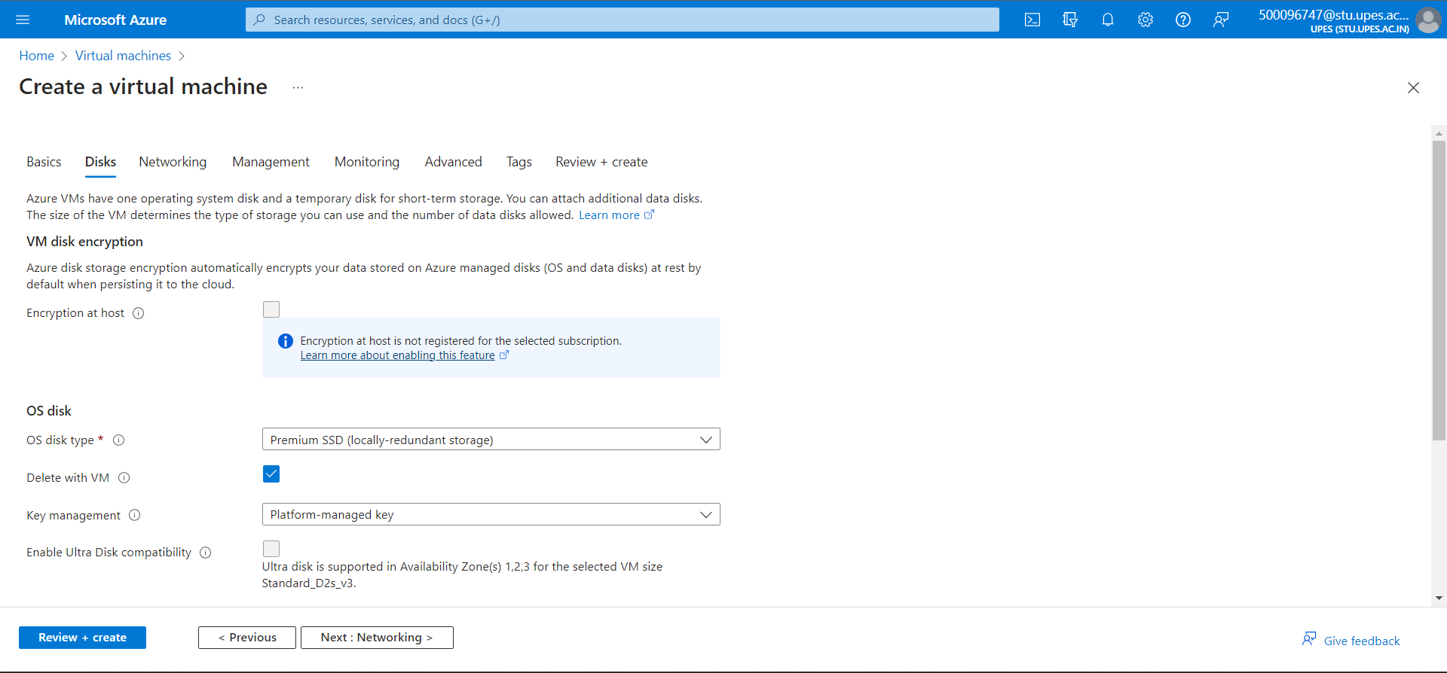

Step 24) Under networking let everything be default.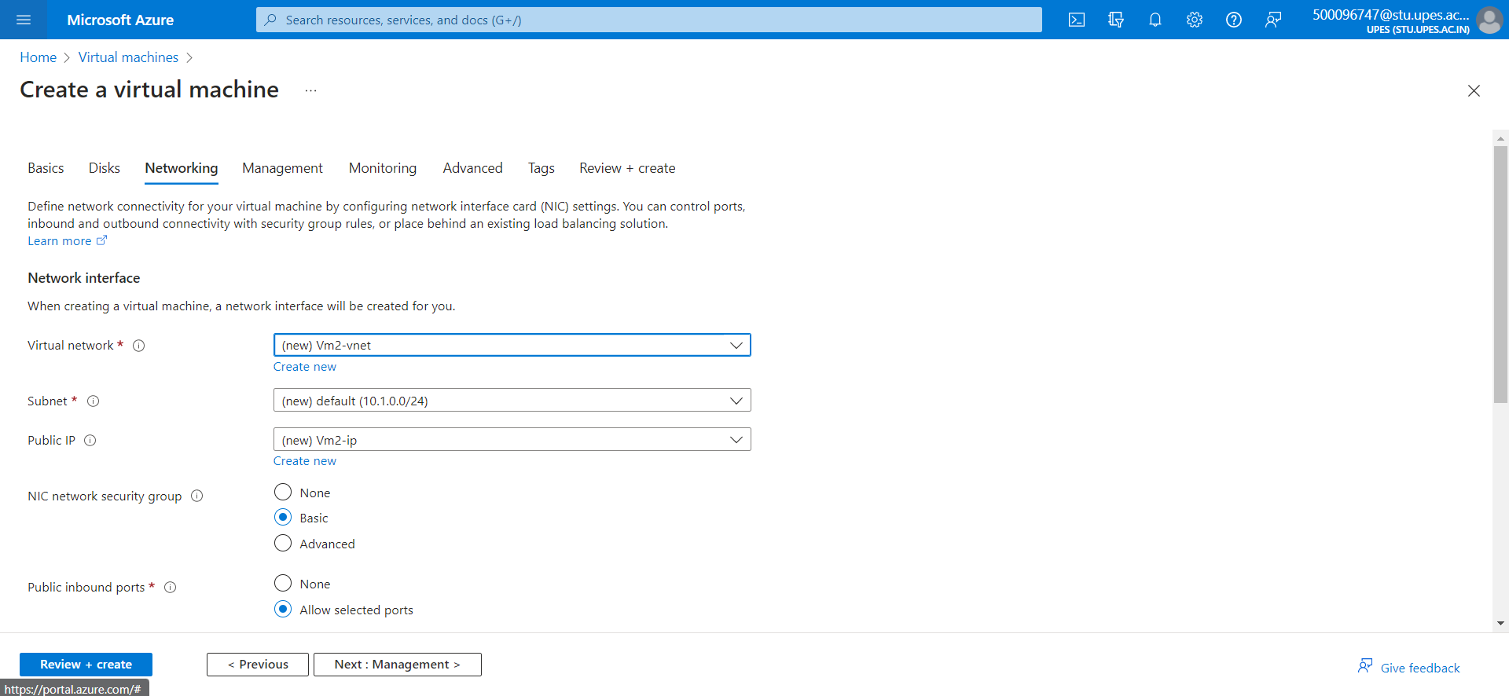

Step 25) Under management let everything be default.

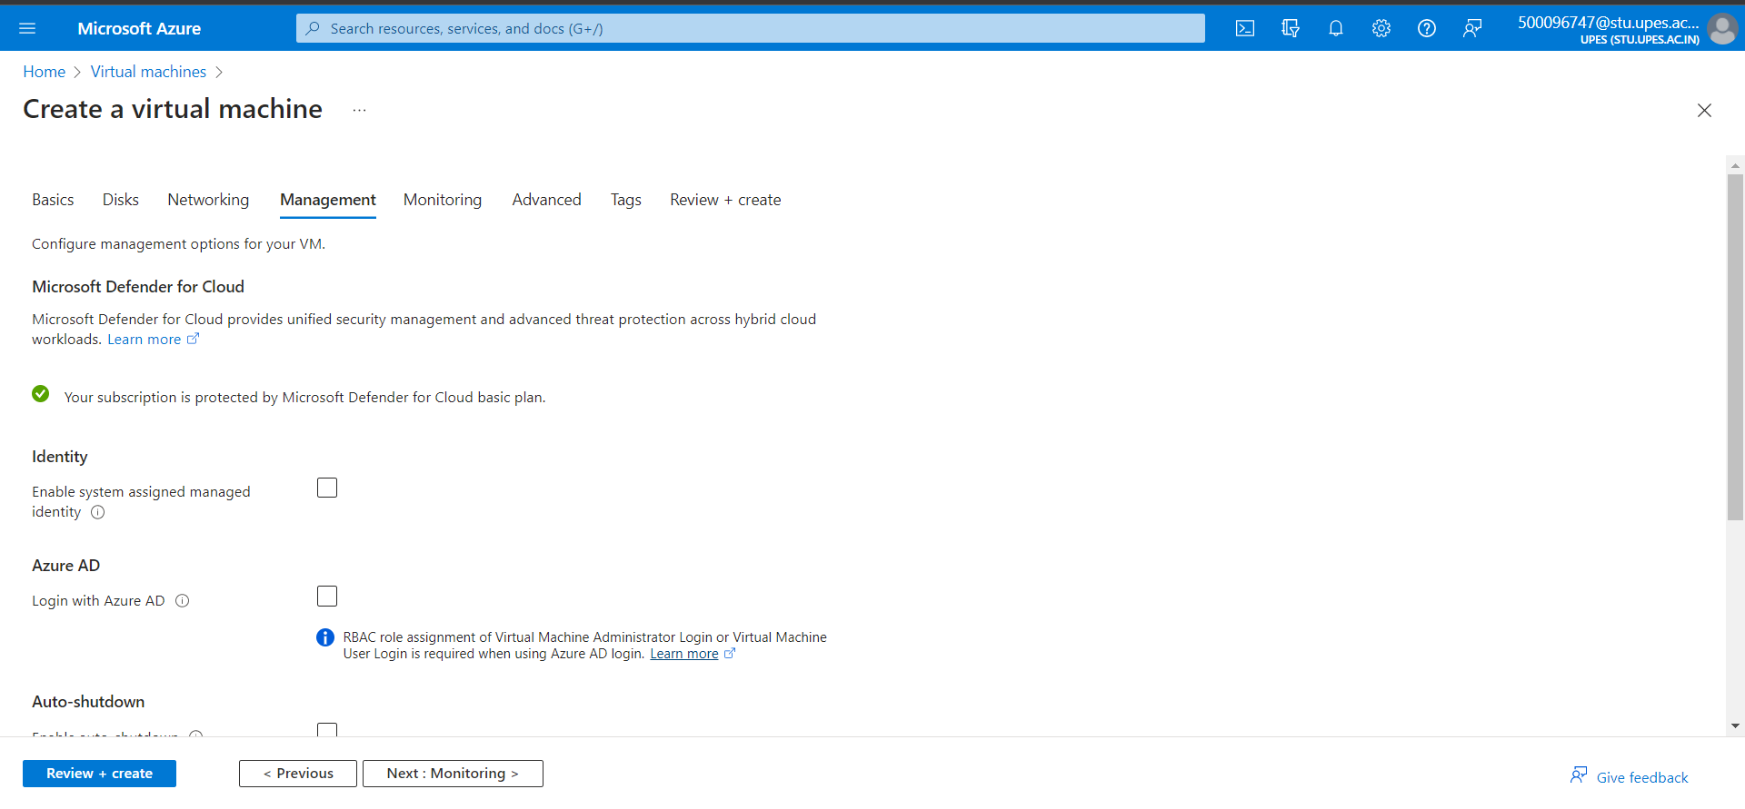

Step 26) Under monitoring let everything be default.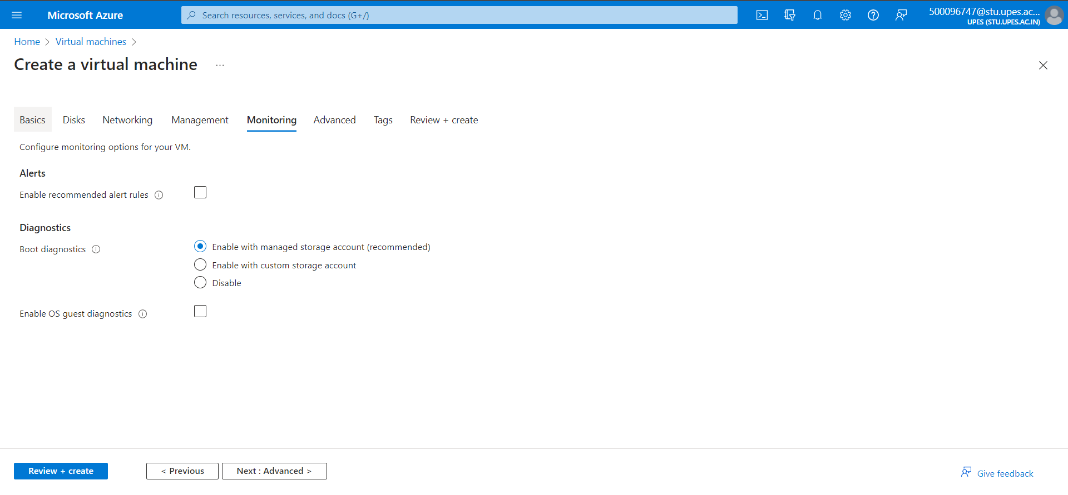Step 27) Under advanced let everything be default and click on next.

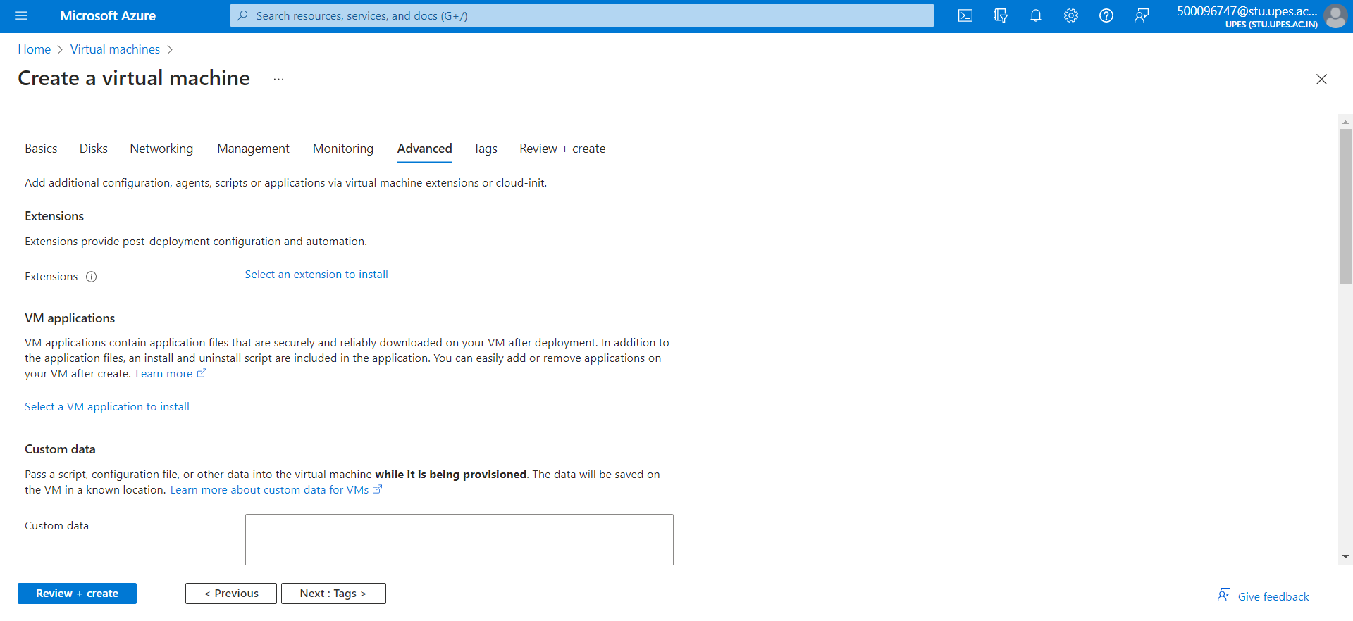

Step 28) Under Review+create review your Vm configuration and click on create.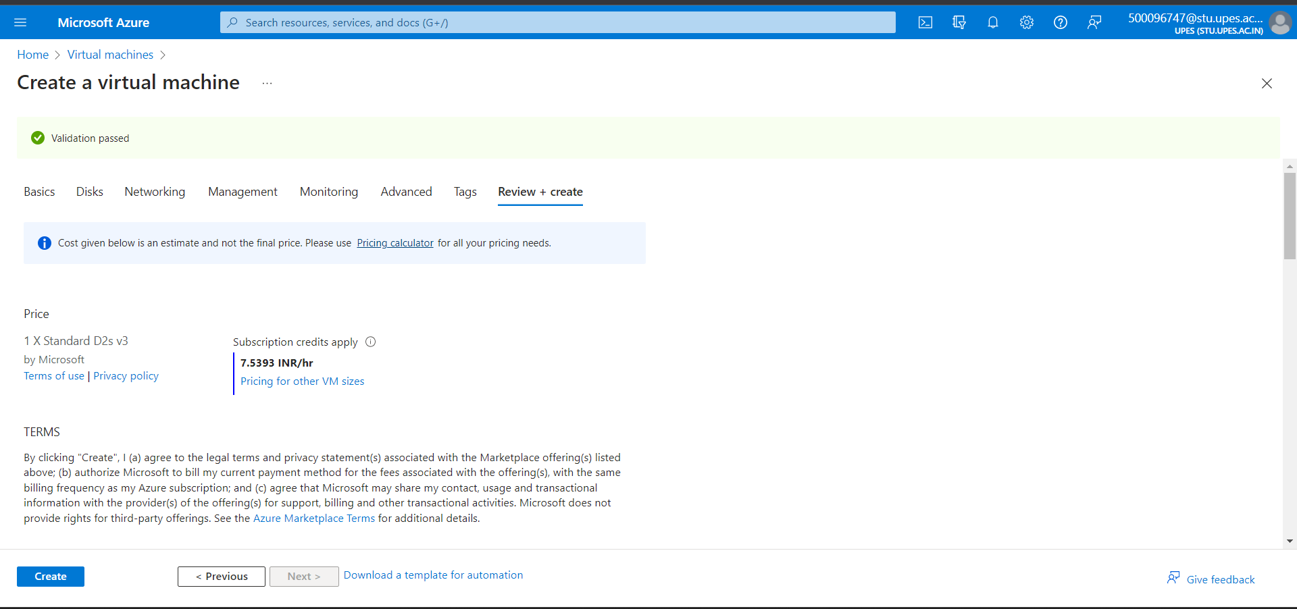

Step 29) Go to your VM Overview.

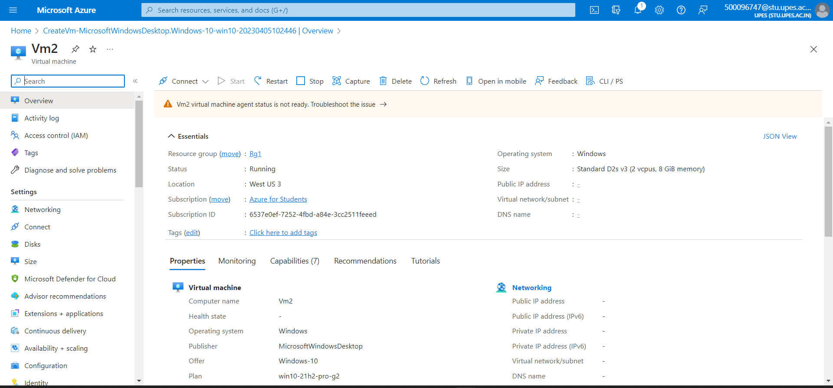

Step 30) Go to Connect -> Bastian. 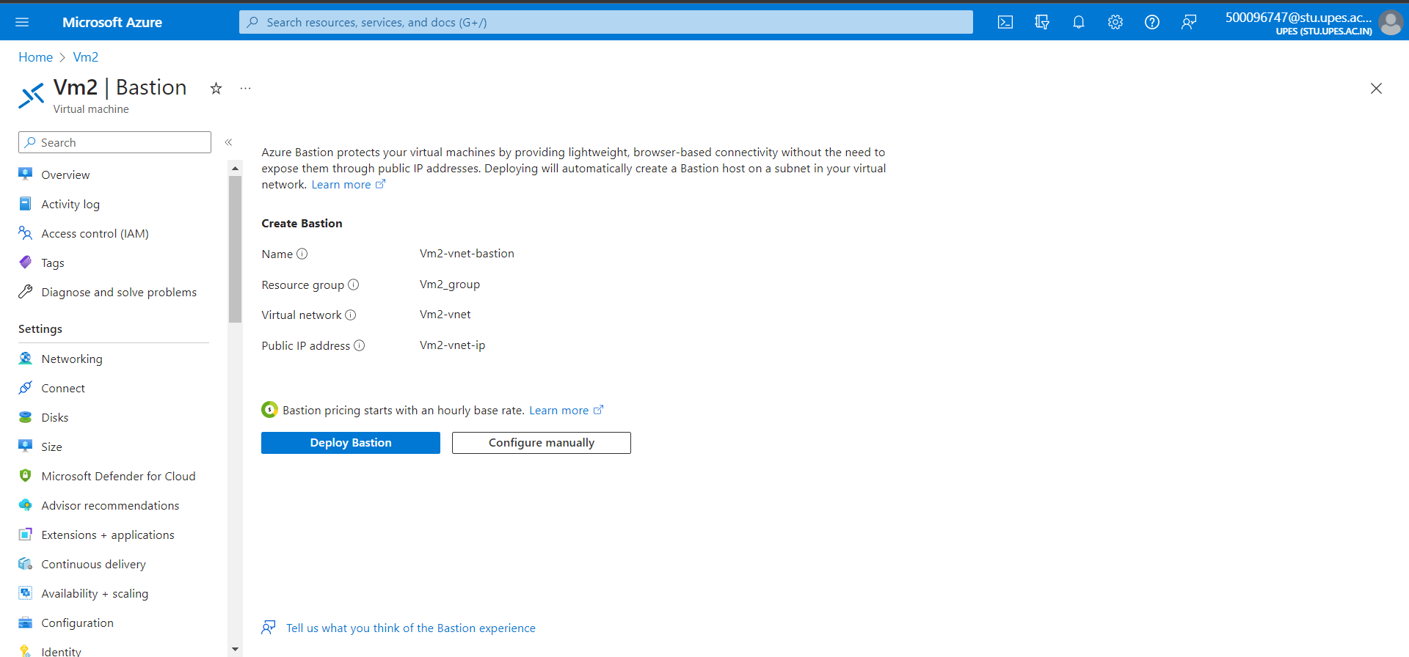

Step 31) Enter username, password and connect.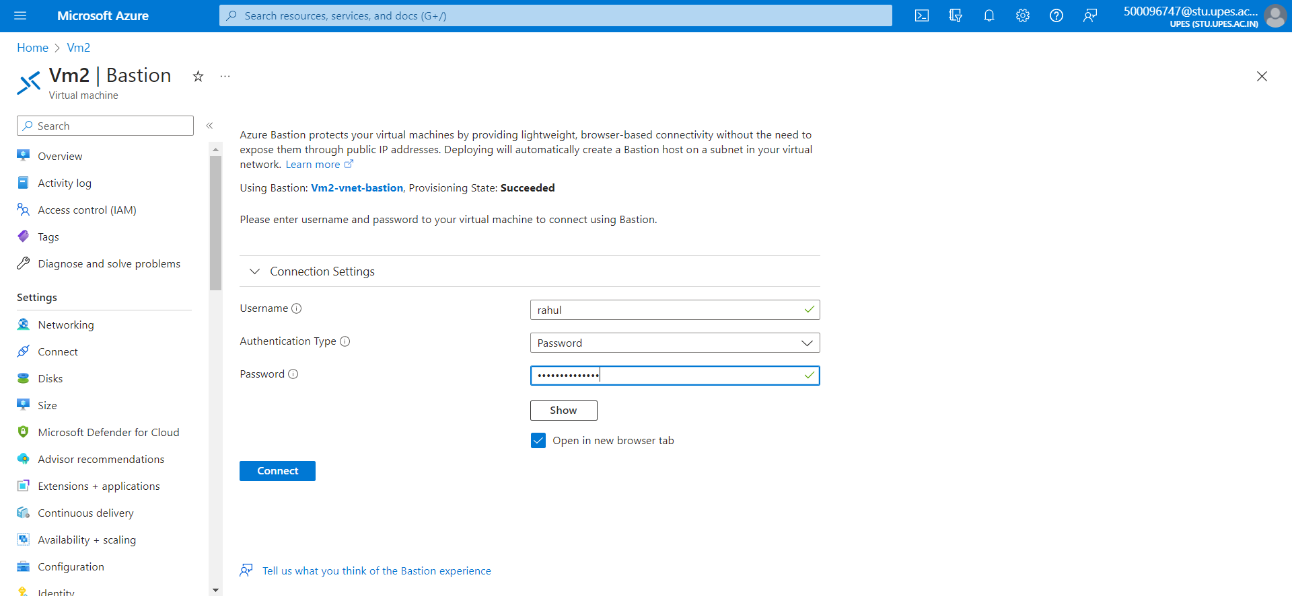

Step 32) Windows window will open.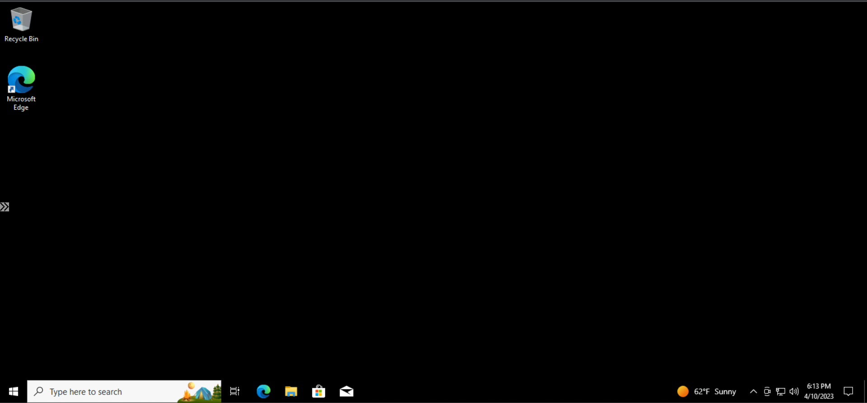

Step 33) After using VM delete the VM.

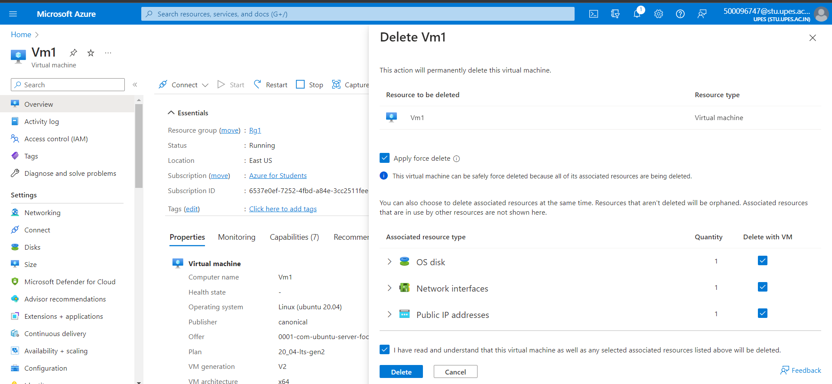

**Experiment -12**

# AWS Web Application Firewall (WAF)

**Ubuntu on Vmware workstation**

Step 1) Open Vmware Workstation player and click on create a new Vm.

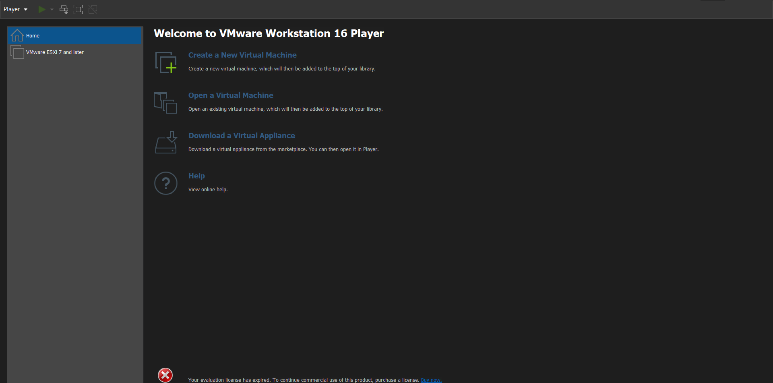

Step 2) Select the iso file you want to install.

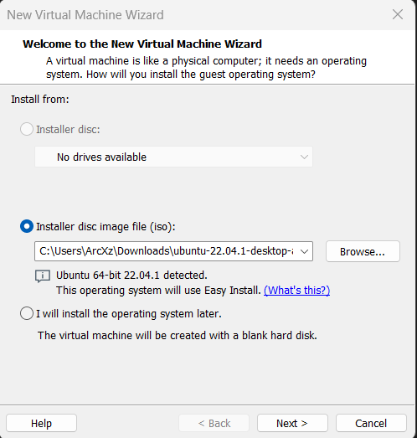

Step 3) Give your username and password.

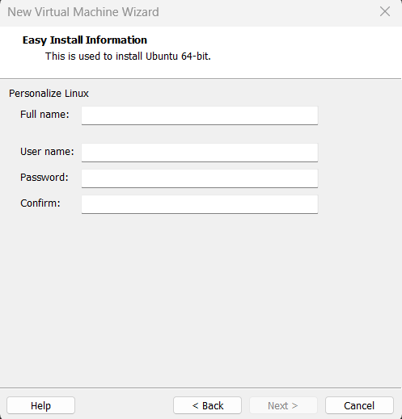

Step 4) Give your VM a name.

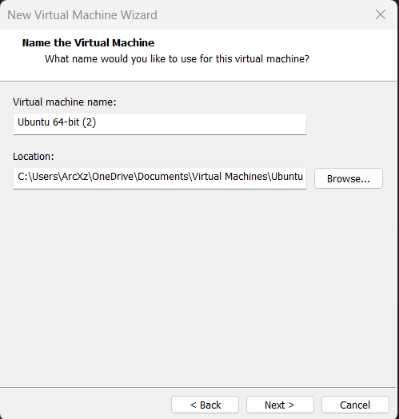

Step 5) Specify Disk Capacity.

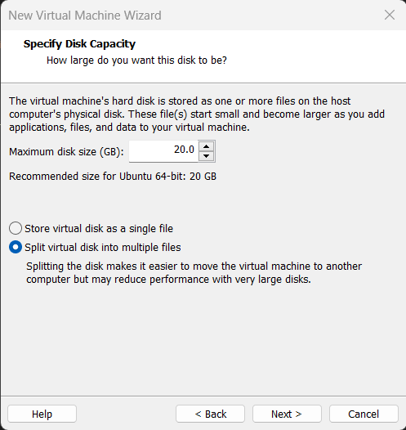

Step 6) Review and finish.

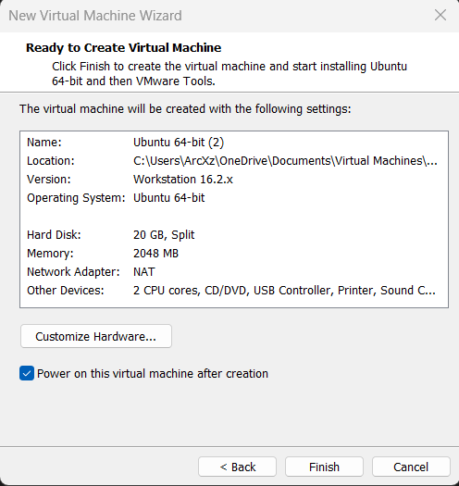

Step 7) After your VM is powered on and install it.

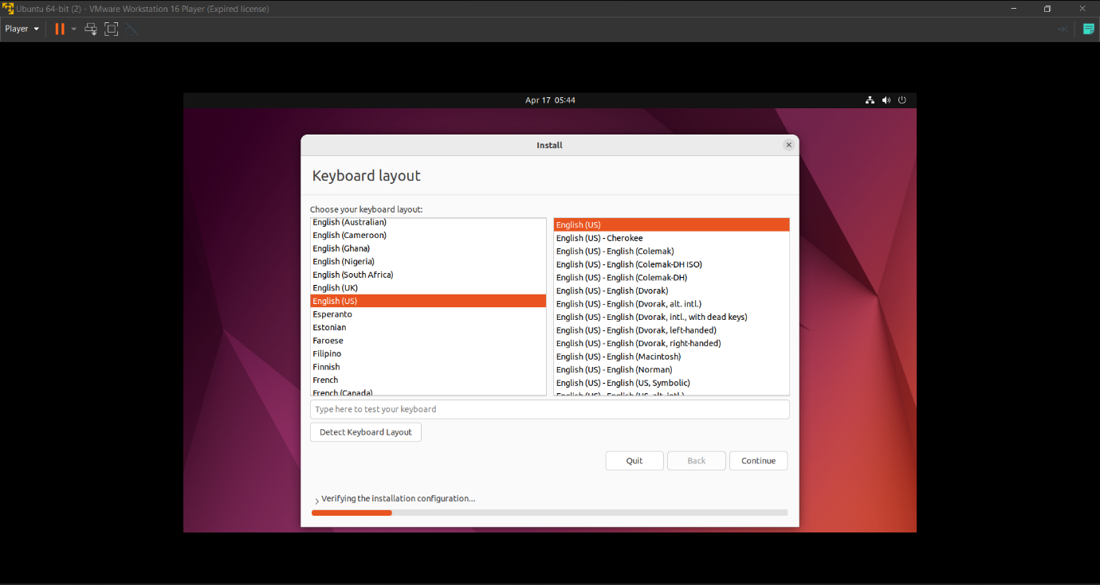

Step 8) After installing your ubuntu VM will be usable.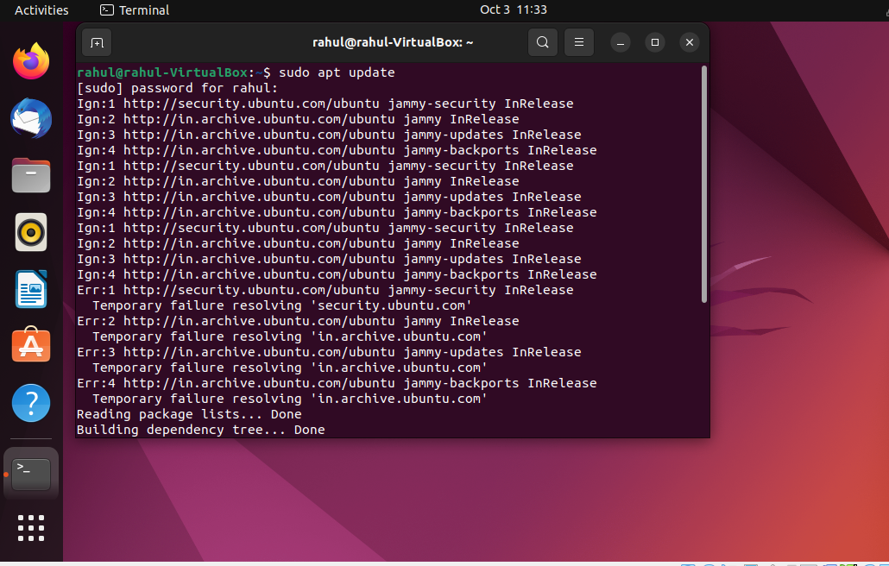

**Experiment -13**

# AWS Web Application Firewall (WAF)

Step 1) First we have to create two instances.

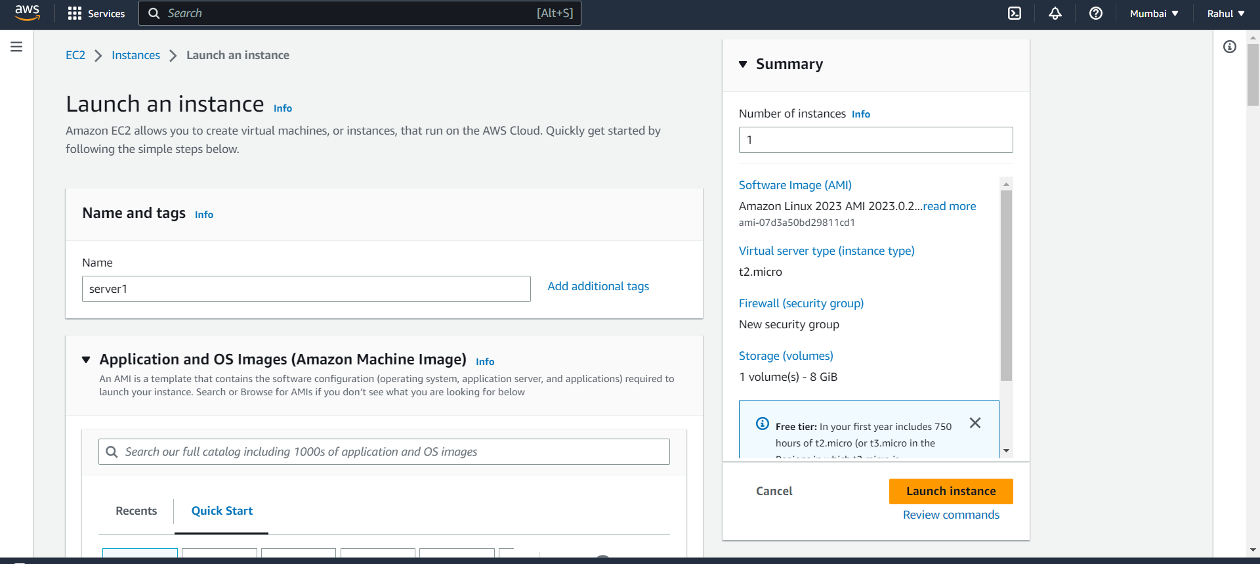

Step 2) Select Linux OS.

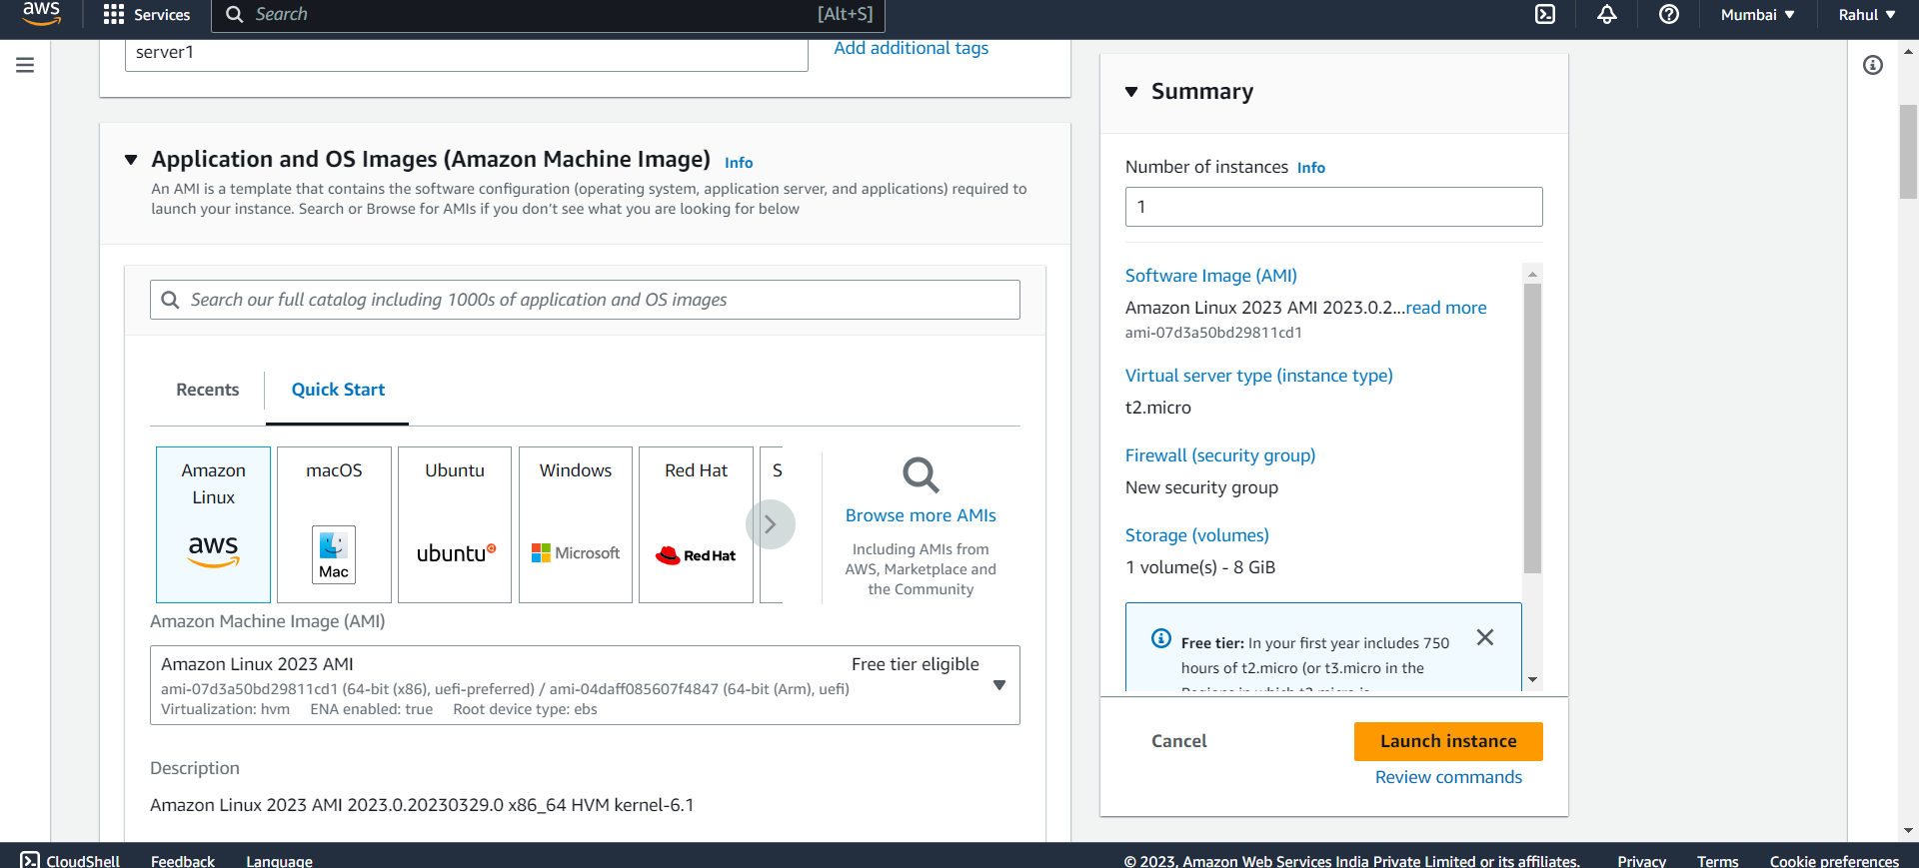

Step 3) And paste this script under advanced -> user data.

#!/bin/bash

sudo su

yum update -y

yum install -y httpd

systemctl start httpd.service

systemctl enable httpd.service

echo "<h1> At $(hostname -f) </h1>" > /var/www/html/index.html

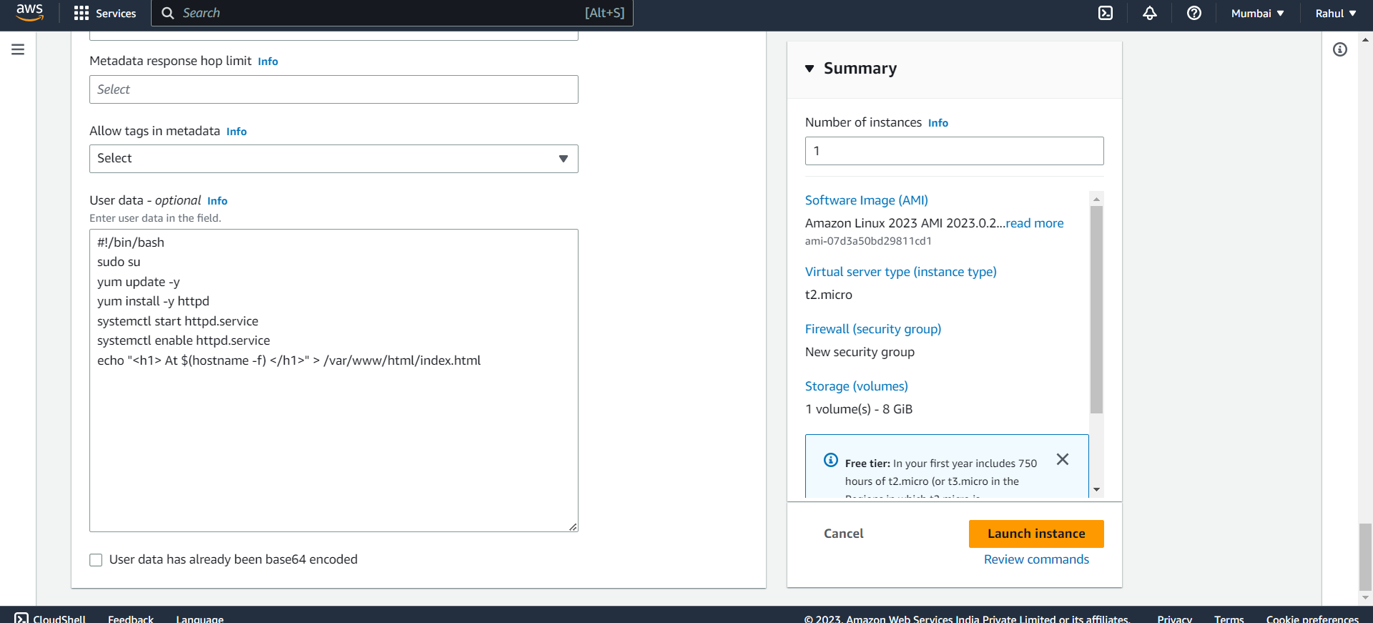

Step 4) Your two instances are ready.

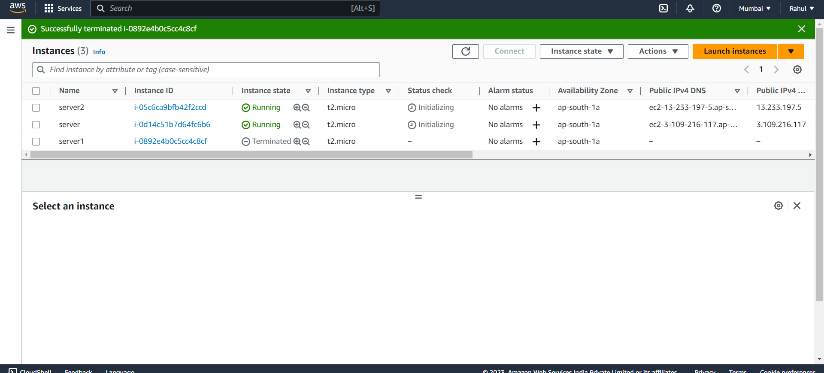

Step 5) Go to Load Balancers and create Load Balancer.

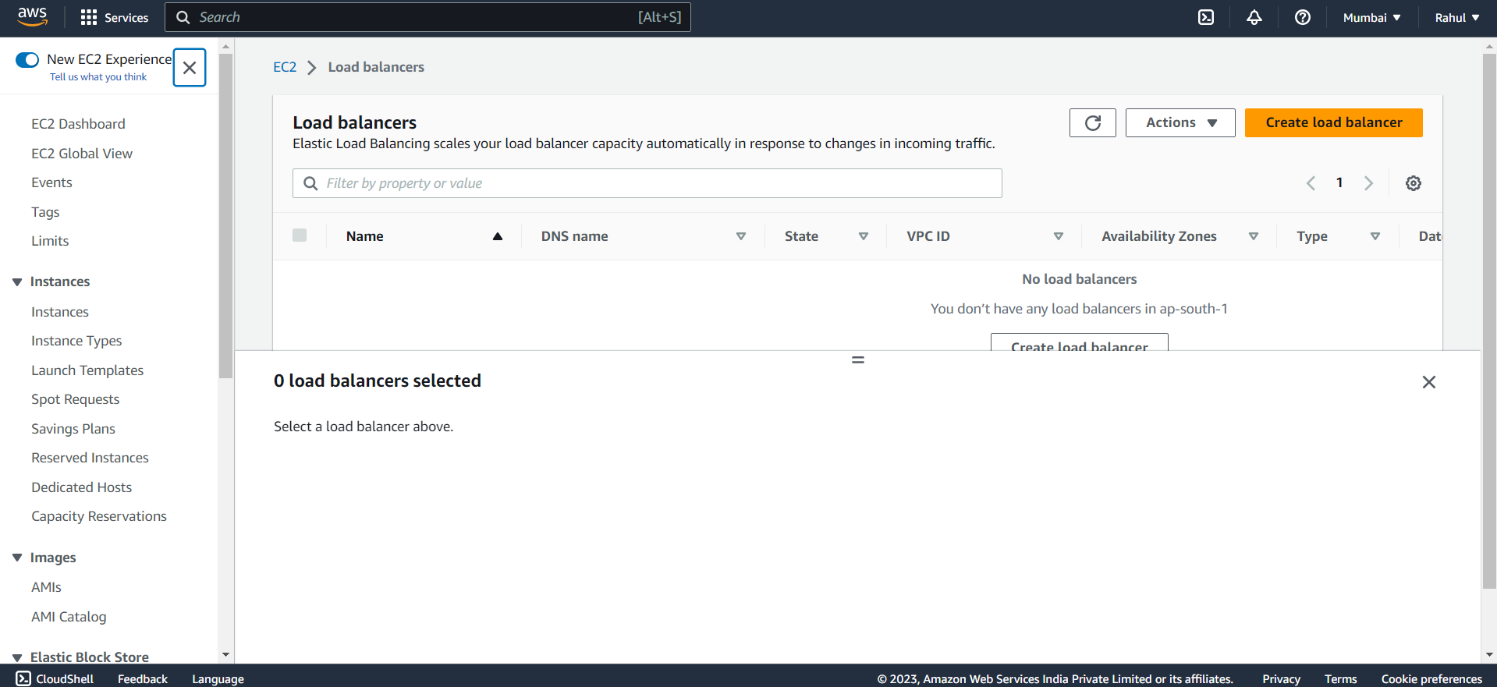

Step 6) Select Application Load Balancer.

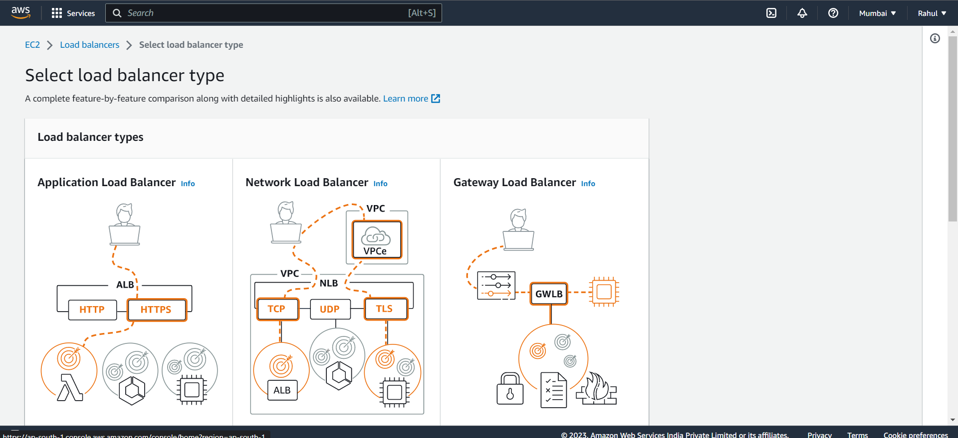

Step 7) Give it a name, Scheme -> Internet facing , Ip address type -> IPv4.

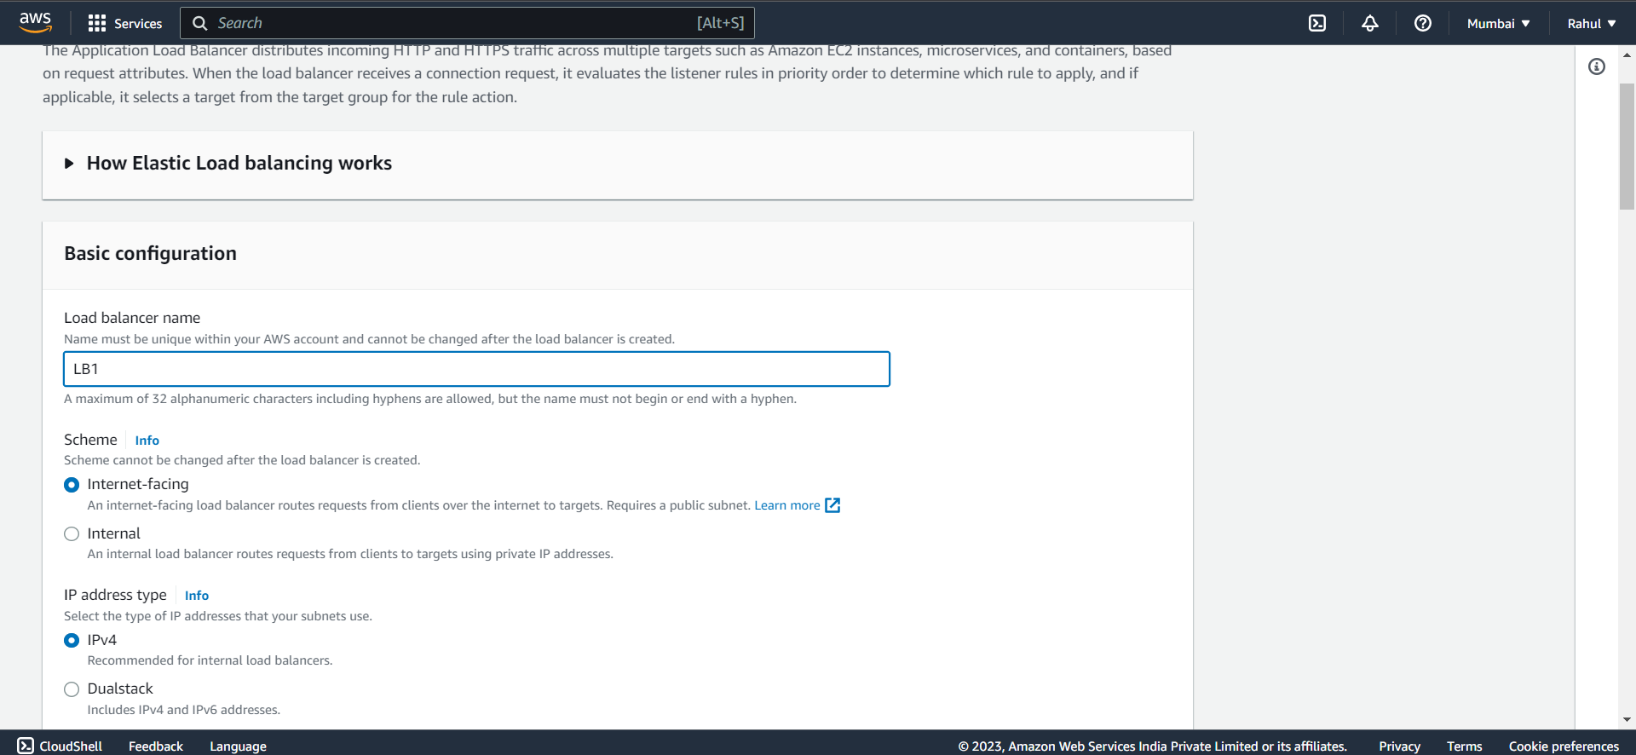

Step 8) Under Network Mapping let VPC be default, and select all three Availability zones and subnets.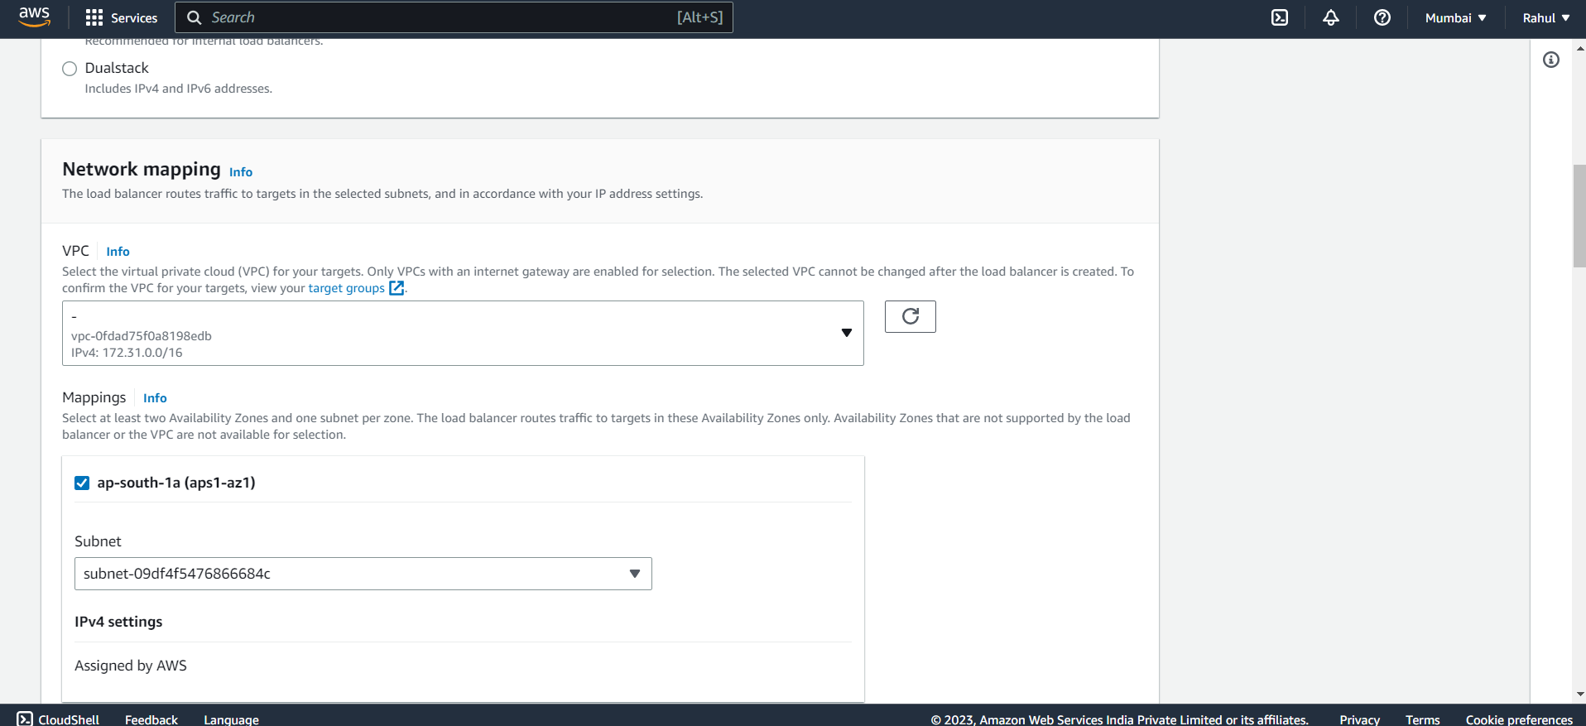

Step 9) Under security groups add the security group used in your instance.

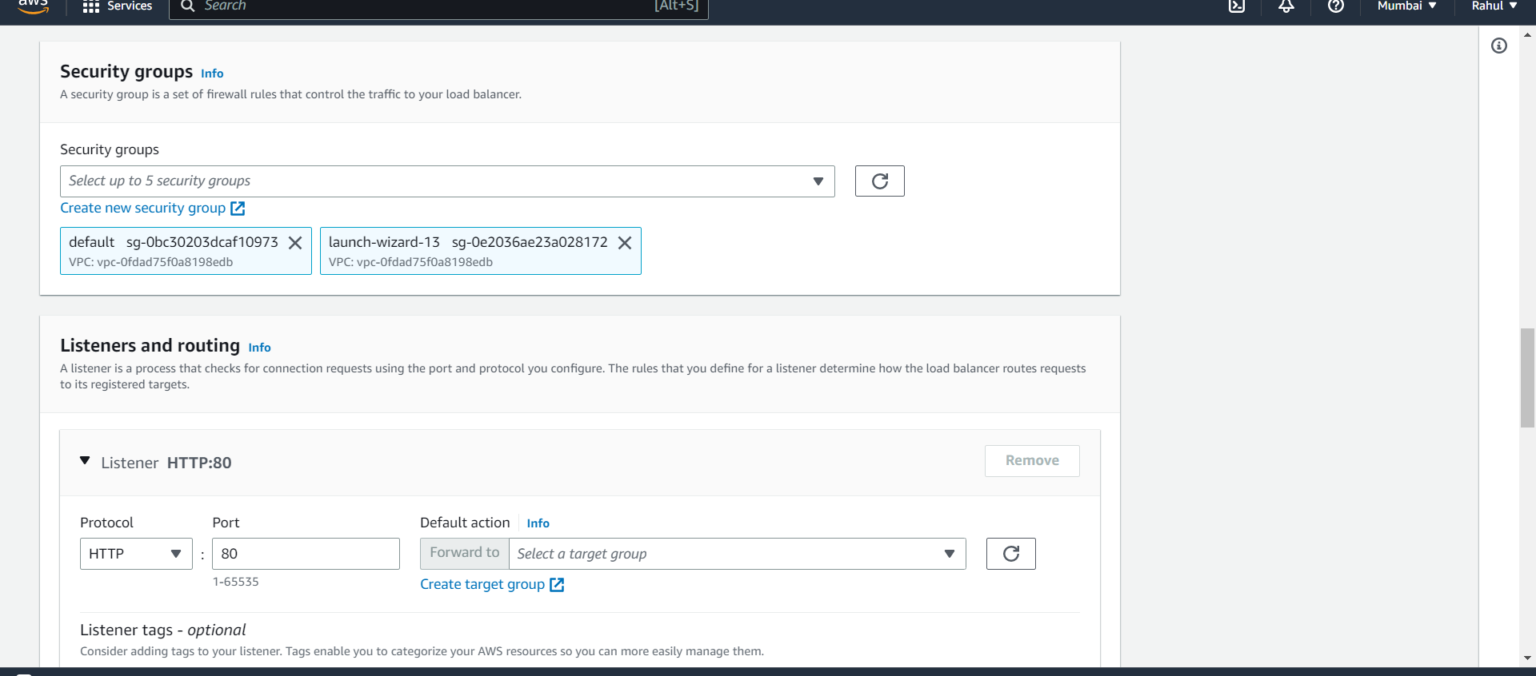

Step 10) Now go to Create target groups and select instances.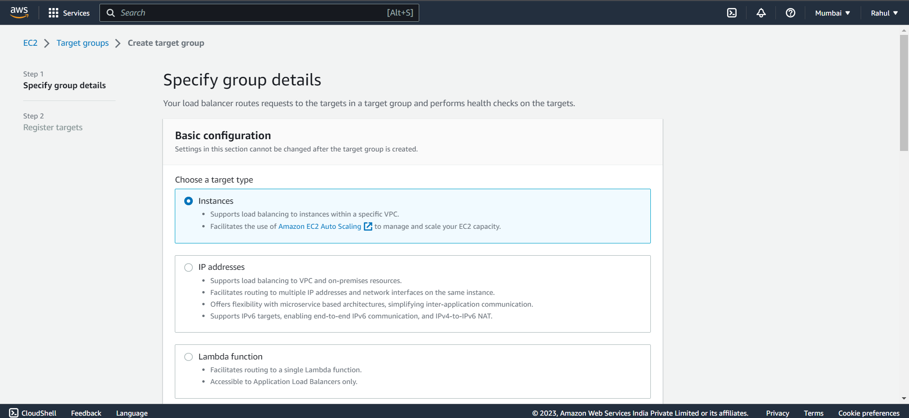

Step 11) Protocol as HTTP and give it a name.

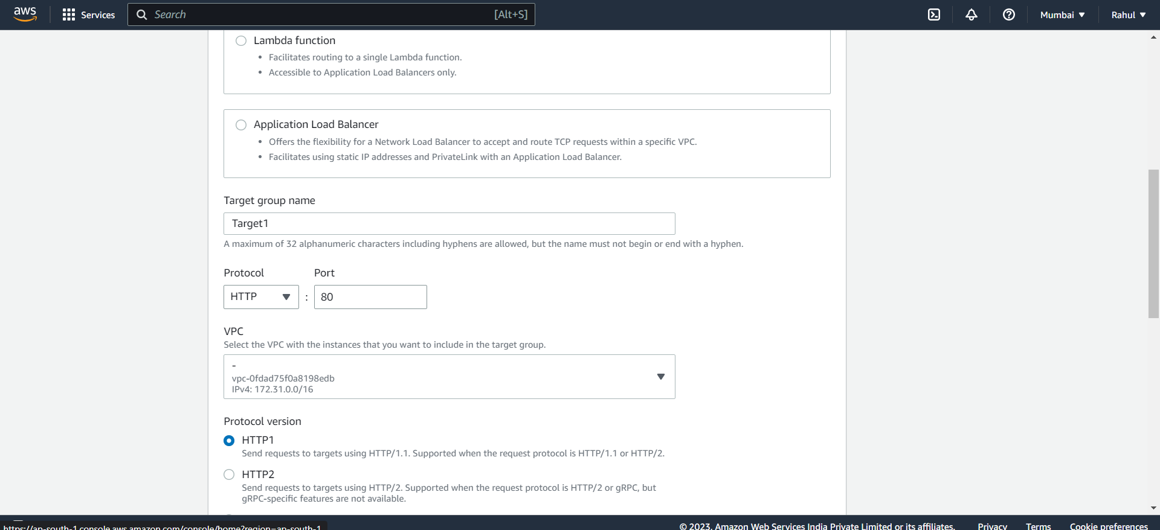

Step 12) Select both instances and click on include as pending below. 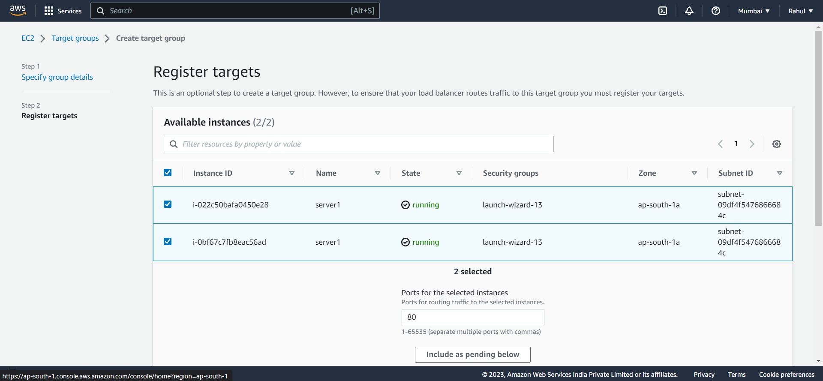

Step 13) Now target group is created.

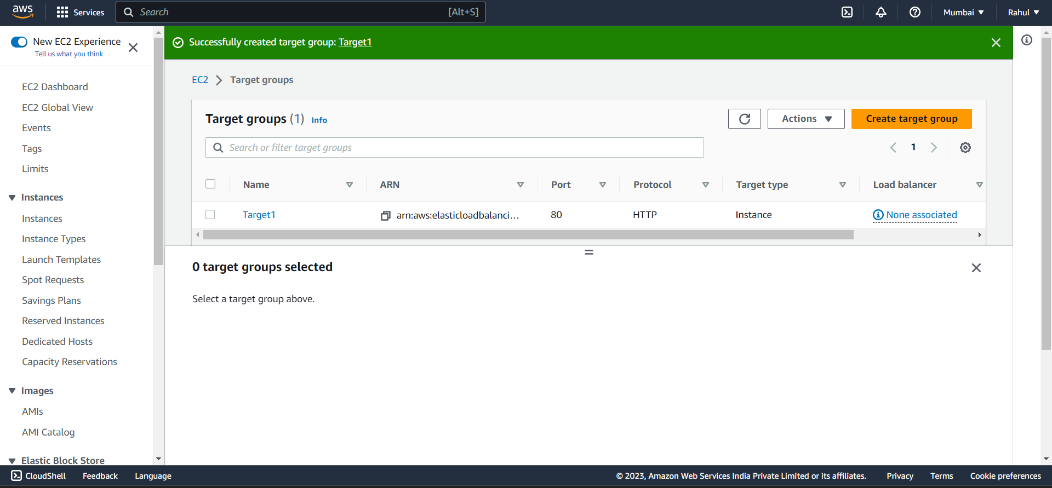

Step 14) Come back to Load balancer and under Listeners and routing add your target groups.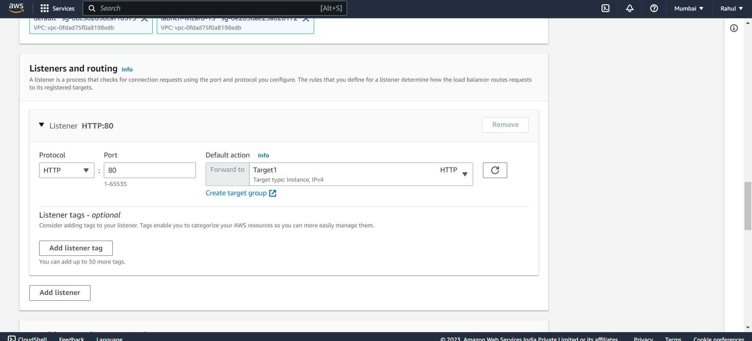

Step 15) And then create your Load Balancer.

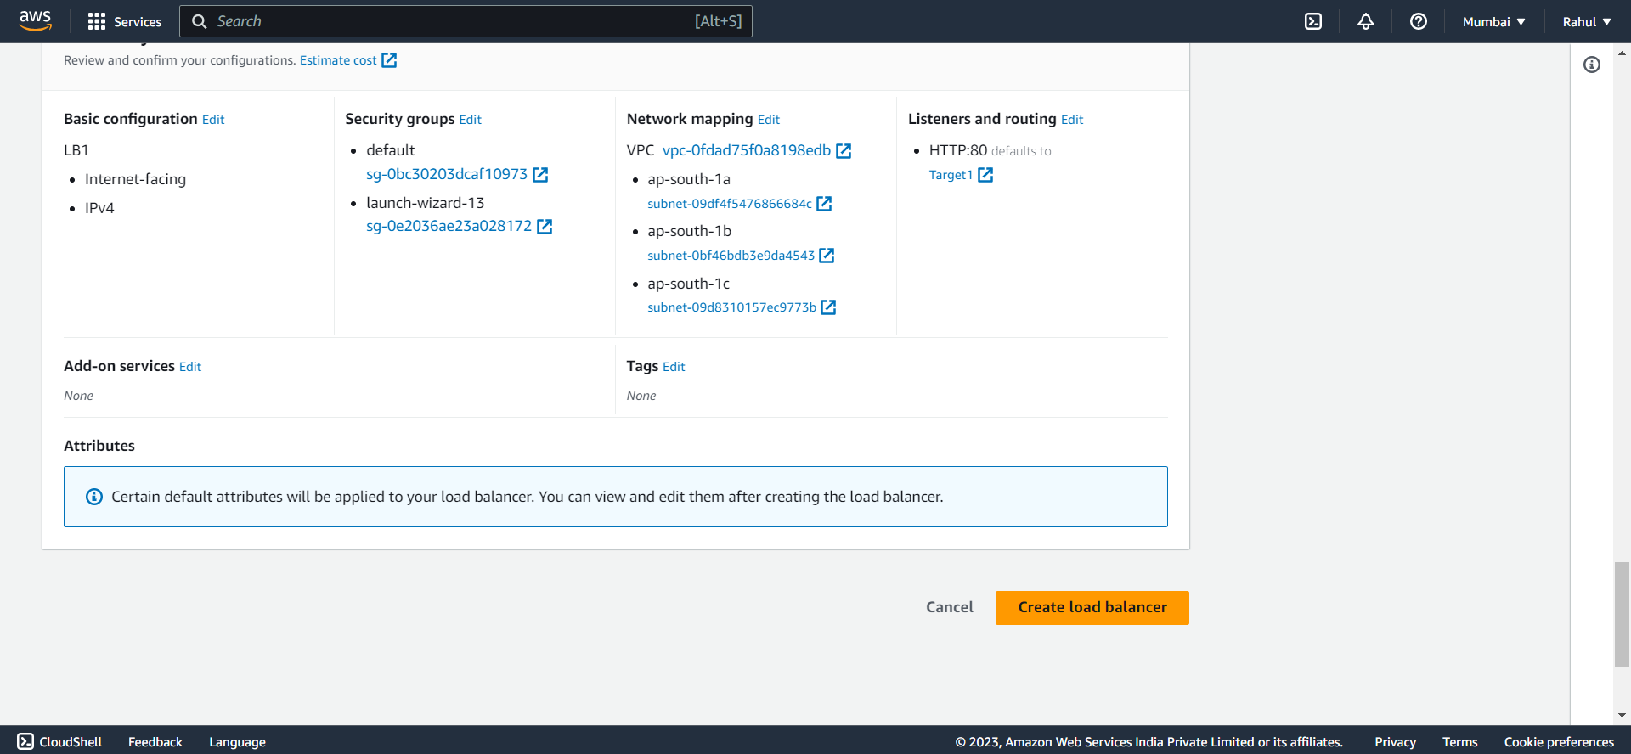

Step 16) Load balancer created.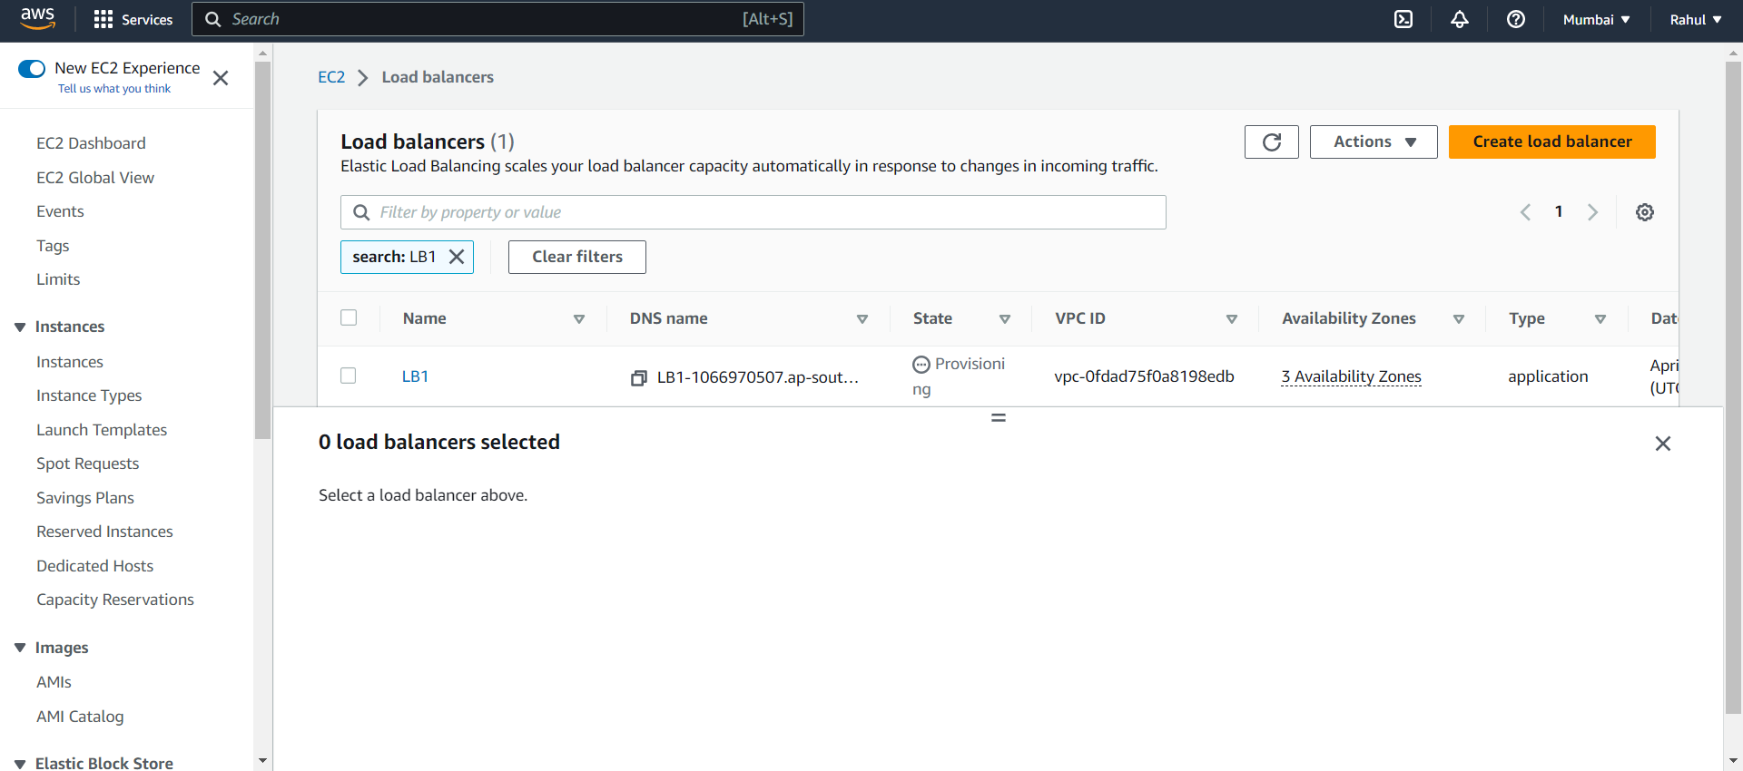

Step 17) Now go to WAF and click on IP sets.

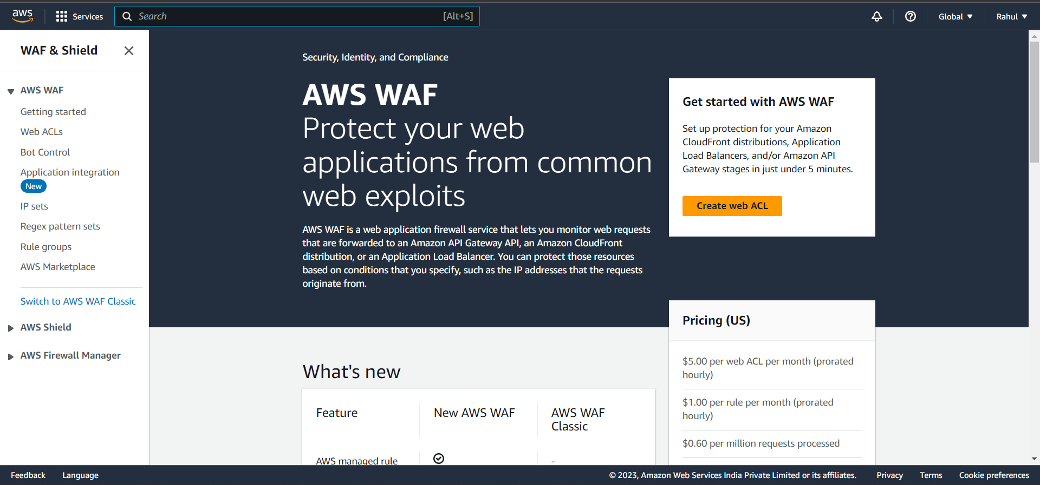

Step 18) Create IP set.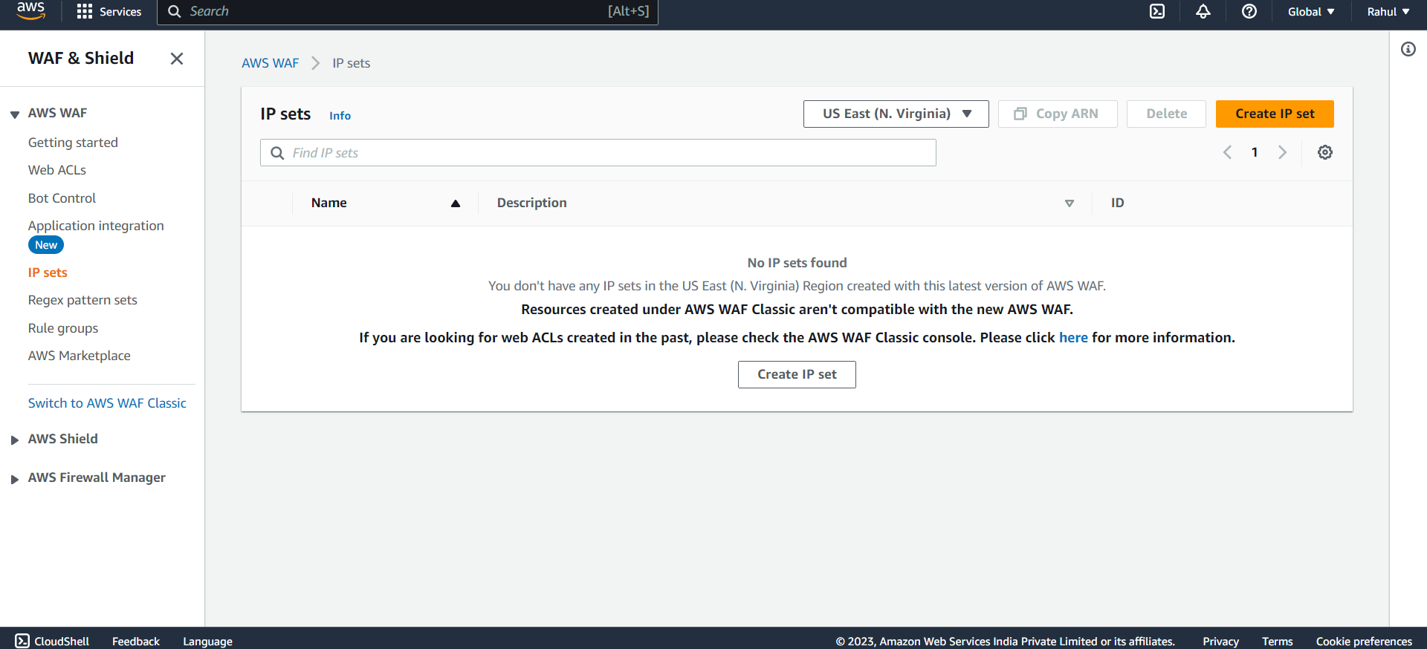

Step 19) Give it a name and paste your Ip address.

(your IP can be found by going to this website

https://whatismyipaddress.com/ )

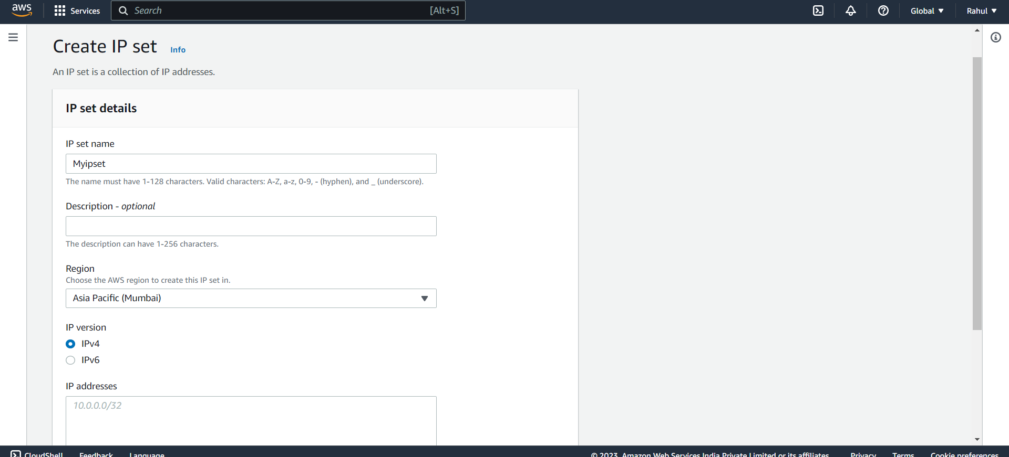

Step 20) Now go to Web ACLs and click on create web ACL.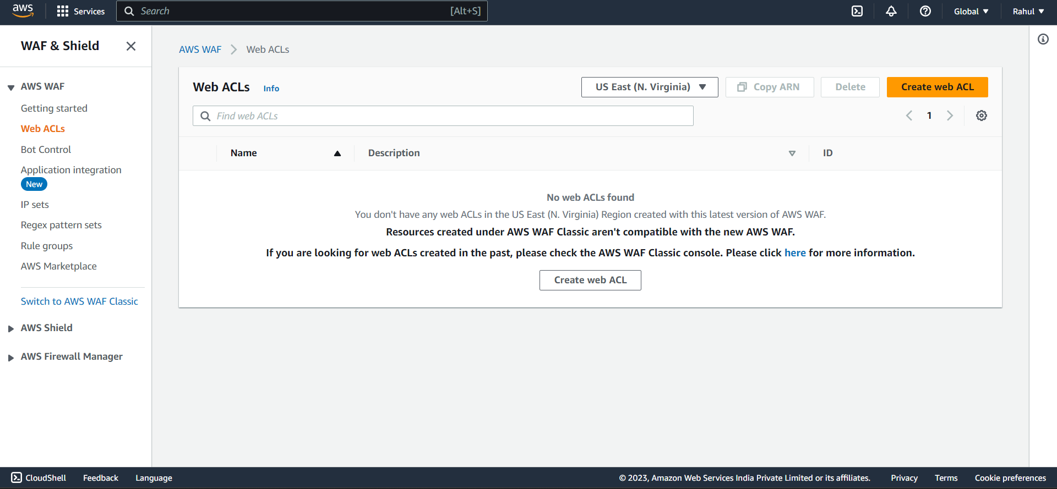

Step 21) Give it a name, select resource type -> Regional resource and Region -> Asia pacific Mumbai.

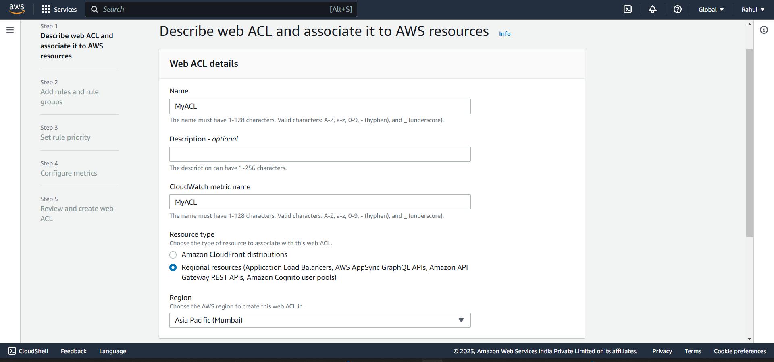

Step 22) Now click on Add resources.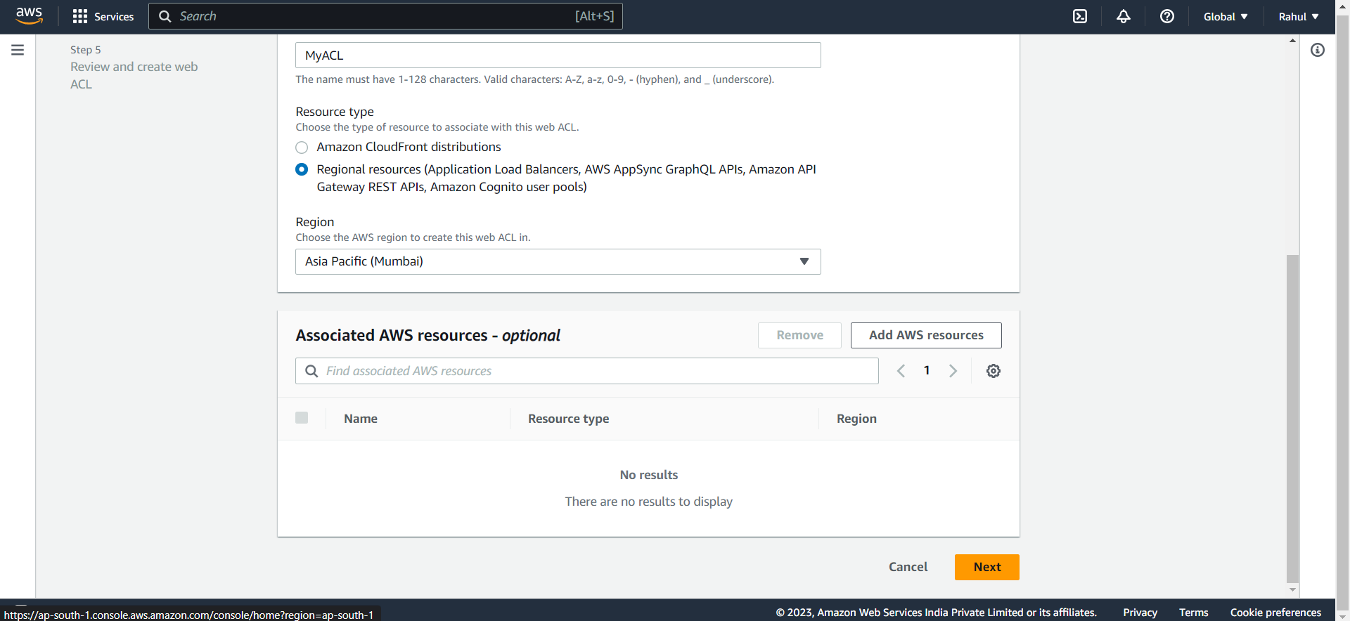

Step 23) Select Application Load Balancer and select your Load balancer created before.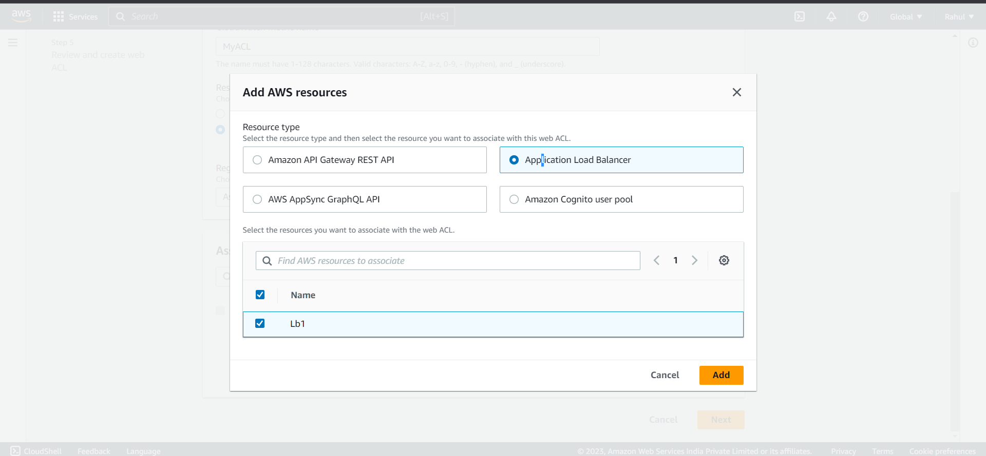

Step 24) After adding click on nect.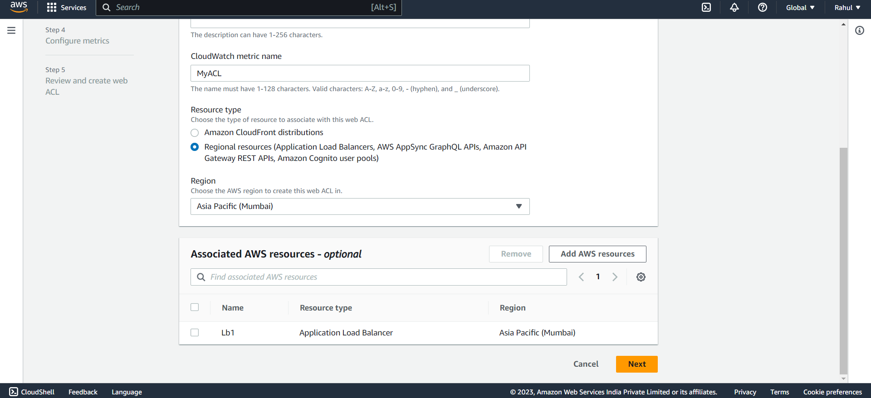

Step 25) Under rules click on Add rules -> Add my own rules and rule groups.

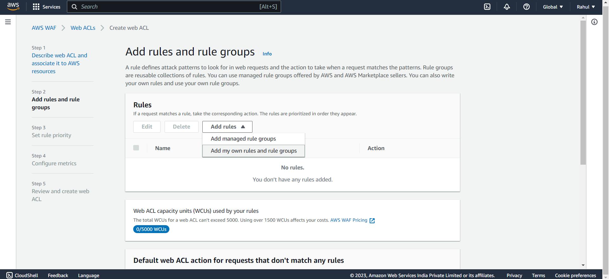

Step 26) Select rule type -> IP set.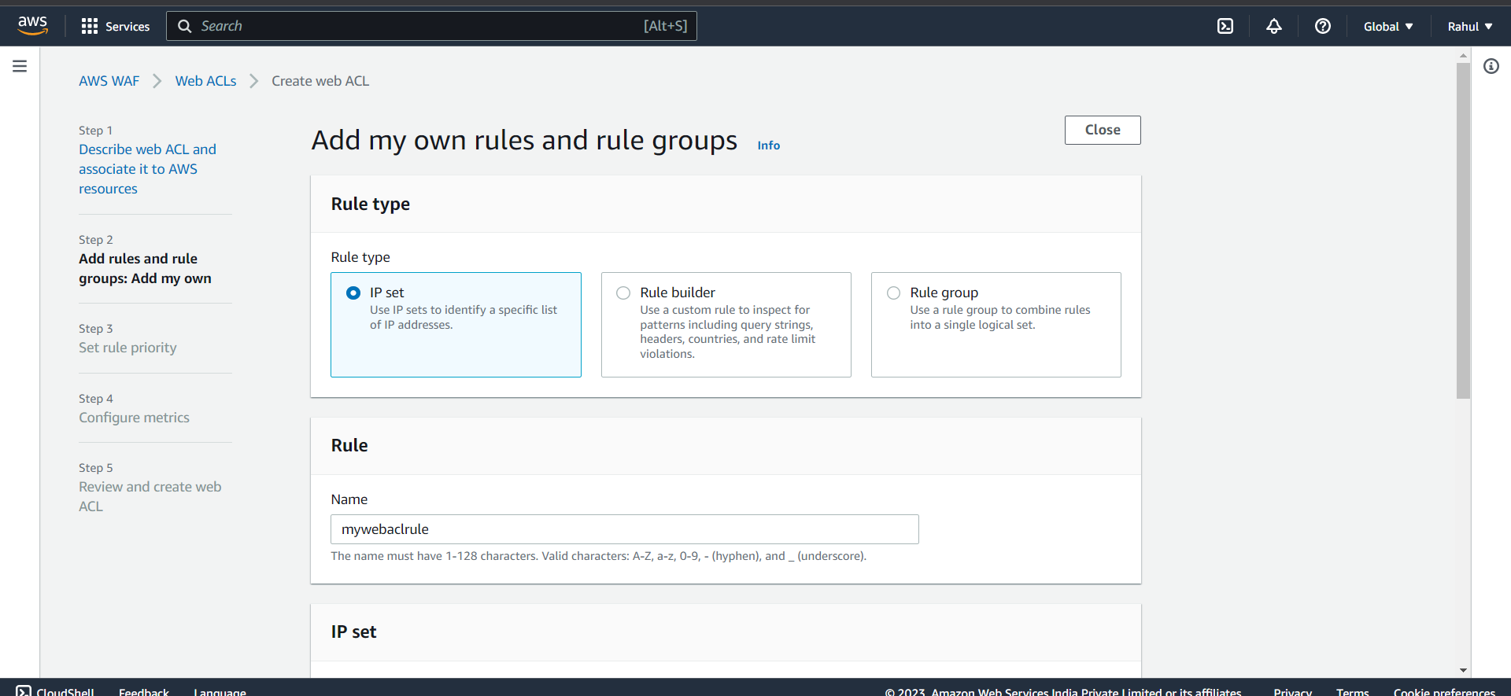

Step 27) Give it a name and select your Ip set created before.

Select

IP address to use as the originating address -> Source IP address.

Action -> Block

And click on Add Rule.

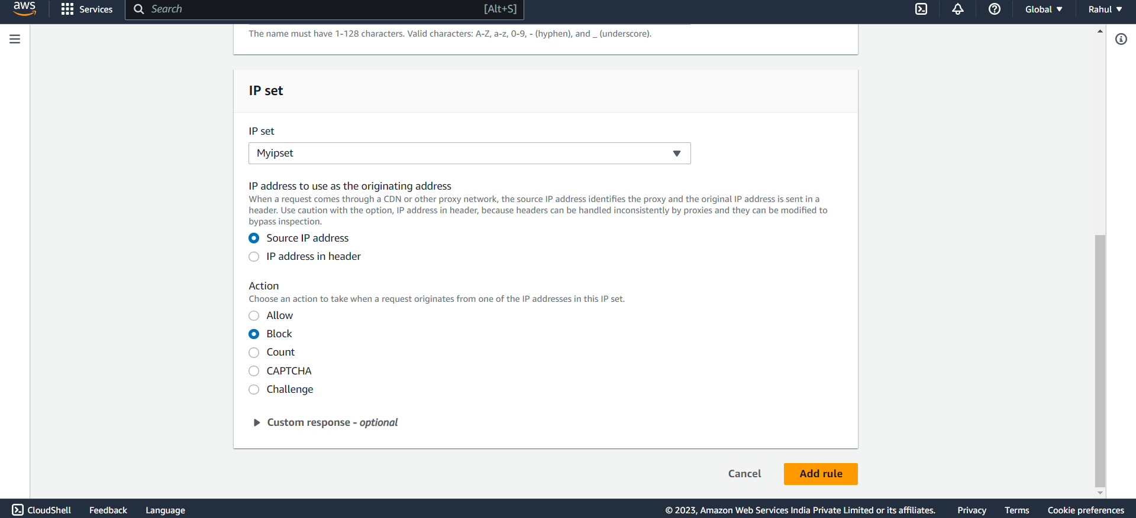

Step 28) Rule will be added.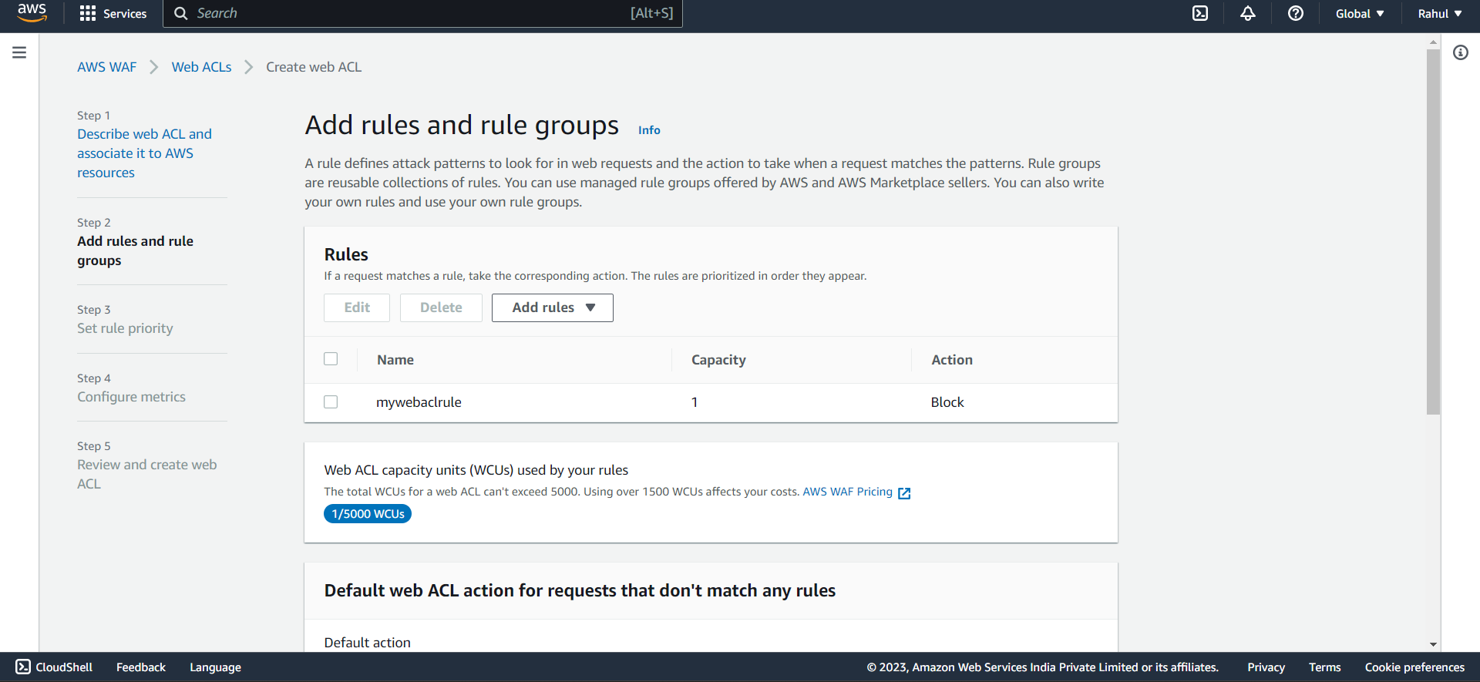

Step 29) Under Default web ACL action for requests that don't match any rules

Select Allow.

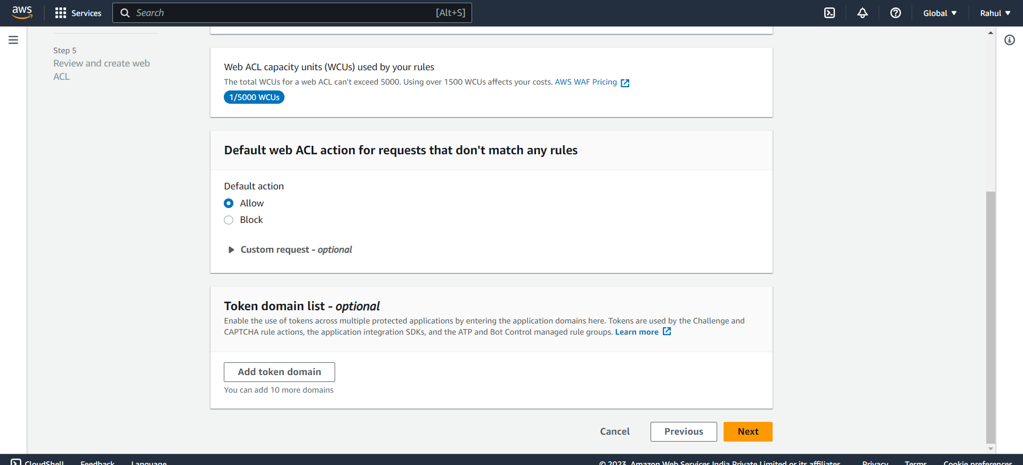

Select 30) Under Set Rule priority click on next.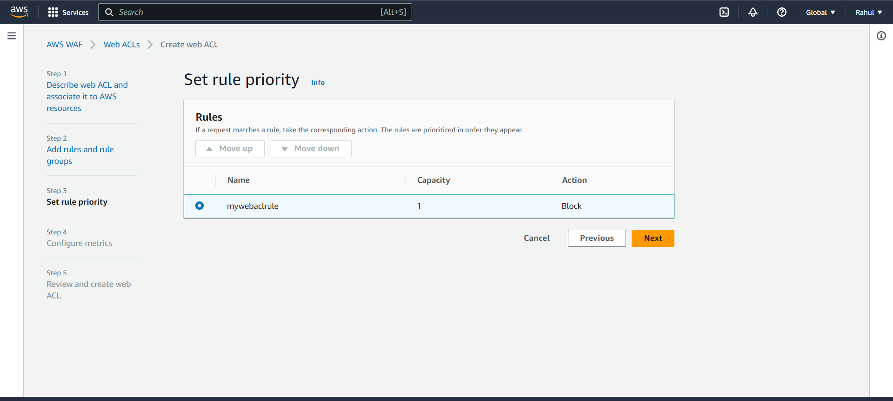

Step 31) Under Configure metrics let everything be default and click on next.

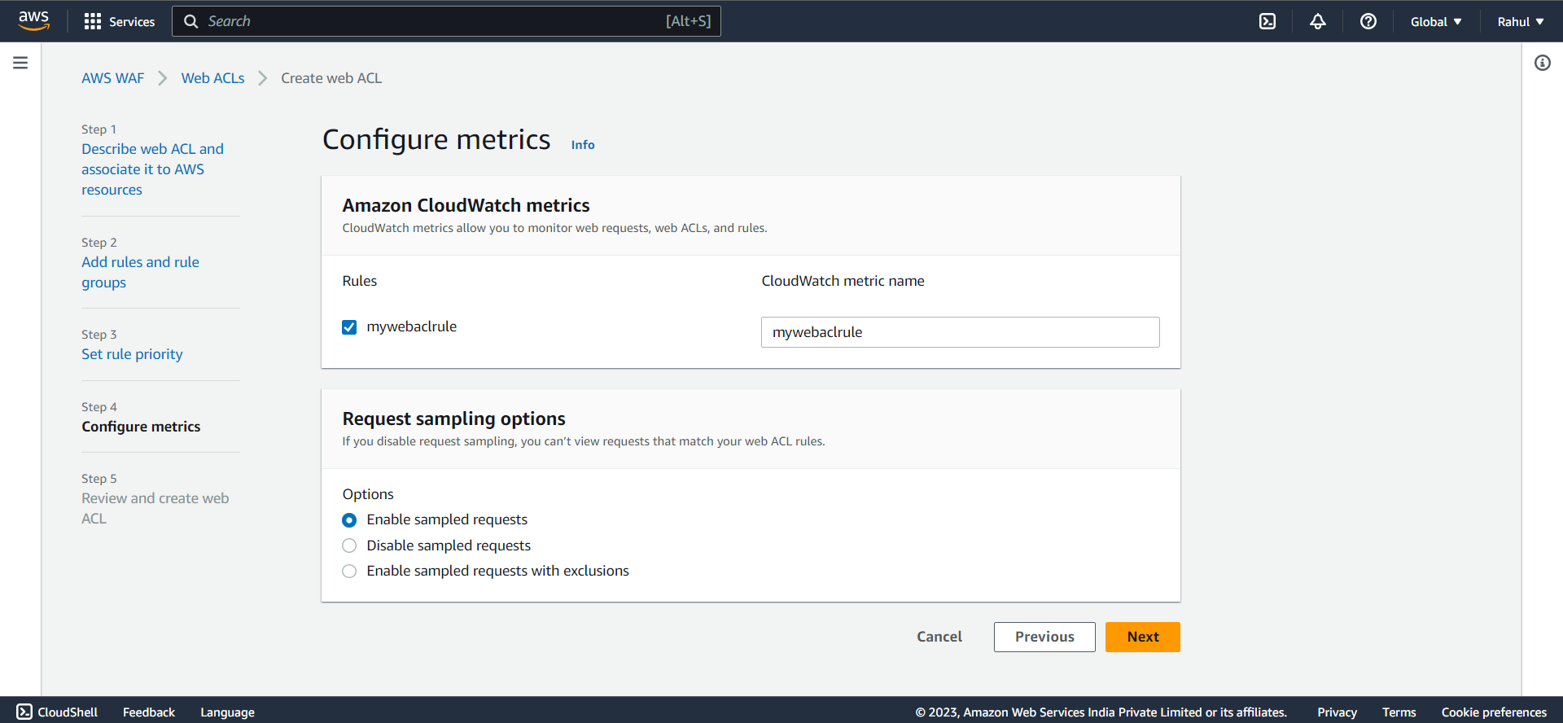

Step 32) Review and create web ACL.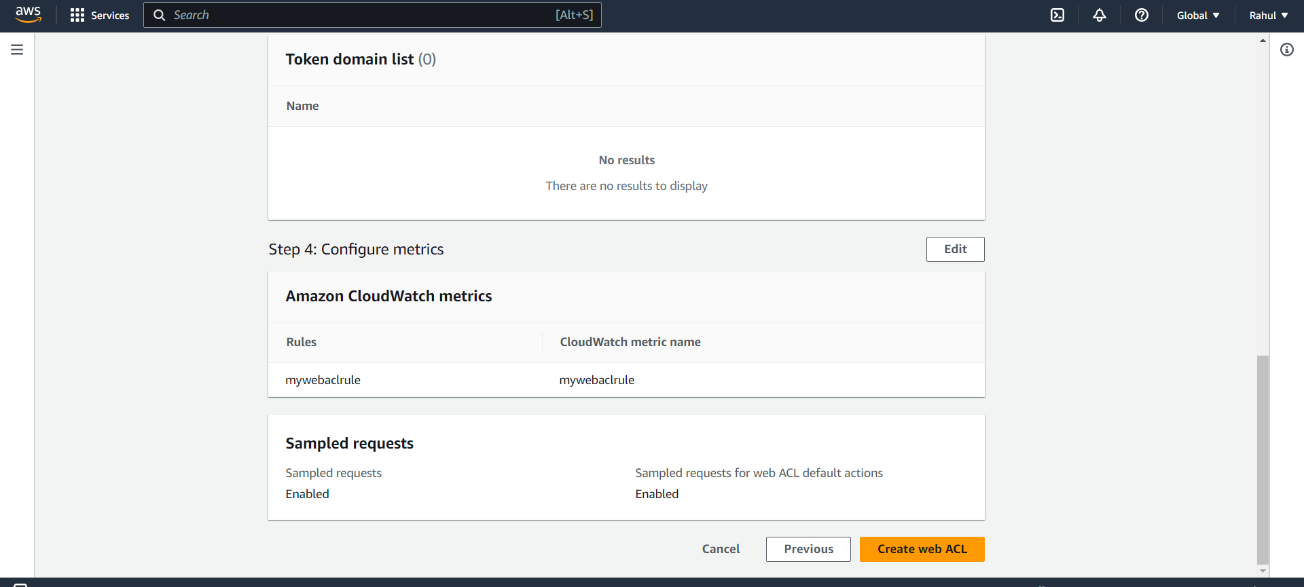

Step 33) After pasting the DNS of the load Balancer on the browser and we can see that our IP is banned.

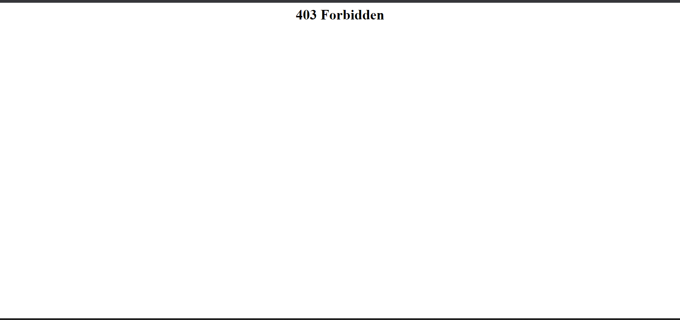

Step 34) Now go back to the WebACL created and Add one more rule.

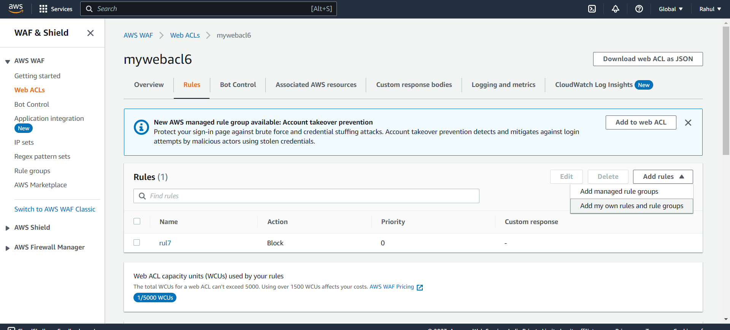

Step 35) Select IP set.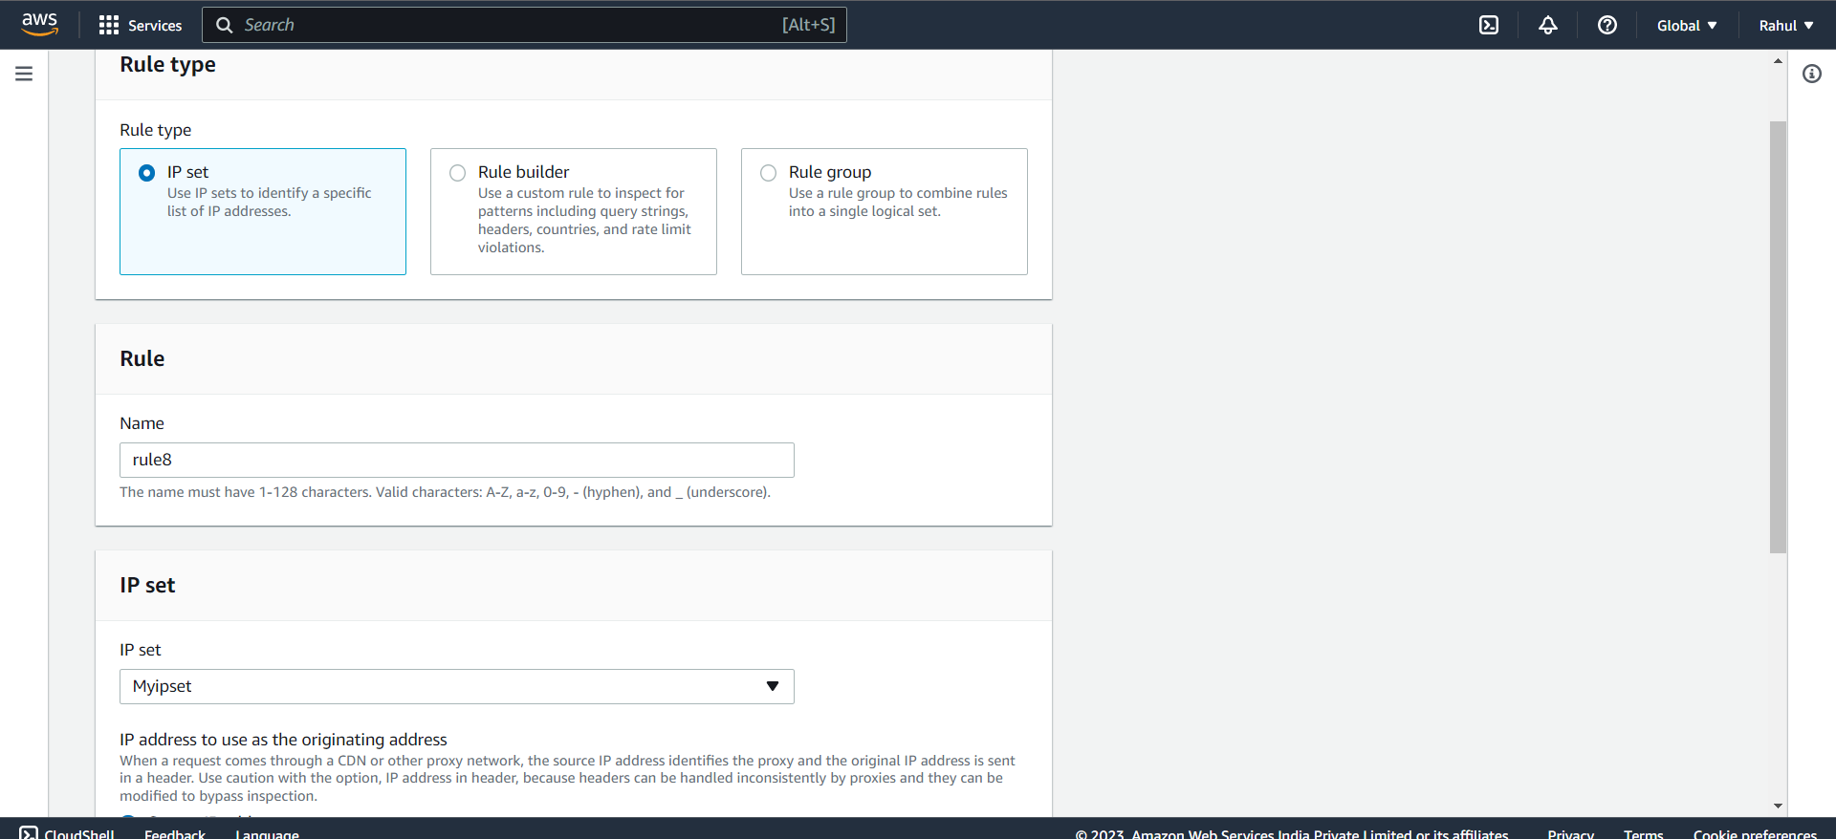

Step 36)

Select

IP address to use as the originating address -> Source IP address.

Action -> Allow

And click on Add Rule.

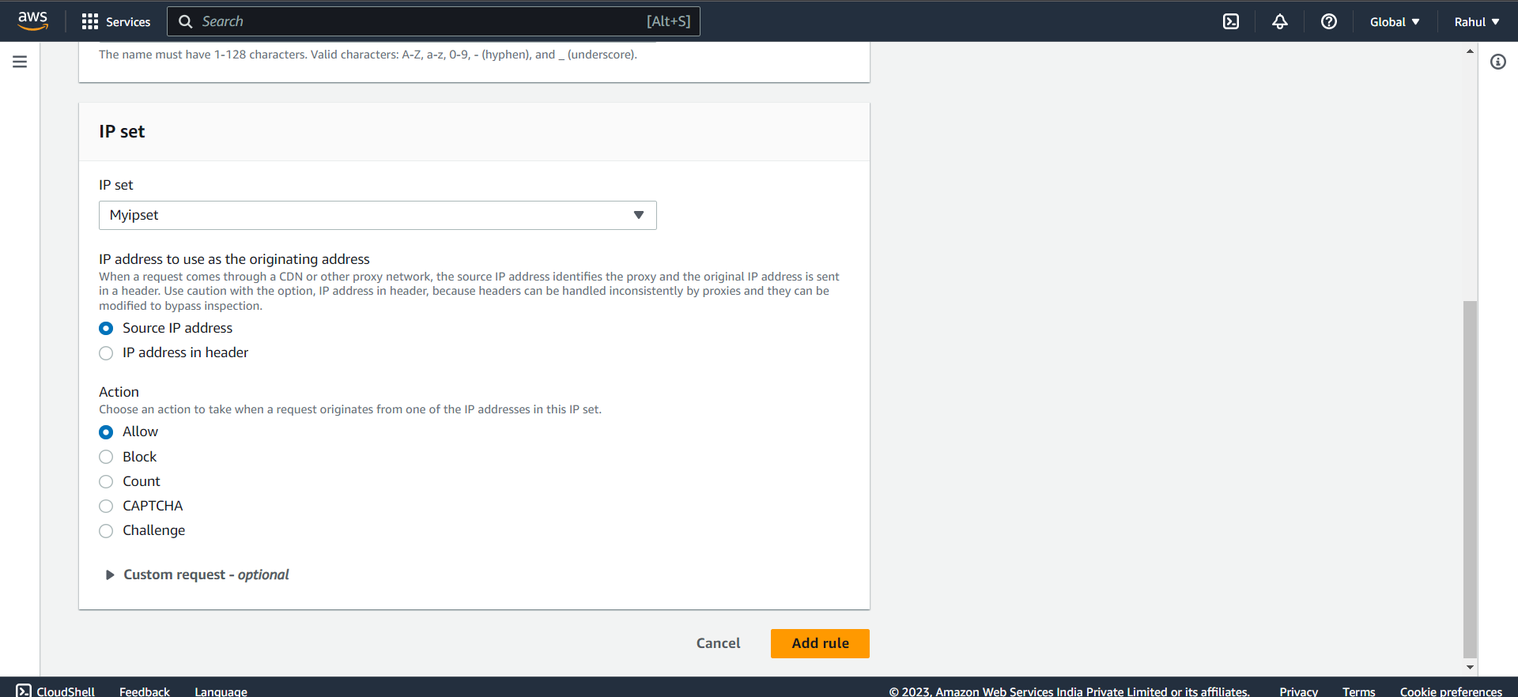

Step 37) Now under rule priority set the priority of the new rule above than previous rule and save it.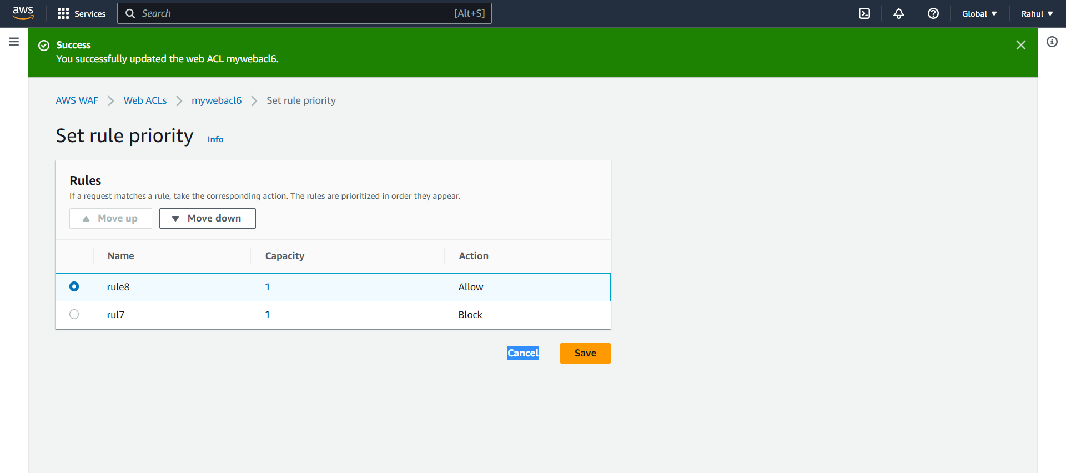

Step 38) Now again refresh the page and you can see that our IP is now unblocked and we are able to access the page.

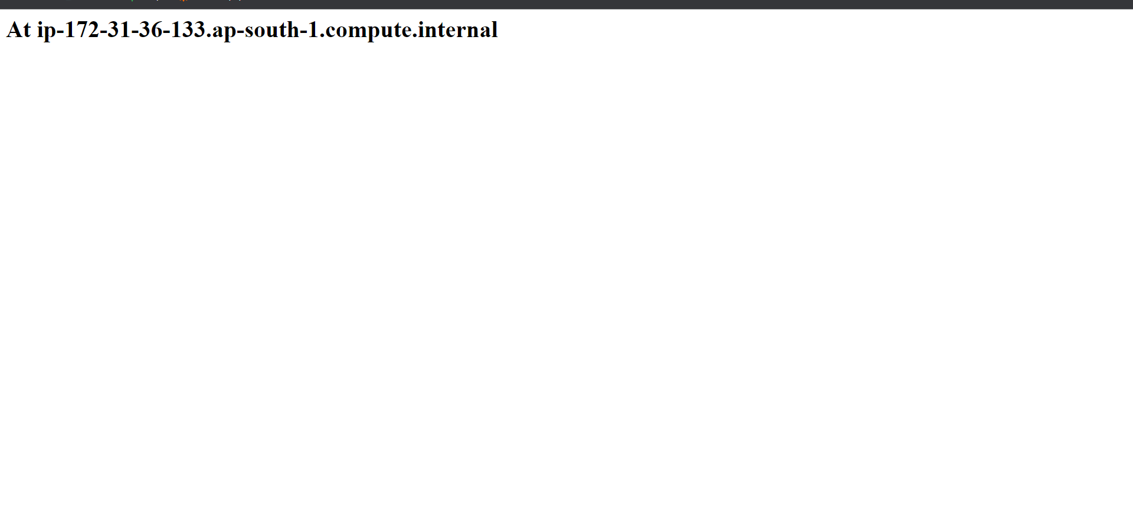

**Experiment- 13**

**Create an instance on GCP**

1. Create an instance on GCP via console, cloud shell and gcloud cli:

**(i).**Linux Instance

**(ii).**Windows Instance

**(i)Linux Instance**

Step 1) Go to GCP Console and click on new vm

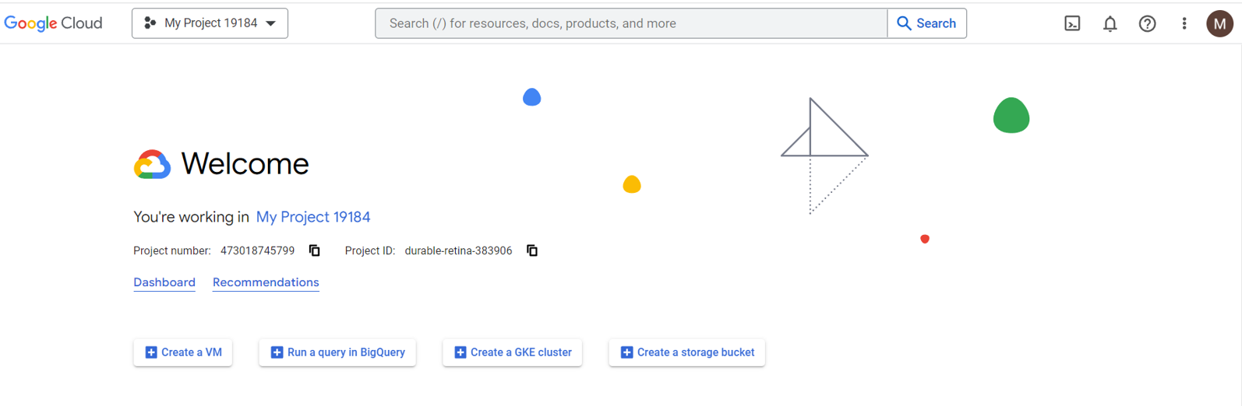

Step 2) Provide appropriate configuration for a Linux machine & create and leave the rest as default.

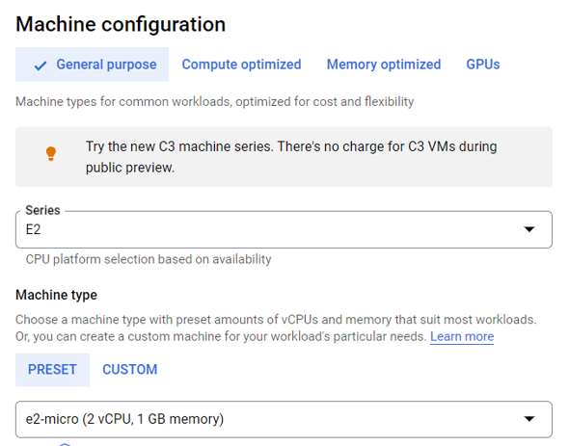

Step 3) Select the operating system.

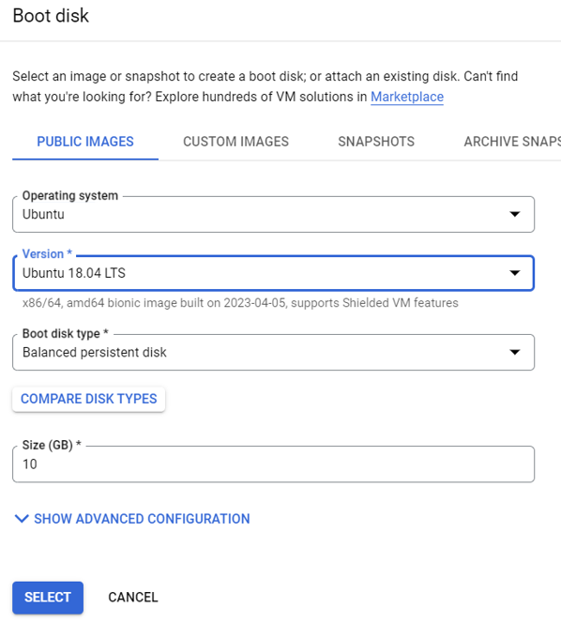

Step 4) Select both firewall.

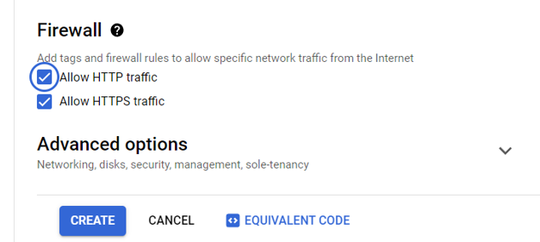

Step 5) In the instances catalogue, select the instance & connect via SSH.

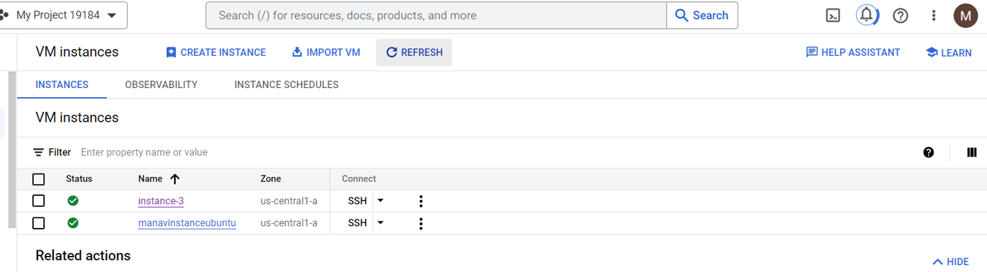

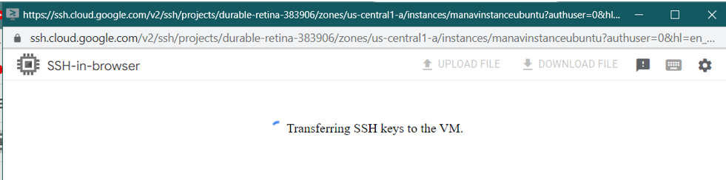

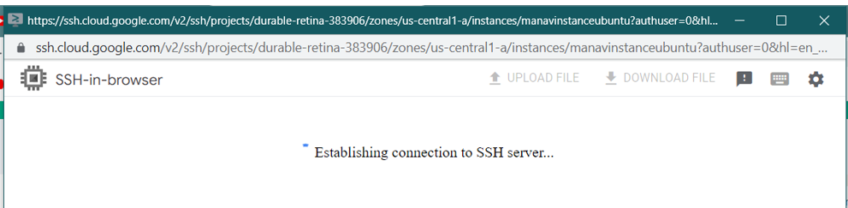

Step 6) Connected through SSH.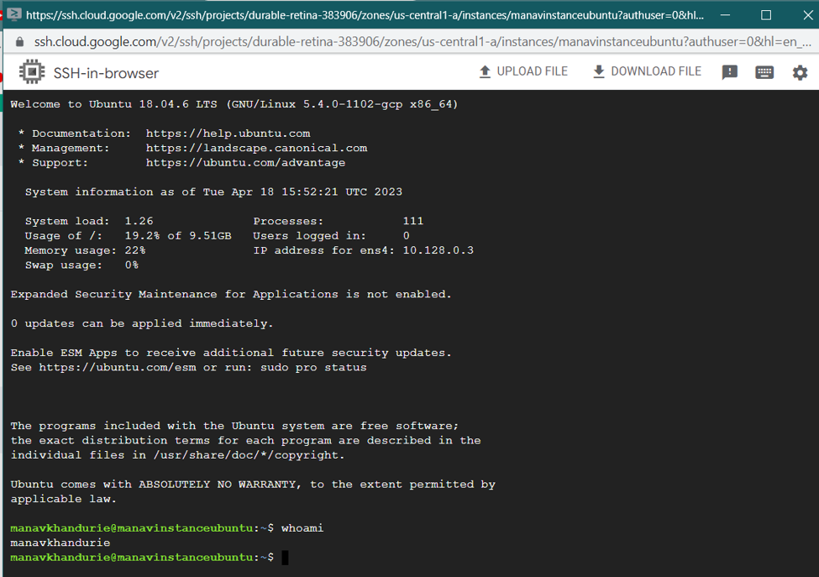

Step 7) To connect via cloud shell, go to instance-> view gcloud command.

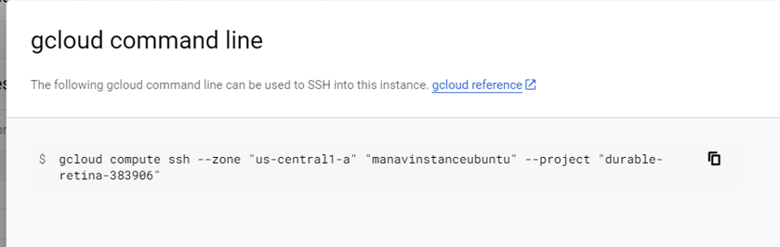

Step 8) Open cloud shell in console(present @ top right of the navbar).

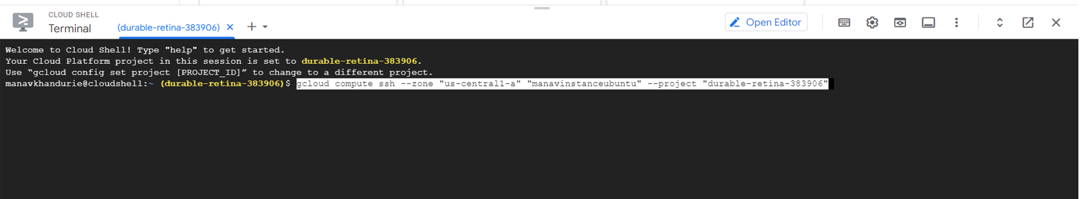

Step 9) Download & run the gcloud cli and run it.

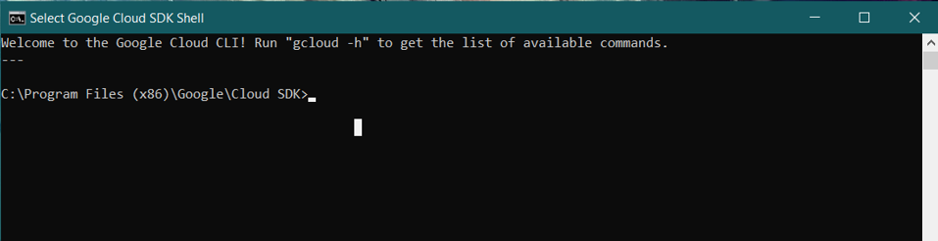

Step 10) Use the command to initialize

gcloud init

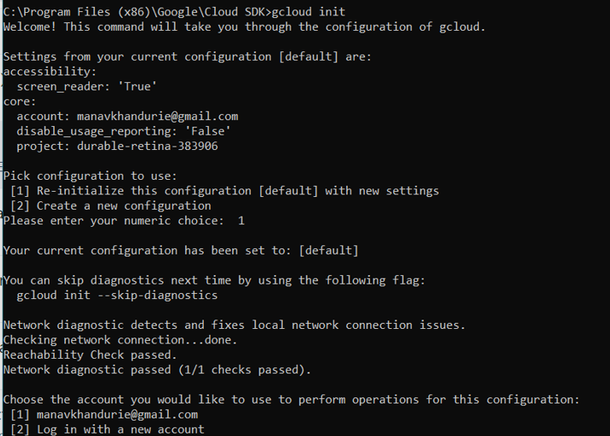

Step 11 ) Use the google account linked with gcp and select the project

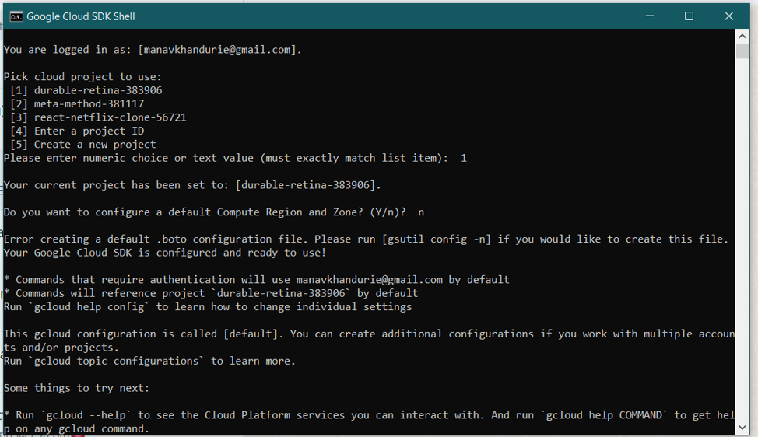

Step 12) Find a equivalent code for creating the instance through console

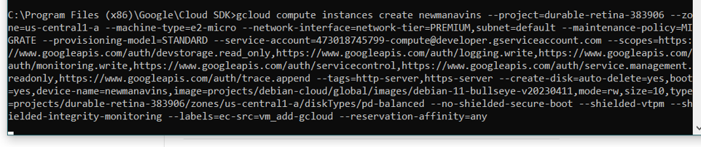

Step 13) paste the code in command line

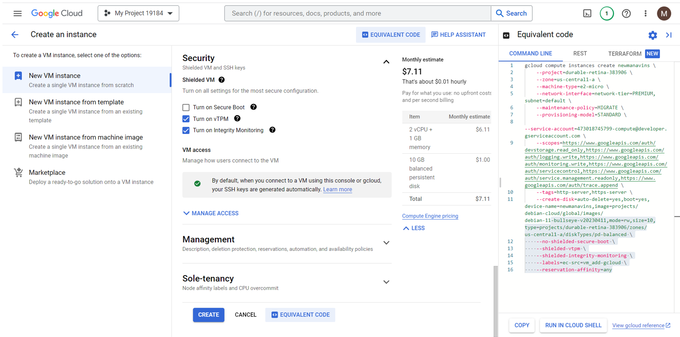

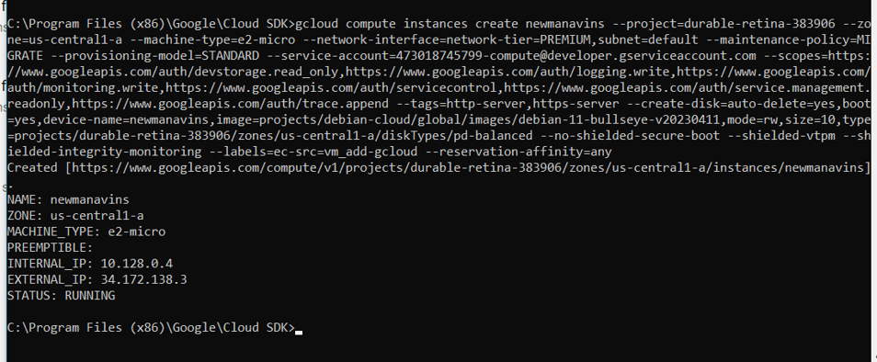

Step 14) Copy the gcloud command to connect

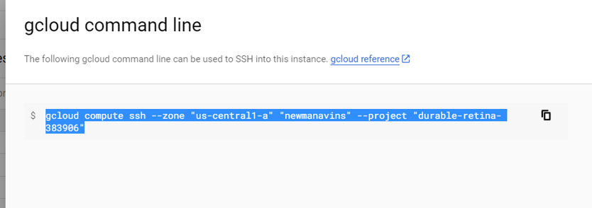

Step 15) Paste the command in the gcloud cli and press enter to connect

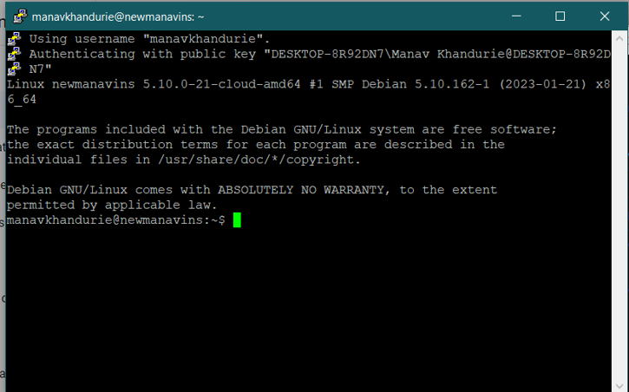

**(ii)Window**

Step 1) Go to Console & click on create VM & assign appropriate configurations

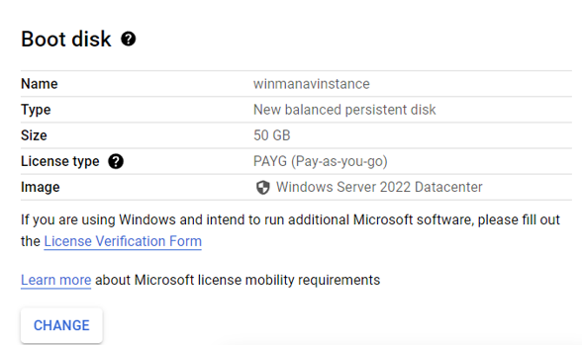

Step 2) Select the firewall

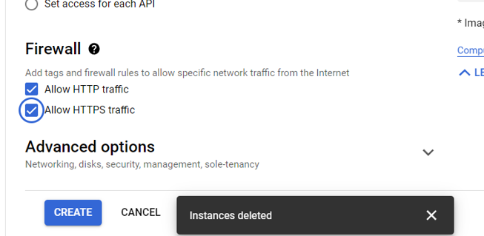

Step 3) Go to instance-> set Windows password & set a new password

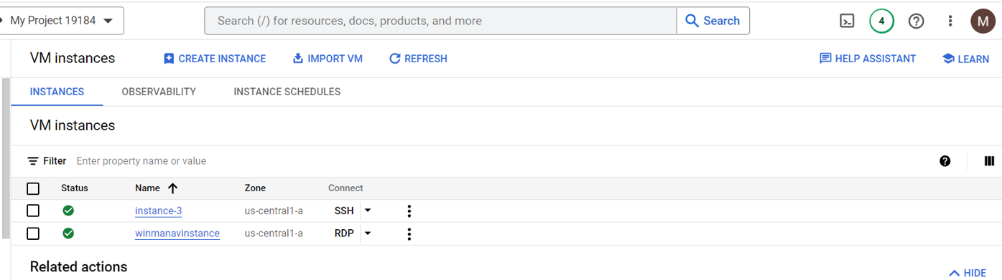

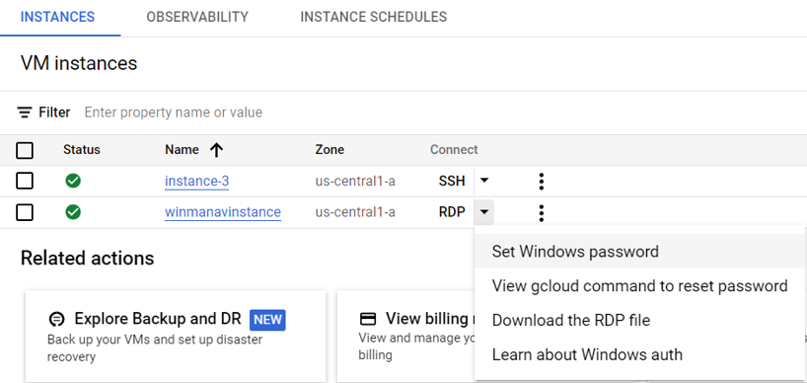

Step 4) Set new password

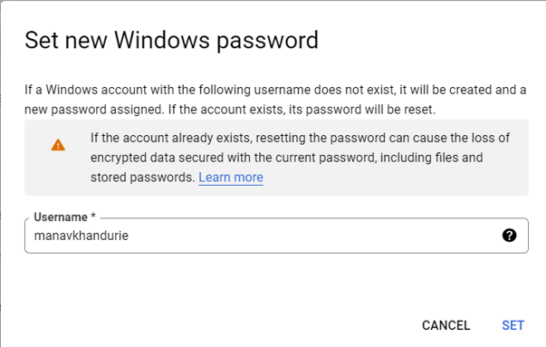

Step 5) Copy the password for login in remote desktop 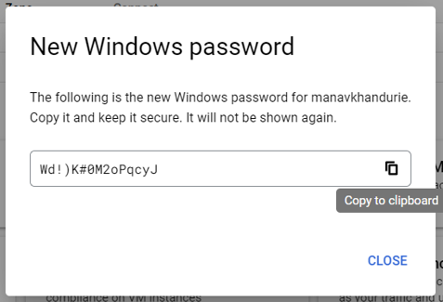

Step 6) Download and open RDP file

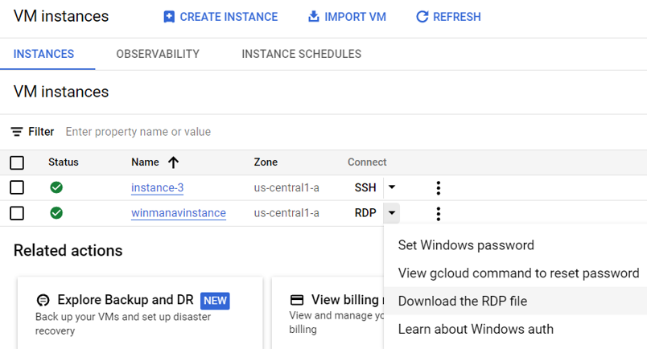

Step 7) open the window remote desktop

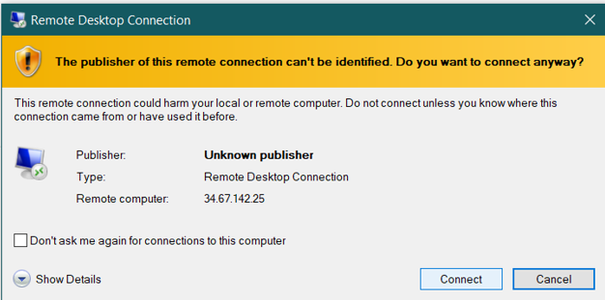

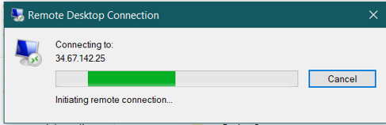

Step 8) Your remote desktop is opened

